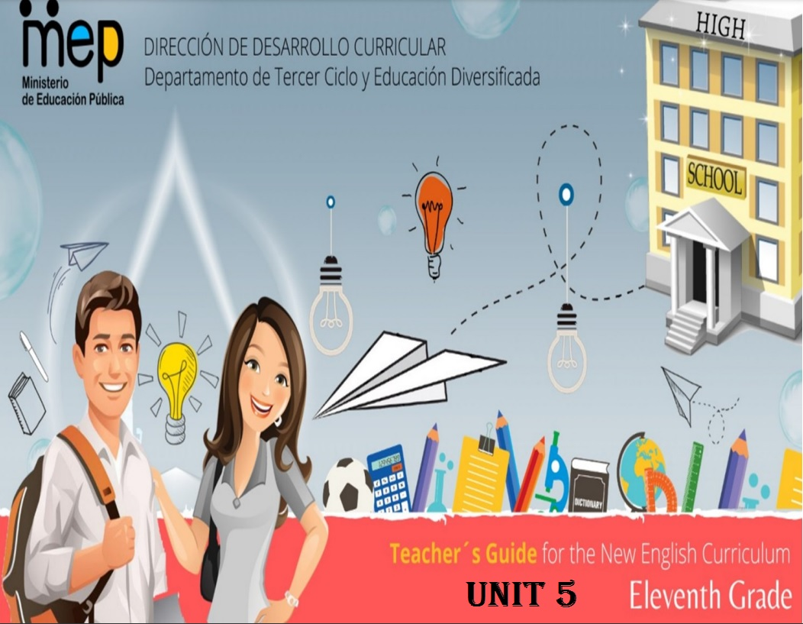

**AUTORIDADES NACIONALES**

Anna Katharina Müller Castro

**Ministra de Educación Pública**

María del Rocío Solís Gamboa

**Viceministra Académica de Educación**

Ana Mariela Abarca Restrepo

**Directora de la Dirección de Desarrollo Curricular**

Rigoberto Corrales Zúñiga

**Jefe del Departamento de Tercer Ciclo y Educación Diversificada**

**Comisión redactora**

**Mag. Marianella Granados Sirias,**

Asesora Nacional de Inglés, Departamento de Tercer Ciclo y Educación Diversificada

**Mag. Alfredo Ortega Cordero**,

Asesor Nacional de Inglés, Departamento de Tercer Ciclo y Educación Diversificada

**Unidad 5**

Max Arias Segura

**Asesor Regional de Inglés, Dirección Regional de Liberia**

**Docentes de Inglés de Tercer Ciclo y Educación Diversificada**

Amalia de la O, Colegio Nocturno de la Cruz

José Enrique Chavarría , Liceo Nocturno de Bagaces

Helena Chaves, Colegio Artístico Felipe Pérez Pérez

Didier Villareal, Liceo de Guardia

Lilliana Ugalde, Colegio José María Gutiérrez

Alejandra Peña, Instituto de Guanacaste

Dear teacher,

We hope this letter finds you and your families really well. We want to thank you for your hard work and commitment to the English teaching in Costa Rica. This is the last unit from our academic curriculum. This unit brings great opportunities to strengthen your teaching experience and promote interaction and production from your learners. This last unit is intended to reach the following aspects in our learners:

|  |  |
| --- | --- |
| **Learn to know** | have a level-appropriate language (words, phrases, formulaic expressions) and topical knowledge related to domains, scenarios and themes. |
| **Learn to do** | use level-appropriate linguistic and topical resources in order to listen, read, speak and write in response to level and age-appropriate tasks, integrating language and topical knowledge, skills and abilities (KSAs) within domains, scenarios and themes. |
| **Learn to be and live in community** | use personal and social dispositions (e.g., engagement, attitudes, cooperation, turn taking, empathy, and other universal values) when interacting and producing in the target language and taking time to search for words using oral and body language for transferable learning beyond the classroom setting (enduring understanding). |

Besides, in the exit profile it is stated that learners…

1. can listen to different opinions or points of view of native speakers of English in order to express argumentations (listening to speak).
2. can express arguments/opinions when exchanging interactions (listening to speak).
3. can interact in long conversations with peers and others about controversial issues using interaction and production strategies (listening to speak).
4. can write about online or printed controversial issues for presenting meaningful information to audiences, e.g. Impromptu speech (reading to write/speak).

Teaching controversial issues is one of the most effective practices for the promotion of democracy in the classroom because it means discussing them in the classroom. The term “controversial issues” refers to “issues which arouse strong feelings and divide communities and society”. https://www.futurelearn.com/info/courses/promoting-democracy-a-guide-for-teachers/0/steps/271445

## Why is it important to teach controversial issues in class?

“Fouberg believes that exposing students to other viewpoints outside of what they know is essential. Students’ knowledge, thinking, and ways of processing information can change in your classroom. Students should wrestle with complicated ideas, including ones they’ve never thought about before. They should become comfortable in not knowing how to solve complex issues while seeking meaning in what they’re learning and while thinking about ideas from multiple points of view” <https://www.hmhco.com/blog/how-to-teach-controversial-issues-in-class>.

## Teacher responsibility

1. It is crucial to be aware of the social and political context of your school.
2. Understand the school and the situations learners’ experience.
3. Take into account that there might be issues that are particularly sensitive to all or some students. Be aware of how it will affect others and how they will react to it.
4. Avoid bullying, derision, sarcasm, embarrassment and humiliation in the class when teaching this unit.

1. Choose topics that will promote engagement, positive attitudes, cooperation, turn taking, empathy, and other universal values when interacting and producing in the target language.
2. Create a safe space for students to share different viewpoints avoiding bias.
3. In the end, every student’s opinion should be considered and respected, and an honest and open dialogue should be promoted.

https://oxfamilibrary.openrepository.com/bitstream/handle/10546/620473/gd-teaching-controversial-issues-290418-en.pdf

## Suggested strategies when working with controversial issues

1. Set clear rules during interactions.
2. Clarify what will and will not be permitted in terms of arguments.
3. Speak with respect and care because students will imitate you.
4. Use real problems to create greater interest in class.
5. Teach your learners how to disagree with someone else’s ideas to avoid personal attacks.
6. Encourage learners to link their opinions to evidence if possible.

**https://poorvucenter.yale.edu/teaching/ideas-teaching/teaching-controversial-topics**

Sincerely,

National English Advisors

Third Cycle and Diversified Education Department

**Weekly Plans and Materials**

**Unit 5**

**Eleventh Grade**

|  |  |  |  |  |  |  |  |  |
| --- | --- | --- | --- | --- | --- | --- | --- | --- |
| **Level 11th Unit 5**  **CEF Level to be Reached B1 Basic User/Independent User** | | | | | | | | |
| **Scenario:** Really???  (Controversial issues) | | | | | | | | |
| **Enduring Understanding** | | What is considered right can be relative depending on personal points of view. | | | | | | |
| **Essential Question** | | How our point of view depends upon the way we look at it? | | | | | | |
| |  | | --- | | **Dimensions** | | **1.** **Ways of thinking (√)** | | **2. Ways of living in the world (√)** | | **3. Ways of relating with others (√)** | | **4. Tools for integrating with the world (√)** | | | | | | | | | |
| **Assessment and Goals** | | | | | | | | |
| **Week 1**  **Goals**  **L.2.** understand classroom talk between two or more native speakers, only occasionally needing to request clarification  **R.2.** understand straightforward, factual text about world facts, issues from health and medicine, controversies from the law and stereotypes and cultural differences satisfactorily.  **SP.2.** express an opinion about world facts, issues from health and medicine, stereotypes and cultural differences and issues such as giving a short talk on animal rights, UFO’s, controversial issues. | **Week 1**  **Assessment**  **L.2.** extracts the main points from classroom talks.  **R.2.** extracts key points in straightforward factual texts.  **SP.2.** expresses opinions about world facts, issues from health and medicine, stereotypes and cultural differences. | **Week 2**  **Goals**  **L.1.** understand the main points of stories and other texts read aloud in the classroom about world facts, issues from health and medicine, controversies and the law and stereotypes and cultural differences**.**  **R.1.** understand short media reports about world facts, issues of health and medicine, controversies from the law and stereotypes and cultural differences | **Week 2**  **Assessment**  **L.1.** interprets the main points of stories and other text read aloud in the classroom.  **R.1.** draws conclusions on short media reports | **Week 3**  **Goals**  **SI.2**. take part in long conversations with peers about world facts, issues from health and medicine, controversies and the law and stereotypes and cultural differences, if others make an effort as well.  **SI.1.** start a conversation and help to keep it going about world facts, issues from health and medicine, controversies and the law and stereotypes and cultural differences**.**  **W.1.** write a short summary of a piece of literature or audiovisual production. | **Week 3**  **Assessment**  **SI.2.** takes part in long conversations with peers, if others make an effort as well.  **SI.1.** starts a conversation and helps to keep it going.  **W.1.** writes a short summary of a piece of literature or audiovisual production. | **Week 4**  **Goals**  **SP.1.** explains a process providing detailed, practical instructions.  **W.2.** write short persuasive paragraph about world facts, issues from health and medicine, controversies from the law and stereotypes and cultural differences**.**  **W.3.** spell and show basic punctuation accurately enough to be followed most to the time.  **W.4.** check written summaries and paragraphs to look for mistakes (subject-verb agreement, pronoun and article agreement, capitalization, using commas, sentence sense, word order, text structure, concrete ideas, cohesion, etc.). | **Week 4**  **Assessment**  **SP.1.** provide detailed, practical instructions to explain a process with which they are familiar (e.g., animal rights, UFO’s, controversial issues).  **W.2.** writes short persuasive paragraphs.  **W.3.** spells and show basic punctuation accurately enough to be followed most to the time.  **W.4.** checks written summaries and paragraphs to look for mistakes (subject-verb agreement, pronoun and article agreement, capitalization, using commas, sentence sense, word order, text structure, concrete ideas, cohesion, etc.). | **Weeks**  **5 & 6**  **Integrated**  **Mini project**   * A survey about a controversial issue. * A recorded inspirational video (TedEx in the class), using cell phones or role-play it. * Writing memories for the class yearbook. |
| **Theme**   1. You gotta be kidding…World facts | | **Theme**   1. Shut up…Issues from Health and Medicine | | **Theme**   1. No way…   Controversies and the Law | | **Theme**   1. OMG… Stereotypes and Cultural Differences | | |
| **Function**  Describing past experiences stories and news about world international issues. | | **Function**  Expressing agreement/ disagreement about health and medical facts. | | **Function**  Describing feelings, emotions, and attitudes when talking about controversial topics related to law. | | **Function**  • Managing interaction (interrupting, changing topic, resuming or continuing) when expressing opinions about cultural patterns. | | |
| **Discourse Markers**  **Linkers**: sequential – past time (first, next, later) | | **Discourse Markers**  **Connecting words expressing cause and effect, contrast, etc.:**  **On the other hand**, we could sue this person. | | **Discourse Markers**  **Markers to structure informal spoken discourse**  **However,** to do that you need to spend a lot of money  Right  Really?  Well, anyway  Oh, I know.  Yes, I supposed so.  I know how you feel  You know, I don´t like her either… | | **Discourse Markers**  **Markers to structure informal spoken discourse**  **However,** to do that you need to spend a lot of money  Right  Really?  Well, anyway  Oh, I know.  Yes, I supposed so.  I know how you feel  You know, I don´t like her either… | | |
| **Grammar & Sentence Frames**  Past tense responses   subject+main verb in past simple   Mass protests and strikes received the media attention last month. | | **Grammar &Sentence Frames**  Reported speech (range of tenses)   Most men said that they fell in love at the first sight.   Most of my friends say that they would not like to have plastic surgery | | **Grammar & Sentence Frames**    Present perfect  **have' / 'has'** + the **past participle**   Some countries have confirmed the practice of voluntary euthanasia. | | **Grammar & Sentence Frames**  Simple passive  [Thing doing action] + [verb] + [thing receiving action]   In brief, I can say that animals are used by scientists in laboratory testing because they are still considered lesser beings. | | |
| **Vocabulary**  **World international:** news, Costa Rica, the happiest country in the world, UFO existence, etc. | | **Vocabulary**  **Health and Medicine,** in vitro conception, xenophobia, nursing, Euthanasia, abortion, cloning | | **Vocabulary**  **Law can be controversial:** Discrimination,  Gender equality, legalizing drugs, Animal mistreated or too much care? corruption | | **Vocabulary**  **Cultural patterns:**  Differences and similarities (food, clothes, gender relationships, racism, music, senior citizens and children care, beliefs, culture shock, beauty, stereotyping, ethnics, etc.). | | |
| **Psycho-social**  Analyzing  implications in local and global decisions.  Appreciating human and animal rights.  **Sociocultural**  Respecting everyone’s cultural differences.  Life is meant to be shared. We need each other. ~Lailah Gifty Akita, | | **Psycho-social**  Analyzing  implications in local and global decisions.  Appreciating human and animal rights.  **Sociocultural**  Respecting everyone’s cultural differences.  Life is meant to be shared. We need each other. ~Lailah Gifty Akita, | | **Psycho-social**  Analyzing  implications in local and global decisions.  Appreciating human and animal rights.  **Sociocultural**  Respecting everyone’s cultural differences.  Life is meant to be shared. We need each other. ~Lailah Gifty Akita, | | **Psycho-social**  Analyzing  implications in local and global decisions.  Appreciating human and animal rights.  **Sociocultural**  Respecting everyone’s cultural differences.  Life is meant to be shared. We need each other. ~Lailah Gifty Akita, | | |

|  |  |  |  |  |  |  |  |  |  |
| --- | --- | --- | --- | --- | --- | --- | --- | --- | --- |
| **Didactic Planning**  **Week # 1** | | | | | | | | | |
| **Term: II** | | **Level: Eleventh** | | | **Unit:5** | | | **Week: 1** | |
| **Domain:** Socio-Interpersonal and Academic | | | | **Scenario:** Really???  (Controversial issues) | | **Theme:** You gotta be Kidding… World facts | | | |
| **Enduring Understanding**: What is considered right can be relative depending on personal points of view. | | | | | | | | | |
| **Essential Question:** How our point of view depends upon the way we look at it? | | | | | | | | | |
| **New Citizenship:**   |  | | --- | | **Dimensions** | | **1.** **Ways of thinking (**√**)** | | **2. Ways of living in the world (**√**)** | | **3. Ways of relating with others (**√**)** | | **4. Tools for integrating with the world (**√ **)** | | | | | | | | | | |
| **Learn to Know** | | | | **Learn to Do** | | **Learn to Be and Live in Community** | | | |
| **Grammar & Sentence Frames**  **Past tense responses**  − subject+main verb in past simple  − Mass protests and strikes received the media attention last month.  **Vocabulary**  **World international:**  news, Costa Rica, the happiest country in the world, UFO existence, etc. | | | | **Function**  Describing past experiences stories and news about world international issues.  **Discourse Markers**  Linkers: sequential  – past time (later)  He got in an accident and then he called the ambulance. Later, he went to the hospital. After that, he got a cast on his leg. Finally, he went home to rest.  **Connecting words expressing cause and effect, contrast, etc.:**  **On the other hand**, we could sue this person.  **Markers to structure informal spoken discourse** **However**, to do that you need to spend a lot of money Right Really?  Well, anyway  Oh, I know.  Yes, I supposed so.  I know how you feel You know, I don´t like her either… | | **Psycho-social**  -Appreciating human and animal rights.  - Analyzing implications in local and global decisions  **Socio-cultural**  Respecting everyone’s cultural differences.  **Social Language Samples**  Really??? Seriously?  **Idioms**  - culture shock - Really? - OMG  **Proverbs / Quotes**  - I have a dream that one day this nation will rise up and live out the true meaning of its creed: 'We hold these truths to be self-evident, that all men are created equal.’ ~Dr. Martin Luther King Jr.  - Life is meant to be shared. We need each other. ~Lailah Gifty Akita | | | |
| **Assessment Strategies & indicators of learning**  (Diagnostic, formative, summative) | **Goals** | | | **Pedagogical Mediation/ Didactic Sequence** | | | | | **Time**  (5 lessons) |
| Learner…  **L.2.** Extracts the main points from classroom talks.  **Indicators of learning:**  L2.1 Identifies the topic from classroom talks about controversies from the law and stereotypes or world news.  L2.2 Recognizes key words from classroom talks about controversies from the law and stereotypes or world news.  L2.3 Gets main points from classroom talks about controversies from the law and stereotypes or world news.  .  **R.2.** extracts key points in straightforward factual texts.  **Indicators of learning:**  R2. 1 Identifies the topic in straightforward factual texts about controversial topics.  R2. 2 Recognizes key words in straightforward factual texts about controversial topics.  R2. 3 Gets key points in straightforward factual texts about controversial topics.  **SP.2.** expresses opinions about world facts, issues from health and medicine, stereotypes and cultural differences.  **Indicators of learning:**  SP.2.1 Plans language content to express an opinion about world facts, issues from health and medicine, stereotypes or cultural differences.  SP.2.2 Organizes the ideas to express an opinion about world facts, issues from health and medicine, stereotypes or cultural differences.  SP.2.3 Makes sentences to express an opinion about world facts, issues from health and medicine, stereotypes or cultural differences.  SP.2.4 Gives an opinion about world facts, issues from health and medicine, stereotypes or cultural differences | L.2. understand classroom talk between two or more native speakers, only occasionally needing to request clarification  **R.2.** understand straightforward, factual text about world facts, issues from health and medicine, controversies from the law and stereotypes and cultural differences satisfactorily.  **SP.2.** express an opinion about world facts, issues from health and medicine, stereotypes and cultural differences and issues such as giving a short talk on animal rights, UFO’s, controversial issues. | | | **Pre-teaching**  **Routine:** Checking attendance, checking in with Ls, teacher sticks the Essential Question on the wall and shares Can Do’s, and class agenda, etc.  **Participating: Warm-up**  Teacher pastes on the board or shows some pictures about controversial issues. Learners match them with the correct concept. (Appendix 1)  **Engaging: Activation of prior knowledge**  The teacher pastes/projects the Unit’s Essential Question on the wall/screen: **How our point of view depends upon the way we look at it?** and the goal for the week.  Teacher explains what controversial issues are and why they are called controversial issues  Controversial issue  ***A controversial issue is one that presents challenge and stimulates debate; it involves no universally held or fixed point of view. Almost any issue can become controversial when people hold different beliefs, views or values.***  **Taken from https://journals.sagepub.com**  **Introducing**  Teacher tells learners that this week they will discuss about some controversial issues such as: climate change, pollution, terrorism, lack of education, etc.  Then, T writes this question ***How did the pandemic issue affect our society?*** Then, T models a paragraph of a controversial issue in past tense with the linkers: first, then, next, later.  For example:  *The pandemic affected our society in different ways. First, many people had different health problems such as depression, stress, insomnia. Then, the unemployment situation affected many areas from the country, tour operators couldn’t work, school bus drivers didn’t have students to transport, waiter and waitresses lost their jobs because restaurants couldn’t open. Finally, some students had limited chance for education because there was no money to pay for the internet connection in their homes, some students didn’t have a home, or some had to move to live with their relatives.*  After that, T asks learners to read the paragraph and underline the verbs in past tense and circle the linkers they can see.  Finally, T lists some topics for learners to choose one (climate change, unemployment, pollution, war, strikes, and natural disasters). Once, they have picked a topic, they work in pairs to write a short paragraph about a world event related to the chosen topic in simple past using the appropriate linkers. Teacher reinforces vocabulary if necessary.  **Pre-listening**  Learners list world news they have seen or read in the media lately. They can include any news related to controversial issues.  Teacher explains learners that they will listen to a radio program called “Here is The News”, and they have to pay attention to what the news reporter is presenting on air.    **Listening for the first time**  Learners listen to a bulletin of world news on the radio taken from <https://www.esl-lounge.com/student/listening/3L8-here-is-the-news.php> Teacher can download the audio from it. (See script on appendix 3)  Learners listen to the information for the first time and answer the following questions:  1. What was the audio about?  2. What controversial issues were mentioned in the audio?  3. What was the intention of the speaker?  **Pair** /**Group feedback**  Learners share their answers with the rest of the class and teacher gives feedback.  **Listening for the second time**  Learners match words with their corresponding meaning. She/he explains that those words are found in the listening activity. Teacher asks learners for the pronunciation of the words and reinforces it if necessary.   |  |  |  |  | | --- | --- | --- | --- | |  | **Key Vocabulary** |  | **Meaning** | | **A** | announcement | ( ) | the condition of being confined. | | **B** | race | ( ) | to feel sad because a thing is not present | | **C** | share | ( ) | the [act](https://dictionary.cambridge.org/es/diccionario/ingles/act) of [moving](https://dictionary.cambridge.org/es/diccionario/ingles/moving) [people](https://dictionary.cambridge.org/es/diccionario/ingles/people) from a [dangerous](https://dictionary.cambridge.org/es/diccionario/ingles/dangerous)  [place](https://dictionary.cambridge.org/es/diccionario/ingles/place) to [somewhere](https://dictionary.cambridge.org/es/diccionario/ingles/somewhere) [safe](https://dictionary.cambridge.org/es/diccionario/ingles/safe) | | **D** | speed | ( ) | An activity all the [competitors](https://dictionary.cambridge.org/es/diccionario/ingles/competitor) [try](https://dictionary.cambridge.org/es/diccionario/ingles/try) to be the [fastest](https://dictionary.cambridge.org/es/diccionario/ingles/fast) and to [finish](https://dictionary.cambridge.org/es/diccionario/ingles/finish) first. | | **E** | issue | ( ) | a public and formal statement about a fact. | | **F** | captivity | ( ) | an important  [subject](https://www.macmillandictionary.com/dictionary/british/subject_1) or problem that [people](https://www.macmillandictionary.com/dictionary/british/people_1) [discuss](https://www.macmillandictionary.com/dictionary/british/discuss) or [argue](https://www.macmillandictionary.com/dictionary/british/argue) about, | | **G** | miss | ( ) | how fast something moves | | **H** | evacuation | ( ) | a [part](https://dictionary.cambridge.org/es/diccionario/ingles/part) of something that has been [divided](https://dictionary.cambridge.org/es/diccionario/ingles/divided) between several [people](https://dictionary.cambridge.org/es/diccionario/ingles/people) |   Learners compare answers and teacher checks them out loud.  Learners listen to the radio program again and answer some questions. (see appendix 4)  **1. Where was the announcement made about the host nation for the 2012 Olympics?**  a. Paris  b. Singapore *  c. London  d. Cairo  **2. Which cities were in the race?**  a. London, Paris, Madrid, New York, Moscow  b. London, Paris, Munich, New York, Moscow *  c. London, Paris, Madrid, Singapore, Moscow  d. London, Paris, Toronto, Singapore, Moscow  **3. What were the new Estonian President's election promises?**  a. Investment in Estonian industry.  b. Privatize Estonian industry and schools.  c. Spend more money on hospitals *  d. Spend more money on education.  **4. What share of the vote did he win?**  a. 62%  b. 82%  c. 72% *  d. 60%  **5. What wind speeds did the hurricanes produce?**  a. 180 kilometers per hour *  b. 180 miles per hour  c. 80 miles per hour  d. 70 mile per hour  **6. When did the government issue an evacuation order?**  a. It hasn't yet.  b. Many days ago.  c. Very recently.*  d. Long ago  **7. How old is Manchester United's new player?**  a. 17  b. 18 *  c. 19  d. 21  **8. Which team did he use to play for?**  a. Flamenco  b. Sao Paolo *  c. Santos  d. Manchester United  **9. What will he miss about Brazil?**  a. Sun and food.  b. Food and beaches.  c. Sun and beaches. *  d. Food and clothing  **10. How long has Chi lived in captivity?**  a. A couple of years.  b. Nearly ten years.  c. More than ten years *  d. More than fifteen years.  **Post-listening**  Learners are asked to think about three important issues that need to be changed. They must write their ideas on a piece of paper and stick it on the wall. (appendix 5)  **Written Comprehension**  **Pre-reading**  Teacher writes on the board ¨Climate Change¨ and activates learner’s previous knowledge using the following questions.  • What do you know about climate change?  • How does climate change affect your daily life?  • Do you actively do anything to protect the environment or to combat climate change?  Learners discuss their answers and share them with the class.    **Reading for the first time**  Teacher will divide the group into four, every group will have a different reading (Canada, Ethiopia and Somalia, Colombia and Venezuela and Southeast and Central Asia). (See appendix 6)  What is the reading about?  How does climate change impact on people’s lives?  How do you think climate change impacts on Costa Ricans´ lives?  How can governments and world institutions protect the environment?  Think about two measures that can help protect the environment and that you consider feasible.  **Pair/Group feedback:** Learners share information with the class.  **Reading for the second time**  Learners read the text one more time. They circle 8 key words and write their meanings in English. After that, they extract the main idea and key details to complete the following graphic organizer.  Text tittle  Main idea  Key point  Key point  Key point    **Post-reading**  After completing the graphic organizer, learners retell the information and explain causes and consequences of the geographical zone. (see appendix 7) in an oral presentation. They prepare a cardboard or PPT presentation with the most relevant details.  **Oral production:**  T asks learners to look for a piece of news about any controversial issue (national or international) from an online or printed English newspaper to prepare an oral report to be delivered in front of the class.  Teacher makes sure learners understood the instructions. T asks learners to work in pairs.  **Planning/organizing**  Learners read the news article carefully and highlight the most important aspects.  To prepare the report, they can use the following guiding questions:  What happened?  Where did it happened?  When did it happened?  Why did the event happen?  Who were involved?  What were the main consequences of the event?  What’s your opinion about the news? How important is it?  (Taken form Speed Up 11,EVN Eduvision)  **Rehearsing**  Learners prepare an outline for their report and present it to their teacher and partner for feedback.  Once everything is reviewed, they will work on a visual aid (cardboard, PPT presentation).  Learners make sentences including linking words/ the appropriate connectors. After that, learners check their presentation/ resources are well-organized and have a logical sequence.   |  |  |  |  | | --- | --- | --- | --- | | **Oral Presentation Checklist** | | | | | The presentation... | Yes | No | Partially | | is well -organized (it has beginning, a middle and an end) |  |  |  | | ´s sentences are well connected. (use of connectors) |  |  |  | | has a logical sequence of ideas |  |  |  | | has resources to support it. |  |  |  | | has clear sentences. |  |  |  | | fulfills the information asked in the task. |  |  |  |   **Producing**  Learners present their controversial news and their opinion about it to the rest of the class and the audience can make questions about the topic. | | | | | 15´ |
| **Integrated Mini-Project** | | | | | | | | | **Time** |
| **Phase: 1 Participating**  Teacher explains and writes on the board ALL options of projects learners have. Teacher can also give a copy with the information in order to save time. Learners are asked to think about each mini-project and choose their favorite. | | | | | | | | |  |
| **Reflective Teaching** | | | | | | | | | |
| What worked well | | | What didn’t work well | | | | How to improve | | |
| **Enduring Understanding Reflection**  How well did the learners progress in their understanding of the Enduring Understanding? | | | | | | | | | |
| At the end of the week, T guides the learners to check their progress using the checklist below.   |  |  |  |  | | --- | --- | --- | --- | | ***Learner Self-Assessment*** | | | | | ***I can…\**** | ***Yes*** | ***In progress*** | ***No*** | | identify the topic from classroom talks about controversies from the law and stereotypes or world news. |  |  |  | | recognize key words from classroom talks about controversies from the law and stereotypes or world news. |  |  |  | | get main points from classroom talks about controversies from the law and stereotypes or world news. |  |  |  | | identify the topic in straightforward factual texts about controversial topics. |  |  |  | | recognize key words in straightforward factual texts about controversial topics. |  |  |  | | get key points in straightforward factual texts about controversial topics. |  |  |  | | plan language content to express an opinion about world facts, issues from health and medicine, stereotypes or cultural differences. |  |  |  | | organize the ideas to express an opinion about world facts, issues from health and medicine, stereotypes or cultural differences. |  |  |  | | make sentences to express an opinion about world facts, issues from health and medicine, stereotypes or cultural differences. |  |  |  | | give an opinion about world facts, issues from health and medicine, stereotypes or cultural differences |  |  |  |   *You must include the indicators of learning from the document “Guidelines on How to Write Indicators of Learning for the Pedagogical Mediation of the English Curriculum under each Assessment Strategy and in the Self -Assessment chart at the end of every week. | | | | | | | | | |

**MATERIALS**

**FOR WEEK 1**

**APPENDIX 1 WARM- UP**

t 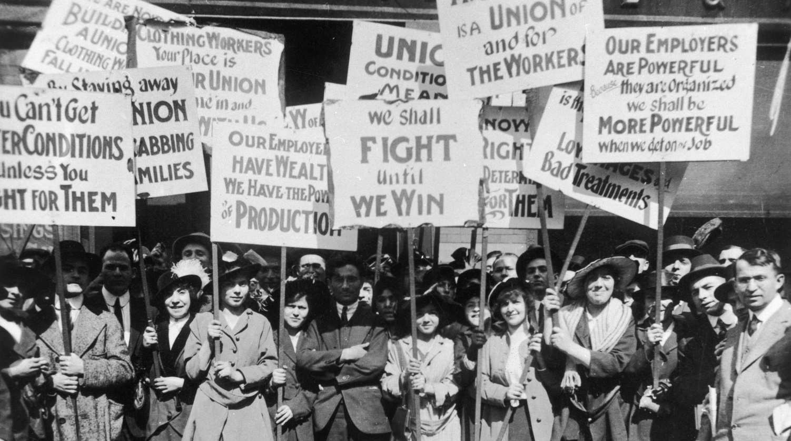

Image taken from Internet

Image taken from Internet

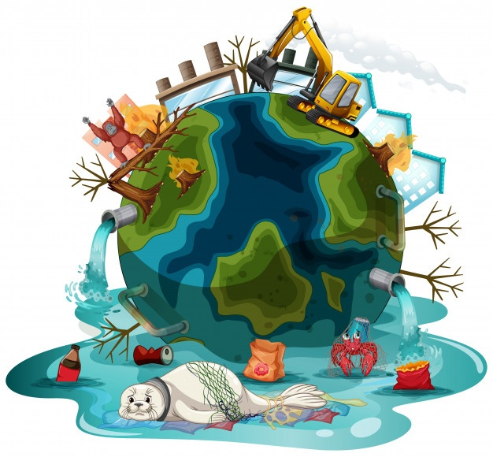

Image taken from Internet

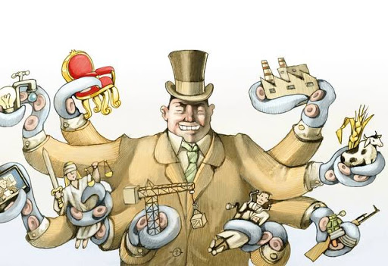

Image taken from Internet



Image taken from Internet

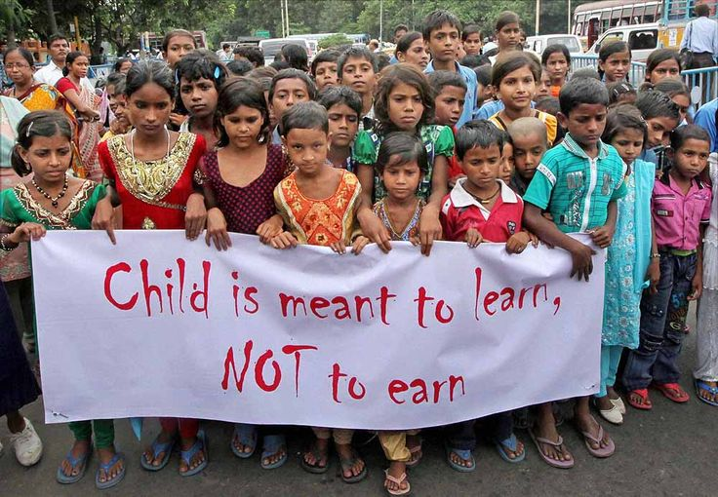

Image taken from Internet

**Unemployment**

**Strikes**

**Terrorism**

**Pollution**

**Climate change**

**Lack of education**

**Government corruption**

It is an issue throughout the world that causes fear and insecurity, violence and death. Across the globe, groups attack innocent people, often without warning. This makes civilians feel defenseless in their everyday lives.

Many people, particularly 15- to 24-year old, struggle to find jobs and create a proper living for themselves and their families. This leads to a lack of necessary resources, such as enough food, clothing, transportation and proper living conditions

The global temperatures are rising and are estimated to increase from 2.6 degrees Celsius to 4.8 degrees Celsius by 2100. This would cause more severe weather, crises with food and resources and the spread of diseases.

It is an issue throughout the world that causes fear and insecurity, violence and death. Across the globe, groups attack innocent people, often without warning. This makes civilians feel defenseless in their everyday lives.

It is a converted labor stoppage decided upon by employees to pursue occupational claims and in defense of their material or moral interests.

It is a major cause of poverty considering how it affects the poor the most, eroding political and economic development, democracy and more. It can be detrimental to the safety and well being of citizens living within the corrupted vicinity, and can cause an increase in violence and physical threats without as much regulation in the government.

More than 72 million children throughout the globe that are of the age to be in primary education are not enrolled in school. This can be attributed to inequality and marginalization as well as poverty forced to work.

**Climate Change**

The global temperatures are rising, and are estimated to increase from 2.6 degrees Celsius to 4.8 degrees Celsius by 2100. This would cause more severe weather, crises with food and resources and the spread of diseases.

**Pollution**It is the introduction of contaminants into the natural environment that cause adverse change. It can take the form of chemical substances or energy, such as noise, heat, or light.

**Lack of Education**

More than 72 million children throughout the globe that are of the age to be in primary education are not enrolled in school. This can be attributed to inequality and marginalization as well as poverty forced to work.

**Unemployment**Many people, particularly 15- to 24-year-old, struggle to find jobs and create a proper living for themselves and their families. This leads to a lack of necessary resources, such as enough food, clothing, transportation and proper living conditions

**Government Corruption**

It is a major cause of poverty considering how it affects the poor the most, eroding political and economic development, democracy and more. Corruption can be detrimental to the safety and well-being of citizens living within the corrupted vicinity, and can cause an increase in violence and physical threats without as much regulation in the government.

**Terrorism**It is an issue throughout the world that causes fear and insecurity, violence and death. Across the globe, groups attack innocent people, often without warning. This makes civilians feel defenseless in their everyday lives.

**Strike:**

It is a converted labor stoppage decided upon by employees to pursue occupational claims and in defense of their material or moral interests.

Appendix 3 **Listening for the first time**

**Script: Listening**

**Good evening, I'm Jed West and this is the six o'clock news. Headlines.**

London has won the race to host the Olympics in 2012. Estonia has elected a new president. Hurricanes Maxwell and Nelly have struck the east coast of America, in particular the Florida Keys. Thousands injured. Manchester United have signed the prodigious young talent, Brillinho, from Sao Paolo for a record €42 million. Chi Chi the panda has given birth to twins in Berlin zoo.

Officials announced early this morning from Singapore that London beat Paris in the race to host the 2012 Olympics. Many people had expected Paris to be the city honored with the Olympics, but in a surprise twist London, following the eliminations of New York, Moscow and Madrid, emerged as victors. Spokesman Georgia Smith said "It's a great day for London, for England and the United Kingdom. We will make this an Olympics never to be forgotten"

Polling stations in Estonia closed just a few hours ago, but it seems clear that Vladimir Shevchenko has already secured enough votes to become the new president. His election campaign was very controversial in that he promised to privatize all Estonian industry and use the money raised to invest in schools and hospitals. Exit polls indicate Mr. Shevchenko took almost 72% of the vote. He is currently preparing his acceptance speech and is expected to assume power in the next 48 hours.

Once again, the south east coast of America and the Caribbean are suffering the effects of hurricanes. The latest two to hit are Maxwell and Nelly, and yesterday wind speeds of up to 180kph were recorded, causing millions of dollars of damage to homes, roads and ports. The US government has issued an evacuation order and since yesterday evening the freeways have been jammed with worried residents looking to escape from the hurricanes.

Sport, and the world's richest football club, Manchester United, yesterday signed young Brazilian star, Brillinho, for a world record €42 million. The player, only just 18 years old, signed a 5-year contract in the Manchester United boardroom in front of the world's cameras and microphones. Speaking through an interpreter he said he was very excited to be playing in the UK but would miss the sun and above all the beaches of Rio De Janeiro.

Finally, good news at last for the endangered panda. This morning, just before 10.00am CET, Chi Chi the Giant Chinese panda gave birth to twins, a male and a female, in Berlin Zoo. Chi Chi, who has been in captivity since 1994, is said to be well and clearly happy to have finally become a mother.

And that was the six o'clock news. Join me at seven for the latest headlines. I'm Jed West and thank you for listening to Radio 105.

1. What was the audio about?

2. What controversial issues were mention in the audio?

3. What was the intention of the speaker?

Appendix 4 Listening **for the second time (*Correct answer)**

1. Where was the announcement made about the host nation for the 2012 Olympics?

a. Paris

b. Singapore *

c. London

d. Cairo

2. Which cities were in the race?

a. London, Paris, Madrid, New York, Moscow

b. London, Paris, Munich, New York, Moscow *

c. London, Paris, Madrid, Singapore, Moscow

d. London, Paris, Toronto, Singapore, Moscow

3. What were the new Estonian President's election promises?

a. Investment in Estonian industry.

b. Privatize Estonian industry and schools.

c. Spend more money on hospitals *

d. Spend more money on education.

4. What share of the vote did he win?

a. 62%

b. 82%

c. 72% *

d. 60%

5. What wind speeds did the hurricanes produce?

a. 180 kilometers per hour *

b. 180 miles per hour

c. 80 miles per hour

d. 70 mile per hour

6. When did the government issue an evacuation order?

a. It hasn't yet.

b. Many days ago.

c. Very recently.*

d. Long ago

7. How old is Manchester United's new player?

a. 17

b. 18 *

c. 19

d. 21

8. Which team did he use to play for?

a. Flamenco

b. Sao Paolo *

c. Santos

d. Manchester United

9. What will he miss about Brazil?

a. Sun and food.

b. Food and beaches.

c. Sun and beaches. *

d. Food and clothing

10. How long has Chi lived in captivity?

a. A couple of years.

b. Nearly ten years.

c. More than ten years *

d. More than fifteen years.

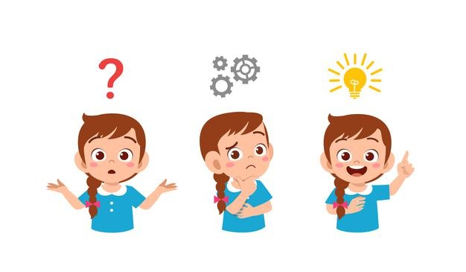

Appendix 5 **Post-listening**



**Important issues that need to be changed**

Appendix 6 **Reading for the first time**

**Text 1**

**INUIT COMMUNITY, CANADA**

Source: Mercer, 2018.

For the people of Rigolet, a former trading post that is the southernmost Inuit community in [**Canada**,](https://www.theguardian.com/world/canada) the vanishing ice and increasingly unpredictable seasons means they’re being forced to adapt in ways they never have before.

Like generations of Inuit before him, Derrick Pottle is a trapper and hunter. His diet of wild game, salmon, berries, trout and seal would have been familiar to his ancestors who were living in Hamilton Inlet around 8,000 years ago.

But Pottle worries all the skills he’s learned from older generations may soon become irrelevant. More and more, Inuit are relying on expensive, store-bought processed foods because it’s safer and easier than catching or shooting supper.

Pottle’s ancestors never experienced a time when their frozen world in northern Labrador was being altered so dramatically because of climate change. Shrinking ice packs and more severe weather has made travel increasingly difficult and dangerous, often cutting people off from other communities and traditional hunting lands.

Some changes are more subtle**.** Summers have always been short here, and marked by tormenting swarms of black flies. But Paula McLean-Sheppard, a Nunatsiavut government employee, said she has been startled to see the insects arriving earlier and earlier in the spring.

Rigolet’s fishermen say new species are arriving in the bay, from cormorants to sharks to sea turtles, chasing warming waters and the food that comes with them. Seals, a key source of food and [**hides for waterproof clothes**,](https://www.theguardian.com/world/2017/may/11/sealskin-trade-inuit-fashion-designers-greenpeace) are moving further and further up the bay as the sea ice vanishes. Others blame the decline of the region’s caribou herd on the changing climate, too.

Some of the changes are harder to see. McLean-Sheppard worries that as coastal Labrador’s sea ice becomes increasingly unreliable, it’s causing more anxiety among Inuit who feel stuck and unable to travel to catch their food.

**Text 2**

**ETHIOPIA & SOMALIA**

Source: Gerth-Niculescu, 2019.

Three times a day, Sara Saban walks under the burning sun to fetch water for her family. Close to her village in the center of Ethiopia's Somali Region, women, children and men line up in front of the only available well within walking distance. Their donkeys patiently wait as they fill their yellow jerry cans with water. A few meters away, others dig a hole in the dried-out riverbed to collect what little murky water they can find.

"The underground water is very limited because we are facing a drought," Sara, a mother of ten, told DW. "The water quality is also very bad, so sometimes we suffer from stomach-related illnesses."

[The Somali Region has suffered from chronic drought for several years,](https://www.dw.com/en/hunger-crisis-if-we-dont-help-the-people-here-they-will-die/a-38802533) with the [worst stretch recorded in 2016,](https://www.dw.com/en/clinging-on-against-drought-in-ethiopia/a-19179222) from which many households have yet to recover. This year the short rainy season known as the 'belg', which typically lasts from March to May, once again failed to provide much-anticipated ground water. The livestock have already started to die.

This has had catastrophic consequences for the pastoral communities, which make up the majority of the Somali population. They rely on cattle and other farm animals for their livelihood: selling them at the market, drinking their milk and eating their meat.

Since the beginning of the year, Sara lost one cow, 20 goats and five sheep. "It rained for only five days, and they were very small showers, so the grass did not grow enough to feed the livestock," she explains. "Cattle are the most vulnerable to drought, followed by sheep and goats," says Ahmed Mohammed, FAO's Somali Region field coordinator. "If we don't protect the core breeding animals at this stage of the drought, this will lead to mass mortality of animals and the families will be stripped of their livelihood assets. Rebuilding these lost livelihoods later on will be an enormous task, so it is less expensive and more efficient to protect and save livelihoods before they are lost." A group of trees in a body of water

**Text 3**

**COLOMBIA & VENEZUELA**

Source: Quinteros & Pachon, 2017.

The Wayuu people are the largest indigenous tribe in northern Colombia and northwest Venezuela. In Colombia, they live in the La Guajira region. Their home area is comprised of 20,000 km and is rich in salt and petroleum deposits. Families often earn a living from harvesting salt and extracting petroleum, but their main sources of income are cattle ranching and fishing, which makes them particularly vulnerable to the effects of climate change.

Recently, in La Guajira, there have been severe water shortages, which have been exacerbated by a lack of rain for three years. Over the past few years, this drought has caused over 20,000 of the region’s cattle to die. For water, many of the Wayuu communities rely on the Ranchería River, one of the longest rivers in La Guajira. Without this water, their struggle to survive becomes increasingly strained.

In addition to suffering from the effects of climate change, the Wayuu must compete for water with the continent’s largest open-pit coal mine. In 2006, the construction of El Cercado dam started. The dam was designed to stop the flow of the Ranchería River and to create a reservoir that would provide nine communities with improved access to water. After the dam was completed, however, it became clear that while the reservoir would supply the mine, the Wayuu communities would be unable to access water from either the reservoir or the river, which would leave them worse off than they had originally been.

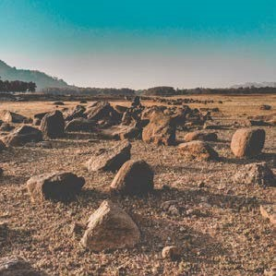

**Text 4**

**SOUTHEAST AND CENTRAL ASIA**

Source: Gupta, 2017

Much of Asia may see 50% more rainfall due to climate change, although countries like Pakistan and Afghanistan may experience a decline in rainfall by 20-50%, says a new report by the Asian Development Bank (ADB) and the Potsdam Institute for Climate Impact Research.

The increase in rainfall is not necessarily good news either, because the Intergovernmental Panel on Climate Change has forecast fewer rainy days, but more intense rainfall on those days. This means more flooding, and less rainwater eventually percolating underground to recharge aquifers.

And there will probably be more intense typhoons and cyclones as global temperatures go up, says the ADB report, called [**A Region at Risk: The Human Dimensions of Climate Change in Asia and the Pacific***.*](https://www.adb.org/sites/default/files/publication/325251/region-risk-climate-change.pdf)

Coastal and low-lying areas in Asia will be at an increased risk of flooding. Nineteen of the 25 cities most exposed to a one-meter sea-level rise are in Asia, seven in the Philippines alone. Indonesia will be the country worst hit by coastal flooding, with approximately 5.9 million people affected every year until 2100. All this will have serious economic consequences. Global flood losses are expected to increase to USD 52 billion per year by 2050 from USD 6 billion in 2005.

Climate change will also make food production in the region more difficult and production costs higher. In some countries of Southeast Asia, rice yields could decline by up to 50% by 2100 if no adaptation efforts are made. Meanwhile, in Central Asia, almost all crop yields in Uzbekistan are projected to decrease by 2050% by 2050 even in a two-degree Celsius temperature increase scenario.

Marine ecosystems, particularly in the Western Pacific, will be in serious danger by 2100. All coral reef systems in the region will collapse due to mass coral bleaching if global warming proceeds as per the *status quo*.

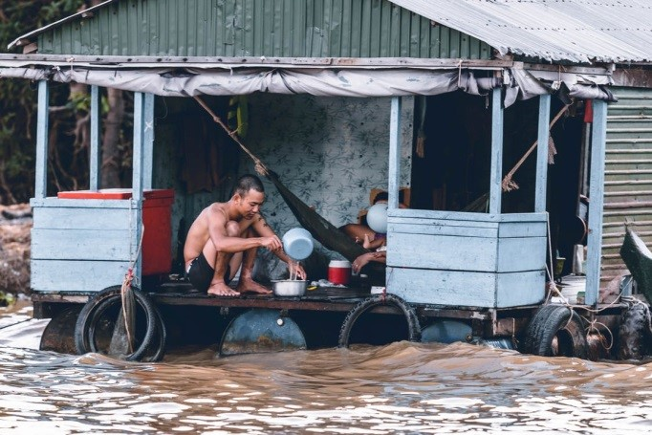

**Questions:**

1-How do you think climate change impacts on people’s lives?

2-How do you think climate change impacts on Costa Rican’s lives?

3-How can governments and world institutions protect the environment?

Think about two measures that can help protect the environment and that you consider feasible.

**Questions:**

1-How do you think climate change impacts on people’s lives?

2-How do you think climate change impacts on Costa Rican’s lives?

3-How can governments and world institutions protect the environment?

Think about two measures that can help protect the environment and that you consider feasible.

**Questions:**

1-How do you think climate change impacts on people’s lives?

2-How do you think climate change impacts on Costa Rican’s lives?

3-How can governments and world institutions protect the environment?

Think about two measures that can help protect the environment and that you consider feasible.

**Questions:**

1-How do you think climate change impacts on people’s lives?

2-How do you think climate change impacts on Costa Rican’s lives?

3-How can governments and world institutions protect the environment?

Think about two measures that can help protect the environment and that you consider feasible.

Appendix 7 **Reading for the second time**

|  |  |
| --- | --- |
| **Title: ___________________________________________________________** | |
| **Main situation** | |
| **Retelling information** | |
| **Causes** | **Consequences** |
|  |  |

Appendix 8

Speaking

Look for a piece of any controversial news (national or international) from an online or printed English newspaper.

Analyse the news and create an oral report about it.

In the report you have to present the following information related to the news:

* **What happened?**
* **Where did it happened?**
* **When did it happened?**
* **Why did the event happen?**
* **Who were involved?**
* **What were the main consequences of the event?**
* **What’s your opinion about the news? How important is it?**

(Taken form Speed Up 11,EVN Eduvision)

|  |  |  |  |  |  |  |  |  |  |
| --- | --- | --- | --- | --- | --- | --- | --- | --- | --- |
| **Didactic Planning**  **Week # 2** | | | | | | | | | |
| **Term: II** | | **Level: Eleventh** | | | **Unit:5** | | | **Week: 2** | |
| **Domain:** Socio-Interpersonal and Academic | | | **Scenario:** Really???  (Controversial issues) | | | **Theme:** Shut up… Issues from Health and Medicine | | | |
| **Enduring Understanding**: What is considered right can be relative depending on personal points of view. | | | | | | | | | |
| **Essential Question:** How our point of view depends upon the way we look at it? | | | | | | | | | |
| **New Citizenship:**   |  | | --- | | **Dimensions** | | **1.** **Ways of thinking (**√**)** | | **2. Ways of living in the world (**√**)** | | **3. Ways of relating with others (**√**)** | | **4. Tools for integrating with the world (**√ **)** | | | | | | | | | | |
| **Learn to Know** | | | **Learn to Do** | | | **Learn to Be and Live in Community** | | | |
| **Grammar & Sentence Frames**  Reported Speech:   * Most men said **that** they fell in love at first sight. * Most girls say **that** they would like to have a plastic surgery.   **Vocabulary**  **Health and Medicine:**  In vitro conception, xenophobia, nursing, Euthanasia, abortion, cloning. | | | **Function**  Expressing agreement/ disagreement about health and medical facts.  **Connecting words expressing cause and effect, contrast, etc…**     * **On the other hand**, we could sue this person. | | | **Psycho-social**   * Analyzing implications in local and global decisions. * Appreciating human and animal rights.   **Sociocultural**   * Respecting everyone’s cultural differences.   ***Life is meant to be shared. We need each other. ~Lailah Gifty Akita.*** | | | |
| **Assessment Strategies & indicators of learning**  **(Diagnostic, formative, summative)** | **Learner can…** | | **Pedagogical Mediation/ Didactic Sequence** | | | | | | **Time**  (5 lessons) |
| **L.1.** interprets the main points of stories and other texts read aloud in the classroom.  **indicators of learning**  L1.1 Identifies the topic of stories and other texts read aloud in the classroom.  L1.2 Identifies the intended audience of stories and other texts read aloud in the classroom.  L1.3 Gets main ideas of stories and other texts read aloud in the classroom.  L.1.4 Extracts supporting details of stories and other texts read aloud in the classroom.  L.1.5 Analyses the author’s argument of stories and other texts read aloud in the classroom.  L.1.6 Draws conclusions of stories and other texts read aloud in the classroom.  **R.1.** draws conclusions on short media reports  **Indicators of learning**  R1.1 Identifies the topic on short media reports.  R1.2 Identifies the intended audience on short media reports.  R1.3 Recognizes the text structure of short media reports.  R1.4 Gets main idea in paragraphs or sections of short media reports.  R1.5 Extracts supporting details in paragraphs or sections of short media reports.  R1.6 Analyzes the author’s argument of short media reports.  R1.7 Draws conclusions from of short media reports. | **L.1.** understand the main points of stories and other texts read aloud in the classroom about world facts, issues from health and medicine, controversies and the law and stereotypes and cultural differences.  **R.1.** understand short media reports about world facts, issues of health and medicine, controversies from the law and stereotypes and cultural differences | | **Pre-teaching**  **Routine:** Checking attendance, checking in with Ls, T posts the Essential Question on the board, Can Do’s, and class agenda, etc.  **Participating: Warm up**  Learners spend one minute writing down all of the different words they associate with the word “cloning”. Learners share their words with their partners and talk about them.  **Engaging: Activation of prior knowledge**  Once finished the warm-up activity, Ls fill a KWL chart about cloning.    Then, learners do a **WORD SEARCH**: they look in their dictionaries / computer to find meanings, information, synonyms for the following words:   |  |  |  |  | | --- | --- | --- | --- | | **List of words** | **Meaning** | **Information- Definition** | **Synonyms** | | cloning |  |  |  | | replica |  |  |  | | genetic |  |  |  | | cruel |  |  |  | | pointless |  |  |  | | ethically |  |  |  | | wrong |  |  |  | | genetic reproduction line |  |  |  | | surrogate |  |  |  | | marvel |  |  |  | | mistake |  |  |  | | identical |  |  |  | | correct |  |  |  | | helping |  |  |  |   **Introducing**  Teacher asks learners to define cloning in their own words. Teacher pastes the concept on the board and reads it aloud for the students to listen and express their doubts. Then, learners watch the video about influencers and their cloned dogs.  <https://www.linguahouse.com/es/esl-lesson-plans/general-english/instagram-influencers-to-clone-their-pets>  **Pre-listening**  Teacher asks learners the following questions:   * Is cloning something good? bad? legal? Illegal? * Do you think many people will do it? Is it common worldwide? * Why do you think people would do it?   **Listening for the first time** Learners watch the video called The pros and cons of pet cloning. Would you do it? | 60 Minutes Australia [**https://www.youtube.com/watch?v=Ag2lNCnJ4eg**](https://www.youtube.com/watch?v=Ag2lNCnJ4eg) After that, learners will answer the following questions.   * + What was the video about?   + Who is this video for?   + Is the reporter against pet cloning?   + Would you clone your dog? Why?   + Is it fair for animals?   **Pair/Group feedback**  Learners compare their answers, and then they share with the whole group.  **Listening for the second time**  Learners watch the video again, but this time, they listen to complete a mind map and answer some questions. Learners check their answers in pairs, and then share them with the group.  **DOG CLONING**  **Why do people want to do it?**  **According to the video, are there more dog lovers than cat lovers?**  **What options do people have when their dogs die?**  a.________________  b.________________  c.________________    **What is the scientist’s goal?**  ____________________________________________________________________  _________________________________  __________________________________   1. What does the scientist want the reporter to believe about cloning his dog in the future? 2. What reasons does he give? 3. Is he making an assumption? 4. In your opinion, are his reasons valid to clone his dog in the future? 5. Based on the video title, “**The pros and cons of pet cloning”**, what conclusion can you draw from it?   **Post-listening**  Teacher organizes learners into two debate groups: One group is pro-dog cloning and the other group is against dog cloning. Learners will give their reasons and opinions in a very respectful way.  **Remember to encourage learners to use personal and social dispositions (e.g., engagement, positive attitudes, cooperation, turn taking, empathy, and other universal values) when interacting and producing in the target language.**  **Pre-reading**  **Definition of xenophobia**  **Fear and hatred of strangers or foreigners or of anything that is strange or foreign.**  https://www.merriam-webster.com/dictionary/xenophobia   1. What is your earliest experience dealing with xenophobia? 2. How did you feel while this was happening? 3. What was your response and what was the response of others around you? 4. What did you learn about this experience?   **Reading for the first time**  T gives learners the article What is Xenophobia? : <https://www.webmd.com/a-to-z-guides/what-is-xenophobia>  Learners read the article for 30 seconds and answer the following questions:   1. What is the article about? 2. Who is the intended audience?   **Pair/Group feedback**  Students share their answers in small groups.  **Reading for the second time**   1. T asks learners to go over the text and check (√) the structure it has.  |  |  |  |  |  |  |  |  | | --- | --- | --- | --- | --- | --- | --- | --- | | **Text Structure** | **( )** | **( )** | **( )** | **( )** | **( )** | **( )** | **( )** | | Sequence/Process | Time order/Chronology | Proposition/Support | Compare/Contrast | Problem/Solution | Cause/Effect | Description |  1. T asks learners to get the main ideas of the paragraphs from the article “What is Xenophobia?” and write them down in the graphic organizer. 2. T asks learners to number the paragraphs and highlight supporting details from each paragraph. After that, learners complete the following chart by using supporting details.  |  |  | | --- | --- | | **Paragraph number** | **Supporting details per paragraph** | |  |  | |  |  | |  |  | |  |  |  1. What is the author’s position in regards Xenophobia? What reasons support your answer. 2. What conclusions can you extract from the article?   **Post-reading**  T asks learners to read the article **5 Ways to Fight Racism and Xenophobia** by Sarah Ferguson  <https://www.unicefusa.org/stories/5-ways-fight-racism-and-xenophobia/34567> In groups, learners comment on what they read. After that, learners create a banner to paste it in a special place in their high school. | | | | | |  |
| **Integrated Mini-Project** | | | | | | | | | **Time** |
| Phase: 1  Learners make groups and choose the mini project they will develop. Teacher writes the name of the members (group) and the mini project they chose. | | | | | | | | |  |
| **Reflective Teaching** | | | | | | | | | |
| What worked well | | | | What didn’t work well | | | How to improve | | |
| **Enduring Understanding Reflection**  How well did the learners progress in their understanding of the Enduring Understanding? | | | | | | | | | |
| At the end of the week, T guides the learners to check their progress using the checklist below.   |  |  |  |  | | --- | --- | --- | --- | | ***Learner Self-Assessment*** | | | | | ***I can…\**** | ***Yes*** | ***In progress*** | ***No*** | |  |  |  |  | | identify the topic of stories and other texts read aloud in the classroom. |  |  |  | | identify the intended audience of stories and other texts read aloud in the classroom. |  |  |  | | get main ideas of stories and other texts read aloud in the classroom. |  |  |  | | extract supporting details of stories and other texts read aloud in the classroom. |  |  |  | | analyze the author’s argument of stories and other texts read aloud in the classroom. |  |  |  | | draw conclusions of stories and other texts read aloud in the classroom. |  |  |  | | identify the topic on short media reports. |  |  |  | | identify the intended audience on short media reports. |  |  |  | | recognize the text structure of short media reports. |  |  |  | | get main idea in paragraphs or sections of short media reports. |  |  |  | | extract supporting details in paragraphs or sections of short media reports. |  |  |  | | analyze the author’s argument of short media reports. |  |  |  | | draw conclusions from of short media reports. |  |  |  |   *You must include the indicators of learning from the document “Guidelines on How to Write Indicators of Learning for the Pedagogical Mediation of the English Curriculum under each Assessment Strategy and in the Self -Assessment chart at the end of every week. | | | | | | | | | |

**MATERIALS**

**FOR WEEK 2**

**K-W-L ABOUT**

**CLONING**

|  |  |  |
| --- | --- | --- |
| **I KNOW:** | **I WANT TO KNOW:** | **I LEARNED:** |
|  |  |  |

**What Is Xenophobia? By Venkat S.R. Medically Reviewed by Poonam Sachdev on April 28, 2022**

Xenophobia is the fear of strangers. The word is also used to describe an attitude of prejudice and an outlook that is exclusionary of foreigners and certain people based on their background and identity. It may also manifest as a display of hostility towards specific ethnic groups.

Xenophobia Versus Racism

There’s a fine line between xenophobia and racism but the two words are mutually exclusive. As the term suggests, xenophobia (phobia meaning fear) is a fear of foreigners and their customs that often transforms into intense dislike. On the other hand, racism is a firm belief in the misplaced idea that gauges an individual’s worth and capabilities based on their physical attributes like the color of their skin and hair.

This belief typically leads to methodical oppression of the individuals and groups of people who are considered inferior. Racist behavior can also lead to a systematic denial of human rights to entire groups of people, rights that other groups in the same region or country enjoy. Racism also limits opportunities in economic, social, and other areas of public life to oppressed groups based on their race.

There have been many studies in the U.S. about white supremacist ideologies that perceive white people as being superior to other races, including African-American, Asian-American, Latin, and Native American populations.

While xenophobia and racism do converge in some aspects, xenophobia does not lead to discrimination based on someone’s physical features or membership in a specific group of people. Xenophobia tends to divide people into two groups — insiders and outsiders. This in turn leads to fear and insecurity about outsiders who are presumed to pose a threat to the existing inhabitants.

A recent example of xenophobia is the increased number of incidences of violence in the U.S. against Asian-Americans since the onset of the Covid-19 pandemic. Several cities across the U.S. have reported unprovoked instances of violence and theft, some of which have also led to fatalities.

**Causes of Xenophobia**

Rapid globalization has led to national boundaries becoming transparent. This, in turn, has led to increased migration to certain countries, especially those that are developed, by people in search of a better life. Mass migration has triggered a sense of identity among both the immigrants to and the existing residents of those countries.

The existing population that has witnessed this massive inflow of immigrants is fearful of losing their social status and identity to the newcomers. There is also the perceived threat of losing their way of life along with the jobs that help sustain their lives. Although the acceptance of free-market economies has spurred development in several countries, it has also led to several confrontations between existing residents of a country and new immigrants.

To cite an example, there were several reports of violence in South Africa in 1994, where many locals who belonged to the Xhosa community (a local tribe based in the Eastern Cape province of South Africa) clashed with Namibian immigrants who had settled in the province. Their point of contention was that the members of the migrant Namibian population that had settled in the province were stealing jobs that were the lifeline for the Xhosa people.

Members of the Xhosa community expressed further anguish about the fact that the Namibian immigrants were undercutting their jobs by agreeing to work for lower wages and not being willing to participate in efforts to bargain with the employers for better wages and working conditions. All of this caused a general distrust of immigrants that eventually led to the launch of a collective campaign against them called “Operation Buyelekhaya” (go back home).

**How To Fight Racism**

Racism has been described as an invisible evil. This is because although racism itself may be explicit, its expression is most often so subtle and deceptive that it can be hard to place.

Children face discrimination based on the color of their skin at an age where they are unable to comprehend such differences. Research has shown that disciplinary policies in preschools target black students by as much as 3.6 times when compared to white students.

A Canadian study found that children from the Caribbean are three times more likely to be identified as “at-risk” students, and, as a result, placed in separate classes. The deep-rooted bias that so discriminates against individuals may also adversely affect their health, which is one reason why it is important to call out such tendencies and to devise other methods to combat racism, We must:

• **Celebrate diversity.** It is important to have a constant reminder that all the inhabitants in this world are equal and every culture has something unique to offer to this world. Children must be taught to acknowledge and enjoy cultural diversity. This can begin with simple measures such as reading about different cultures from around the world, exploring various cuisines, and watching movies from other countries.

• **Educate.** There should be a concerted effort to educate adults and children alike about unity in diversity and to reinforce the benefits of science-based education. This includes doing away with the idea that racially different groups are inherently distinct and fostering a sense of human oneness in its place.

• **Inculcate kindness.** Feelings such as prejudice and dislike are not natural. They are learned behaviors that many people pick up by watching adults around them. That’s why it’s essential to start early and make children understand that differences are to be celebrated. the innate humanness in everyone recognized, and judgements based on external appearances shunned. It is also important to teach children the importance of choosing kindness at all times as an alternative to hostility.

• **Create concrete action plans**. It’s important to build and promote platforms to monitor acts of discrimination in everyday life and take the necessary measures to call out racism in all its forms. This should be coupled with strengthening civil rights for people from all backgrounds.

• **Track social media.** Social media has long been thought of as one of the platforms where racist views get a lot of traction. There is an acute need to monitor the role of the social media platforms that don’t keep a check on the spread of biased views and permit the propagation of online hate speech directed towards specific groups.

Taken from: https://www.webmd.com/a-to-z-guides/what-is-xenophobia

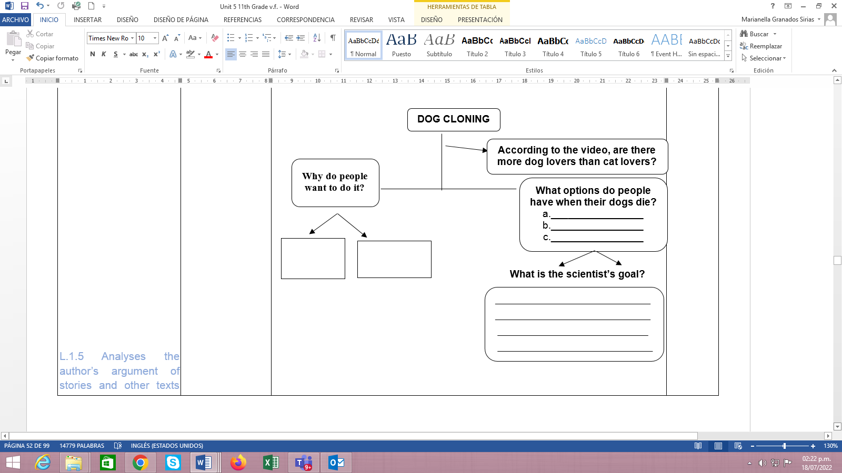

|  |  |  |  |  |  |  |  |
| --- | --- | --- | --- | --- | --- | --- | --- |
| **Text Structure** | **( )** | **( )** | **( )** | **( )** | **( )** | **( )** | **( )** |
| Sequence/Process | Time order/chronology | Proposition/Support | Compare/Contrast | Problem/Solution | Cause/Effect | Description |

|  |  |  |  |  |  |  |  |
| --- | --- | --- | --- | --- | --- | --- | --- |
| **Text Structure** | **( )** | **( )** | **( )** | **( )** | **( )** | **( )** | **( )** |
| Sequence/Process | Tme order/chronology | Proposition/Support | Compare/Contrast | Problem/Solution | Cause/Effect | Description |

|  |  |  |  |  |  |  |  |  |  |
| --- | --- | --- | --- | --- | --- | --- | --- | --- | --- |
| **Didactic Planning**  **Week # 3** | | | | | | | | | |
| **Term: II** | | **Level: Eleventh** | | | **Unit:5** | | | **Week: 3** | |
| **Domain:** Socio-Interpersonal and Academic | | | **Scenario:** Really???  (Controversial issues) | | | **Theme:** No way… Controversies and the law | | | |
| **Enduring Understanding**: What is considered right can be relative depending on personal points of view. | | | | | | | | | |
| **Essential Question:** How our point of view depends upon the way we look at it? | | | | | | | | | |
| **New Citizenship:**   |  | | --- | | **Dimensions** | | **1.** **Ways of thinking (**√**)** | | **2. Ways of living in the world (**√**)** | | **3. Ways of relating with others (**√**)** | | **4. Tools for integrating with the world (**√ **)** | | | | | | | | | | |
| **Learn to Know** | | | **Learn to Do** | | | **Learn to Be and Live in Community** | | | |
| * **Grammar & Sentence Frames**   Present perfect  **have' / 'has'** + the **past participle**   * Some countries have confirmed the practice of voluntary euthanasia. * **Vocabulary**   **Law can be controversial:** Discrimination, legalizing drugs, Animal mistreated or too much care? corruption | | | **Function**  Describing feelings, emotions, and attitudes when talking about controversial topics related to law.  **Discourse Markers**  **Markers to structure informal spoken discourse:**  **However,** to do that you need to spend a lot of money:   * Right * Really? * Well, anyway * Oh, I know. * Yes, I supposed so. * I know how you feel * You know, I don´t like her either… | | | **Psycho-social**   * Analyzing implications in local and global decisions. * Appreciating human and animal rights.   **Sociocultural**   * Respecting everyone’s cultural differences.   Life is meant to be shared. We need each other. – Lailah Gifty Akita | | | |
| **Assessment Strategies & indicators of learning**  (Diagnostic, formative, summative) | **Learner can…** | | **Pedagogical Mediation/ Didactic Sequence** | | | | | | **Time**  (5 lessons) |
| **SI.1.** starts a conversation and helps to keep it going.  **Indicators of learning:**  **SI.1.1** Starts fairly fluent conversations about past experiences stories and news about world international issues with peers by using a large number of different words and expressions, though there may be pauses for self-correction and checking understanding from the listener's point of view.  **SI.1.2** Interrupts, the listener in a conversation about past experiences stories and news about world international issues by using phrases such as: Excuse me, May I say something? No, I'm sorry but…, Changing topic…  **SI.1.3** Keeps the conversation going by using phrases such as: Really…, Right,…  **SI.1.4** Closes the conversation by using a leave-taking.  **SI.2**. takes part in long conversations with peers, if others make an effort as well.  **Indicators of learning:**  **SI.2.1** Starts fairly fluent conversation to agree or disagree about health and medical facts related to law with peers by using a large number of different words and expressions, though there may be pauses for self-correction and checking understanding from the listener's point of view.  **SI.2.2** Interrupts the listener in a conversation about health and medical facts related to law by using phrases such as: Excuse me, May I say something? No, I'm sorry but…, Changing topic…  **SI.2.3** Keeps the conversation going by using phrases such as: Really…, Right,…  **SI.2.4** Closes the conversation by using a leave-taking.  **W.1.** writes a short summary of a piece of literature or audiovisual production.  **Indicators of learning:**  **W1.1** Prewrites a list of a text main points and specific details of a piece of literature or audiovisual production about world  **W1.2** Drafts a short summary of a piece of literature or audiovisual production about world facts, issues from health and medicine, stereotypes or cultural differences including main points and giving specific details using the appropriate linkers or connecting words.  **W1.3** Revises a short summary of a piece of literature or audiovisual  sentences, proper nouns, the pronoun “I,” proper adjectives, titles, and abbreviations), sentence sense, word order, text structure, concrete ideas, using commas: (to punctuate items in a series, dates), spelling, punctuation and content accurately in a pair-share activity.  **W1.4** Edits a short summary by correcting mistakes before publishing. | **SI.1.1.** start fairly fluent conversations about past experiences stories and news about world international issues with peers by using a large number of different words and expressions, though there may be pauses for self-correction and checking understanding from the listener's point of view.  **SI.2**. take part in long conversations with peers, if others make an effort as well.  **W.1.** write a short summary of a piece of literature or audiovisual production. | | **Pre-teaching**  **Routine:** Checking attendance, checking in with Ls, T posts the Essential Question on the board, Can Do’s, and class agenda, etc.  **Participating** **Warm up** - **Speed Interview**  T tells learners the topic of the day is ***How to prevent animal cruelty.*** Teacher puts learners into pairs and has them interview their partners by using some questions within one minute, and then their partner has one minute to ask them questions. After the time is up, put students into new pairs and repeat as time allows.   1. What is animal cruelty? 2. How can you prevent it? 3. Is it a concern in Costa Rica?   **Engaging:** Activation of prior knowledge Teacher prepares a mind map with one topic before the class starts. Then, T distributes a mind map for each pair/group and asks learners to provide ideas/vocabulary for it. Students get into pairs/groups to complete it with the information required. They can read articles after surfing the net.  **Introducing**  T reviews present perfect tense have’ */ 'has' + the past participle* by providing some sample sentences. Then, T asks learners to write some sentences in present perfect tense related the actions Costa Rica has done to prevent animal cruelty.    **Oral Production**  **Task**: T asks learners to work in groups of four. Each group plans a talk show about a question that will be assigned to each.  Party# 1 **Is it ethical to train dogs as service animals?**  Party# 2 **Is global warming humanity a greatest threat?**  Party# 3 **Is there ever a good reason for war?**  Party# 4 **How much should the public know about a celebrity's personal life?**  T finds a short clip of popular celebrities being interviewed on a talk show to show the class, or simply talk about talk shows: what kinds of questions are asked, etc.  **Planning**  T gives the following instructions to each group:   * 1. Produce no more than 8 minutes talk show script based on the questions and the four participants for each group.   2. Give a title to the script that matches the assigned question.   3. Think of possible images or short videos to share during the talk show to provide examples that support their points of view.   4. Include a short biography of each participant to introduce them during the talk show.   Learners go over the instructions and task.  **Organizing/Rehearsing**  Learners start writing the Talk Show script and biographies. The teacher walks around the class monitoring learners’ work and giving support and feedback. T provides the following phrases to give opinions so learners can use them during the talk show. (See annex in the materials section for more expressions)   * In my opinion, ... * In my eyes, ... * To my mind, ... * As far as I am concerned, ... ... * From my point of view, ... ... * My view / opinion / belief / impression / conviction is that ... ... * I would say that ... ... * My impression is that ... ... * I have the feeling that ... ... * I have no doubt that ...   T also makes sure each group has these stages in their talk show: A conversation starts, that there are polite interruptions, and the conversation keeps going and finally the conversation is closed.  **Interacting**  Learners set up the front of the class as a talk show set with a desk and chair (for the host) and four chairs for the people being interviewed. Each group comes to the front and the host starts the interaction with the panel of guests. After that, the host opens the floor to the audience questions or comments.  **Note: Indicators of learning have to be put into practice during the interaction in the talk show. T needs to make sure a conversation starts, that there are polite interruptions, the conversation keeps going, and that the conversation is closed.** Learners Read the article What Is Long-Term Care?<https://www.nia.nih.gov/health/what-long-term-care> and watch the following video <https://www.youtube.com/watch?v=CseQoq6H9Ps> related to long term care for senior citizens to take notes. Teacher makes sure learners understood the video article and took notes. **Planning**  Learners fill in a graphic organizer with the information from the article and video.     |  |  | | --- | --- | | **Questions** | **Answers** | | What is long-term care? |  | | Where is it provided? |  | | Who needs long- term care? |  | | Does long- term care require planning? |  |   **Organizing/Rehearsing** **Task:** Today is a school day and your best friend didn’t come to school. You call him to know why he is not at school. He says he decided to stop going to school for a year to take care of his grandma. Work with a partner to create a conversation about this situation. Take turns practicing the conversation with his/her partner.When writing the conversation, learners can use different previously learned sentence frames with social courtesy for interrupting, keep the conversation going and closing an interaction. **Interacting** Learners start their own conversations. Teacher monitors the conversation and gives feedback and support when needed. **Note: Indicators of learning have to be put into practice during the interaction in the talk show. T needs to make sure a conversation starts, that there are polite interruptions, the conversation keeps going, and that the conversation is closed.**  **Written Production**  **Task**: Learners will make a campaign to prevent animal cruelty in their towns. They watch different videos to write a summary with the best tips for prevention.T asks learners to watch the following video and then, leaners discuss what they watched.  [**https://www.azhumane.org/news/prevention-animal-cruelty/**](https://www.azhumane.org/news/prevention-animal-cruelty/)  **Pre-writing**  Learners are given a graphic organizer with questions some questions. They review the questions. After that, they watch the video again but this time they take notes to answer each question.  **Drafting**  This is a guided writing activity. Learners read the questions and check their notes. Then, learners start to write their summaries based on their answers.  **Revising:**  Learners revise the summary first individually and then in a pair-share activity by using the following instrument. .   |  |  |  |  |  |  |  | | --- | --- | --- | --- | --- | --- | --- | | **Editing Checklist** | **My revision** | | | **My classmate’s revision** | | | | **The summary…** | **Yes** | **No** | **Partially** | **Yes** | **No** | **Partially** | | is well- capitalized. |  |  |  |  |  |  | | ‘s verbs match with the subject. |  |  |  |  |  |  | | ‘s pronoun and articles agree |  |  |  |  |  |  | | has a topic sentence |  |  |  |  |  |  | | has actions that show animal cruelty |  |  |  |  |  |  | | has ideas on what to do |  |  |  |  |  |  | | has ideas to prevent animal cruelty |  |  |  |  |  |  | | is indented. |  |  |  |  |  |  | | has clear sentences. |  |  |  |  |  |  | | fulfills with the information asked in the task. |  |  |  |  |  |  | | has punctuation marks correctly used. |  |  |  |  |  |  |   **Editing:**  Learners see their own revision and also check their peer’s. Based on these two, they start editing their summaries before publishing**.** . | | | | | |  |
| **Integrated Mini-Project** | | | | | | | | | **Time** |
| Phase: 2  Learners start planning, negotiating and finding information collaboratively about the language content and strategies, resources and organizing the work to distribute assignments among the group members. They assign roles of participants, make lists of resources they need, learners do some online research about the selected topic. | | | | | | | | |  |
| **Reflective Teaching** | | | | | | | | | |
| What worked well | | | | What didn’t work well | | | How to improve | | |
| **Enduring Understanding Reflection**  How well did the learners progress in their understanding of the Enduring Understanding? | | | | | | | | | |
| At the end of the week, T guides the learners to check their progress using the checklist below.   |  |  |  |  | | --- | --- | --- | --- | | ***Learner Self-Assessment*** | | | | | ***I can… \**** | ***Yes*** | ***In process*** | ***No*** | | start fairly fluent conversations about past experiences stories and news about world international issues with peers by using a large number of different words and expressions, though there may be pauses for self-correction and checking understanding from the listener's point of view. |  |  |  | | interrupt, the listener in a conversation about past experiences stories and news about world international issues by using phrases such as: Excuse me, May I say something? No, I'm sorry but…, changing topic… |  |  |  | | keep the conversation going by using phrases such as: Really…, Right,… |  |  |  | | close the conversation by using a leave-taking. |  |  |  | | start fairly fluent conversation to agree or disagree about health and medical facts related to law with peers by using a large number of different words and expressions, though there may be pauses for self-correction and checking understanding from the listener's point of view. |  |  |  | | interrupt the listener in a conversation about health and medical facts related to law by using phrases such as: Excuse me, May I say something? No, I'm sorry but…, Changing topic… |  |  |  | | keep the conversation going by using phrases such as: Really…, Right,… |  |  |  | | close the conversation by using a leave-taking. |  |  |  | | prewrite a list of a text main points and specific details of a piece of literature or audiovisual production about world facts, issues from health and medicine, stereotypes or cultural differences. |  |  |  | | draft a short summary of a piece of literature or audiovisual production about world facts, issues from health and medicine, stereotypes or cultural differences including main points and giving specific details using the appropriate linkers or connecting words. |  |  |  | | revise a short summary of a piece of literature or audiovisual production about world facts, issues from health and medicine, stereotypes or cultural differences by checking subject-verb agreement; pronoun and article agreement, capitalization (at the beginning of sentences, proper nouns, the pronoun “I,” proper adjectives, titles, and abbreviations), sentence sense, word order, text structure, concrete ideas, using commas: (to punctuate items in a series, dates), spelling, punctuation and content accurately in a pair-share activity. |  |  |  | | edit a short summary by correcting mistakes before publishing. |  |  |  |   *You must include the indicators of learning from the document “Guidelines on How to Write Indicators of Learning for the Pedagogical Mediation of the English Curriculum under each Assessment Strategy and in the Self -Assessment chart at the end of every week. | | | | | | | | | |

**MATERIALS**

**FOR WEEK 3**

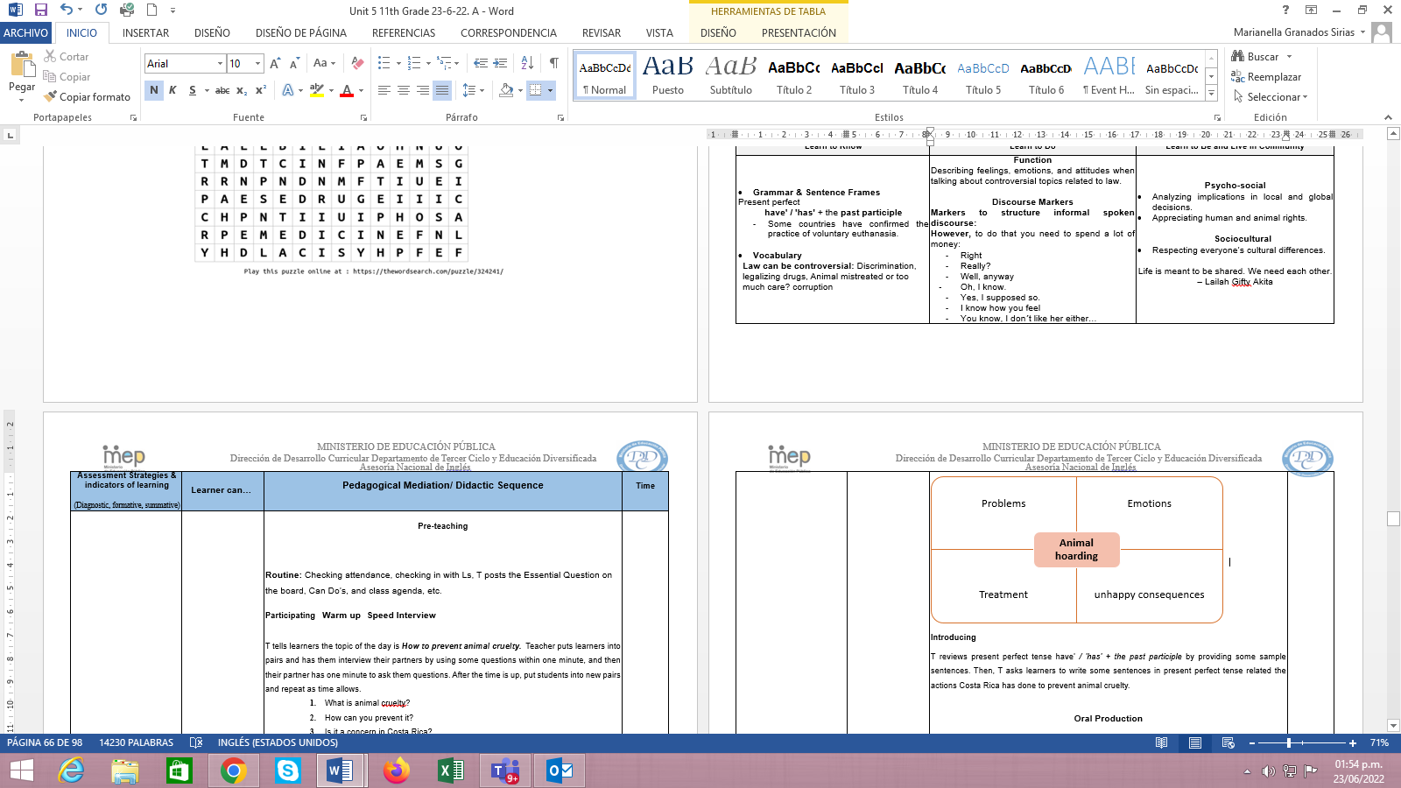



|  |  |  |  |  |  |  |
| --- | --- | --- | --- | --- | --- | --- |
| **Editing Checklist** | **My revision** | | | **My classmate’s revision** | | |
| **The summary…** | **Yes** | **No** | **Partially** | **Yes** | **No** | **Partially** |
| is well- capitalized. |  |  |  |  |  |  |
| ‘s verbs match with the subject. |  |  |  |  |  |  |
| ‘s pronoun and articles agree |  |  |  |  |  |  |
| has a topic sentence |  |  |  |  |  |  |
| has actions that show animal cruelty |  |  |  |  |  |  |
| has ideas on what to do |  |  |  |  |  |  |
| has ideas to prevent animal cruelty |  |  |  |  |  |  |
| is indented. |  |  |  |  |  |  |
| has clear sentences. |  |  |  |  |  |  |
| fulfills with the information asked in the task. |  |  |  |  |  |  |
| has punctuation marks correctly used. |  |  |  |  |  |  |

|  |  |  |  |  |  |  |
| --- | --- | --- | --- | --- | --- | --- |
| **Editing Checklist** | **My revision** | | | **My classmate’s revision** | | |
| **The summary…** | **Yes** | **No** | **Partially** | **Yes** | **No** | **Partially** |
| is well- capitalized. |  |  |  |  |  |  |
| ‘s verbs match with the subject. |  |  |  |  |  |  |
| ‘s pronoun and articles agree |  |  |  |  |  |  |
| has a topic sentence |  |  |  |  |  |  |
| has actions that show animal cruelty |  |  |  |  |  |  |
| has ideas on what to do |  |  |  |  |  |  |
| has ideas to prevent animal cruelty |  |  |  |  |  |  |
| is indented. |  |  |  |  |  |  |
| has clear sentences. |  |  |  |  |  |  |
| fulfills with the information asked in the task. |  |  |  |  |  |  |
| has punctuation marks correctly used. |  |  |  |  |  |  |

**25 PHRASES FOR EXPRESSING OPINIONS**

[**http://myenglishonline.ca/wp-content/uploads/2014/08/100-Phrases.pdf**](http://myenglishonline.ca/wp-content/uploads/2014/08/100-Phrases.pdf)

|  |  |
| --- | --- |
| I think…. I believe….  I feel…. I suppose….  I guess…. According to me….  In my view…. In my opinion….  In my eyes…. It seems to me that….  From my perspective…. From my point of view….  From my view point…. As far as I’m concerned….  Personally, I think…. I’d like to point out that….  What I mean is…. Generally it is thought that….  Some people say that…. Well, it is considered that….  It is generally accepted that…. My impression is that….  It goes without saying that…. I hold the view that….  I’m of the opinion that…. | **25 PHRASES FOR EXPRESSING DISAGREEMENT**  I see your point, but…. I see what you are getting at, but….  That’s one way of looking at it, however…. I completely disagree….  Well, I see things rather differently…. Umm, I’m not sure about that…. I’m not sure I go along with that view…. I don’t really agree with that idea….  I agree up to a point, but…. You could say that, however….  I wouldn’t quite put it that way myself…. I still have my doubts….  I can’t/ couldn’t go along with that…. That’s out of question….  You’ve got to be kidding…. Well, I don’t quite agree with you….  I find that very difficult to accept…. We don’t seem to agree here….  Not necessarily…. That’s not always true….  There is no way I could agree with that…. I don’t think so….  No, I’m not sure about that because…. I’m afraid, I disagree…. We don’t seem to be in complete agreement…. |
| **25 PHRASES FOR EXPRESSING AGREEMENT**  I agree…. I totally agree….  Definitely…. I couldn’t agree more….  Absolutely…. Precisely….  I see your point…. I see what you are getting at….  I’d go along with that view to a point… Sure, that’s one way of looking at it….  I have to side with you on this one…. I suppose so….  I think so too…. I’d go along with that….  That’s a good point…. I see exactly what you mean….  You’re right, that’s a good point…. Actually, I think you’re right….  That’s true…. Well, I agree with you here….  You have my full agreement…. I second that….  Ok, that’s convincing…. I take your word on it….  You took the words right out of my mouth… Jagrati Chauhan, 2014 | **25 PHRASES FOR EXPRESSING INTERRUPTION**  Sorry to interrupt, but…. Can I add something here….  Is it ok if I jump in for a moment…. If I might add something….  If I may interrupt…. Can I throw my two cents in….  Do you mind if I add something…. Umm, well not really….  Excuse me, but in my opinion…. Are you telling that….  Excuse me for a second, but…. Sorry, but I’m not done yet….  Let me finish what I have to say first…. May I say something here….  Excuse me for interrupting, but…. Sorry to cut you off, but….  Well, that reminds me that…. So, you’re telling me….  I don’t mean to intrude, but…. Well, if that is the case….  Sorry, but can you let me finish…. Wait a minute….  Before you go on, I’d like to say something….  Before you move on, I’d like to say something….  Just a moment, I like to add something here…. |

|  |  |  |  |  |  |  |  |  |  |
| --- | --- | --- | --- | --- | --- | --- | --- | --- | --- |
| **Didactic Planning**  **Week # 4** | | | | | | | | | |
| **Term: II** | | **Level: Eleventh** | | | **Unit:5** | | | **Week: 4** | |
| **Domain:** Socio-Interpersonal and Academic | | | | **Scenario:** Really???  (Controversial issues) | | **Theme: Theme:** OMG… Stereotypes and Cultural Differences | | | |
| **Enduring Understanding**: What is considered right can be relative depending on personal points of view. | | | | | | | | | |
| **Essential Question:** How our point of view depends upon the way we look at it? | | | | | | | | | |
| **New Citizenship:**   |  | | --- | | **Dimensions** | | **1.** **Ways of thinking (**√**)** | | **2. Ways of living in the world (**√**)** | | **3. Ways of relating with others (**√**)** | | **4. Tools for integrating with the world (**√ **)** | | | | | | | | | | |
| **Learn to Know** | | | | **Learn to Do** | | **Learn to Be and Live in Community** | | | |
| **Grammar & Sentence Frames**  Simple passive  [Thing doing action] + [verb] + [thing receiving action]   * In brief, I can say that animals are used by scientists in laboratory testing because they are still considered lesser beings.   **Vocabulary**  Differences and similarities (food, clothes, gender relationships, racism, music, senior citizens and children care, beliefs, culture shock, beauty, stereotyping, ethnics, etc.). | | | | Function: Managing interaction (interrupting, changing topic, resuming or continuing) when expressing opinions about cultural patterns.  **Discourse Markers**  **Markers to structure informal spoken discourse**  **However,** to do that you need to spend a lot of money  Right  Really?  Well, anyway  Oh, I know.  Yes, I supposed so.  I know how you feel  You know, I don´t like her either… | | **Psycho-social**  Analyzing  Implications in local and global decisions.  Appreciating human and animal rights.  **Sociocultural**  Respecting everyone’s cultural differences.  Life is meant to be shared. We need each other. ~Lailah Gifty Akita, | | | |
| **Assessment Strategies & indicators of learning**  (Diagnostic, formative, summative) | **Goals** | | | **Pedagogical Mediation/ Didactic Sequence** | | | | | **Time**  (5 lessons) |
| **SP.1.** explains a process providing detailed, practical instructions.  **Indicators of learning:**  **SP.1.1 Plans the language, content and resources to explain a previously selected process by providing detailed, practical instructions.**  **SP.1.2 Organizes the content and resources by identifying the stages to carry out the process.**  **SP.1.3 Makes sentences to describe in a detailed way each stage involved in the process using the appropriate linkers or connecting words.**  **SP.1.4 Gives an oral presentation to describe in a detailed way each stage involved in the process.**  **W.2.** writes short persuasive paragraphs.  **Indicators of learning**  **W2.1 Prewrites a persuasive paragraph about a controversial issue.**  **W2.2 Drafts a persuasive paragraph about a controversial issue that includes thesis statement (that states a position/claim), main reasons (arguments), facts and examples (evidence) conclusion (most important details of the argument and what you want the reader to do) while also acknowledging contrasting opinions with new structures (e.g., on the one hand, Yet on the other hand…) with the appropriate linkers or connecting words.**  **W2.3 Revises a persuasive paragraph about a controversial issue by checking subject-verb agreement; pronoun and article agreement, capitalization (at the beginning of sentences, proper nouns, the pronoun “I,” proper adjectives, titles, and abbreviations), sentence sense, word order, text structure, concrete ideas, using commas: (to punctuate items in a series, dates), spelling, punctuation, content cohesion accurately in a pair-share activity.**  **W2.4 Edits a persuasive paragraph about a controversial issue before publishing.**  **W.3.** spells and shows basic punctuation accurately enough to be followed most to the time.  **W.4.** checks written summaries and paragraphs to look for mistakes (subject-verb agreement, pronoun and article agreement, capitalization, using commas, sentence sense, word order, text structure, concrete ideas, cohesion, etc**.** | **SP.1.** provide detailed, practical instructions to explain a process with which they are familiar (e.g., animal rights, UFO’s, controversial issues).  **W.2.** write short persuasive paragraph about world facts, issues from health and medicine, controversies from the law and stereotypes and cultural differences**.**  **W.3.** spell and show basic punctuation accurately enough to be followed most to the time.  **W.4.** check written summaries and paragraphs to look for mistakes (subject-verb agreement, pronoun and article agreement, capitalization, using commas, sentence sense, word order, text structure, concrete ideas, cohesion, etc**.** | | | **Pre-teaching**  **Routine**: Checking attendance, checking in with Ls, T posts the Essential Question on the board, Can Do’s, and class agenda, etc.  **Participating: Warm -up**  Learners make groups of four and play charades. The teacher will show pictures of stereotypes and cultural differences -- the group that guesses the most in the least amount of time wins.  **Engaging: Activation of prior knowledge**  Teacher has Ss to watch a video about Cultural differences  <https://www.youtube.com/watch?v=vO6N0ha22Mk> Learners try to identify the different topics and what they do. Then., they compare it to Costa Rica.    **Introducing**  Teacher reviews the use of the Simple passive [Thing doing action] + [verb] + [thing receiving action]. Then, T asks learners to write some sentences in simple passive by using the information they saw in the video.  As well introduces vocabulary like food, clothes, art creation, manners, dress code or rituals, cultural differences, stereotypes, etc. Then, learners fill out a chart about Costa Rica and other three countries. They can look for information before attending this lesson.     |  |  |  |  |  | | --- | --- | --- | --- | --- | | **Aspects** | **China** | **France** | **New Zealand** | **Costa Rica** | | food |  |  |  |  | | clothes |  |  |  |  | | manners |  |  |  |  | | sports |  |  |  |  | | dress code |  |  |  |  | | rituals |  |  |  |  | | stereotypes |  |  |  |  | | animals |  |  |  |  |   ***Spoken Production***  **Task:** Alvaro and Sonia want to travel to all the continents. So, they decided to watch documentaries about the different cultures in each continent to prepare an oral presentation to explain the information found to the rest of the class. They want to talk about a specific process related to art creation, manners, dress code or rituals in a specific culture and how different it is in Costa Rica.  **Planning**  After watching different documentaries, learners prepare a set of ideas with specific resources to explain one process and its stages related to art creation, manners, dress code or rituals in a specific culture and how different it is in Costa Rica.  .  **Organizing**  Learners go over the words, ideas and pictures to create an outline that will guide their oral presentation to explain one process and its stages related to art creation, manners, dress code or rituals in a specific culture and how different it is in Costa Rica.  Then, they start writing sentences including linking words/ the appropriate connectors. After that, learners make sure their presentation and resources are well-organized and have a logical sequence**.**  **Rehearsing**  As soon as they finish organizing their ideas and material, learners start practicing what they will explain during the presentation. Teacher walks around and clarifies any questions, doubts or concerns students may have. He/she helps to correct or clarify any grammatical or pronunciation error. Once students have finished, they rehearse their presentation in front of two classmates who will listen and provide recommendations if necessary.   |  |  |  |  | | --- | --- | --- | --- | | **Oral Presentation Checklist** | | | | | The presentation... | Yes | No | Partially | | is well -organized (it has beginning, a middle and an end) |  |  |  | | ´s sentences are well connected. (use of connectors) |  |  |  | | has a logical sequence of ideas |  |  |  | | has resources to support it. |  |  |  | | has clear sentences. |  |  |  | | fulfills the information asked in the task. |  |  |  |   **Producing**  Learners give an oral presentation to explain a process and its stages with which they are familiar in the chosen culture. After all learners have finished their presentations, teacher provides positive feedback to motivate them. He/she also lists some aspects regarding the presentation ( grammar, vocabulary or any other aspects) that can help to improve learners’ presentations.  **Task:** You have been invited to write a persuasive paragraph about cell phones for your school newspaper editorial. Before writing it, you surfed the web to find an online article to get informed about this topic. Read the online article entitled “How to Tell If You Could Be Addicted to Your Phone” https://www.healthline.com/health/mental-health/cell-phone-addiction#whos-at-risk and write short persuasive paragraph. Include a **topic sentence** (that states a position/claim), **main reasons** (arguments), facts and examples (evidence) **conclusion** (most important details of the argument and what you want the reader to do) while also acknowledging contrasting opinions with new structures (e.g., on the one hand, Yet on the other hand…).  **Pre-writing:** Have learners to use listing**;** listing is a process of generating a lot of information within a short time by generating some broad ideas and then building on those associations for more details about the topic in order to write a short persuasive paragraph.    **Drafting:**  Drafta persuasive paragraph which includes **topic sentence** (that states a position/claim), main **reasons** (arguments), **facts** and examples (evidence) **conclusion** (most important details of the argument and what you want the reader to do) while also acknowledging contrasting opinions with new structures (e.g., on the one hand, Yet on the other hand…).  **Revising:**  Then, each learner checks his/her persuasive paragraph by using the following editing checklist. After that, each learner shares his/her report with another classmate, and he/she checks it using the same checklist.   |  |  |  |  |  |  |  | | --- | --- | --- | --- | --- | --- | --- | | **Editing Checklist** | **My revision** | | | **My classmate’s revision** | | | | **The persuasive paragraph …** | **Yes** | **No** | **Partially** | **Yes** | **No** | **Partially** | | is well- capitalized. |  |  |  |  |  |  | | ‘s verbs match with the subject. |  |  |  |  |  |  | | ‘s pronoun and articles agree |  |  |  |  |  |  | | has topic **sentence** (that states a position/claim), |  |  |  |  |  |  | | has main **reasons** (arguments), |  |  |  |  |  |  | | has **facts** and examples (evidence) |  |  |  |  |  |  | | Has a **conclusion** (most important details of the argument and what you want the reader to do |  |  |  |  |  |  | | is indented. |  |  |  |  |  |  | | has clear sentences. |  |  |  |  |  |  | | fulfills with the information asked in the task. |  |  |  |  |  |  | | has punctuation marks correctly used. |  |  |  |  |  |  |   **Editing**  Considering their classmates’ feedback and his/her self-assessment, learners correct and modify their persuasive essay. Teacher also monitors students and helps them in the editing process before publishing.  Suggested idea for Assessment Strategies **W.3. and W.4.**  In order to achieve the assessment strategiesW.3. and W.4., follow the next process: | | | | |  |
| **Integrated Mini-Project** | | | | | | | | | **Time** |
| Participating, thinking, acting out, responding, and sharing:   * A survey about a controversial issue.   Learners get in their groups and make a list of subject experts in their community or school to interact with them about the Mini Project topic. They can also meet many subject experts from various parts of CR through social media. This helps them in getting suggestions in different possible ways, through which they can get a clear idea on their Mini Project topic.  After getting a clear idea about the topic, they are asked to prepare a rough plan about procurement of resources. They should make a rough schedule and distribute the work among the teammates. This will keep their Mini Project on track and individuals will come to know about their part in the Mini Project rather than any individual (leader) taking full responsibilities.  Learners make sure that the materials will be ready for the next week and that all members know their responsibility. | | | | | | | | |  |
| **Reflective Teaching** | | | | | | | | | |
| What worked well… | | | What didn’t work well… | | | | How to improve | | |
| **Enduring Understanding Reflection** | | | | | | | | | |
| How well did the learners progress in their understanding of the Enduring Understanding? | | | | | | | | | |
| **Week Plan Self-Assessment** | | | | | | | | | |
| At the end of the week, T guides the learners to check their progress using the checklist below. (Can be translated into Spanish if needed to ensure Ls’ understanding.)   |  |  |  |  | | --- | --- | --- | --- | | ***Learner Self-Assessment*** | | | | | ***I can… \**** | ***Yes*** | ***In process*** | ***No*** | | plan the language, content and resources to explain a previously selected process by providing detailed, practical instructions. |  |  |  | | organize the content and resources by identifying the stages to carry out the process. |  |  |  | | make sentences to describe in a detailed way each stage involved in the process using the appropriate linkers or connecting words. |  |  |  | | give an oral presentation to describe in a detailed way each stages involved in the process. |  |  |  | | prewrite a persuasive paragraph about a controversial issue. |  |  |  | | draft a persuasive paragraph about a controversial issue that includes thesis statement (that states a position/claim), main reasons (arguments), facts and examples (evidence) conclusion (most important details of the argument and what you want the reader to do) while also acknowledging contrasting opinions with new structures (e.g., on the one hand, Yet on the other hand…) with the appropriate linkers or connecting words. |  |  |  | | revise a persuasive paragraph about a controversial issue by checking subject-verb agreement; pronoun and article agreement, capitalization (at the beginning of sentences, proper nouns, the pronoun “I,” proper adjectives, titles, and abbreviations), sentence sense, word order, text structure, concrete ideas, using commas: (to punctuate items in a series, dates), spelling, punctuation, content cohesion accurately in a pair-share activity. |  |  |  | | edit a persuasive paragraph about a controversial issue before publishing. |  |  |  | | spell and show basic punctuation accurately enough to be followed most to the time. |  |  |  | | check written summaries and paragraphs to look for mistakes (subject-verb agreement, pronoun and article agreement, capitalization, using commas, sentence sense, word order, text structure, concrete ideas, cohesion, etc. |  |  |  |   *You must include the indicators of learning from the document “Guidelines on How to Write Indicators of Learning for the Pedagogical Mediation of the English Curriculum under each Assessment Strategy and in the Self -Assessment chart at the end of every week. | | | | | | | | | |

**MATERIALS**

**FOR WEEK 4**

|  |  |  |  |  |
| --- | --- | --- | --- | --- |
| **Aspects** | **China** | **France** | **New Zealand** | **Costa Rica** |
| food |  |  |  |  |
| clothes |  |  |  |  |
| manners |  |  |  |  |
| sports |  |  |  |  |
| dress code |  |  |  |  |
| rituals |  |  |  |  |
| stereotypes |  |  |  |  |
| animals |  |  |  |  |

|  |  |  |  |  |
| --- | --- | --- | --- | --- |
| **Aspects** | **China** | **France** | **New Zealand** | **Costa Rica** |
| food |  |  |  |  |
| clothes |  |  |  |  |
| manners |  |  |  |  |
| sports |  |  |  |  |
| dress code |  |  |  |  |
| rituals |  |  |  |  |
| stereotypes |  |  |  |  |
| animals |  |  |  |  |

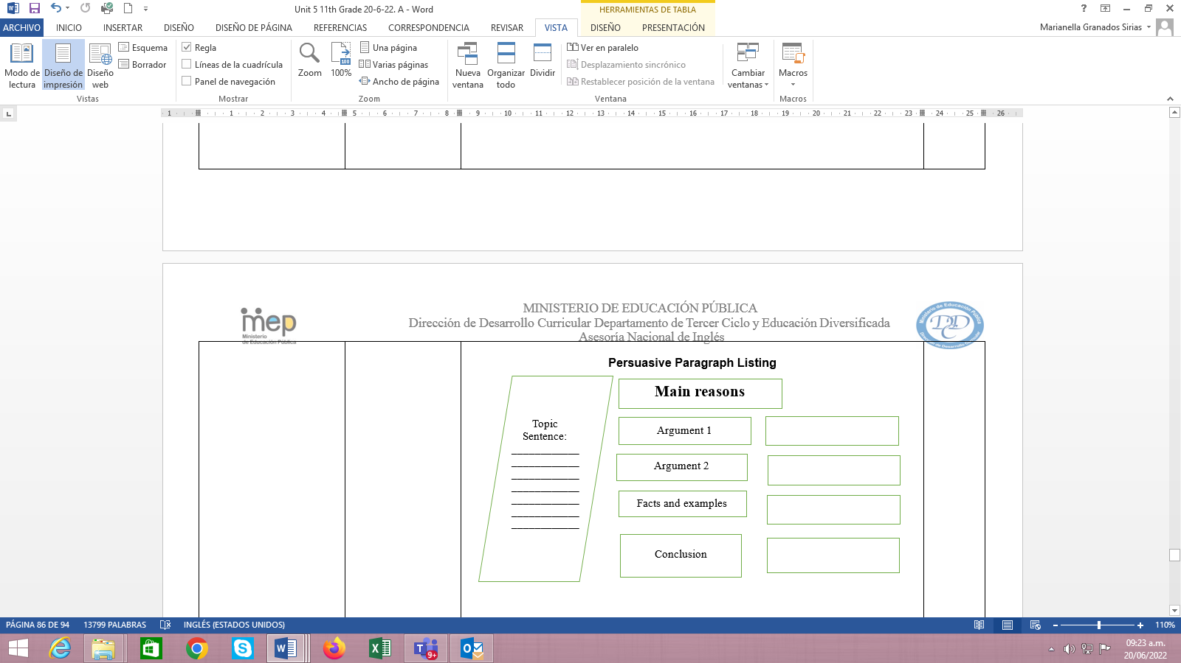

|  |  |  |  |  |  |  |
| --- | --- | --- | --- | --- | --- | --- |
| **Editing Checklist** | **My revision** | | | **My classmate’s revision** | | |
| **The persuasive paragraph …** | **Yes** | **No** | **Partially** | **Yes** | **No** | **Partially** |
| is well- capitalized. |  |  |  |  |  |  |
| ‘s verbs match with the subject. |  |  |  |  |  |  |
| ‘s pronoun and articles agree |  |  |  |  |  |  |
| has topic **sentence** (that states a position/claim), |  |  |  |  |  |  |
| has main **reasons** (arguments), |  |  |  |  |  |  |
| has **facts** and examples (evidence) |  |  |  |  |  |  |
| Has a **conclusion** (most important details of the argument and what you want the reader to do |  |  |  |  |  |  |
| is indented. |  |  |  |  |  |  |
| has clear sentences. |  |  |  |  |  |  |
| fulfills with the information asked in the task. |  |  |  |  |  |  |
| has punctuation marks correctly used. |  |  |  |  |  |  |

|  |  |  |  |  |  |  |
| --- | --- | --- | --- | --- | --- | --- |
| **Editing Checklist** | **My revision** | | | **My classmate’s revision** | | |
| **The persuasive paragraph …** | **Yes** | **No** | **Partially** | **Yes** | **No** | **Partially** |
| is well- capitalized. |  |  |  |  |  |  |
| ‘s verbs match with the subject. |  |  |  |  |  |  |
| ‘s pronoun and articles agree |  |  |  |  |  |  |
| has topic **sentence** (that states a position/claim), |  |  |  |  |  |  |
| has main **reasons** (arguments), |  |  |  |  |  |  |
| has **facts** and examples (evidence) |  |  |  |  |  |  |
| Has a **conclusion** (most important details of the argument and what you want the reader to do |  |  |  |  |  |  |
| is indented. |  |  |  |  |  |  |
| has clear sentences. |  |  |  |  |  |  |
| fulfills with the information asked in the task. |  |  |  |  |  |  |
| has punctuation marks correctly used. |  |  |  |  |  |  |

**Weeks 5 and 6**

**Review and Integrated Mini-Project**

|  |  |  |  |  |  |  |
| --- | --- | --- | --- | --- | --- | --- |
| **Level: 11th** | | | | **Unit: 5** | | |
| **Enduring Understanding**: What is considered right can be relative depending on personal points of view  **Essential Question:** How our point of view depends upon the way we look at it? | | | | | | |
| **New Citizenship:**     |  | | --- | | **Dimensions** | | **1.** **Ways of thinking (√ )** | | **2. Ways of living in the world (√ )** | | **3. Ways of relating with others (√ )** | | **4. Tools for integrating with the world ( √ )** | | | | | | | |
| **Learn to Know** | | | **Learn to Do** | | **Learn to Be and Live in Community** | |
| **Grammar & Sentence Frame**   * Did Ls use all sentence frames?   **Vocabulary**   * Did Ls say aloud and write all vocabulary?   **Phonology**   * Did Ls recognize, articulate and produce phonological sounds? | | | **Function**   * Did Ls use all functions?   **Discourse Markers**   * Did Ls practice connecting words: and, but, because? | | **Psychosocial**   * Did Ls show evidence of … * Being aware and committed to protecting the environment * Appreciating natural wonders   **Sociocultural**   * Did Ls practice idioms and quotes? | |
| **Assessment Strategies & indicators of learning**  (Diagnostic, formative, summative) | **Learner can** | **Didactic Sequence Mediation** | | | | **Time** Total:   (5 lessons) |
| * Did Ls achieve all learning outcomes? | * Can Ls do all tasks? | Referencing notes from formative assessments throughout the weeks, repeat activities to strengthen Ls in weaker areas or select from Optional Activities that follow these plans. | | | | All of week 5 or 6 |
| **Options** | | **Integrated Mini-Project** | | | | **Time** |
| **Possible projects:**   * A recorded inspirational video (TedEx in the class), using cell phones or role-play it. * Writing memories for the class yearbook. | | By allowing time for the Mini-Project each week for participating, thinking, and acting out, learners should now have a chosen project and determined content and strategies. In the presentation week Ls focus on:  **Responding and sharing:** Participating in individual and peer assessment of mini-project.   |  |  |  |  |  | | --- | --- | --- | --- | --- | | ***Integrated Mini-project Self-Assessment*** | | | | | | ***Participating to Negotiate***  I participated by   * sharing my own ideas and interests with my family or classmates * respecting my family or classmates’ opinions, * communicating respectfully * making decisions | | | | | | **A lot**  **5** | **4** | **A little**  **3** | **2** | **Not at all**  **1** | | ***Thinking****:*  I planned by   * looking for information and resources, * thinking of a design for my presentation * interacting with my classmates. * making decisions | | | | | | **A lot**  **5** | **4** | **A little**  **3** | **2** | **Not at all**  **1** | | ***Acting out:***  I acted out by   * reviewing the information * improving my video * correcting the information, * rehearsing and working on pronunciation, intonation, fluency and other aspects, | | | | | | **A lot**  **5** | **4** | **A little**  **3** | **2** | **Not at all**  **1** | | ***Responding and Sharing****:*  I can demonstrate I was well prepared in delivering and sharing the information by   * responsibly delivering the project during the virtual / classroom exchange. * answering questions from the audience respectfully. * self-assessing the final product. | | | | | | **A lot**  **5** | **4** | **A little**  **3** | **2** | **Not at all**  **1** |   Teachers monitor ….   * Did Ls use English during all aspects of Integrated Mini-Project? * How didproject presentations reflect understanding and/or mastery of Can Do statements? * Did Ls put into practice the focus of Learn to Be and Live in Community? * Did the Integrated Mini-Project provide answers to the Essential Question? | | | | All of week 5 or 6 of unit |