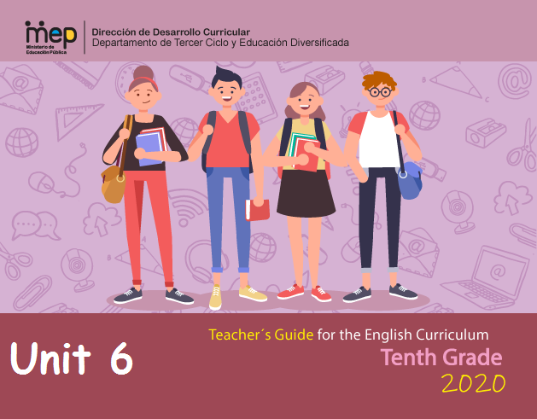

**Autoridades**

**Giselle Cruz Maduro**

Ministro de Educación Pública

**Melania Brenes Monge**

Viceministra Académica de Educación

**María Alexandra Ulate Espinoza**

Directora de la Dirección de Desarrollo Curricular

**Rigoberto Corrales Zúñiga**

Jefe del Departamento de Tercer Ciclo y Educación

**Comisión redactora**

**Mag. Marianella Granados Sirias,**

Asesora Nacional de Inglés, Departamento de Tercer Ciclo y Educación Diversificada

**Mag. Alfredo Ortega Cordero**,

Asesor Nacional de Inglés, Departamento de Tercer Ciclo y Educación Diversificada

**MSc. Henry Enríquez**

Asesor Regional de Inglés, Dirección Regional Cañas

**Docentes de Inglés de Tercer Ciclo y Educación Diversificada**

Elibeth Salas Rodríguez , Liceo de Colorado

Johan Córdoba Guzmán, Liceo de Colorado

Andrea Lobo, CTP Abangares

Irene Agüero, Liceo de San Rafael

Roberto López, Liceo Maurilio Alvarado

José Francisco Porras, Liceo Maurilio Alvarado

Yorhani Esquivel Baltodano, Liceo de Colorado

Diógenes Gutiérrez López. CTP de Cañas

**Voluntarios Cuerpo de Paz**

Breanne Schnell

Daniel Larson

**Marco Brenes López**

Dirección de Recursos Tecnológicos, Diseño de portada

|  |  |  |  |  |  |  |  |  |
| --- | --- | --- | --- | --- | --- | --- | --- | --- |
| **Level 10th Unit 6**  **CEF Level to be Reached B1 Basic User/Independent User** | | | | | | | | |
| **Scenario:** What Comes Next? | | | | | | | | |
| **Enduring Understanding** | | Every day people are faced with choices - some big, some small - and the way people react to those choices shape their future. | | | | | | |
| **Essential Question** | | How do decisions we make today change our lives tomorrow? | | | | | | |
| **New Citizenship:**   |  | | --- | | **Dimensions** | | **1.** **Ways of thinking (√)** | | **2. Ways of living in the world (√)** | | **3. Ways of relating with others (√)** | | **4. Tools for integrating with the world (√ )** | | | | | | | | | |
| **Assessment and Goals** | | | | | | | | |
| **Week 1**  **Goals**  **L.1.** understand when people speak at normal speed on familiar topics. There may be a need to repeat particular words and phrases.  **L.2.** follow the main idea of audio text if the topic is familiar and the text can be replayed.  **R.1.** understand factual text and simple reports on familiar topics (e.g., interviews).  **SP.1.** describe personal goals and intentions. | **Week 1**  **Assessment**  **L.1.** recognizes when people speak at normal speed on familiar topics. There may be a need to repeat particular words and phrases.  **L.2.** extracts the main idea of audio text if the topic is familiar and the text can be replayed.  **R.1**. recognizes factual text and simple reports on familiar topics.  **SP.1**. describes personal goals and  Intentions. | **Week 2**  **Goals**  **R.3.** use key words, diagrams, and illustrations to support reading comprehension.  **R.4**. understand texts of various lengths as long as the words used are familiar and/or concern areas of student interest.  **W.1.** summarize simple text dealing with familiar subjects. | **Week 2**  **Assessment**  **R.3.** uses texts of various lengths as long as the words used are familiar.  Identifying relevant information and drawing conclusions.  **R.4**. interprets texts of various lengths as long as the words used are familiar and/ or concern areas of student interest.  **W.1**. restates a main idea in a few words. | **Week 3**  **Goals**  **SI.1**. interview others if the questions have been prepared beforehand. Sometimes, can pose a further question without having to pause very long to formulate the question.  **SP.2.** express and ask for others´ opinions and needs on familiar subjects.  **SI.2.** sustain a conversational exchange with a peer in the classroom when the topic is familiar, though there may be some difficulty in understanding and being understood from time to time. | **Week 3**  **Assessment**  **SI.1**. interviews others if the questions have been prepared beforehand.  **SP.2.** expresses and asks for others´ opinions and needs.    **SI.2.** starts, sustains and closes a conversational exchange with a peer in the classroom when the topic is familiar. | **Week 4**  **Goals**  **SP.3.** explain and justify points of view, assumptions, and future plans, briefly.  **W.2**. write a report on an important personal experience (e.g., graduating from school, getting interviewed, and choosing a career) and check written summaries and reports to look for mistakes (subject-verb agreement, pronoun and article agreement, capitalization, using commas, sentence sense, word order, text structure, concrete ideas). | **Week 4**  **Assessment**  **SP.3.** explains and justifies points of view, assumptions, and plans, briefly.  **W.2**.writes a one-page report based on real events. | **Week 5/6**  **Assessment**  Anecdotal reports / rubrics / instruments for self and co-assessment  **Suggested Integrated Mini project**   * Essay about *future plans*. * A multi-step research Career Research: *“Planning my Future”*- Gallery Walk (learners explore different careers and professions they want to pursue, complete with educational requirements, salary and job opportunities) |
| **Phonology**  **R2.** manipulates English language sounds using prior knowledge in phonics, syllabification and word parts.   * Review of sound articulation (7th to 9th) and of phonological features of most unfamiliar words when needed. * Use of prosodic features (stress, intonation, rhythm) to support the message intended to convey. * Even though this goal is still linked to reading in Diversified Education, teachers can reinforce it in Spoken Interaction and Spoken Production activities as well. | | | | | | | |
| **Theme**   1. Pass or Fail? | | **Theme**   1. College or Career? | | **Theme**   1. Study Here or Abroad? | | **Theme**   1. Getting By or Getting Ahead? | |
| **Function**   * Describing feelings, emotions, and attitudes about my goals for passing or failing. | | **Function**   * Giving advice and suggestions about deciding to go to college or career. | | **Function**   * Describing experiences, events and opinions about studying locally or abroad. | | **Function**   * Stating obligation and necessity about getting by or getting ahead in the future. | |
| **Discourse Markers**  Connecting words expressing cause and effect, contrast:   * **On the other hand**, I am going to work hard to reach my goals. * **However,** it will take lots of effort and sacrifices.   Initiating and closing a conversation  **Initiating**   * Can I talk to you for a minute? * Excuse me, please. Do you have a minute?   Managing interaction  Interrupting   * Sorry to interrupt you but … * I have a question. * Could I interrupt here?   Closing   * It´s been nice talking to you. See you later. * I´m sorry, I have to go now. * Must go. | | **Discourse Markers**  Initiating and closing a conversation  **Initiating**   * Can I talk to you for a minute? * Excuse me, please. Do you have a minute?   Managing interaction  Interrupting   * Sorry to interrupt you but … * I have a question. * Could I interrupt here?   Closing   * It´s been nice talking to you. See you later. * I´m sorry, I have to go now. * Must go. | | **Discourse Markers**  Changing the topic   * Anyway…, by the way, there´s something else I wanted to tell you…   Resuming a conversation   * Anyway…, anyway, what I was saying? * What were we talking about? * To get back to what I was saying   Continuing   * Anyway….   So, as I was saying, Well… | | **Discourse Markers**  Changing the topic   * Anyway…, by the way, there´s something else I wanted to tell you…   Resuming a conversation   * Anyway…, anyway, what I was saying? * What were we talking about? * To get back to what I was saying   Continuing   * Anyway….   So, as I was saying, Well… | |
| **Grammar & Sentence Frames**  Past Tense   * I passed all my subjects but I failed to understand some things very well. * I want to be like my brother who went away to college. * I respected my friend’s choice to study at INA and now he is a great mechanic.   Phrasal Verbs   * You should shape up or you will have to drop out of school. * You need to find out what your choices are. * Don’t give up your dreams. | | **Grammar &Sentence Frames**  Modals   * I **might** stay in my hometown, or go to San José to study. * You **might** schedule your interview in the morning, or you could wait until the afternoon. * You **should** ask yourself exactly what you want from a job or a career. * What **could** the speaker say in answer to the question? * **Should** you write about the paragraph you read? | | **Grammar & Sentence Frames**  Present continuous   * **I’m doing** my homework this evening. * **I’m starting** university in January. * **We´re planning** to study in San José next year. * My teacher is **thinking** of taking a sabbatical year after next year. * As for now, **I am** only **focusing** my attention on finishing my studies. | | **Grammar & Sentence Frames**  Going to  To talk about plans and intentions   * I’m going to have an interview next week. * He is going to move to the U.S. for an exchange program.   *If* clause   * We won’t be able to get into the university if we don’t pass the bachillerato. * If I graduate from high school, I will try to get a job soon.   Adjectives   * I am a critical and business-oriented person. * I am math-oriented, so I’d like to study something related to that field.   Wh- questions   * **What** are your goals for the future? * **What** do you plan to do after graduating from high school? * **Where** would you like to study?   **Which** profession should I choose? | |
| **Vocabulary**  Pass or Fail?   * Success, failure, choice, pass, fail, | | **Vocabulary**  College or Career?   * College, university, career, study abroad, decision, decide, enroll, analytical, artistic, musical, athletic, compassionate, competent | | **Vocabulary**  Study Here or Abroad?   * **Exchange program, academics,** choose, decision making, goals. | | **Vocabulary**  Getting by or Getting Ahead?  Short- and long- term goals, getting by/ getting ahead, disciplined, down-to-earth, hard-working, responsible, goal-oriented (business-; math-; music, etc.) | |
| **Psycho-social**   * Being aware of own strengths and limitations.   **Sociocultural**   * Being open to give and receive constructive feedback. | | **Psycho-social**   * Thinking critically about my own future for setting my goals.   **Sociocultural**   * Being open to give and receive constructive feedback. | | **Psycho-social**   * Thinking critically about my own future for setting my goals.   **Sociocultural**   * Showing interest and respect for other´s life and feelings with a non-judgmental attitude. | | **Psycho-social**   * Managing own emotions and self-control when interacting with others.   **Sociocultural**   * Showing interest and respect for other´s life and feelings with a non-judgmental attitude. | |

**Didactic Planning**

**Week # 1**

|  |  |  |  |  |  |  |  |  |
| --- | --- | --- | --- | --- | --- | --- | --- | --- |
| **Level: 10th** | | | | | **Unit: 6** | | | |
| **Domain:** | | | **Scenario:** What Comes Next? | | | **Theme:** Pass or Fail? | | |
| **Enduring Understanding**: Every day people are faced with choices - some big, some small - and the way people react to those choices shape their future.  **Essential Question:** How do decisions we make today change our lives tomorrow? | | | | | | | | |
| **New Citizenship:**     |  | | --- | | **Dimensions** | | **1.** **Ways of thinking (√ )** | | **2. Ways of living in the world (√ )** | | **3. Ways of relating with others (√ )** | | **4. Tools for integrating with the world ( √ )** | | | | | | | | | |
| **Learn to Know** | | | **Learn to Do** | | | **Learn to Be and Live in Community** | | |
| **Grammar & Sentence Frames**  **Past Tense**   I passed all my subjects but I failed to understand some things very well.   I want to be like my brother who went away to college.   I respected my friend’s choice to study at INA and now he is a great mechanic.  **Phrasal Verbs**   You should shape up or you will have to drop out of school.   You need to find out what your choices are.   Don’t give up your dreams.  **Vocabulary**  Pass or Fail?   Success, failure, choice, pass, fail. | | | **Functions**  • Describing feelings, emotions, and attitudes about  my goals for passing or failing.  **Discourse Markers**  Connecting words expressing cause and effect, contrast:  **On the other hand**, I am going to work hard to reach my goals.  **However,** it will take lots of effort and sacrifices.  Initiating and closing a conversation.  **Initiating**   Can I talk to you for a minute?   Excuse me, please. Do you have a minute?  **Managing interaction**  **Interrupting**   Sorry to interrupt you but …   I have a question.   Could I interrupt here?  **Closing**   It´s been nice talking to you. See you later.   I´m sorry, I have to go now.   Must go. | | | **Psycho-social**   Being aware of own strengths and limitations.  **Sociocultural**   Being open to give and receive constructive  feedback. | | |
| **Assessment Strategies & indicators of learning**  (Diagnostic, formative, summative) | **Learner can** | **Didactic Sequence Mediation** | | | | | | **Time** Total:  200 min (5 lessons) |
| **L.1.** recognizes when people speak at normal speed on familiar topics. There may be a need to repeat particular words and phrases.  Indicators of Learning  Recognizes the topic when people speak at normal speed on familiar topics  Identifies key words when people speak at normal speed on familiar topics  Distinguishes main points when people speak at normal speed on familiar topics.  **L.2.** extracts the main idea of audio text if the topic is familiar and the text can be replayed.  Indicators of Learning  Identifies the topic of audio text if the topic is familiar and the text can be replayed  Recognizes key words of audio text if the topic is familiar and the text can be replayed  Gets main ideas of audio text if the topic is familiar and the text can be replayed  **R.1**. recognizes factual text and simple reports on familiar topics.  Indicators of Learning  Identifies main ideas in factual text and simple reports on familiar topics.  Distinguishes supporting details in factual text and simple reports on familiar topics.  **SP.1**. describes personal goals and  Intentions.  Indicators of Learning  Selects the appropriate online information and visuals to give a presentation about personal goals and  Intentions.  .  Organizes the online information and visuals to give a presentation about personal goals and  Intentions.  .  Makes sentences with the online information and with the appropriate linkers or connecting words to give a well-organized presentation about personal goals and  Intentions.  Gives a well-organized presentation about personal goals and  Intentions. | **L.1.** understand when people speak at normal speed on familiar topics. There may be a need to repeat particular words and phrases.  **L.2.** follow the main idea of audio text if the topic is familiar and the text can be replayed.  **R.1**. understand factual text and simple reports on familiar topics (e.g., interviews).  **SP.1.** describe personal goals and intentions. | **Pre-teaching**  **Routine:** Checking attendance, checking in with Ls, T posts the Essential Question on the board, Can Do’s, and class agenda, etc.  **Participating: Warm up**  [**https://www.youtube.com/watch?v=zLYECIjmnQs&pbjreload=10**](https://www.youtube.com/watch?v=zLYECIjmnQs&pbjreload=10)  Learners will watch a short video about “famous failures” and how these famous people became successful. Based on the video, learners will comment on what was his/her favorite one and why?  **Engaging: Activation of prior knowledge**  In groups, learners are given the following questions to reflect on.   1. Have you ever failed any subject in school? 2. Have you ever failed a game? 3. Have you ever failed at something that was important to you? 4. How did you react to that failure? 5. Did something positive come out of it? What?   **Introducing**  Teacher shares four phrasal verbs for education by using a chart. T models how to pronounce them and also their meaning by using them in context.   |  |  | | --- | --- | | **Phrasal Verbs for Education** | | | **shape up**  **meaning:** to develop in a particular way, especially in a good way  **sample:** *Our plans are shaping up nicely*(= showing signs that they will be successful)*.* | **drop out (of something)**  **meaning:** to leave school, college, etc. without finishing your studies  **sample:** *to****drop out of school/college***  *She started a degree but dropped out after only a year.* | | **find out**  **meaning:** *find out (about something/somebody) | find out something (about something/somebody)*  *to get some information about something/somebody by asking, reading, etc.*  **sample:** *Visit our website to find out more.* | **give something up**  **meaning:** to stop doing or having something  **sample:**She didn't give up her dream of  being a doctor when she had the baby.  You shouldn’t give up attending the course. | | **drop in**  **meaning:** *to come for a visit without having received an invitation for a specific time*  **sample :** Drop in whenever you are in the neighborhood. | |   T asks learners to write some sentences using the phrasal verbs. Then, learners read them out loud. T helps learner to improve intonation if necessary.  **Pre-listening**  T shows a picture to students and asks learners to predict what they think the video will be about.    **Listening for the first time**  T shows learners a video called **Why did Steve Jobs drop out of college?** <https://youtu.be/DjxhenAHyGk> Then, learners listen to it very carefully and at the end of the video they will write down what the video is about.  Finally, learners identify the correct key words to complete each sentence based on the video.   |  |  | | --- | --- | | **Word bank**  **drop in / drop out / found out/ gave up** | | | **1.** | Steve Job’s biological mother ____________that the parents were going to adopt Steve didn’t finish their studies. | | **2.** | Steve has his own reasons to ____________ college. | | **3.** | Steve decided to ______________in classes that were more interesting for him. | | **4.** | Based on the video, we can conclude Steve never ___________on his dreams. |     **Pair/Group feedback**  T asks learners to work in pairs and comment on the content of video. Learners help each other if finding difficulties to solve the exercise or problems understanding vocabulary words.  **Listening for the second time**  Ls watch the video again and create a chronology of events in Steve’s life. They have to write 7 events in chronological order.   |  |  | | --- | --- | | **Steve Jobs** |  | | **Chronology of events** | | |  | | |  | | |  | | |  | | |  | | |  | | |  | |   **Post-listening**  Ls will write a seven line paragraph about Steve’s biography based on the ideas from the previous activity.  **Pre-listening**  Teacher asks learners to google Malala ‘information by using their phones and share their findings.  **Listening for the first time**  T shows learners a video called Malala Yousafzai, Activist | Biography [**https://youtu.be/6by9NEhT9GM**](https://youtu.be/6by9NEhT9GM)**.**.  **Learners answer the following questions:**   1. What is the video about? 2. Why did Malala become an education activist?     **Pair/Group feedback**  T asks learners to work in pairs and comment on the content of video. Learners help each other if finding difficulties to solve the exercise or problems understanding vocabulary words.  **Listening for the second time**  Learners watch the video for the second time. Then, teacher asks learners to complete a graphic organizer by using the key words and phrases from the video. After that, learners write sentences to expand the phrases.  **Post-listening**  Learners share their graphic organizer information orally in groups**.**  **Pre-reading**  Learners get a text without a title. Teachers asks learners to go over the text rapidly and decide on a title. T asks learners to check on important keywords, pictures and dates.    **Reading for the first time**  Teacher asks learners to go over the text again but this time learners will focus on each paragraph to highlight main ideas.  **Pair/Group feedback**  Learners work in pairs to share the highlighted ideas per paragraph. Then, learners highlight together the ones omitted after sharing.    **Reading for the second time**  Learners read the article again to answer some reading comprehension questions. Then, in pairs they will check the answers and do peer correction if necessary.    **Post-reading**  Teacher divides the reading into three parts. Then, Ls get in groups of three. T assigns a different text section to each group to read. Each group reads the assigned part. After that, students report to the whole group what they read orally.  **Planning**  **Task:** In the counseling class, learners have been asked to prepare a presentation about their personal goals and intentions because this can be useful for their future life and career project.  Teacher asks learners to brainstorm their more meaningful events in life and also their personal goals and intentions.  **Organizing**  Teacher explains what a timeline is and asks learners to design their own.  https://qph.fs.quoracdn.net/main-qimg-0864d6aaafa6c1309b011d11548ef68a  Learners write sentences to explain the ideas they wrote in timeline of their own lives using the appropriate linkers or connecting words. They include meaningful events but also personal goals and intentions.  **Rehearsing**  Ls practice what they will explain about their timelines in the presentation and do a self –monitoring activity with a chart to make sure they are including all the task elements.   |  |  |  |  | | --- | --- | --- | --- | | **Oral Presentation Checklist** | | | | | The presentation... | Yes | No | Partially | | is well -organized (it has beginning, a middle and an end) |  |  |  | | ´s sentences are well connected. ( use of connectors) |  |  |  | | timeline has a logical sequence of events |  |  |  | | has resources to support it. |  |  |  | | has clear sentences. |  |  |  | | fulfills the information asked in the task. |  |  |  |   **Producing**  Learners deliver their presentation about their timelines to the rest of the group. | | | | | |  |
| **Integrated Mini-Project** | | | | | | | | **Time** |
| Allow time for the Mini-Project each week. NOTE: All phases of the Integrated Mini-Project should be opportunities for Ls to practice English, not just those related to presentation.  **Option #1**  Learners prepare one presentation about one person that changed the world although, they were unsuccessful at the beginning of his / her goals.  In groups of 3, Ls will design one stand to honor the person they have chosen.  **Option #2**  A multi-step research Career Research: *“Planning my Future”*- Gallery Walk (learners explore different careers and professions they want to pursue, complete with educational requirements, salary and job opportunities)  **Participating to negotiate:** (5 or 10 minutes in week 1 or 2) | | | | | | | | Adjust previous times listed above to allow 5 min each week.  Group presentations can be week 5 or 6. |
| **Reflective Teaching** | | | | | | | | |
| What worked well | | | | What didn’t work well | | | How to improve | |
| **Enduring Understanding Reflection**  How well did the learners progress in their understanding of the Enduring Understanding? | | | | | | | | |
| **Week Plan Self-Assessment** | | | | | | | | |
| At the end of the week, T guides the learners to check their progress using the checklist below. (Can be translated into Spanish if needed to ensure Ls’ understanding.)   |  |  |  |  | | --- | --- | --- | --- | | ***Learner Self-Assessment*** | | | | | ***I can…*** | ***Yes*** | ***In progress*** | ***No*** | | recognize the topic when people speak at normal speed on familiar topics |  |  |  | | identify key words when people speak at normal speed on familiar topics |  |  |  | | distinguish main points when people speak at normal speed on familiar topics. |  |  |  | | identify the topic of audio text if the topic is familiar and the text can be replayed |  |  |  | | recognize key words of audio text if the topic is familiar and the text can be replayed |  |  |  | | get main ideas of audio text if the topic is familiar and the text can be replayed. |  |  |  | | identify main ideas in factual text and simple reports on familiar topics. |  |  |  | | distinguish supporting details in factual text and simple reports on familiar topics. |  |  |  | | select the appropriate online information and visuals to give a presentation about personal goals and  intentions. |  |  |  | | organize the online information and visuals to give a presentation about personal goals and  intentions. |  |  |  | | make sentences with the online information and with the appropriate linkers or connecting words to give a well-organized presentation about personal goals and intentions. |  |  |  | | give a well-organized presentation about personal goals and intentions. |  |  |  | | | | | | | | | |

**Week 1 Resources**

|  |  |
| --- | --- |
| **Phrasal Verbs for Education** | |
| **shape up**  **meaning:** to develop in a particular way, especially in a good way  **sample:** *Our plans are shaping up nicely*(= showing signs that they will be successful)*.* | **drop out (of something)**  **meaning:** to leave school, college, etc. without finishing your studies  **sample:** *to****drop out of school/college***  *She started a degree but dropped out after only a year.* |
| **find out**  **meaning:** *find out (about something/somebody) | find out something (about something/somebody)*  *to get some information about something/somebody by asking, reading, etc.*  **sample:** *Visit our website to find out more.* | **give something up**  **meaning:** to stop doing or having something  **sample:**She didn't give up her dream of  being a doctor when she had the baby.  You shouldn’t give up attending the course. |
| **drop in**  **meaning:** *to come for a visit without having received an invitation for a specific time*  **sample :** Drop in whenever you are in the neighborhood. | |

|  |  |
| --- | --- |
| **Phrasal Verbs for Education** | |
| **shape up**  **meaning:** to develop in a particular way, especially in a good way  **sample:** *Our plans are shaping up nicely*(= showing signs that they will be successful)*.* | **drop out (of something)**  **meaning:** to leave school, college, etc. without finishing your studies  **sample:** *to****drop out of school/college***  *She started a degree but dropped out after only a year.* |
| **find out**  **meaning:** *find out (about something/somebody) | find out something (about something/somebody)*  *to get some information about something/somebody by asking, reading, etc.*  **sample:** *Visit our website to find out more.* | **give something up**  **meaning:** to stop doing or having something  **sample:**She didn't give up her dream of  being a doctor when she had the baby.  You shouldn’t give up attending the course. |
| **drop in**  **meaning:** *to come for a visit without having received an invitation for a specific time*  **sample :** Drop in whenever you are in the neighborhood. | |

|  |  |
| --- | --- |
| **Word bank**  **drop in / drop out / found out/ gave up** | |
| **1.** | Steve Job’s biological mother ____________that the parents were going to adopt Steve didn’t finish their studies. |
| **2.** | Steve has his own reasons to ____________ college. |
| **3.** | Steve decided to ______________in classes that were more interesting for him. |
| **4.** | Based on the video, we can conclude Steve never ___________on his dreams. |

|  |  |
| --- | --- |
| **Word bank**  **drop in / drop out / found out/ gave up** | |
| **1.** | Steve Job’s biological mother ____________that the parents were going to adopt Steve didn’t finish their studies. |
| **2.** | Steve has his own reasons to ____________ college. |
| **3.** | Steve decided to ______________in classes that were more interesting for him. |
| **4.** | Based on the video, we can conclude Steve never ___________on his dreams. |

|  |  |
| --- | --- |
| **Steve Jobs** |  |
| **Chronology of events** | |
|  | |
|  | |
|  | |
|  | |
|  | |
|  | |
|  | |

|  |  |
| --- | --- |
| **Steve Jobs** |  |
| **Chronology of events** | |
|  | |
|  | |
|  | |
|  | |
|  | |
|  | |
|  | |

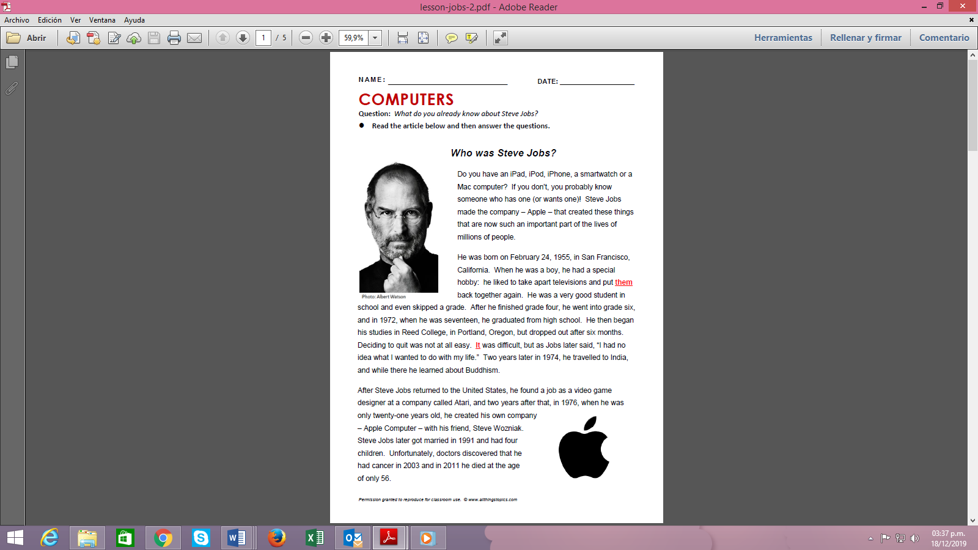 

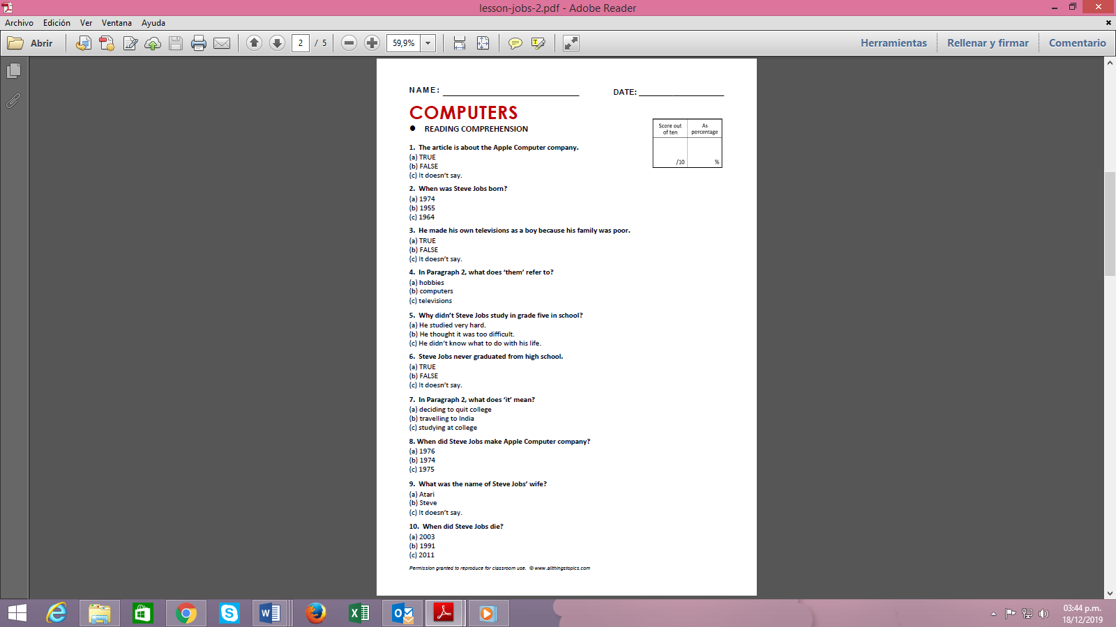

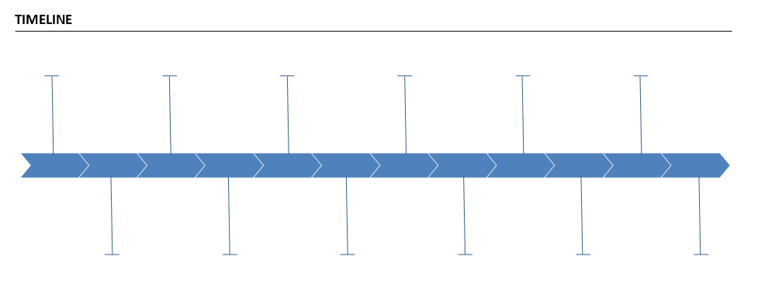



|  |  |  |  |
| --- | --- | --- | --- |
| **Oral Presentation Checklist** | | | |
| The presentation... | Yes | No | Partially |
| is well -organized (it has beginning, a middle and an end) |  |  |  |
| ´s sentences are well connected. ( use of connectors) |  |  |  |
| timeline has a logical sequence of events |  |  |  |
| has resources to support it. |  |  |  |
| has clear sentences. |  |  |  |
| fulfills the information asked in the task. |  |  |  |

|  |  |  |  |
| --- | --- | --- | --- |
| **Oral Presentation Checklist** | | | |
| The presentation... | Yes | No | Partially |
| is well -organized (it has beginning, a middle and an end) |  |  |  |
| ´s sentences are well connected. (use of connectors) |  |  |  |
| timeline has a logical sequence of events |  |  |  |
| has resources to support it. |  |  |  |
| has clear sentences. |  |  |  |
| fulfills the information asked in the task. |  |  |  |

**Didactic Planning**

**Week # 2**

|  |  |  |  |  |  |  |  |  |
| --- | --- | --- | --- | --- | --- | --- | --- | --- |
| **Level: 10th** | | | | | **Unit: 6** | | | |
| **Domain:** | | | **Scenario:** What Comes Next? | | | **Theme:** College or Career? | | |
| **Enduring Understanding**: Every day people are faced with choices - some big, some small - and the way people react to those choices shape their future.  **Essential Question:** How do decisions we make today change our lives tomorrow? | | | | | | | | |
| **New Citizenship:**     |  | | --- | | **Dimensions** | | **1.** **Ways of thinking (√ )** | | **2. Ways of living in the world (√ )** | | **3. Ways of relating with others (√ )** | | **4. Tools for integrating with the world ( √ )** | | | | | | | | | |
| **Learn to Know** | | | **Learn to Do** | | | **Learn to Be and Live in Community** | | |
| **Grammar & Sentence Frames**  Modals   * I **might** stay in my hometown, or go to San José to study. * You **might** schedule your interview in the morning, or you could wait until the afternoon. * You **should** ask yourself exactly what you want from a job or a career. * What **could** the speaker say in answer to the question? * **Should** you write about the paragraph you read?   **Vocabulary**  College or Career?  College, university, career, study abroad, decision, decide, enroll, analytical, artistic, musical, athletic, compassionate, competent | | | **Function**  Giving advice and suggestions about deciding to go to  college or career.  **Discourse Markers**  Initiating and closing a conversation  **Initiating**   * Can I talk to you for a minute? * Excuse me, please. Do you have a minute?   Managing interaction  Interrupting   * Sorry to interrupt you but … * I have a question. * Could I interrupt here?   Closing   * It´s been nice talking to you. See you later. * I´m sorry, I have to go now.   -- Must go | | | **Psychosocial**   * Thinking critically about my own future for setting my goals.   **Sociocultural**   * Being open to give and receive constructive feedback. | | |
| **Assessment Strategies & indicators of learning**  (Diagnostic, formative, summative) | **Learner can** | **Didactic Sequence Mediation** | | | | | | **Time** Total:  200 min (5 lessons) |
| **R.3.** uses texts of various lengths as long as the words used are familiar.  Indicators of Learning  Identifies the topic of texts of various lengths as long as the words used are familiar.  Identifies key words of texts of various lengths as long as the words used are familiar.  Distinguishes the gist of texts of various lengths as long as the words used are familiar.  **R.4.** interprets texts of various lengths as long as the words used are familiar and/ or concern areas of student interest.  Indicators of Learning  Identifies the topic in texts of various lengths as long as the words used are familiar and/ or concern areas of student interest.  Identifies the intended audience in texts of various lengths as long as the words used are familiar and/ or concern areas of student interest.  .  Recognizes the text structure in texts of various lengths as long as the words used are familiar and/ or concern areas of student interest.  Gets main idea in paragraphs or sections of texts of various lengths as long as the words used are familiar and/ or concern areas of student interest.  Extracts supporting details in paragraphs or sections of texts of various lengths as long as the words used are familiar and/ or concern areas of student interest.  .  Analyzes the author’s argument in texts of various lengths as long as the words used are familiar and/ or concern areas of student interest.  Draws conclusions texts of various lengths as long as the words used are familiar and/ or concern areas of student interest.  .  **W.1**. restates a main idea in a few words.  Indicators of Learning  Prewrites a summary with a main idea in a few words dealing with familiar subjects.  Drafts a summary with the main idea in a few words using the appropriate linkers or connecting words.  Revises a summary with the main idea in a few words by checking subject-verb agreement, pronoun and article agreement, sentence sense, text structure, word order and punctuation .  Edits a summary with the main idea in a few words before publishing. | **R.3.** use key words, diagrams, and illustrations to support reading comprehension.  **R.4.**Understand texts of various lengths as long as the words used are familiar and/or concern areas of student interest.  **W.1.** summarize simple text dealing with familiar subjects | **Pre-teaching**  **Routine:** Checking attendance, checking in with Ls, T posts the Essential Question on the board, Can Do’s, and class agenda, etc.  **Participating: Warm up**  T writes on the board two words in big letters and circles them: COLLEGE/ CAREER.  T asks students to mention what comes to their minds when they think about these two words. T writes students opinions on the board under each of them. The students explain the difference between these two concepts with their own words, by doing a short research about the terms.  **Engaging:**  T mentions different dictionary definitions for college and career. Ls read them and point key words in the definitions.  **A career** is all about building up skills through various employment opportunities, giving you the ability to move on to higher paying and more prestigious ones. Careers provide a foundation of experiences that help fuel your professional life for many years. Careers are more long-term and are about learning, gaining experience, building connections, and putting yourself in the right position for promotions and raises. Also, careers tend to be more salary based, as opposed to hourly based like jobs, and often include benefits such as paid time off and health. <https://www.south.edu/blog/the-difference-between-a-job-and-a-career/>  **College:** A smaller institution that usually offers undergraduate degrees is considered a college. There are even community college and junior colleges that provide students with two-year degrees. Most four-year colleges offer bachelor’s degrees with some also offering associate degrees.  <https://www.collegerank.net/difference-college-university>  **Introducing :**  Teacher explains the use of the three modals by using the images below in the context of college and careers. Teacher models sentences such as:   * + I **might** stay in my hometown, or go to San José to study.   + You **might** schedule your interview in the morning, or you could wait until the afternoon.   + You **should** ask yourself exactly what you want from a job or a career.   + What **could** the speaker say in answer to the question?   + **Should** you write about the paragraph you read?     cid:caa0f150-d6b2-4305-9ef0-657beca63b59  cid:494229c3-af24-47e6-911b-007ad3e99666  cid:e2e7ea75-3efd-4115-8c50-1bd0d167a64e  Teacher shows learners a list of highly demanded technical careers from CINDE, a list of soft skills needed for these careers and the English level required. Based on all the information learners will go over them and fill out the chart below with the required information. See the example below.     |  |  |  | | --- | --- | --- | | Technical career | Soft skills required | English Level | | Quality Inspector |  |  | |  |  |  | |  |  |  | |  |  |  | |  |  |  | |  |  |  | |  |  |  |   Finally, learners share and discuss their answers with the teacher and the rest of the group.  **Pre-reading**  Learners work in groups of three and discuss the following questions:  1- Have you already made up your mind about going to college?  2- If yes, what factors should you consider to make your career choice?  **Reading for the first time**  Teacher gives students a couple of minutes to scan the reading by using their phones in groups.  <https://www.thebalancecareers.com/should-you-go-to-college-525564>  Then she asks some students to mention what the article is about and which of the reasons given they consider most important and why.  **Pair/Group feedback**  Students share their answers about the previous exercise in small groups.  **Reading for the second time**   1. Learners match the keywords with their meanings.  |  |  |  |  | | --- | --- | --- | --- | | **Keyword** | | **Meaning** | | | 1. | pursue | It can be an associate's, bachelor's, master's, or even a doctorate. It can take anywhere from two to four years or longer to get a certificate. | ( ) | | 2. | degree | a job or profession | ( ) | | 3. | aptitude | An institution of higher education created to educate and grant degrees; often a part of a university. | ( ) | | 4. | skills | Specialization in a particular subject or field at college or university. | ( ) | | 5. | majors | An act of selecting or making a decision when faced with two or more possibilities. | ( ) | | 6. | choice | The ability to use one's knowledge effectively and readily in execution or performance. A learned power of doing something competently. | ( ) | | 7. | college | Capability; ability; innate or acquired capacity for something, talent. | ( ) | | 8. | occupation | To find or employ measures to obtain or accomplish something. | ( ) |  1. Answer the following questions based on the reading: Should I go to college? 2. Who is the reading intended to? 3. What is the main topic of the reading? 4. When is it recommended to look for this type of reading?   **Post-reading**  In small groups, students discuss some aspects they consider important when choosing a university to attend. Then, they will share their answers with their classmates.  **Pre-reading**  Ls work in groups to brainstorm ideas about how to make the right career choice.  **Reading for the first time**  Learners read the articleentitled **Making the Right Career Move.** <https://www.mindtools.com/pages/article/newCDV_73.htm> Learners read the article for 30 seconds and answer the following questions:   1. What is the article about? 2. Who is the intended audience?   **Pair/Group feedback**  Students share their answers in small groups.  **Reading for the second time**   1. Go over the text and check (√) the structure it has.  |  |  | | --- | --- | | **Text Structures** |  | | sequence/process |  | | description |  | | time order/chronology |  | | proposition/support |  | | compare/contrast |  | | problem/solution |  | | cause/effect |  |  1. Get the main idea of the paragraphs of Job Analysis and Analysis of Satisfaction Criteria   and write it down next to each circle.   1. T asks learners to number the paragraphs, then, highlight supporting details from each paragraph and after that, complete the following chart by using supporting details.  |  |  | | --- | --- | | **Paragraph number** | **Supporting details per paragraph** | |  |  | |  |  | |  |  | |  |  |      1. What is the author’s position in regards Making the Right Career Move? 2. What conclusions can you take from the article?   **Post-reading**  T asks learners to work in groups and comment on the following situation.  **You are offered two different positions and you have to decide which one you want. So, how do you choose the right one for you? Go over the article again and use the information to justify your answer.**  **Pre-writing**  T asks learners to watch a video and take notes about it. After watching the video Ls create a graphic organizer about useful tips to get organized for college. **HOW TO GET ORGANIZED FOR COLLEGE | How To Prepare For College** <https://www.youtube.com/watch?v=pkqibzvUehk> **Drafting**  Learners write an- eight sentence summary about useful tips to get organized for college by using the notes and information from the graphic organizer and the video.  **Revising**  Learners check their sentences, and the teacher makes a quick check of their work by using the following chart.       |  |  |  |  | | --- | --- | --- | --- | | The summary… | Yes | No | Partially | | has the form of a paragraph. |  |  |  | | begins with an introductory sentence that states the text’s title, author and main point |  |  |  | | has two or three sentences that describes the ending. |  |  |  | | contains only the ideas of the original text. |  |  |  | | ´s sentences are well connected. (use of connectors). |  |  |  | | is well capitalized. |  |  |  | | ‘s verbs match with the subject. |  |  |  | | is indented. |  |  |  | | fulfills the information asked in the task. |  |  |  |   **Editing**  Learners correct any mistake found during peer correction and add the suggestions given by his/her teacher.    **Publishing**  Ls get in groups of 3 and read aloud their eight sentence summaries. | | | | | |  |
| **Integrated Mini-Project** | | | | | | | | **Time** |
| Allow time for the Mini-Project each week. NOTE: All phases of the Integrated Mini-Project should be opportunities for Ls to practice English, not just those related to presentation.  **Participating to negotiate:** (5 or 10 minutes in week 1 or 2) Students answer the following questions about choosing a career:   1. What **would** you like to study? 2. Where **could** you study that career? 3. Why did you choose that place and that career?   **Thinking for planning**: (5 or 10 minutes in week 3 and 4) Based on the answers from the previous exercise, students write a short paragraph explaining their choices. They have to use the modals studied. | | | | | | | | Adjust previous times listed above to allow 5 min each week.  Group presentations can be week 5 or 6. |
| **Reflective Teaching** | | | | | | | | |
| What worked well | | | | What didn’t work well | | | How to improve | |
| **Enduring Understanding Reflection**  How well did the learners progress in their understanding of the Enduring Understanding? | | | | | | | | |

|  |
| --- |
| **Week Plan Self-Assessment** |
| At the end of the week, T guides the learners to check their progress using the checklist below. (Can be translated into Spanish if needed to ensure Ls’ understanding.)   |  |  |  |  | | --- | --- | --- | --- | | ***Learner Self-Assessment*** | | | | | ***I can…*** | ***Yes*** | ***In progress*** | ***No*** | | identify the topic of texts of various lengths as long as the words used are familiar. |  |  |  | | identify key words of texts of various lengths as long as the words used are familiar. |  |  |  | | distinguish the gist of texts of various lengths as long as the words used are familiar. |  |  |  | | identify the topic in texts of various lengths as long as the words used are familiar and/ or concern areas of student interest. |  |  |  | | identify the intended audience in texts of various lengths as long as the words used are familiar and/ or concern areas of student interest. |  |  |  | | recognize the text structure in texts of various lengths as long as the words used are familiar and/ or concern areas of student interest. |  |  |  | | get main idea in paragraphs or sections of texts of various lengths as long as the words used are familiar and/ or concern areas of student interest. |  |  |  | | extract supporting details in paragraphs or sections of texts of various lengths as long as the words used are familiar and/ or concern areas of student interest. |  |  |  | | analyze the author’s argument in texts of various lengths as long as the words used are familiar and/ or concern areas of student interest. |  |  |  | | draw conclusions texts of various lengths as long as the words used are familiar and/ or concern areas of student interest. |  |  |  | | prewrite a summary with a main idea in a few words dealing with familiar subjects. |  |  |  | | draft a summary with the main idea in a few words using the appropriate linkers or connecting words. |  |  |  | | revise a summary with the main idea in a few words by checking subject-verb agreement, pronoun and article agreement, sentence sense, text structure, word order and punctuation |  |  |  | | edits a summary with the main idea in a few words before publishing. |  |  |  | |

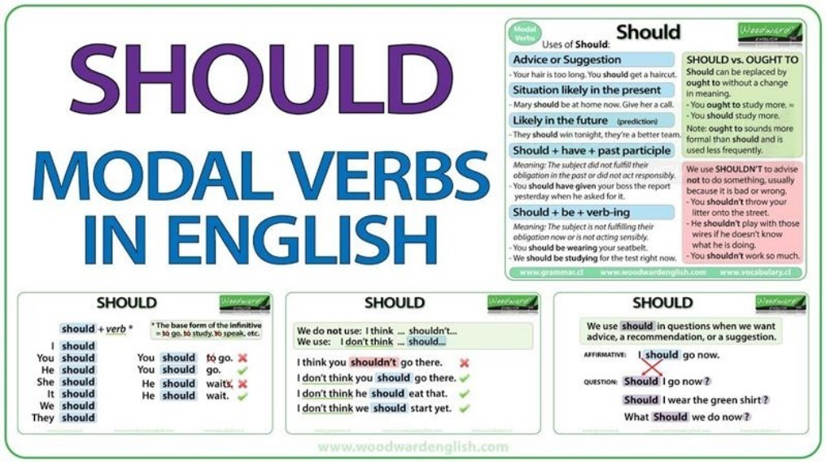**Week 2 Resources**

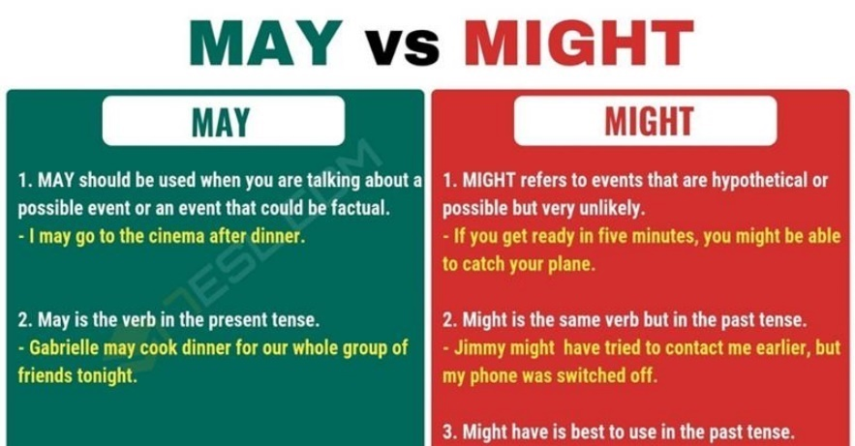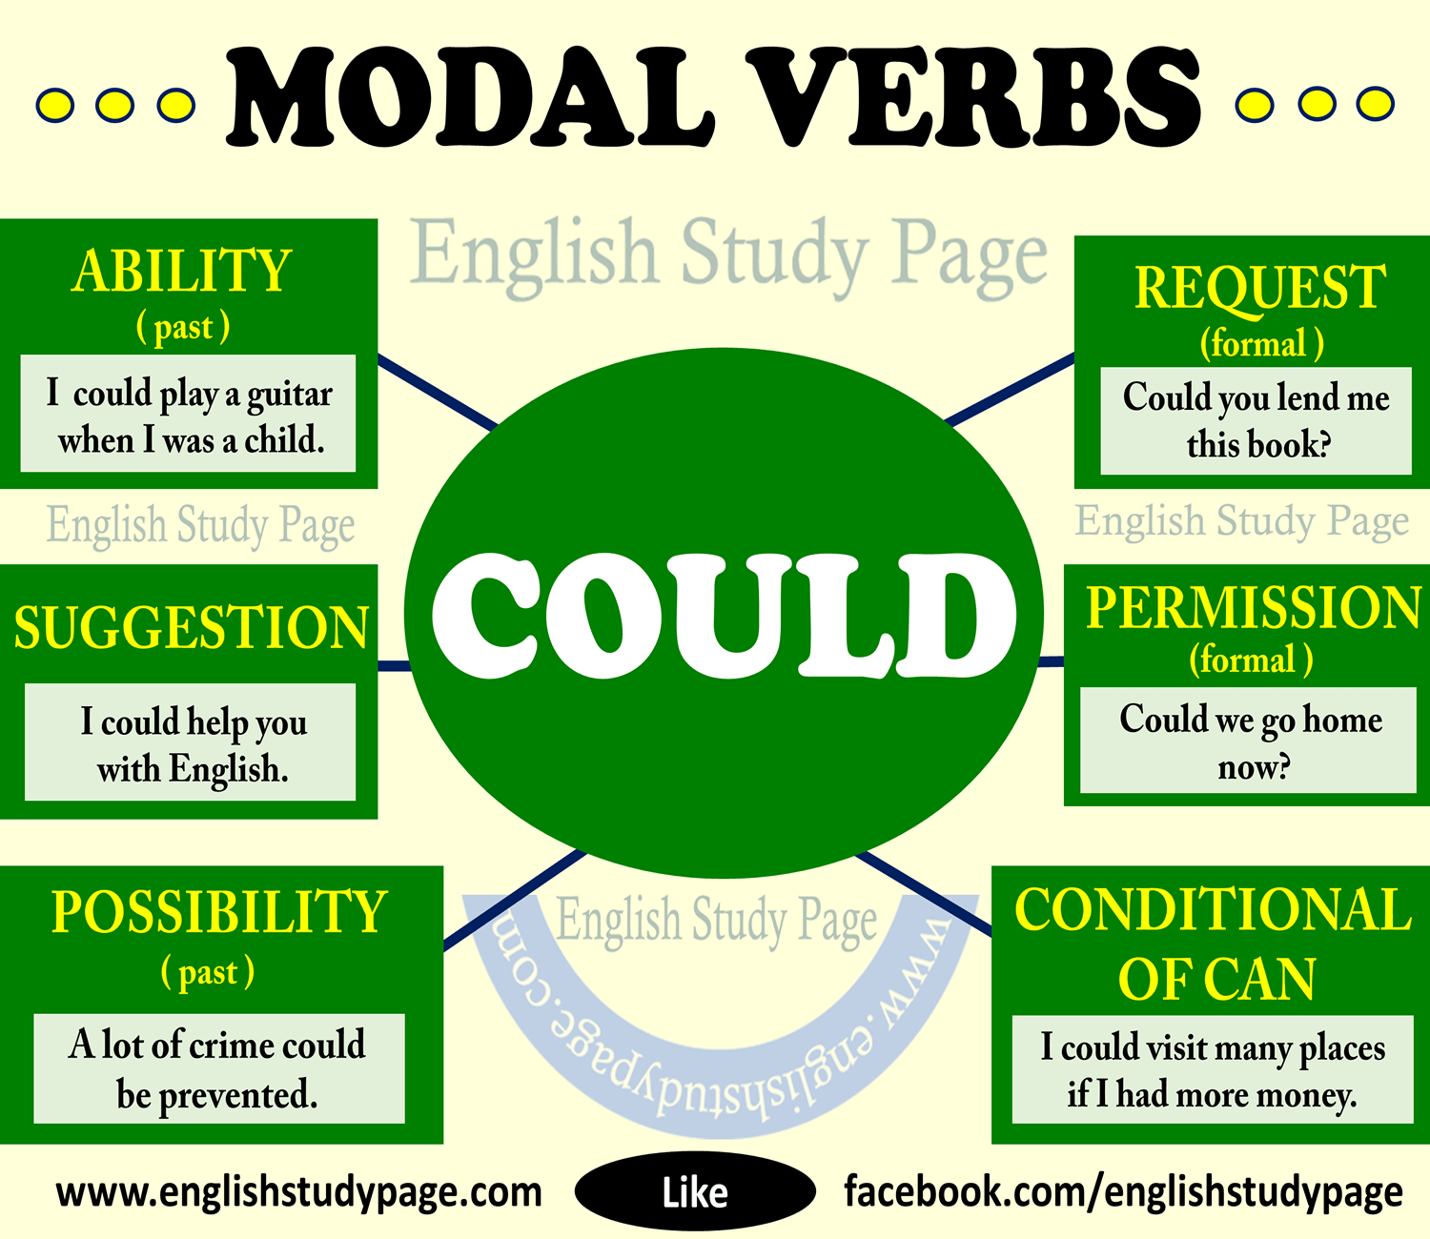

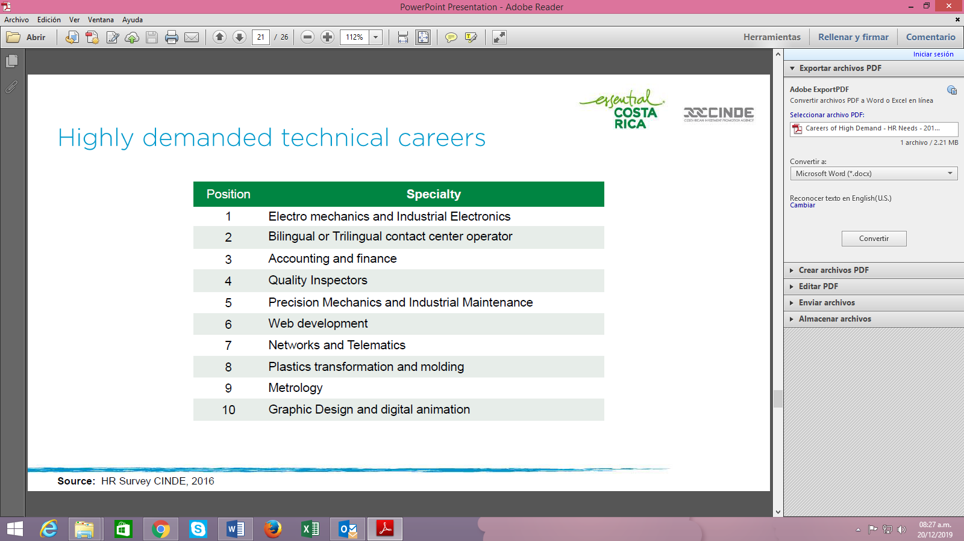

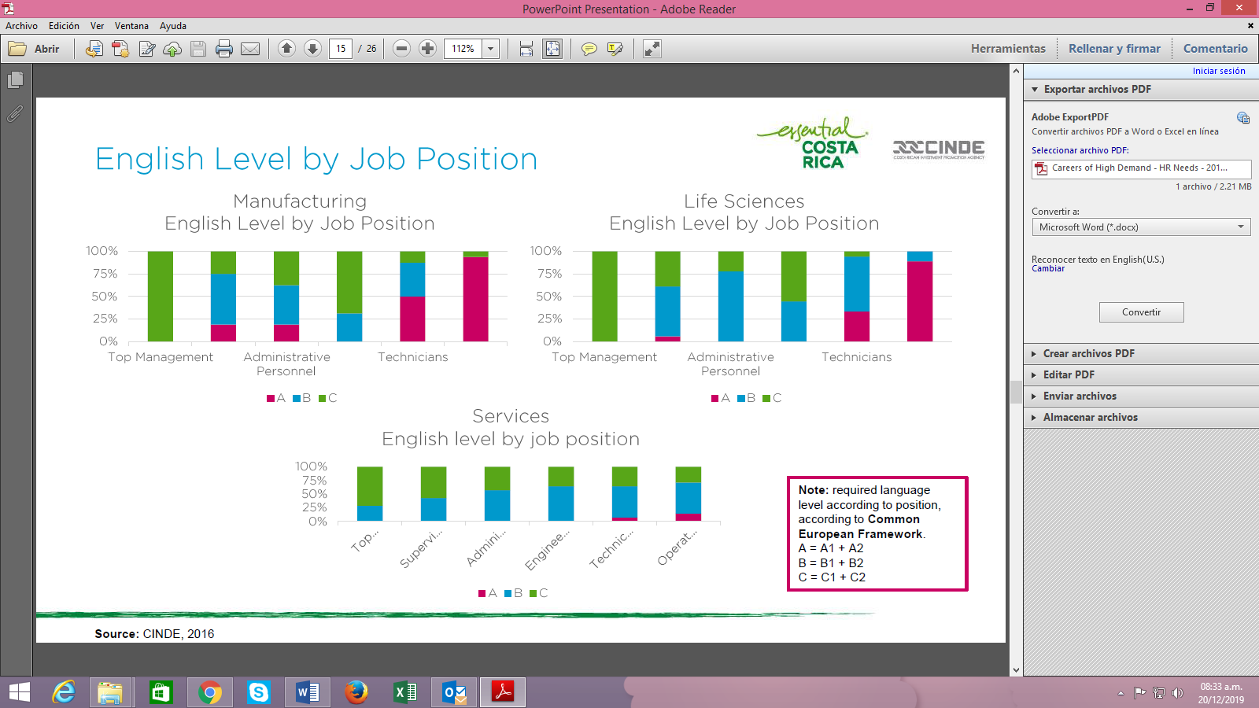

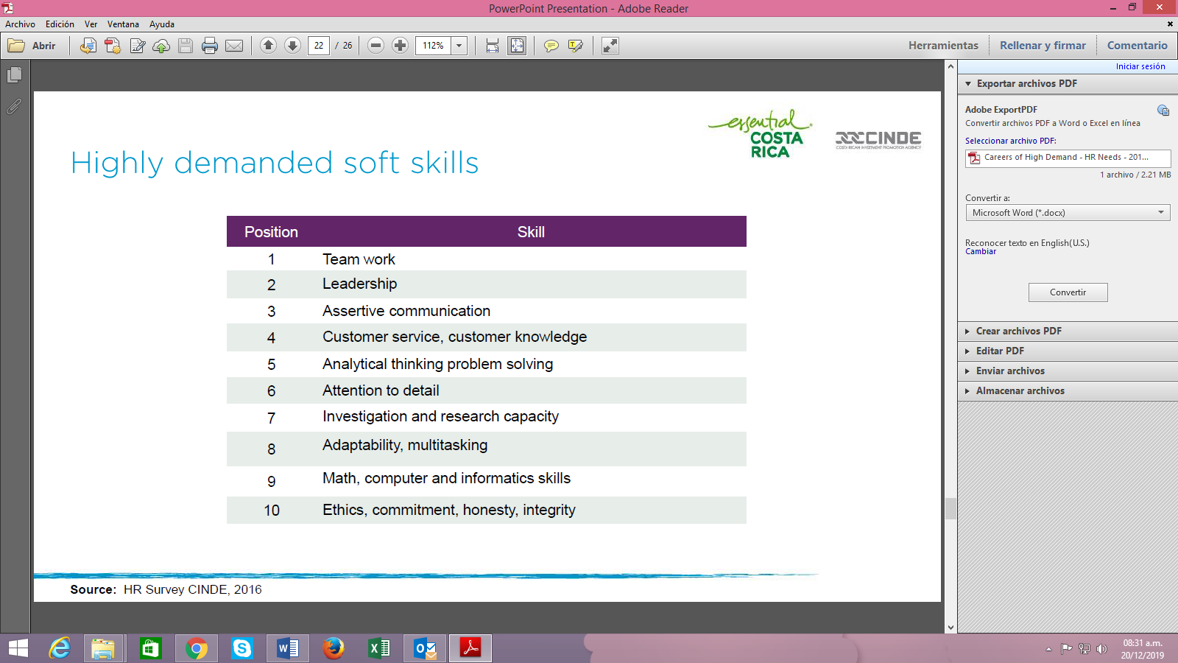

|  |  |  |  |
| --- | --- | --- | --- |
| The summary… | Yes | No | Partially |
| has the form of a paragraph. |  |  |  |
| begins with an introductory sentence that states the text’s title, author and main point |  |  |  |
| has two or three sentences that describes the ending. |  |  |  |
| contains only the ideas of the original text. |  |  |  |
| ´s sentences are well connected. (use of connectors). |  |  |  |
| is well capitalized. |  |  |  |
| ‘s verbs match with the subject. |  |  |  |
| is indented. |  |  |  |
| fulfills the information asked in the task. |  |  |  |

|  |  |  |  |
| --- | --- | --- | --- |
| The summary… | Yes | No | Partially |
| has the form of a paragraph. |  |  |  |
| begins with an introductory sentence that states the text’s title, author and main point |  |  |  |
| has two or three sentences that describes the ending. |  |  |  |
| contains only the ideas of the original text. |  |  |  |
| ´s sentences are well connected. (use of connectors). |  |  |  |
| is well capitalized. |  |  |  |
| ‘s verbs match with the subject. |  |  |  |
| is indented. |  |  |  |
| fulfills the information asked in the task. |  |  |  |

**Didactic Planning**

**Week # 3**

|  |  |  |  |  |  |  |  |  |
| --- | --- | --- | --- | --- | --- | --- | --- | --- |
| **Level: 10th** | | | | | **Unit: 6** | | | |
| **Domain:** | | | **Scenario: What comes next?** | | | **Theme: Study here or abroad** | | |
| **Enduring Understanding**: Everyday people are faced with choices - some big, some small - and the way people react to those choices shape their future.  **Essential Question:** How do decisions we make today change our lives tomorrow? | | | | | | | | |
| **New Citizenship:**     |  | | --- | | **Dimensions** | | **1.** **Ways of thinking (√ )** | | **2. Ways of living in the world (√ )** | | **3. Ways of relating with others (√ )** | | **4. Tools for integrating with the world ( √ )** | | | | | | | | | |
| **Learn to Know** | | | **Learn to Do** | | | **Learn to Be and Live in Community** | | |
| **Grammar & Sentence Frames**  Present continuous   * **I’m doing** my homework this evening. * **I’m starting** university in January. * **We´re planning** to study in San José next year. * My teacher is **thinking** of taking a sabbatical year after next year. * As for now, **I am** only **focusing** my attention on finishing my studies.   **Vocabulary**  Study Here or Abroad?   * **Exchange program, academics,** choose, decision making, goals. | | | **Function**   * Describing experiences, events and opinions about studying locally or abroad.   **Discourse Markers**  Changing the topic   * Anyway…, by the way, there´s something else I wanted to tell you…   Resuming a conversation   * Anyway…, anyway, what I was saying? * What were we talking about? * To get back to what I was saying   Continuing   * Anyway….   So, as I was saying, Well… | | | **Psychosocial**   * Thinking critically about my own future for setting my goals.   **Sociocultural**   * Showing interest and respect for other´s life and feelings with a non-judgmental attitude. | | |
| **Assessment Strategies & indicators of learning**  (Diagnostic, formative, summative) | **Learner can** | **Didactic Sequence Mediation** | | | | | | **Time** Total:  200 min (5 lessons) |
| **SI.1**. interviews others if the questions have been prepared beforehand.  Indicators of Learning  Prepares questions for an interview about studying in Costa Rica or abroad.  Exchanges personal experiences, feelings, opinions, and reactions about studying in Costa Rica or abroad in an interview.  **SP.2.** expresses and asks for others´ opinions and needs.    Indicators of Learning  Plans the language, content and resources to express opinions about studying in Costa Rica or abroad.  Makes sentences to express opinions about studying in Costa Rica or abroad.  Expresses ideas to give opinions about studying in Costa Rica or abroad.  Asks for other’s opinions about studying in Costa Rica or abroad.  **SI.2.** starts, sustains and closes a conversational exchange with a peer in the classroom when the topic is familiar.  Indicators of Learning  Starts the simple face-to-face conversation with a greeting.  Keeps a face-to-face conversation going about studying in Costa Rica or abroad.  Continues with the conversation about studying in Costa Rica or abroad by checking understanding from the speaker's point of view or listener's point of view.  Asks for agreement and disagreement in given statements about studying in Costa Rica or abroad  Answers questions about studying in Costa Rica.  Closes the conversation about studying in Costa Rica or abroad. | **SI.1**. interview others if the questions have been prepared beforehand. Sometimes, can pose a further question without having to pause very long to formulate the question.  **SP.2.** express and ask for others´ opinions and needs on familiar subjects.  **SI.2.** sustain a conversational exchange with a peer in the classroom when the topic is familiar, though there may be some difficulty in understanding and being understood from time to time. | **Pre-teaching**  **Routine:** Checking attendance, checking in with Ls, T posts the Essential Question on the board, Can Do’s, and class agenda, etc.  **Participating: Warm up**  Teacher provides a list of verbs related to studying for learners to classify them into different categories.   |  |  | | --- | --- | | Word bank:  drop out / find out / give up / shape up/ take up/go over /apply/ hand in / sign up /submit / put off | | | stop studying |  | | study methods |  | | exams |  | | document |  |     **Engaging: Activation of prior knowledge**  The teacher divides the class into four groups; each group will fill the chart about with what they already know, what they want to know and at the end of the unit what they have learnt about study here or abroad.    **Introducing**  -Students watch a video about the present continuous. <https://www.youtube.com/watch?v=Dl8g2pZ82ME>  -Teacher reminds learners how and when to use the present continuous with some examples from the unit. Besides, teacher explains some grammar rules about the ING ending.  Present continuous   * **I’m doing** my homework this evening. * **I’m starting** university in January. * **We´re planning** to study in San José next year. * My teacher is **thinking** of taking a sabbatical year after next year. * As for now, **I am** only **focusing** my attention on finishing my studies.   **Planning**  **Task:** A learner from Costa Rica wants to study abroad, he /she surfs the university site to get as much information as he/she can. However, he/she still has some questions. He/she decided to ask some questions to a representative of the Academic Administration Department from the university about how to apply, housing, courses, visas, payment options, schedules, security, what to do in case of emergency, how to get the student ID, student lounge, health status, vaccinations, English courses and so forth.  Learners write a list of questions related to how to apply, paperwork, housing, courses, visas, payment options, scholarships, schedules, security, what to do in case of emergency, how to get the student id, student lounge, health status, vaccinations, English courses and other services. They can use the following template to brainstorm additional information and write a set of questions.    **Elaborating**  Before exchanging information, learners work in pairs and write answers for the questions they prepared before.  **Using**  Once they have found the answers, T asks learners to work in pairs one is a representative of the Academic Administration Department from the university **(A)** and the other one is the student interested in studying abroad **(B). Learner**s stand in two circles (A=Outside – B=inside). Students B change their position by walking one step to their right after finishing the conversation.  Student A  Student B  **Planning**  After surfing the sites of different universities, learners prepare a set of ideas with specific resources (how to apply, paperwork, housing, courses, visas, payments, scholarships, schedules, security, what to do in case of emergency, how to get the student id, student lounge, health, vaccinations, English courses and other services, pictures, application forms, etc.) to express their opinions about different universities and what it takes to study abroad in an oral presentation.  **Organizing**  Ls write sentences using appropriate linkers in which they specify aspects such as how to apply, paperwork, housing, courses, visas, payments, scholarships, schedules, security, what to do in case of emergency, how to get the student id, student lounge, health, vaccinations, English courses and other services. They also organize the resources they want to share with classmates.  **Rehearsing**  Before expressing the information collected and prepared, learners practice with other learners the information they will share during a presentation. They help each other if any doubts about pronunciation or vocabulary.  **Interacting**  Learners share their information and express their personal opinion about studying abroad and what it takes.  After giving their own opinions, learners ask others their opinions about studying abroad.  **Planning**  T asks learners to read the article **Overcoming 21 Challenges of Studying Overseas** <https://www.azent.com/studying-overseas-challenges-advantages/>.  **Elaborating**  Ls need to identify either challenges or advantages. Once L have identified both, they take notes about the ideas they identified before.  **Interacting**  Learners start greeting each other and start the conversation by using phrases such as: Can I talk to you for a minute? / Excuse please. Do you have a minute?  Once, they have greeted each other, one learner starts talking about the advantages of studying abroad. Then, he asks the other learner to talk about the disadvantages.  Then, the other student talks about the disadvantages. It is important to encourage each learner to use strategies or questions to make sure the listener is understanding his/her point. Learners can use the following expressions and questions to foster interaction : Sorry to interrupt you but…/ I have a question. ? Could I interrupt here?  In order to encourage more interaction between learners, they need to ask for agreement or disagreement after listening to each other’s ideas.  After finishing the previous activity, learners expand the conversation or change the topic by talking about studying in Costa Rica. They can ask and answer questions about the advantages or disadvantages of doing so.  Finally, learners close their conversation by using polite forms such as: It’s been nice talking to you. Your ideas were very interesting. / See you later. Love talking to you. / I’m sorry I have to go now. Let’s keep in touch. | | | | | |  |
| **Integrated Mini-Project** | | | | | | | | **Time** |
| Allow time for the Mini-Project each week. NOTE: All phases of the Integrated Mini-Project should be opportunities for Ls to practice English, not just those related to presentation.  POSSIBLE MINI PROJECT FOR THIS UNIT  Topic for Mini Project: Planning My Future  Teacher asks learners to work in pairs  Teacher asks Ls to plan the content for a (3min) video related to their future plans. Ls explore different careers and professions they want to pursue, educational requirements, salary and job opportunities. | | | | | | | | Adjust previous times listed above to allow 5 min each week.  Group presentations can be week 5 or 6. |
| **Reflective Teaching** | | | | | | | | |
| What worked well | | | | What didn’t work well | | | How to improve | |
| **Enduring Understanding Reflection**  How well did the learners progress in their understanding of the Enduring Understanding? | | | | | | | | |

|  |
| --- |
| **Week Plan Self-Assessment** |
| At the end of the week, T guides the learners to check their progress using the checklist below.   |  |  |  |  | | --- | --- | --- | --- | | ***Learner Self-Assessment*** | | | | | ***I can…*** | ***Yes*** | ***In progress*** | ***No*** | | Prepares questions for an interview about studying in Costa Rica or abroad. |  |  |  | | Exchanges personal experiences, feelings, opinions and reactions about studying in Costa Rica or abroad in an interview. |  |  |  | | Plans the language, content and resources to express opinions about studying in Costa Rica or abroad. |  |  |  | | Makes sentences to express opinions about studying in Costa Rica or abroad. |  |  |  | | Expresses ideas to give opinions about studying in Costa Rica or abroad. |  |  |  | | Asks for other’s opinions about studying in Costa Rica or abroad. |  |  |  | | Starts the simple face-to-face conversation with a greeting. |  |  |  | | Keeps a face-to-face conversation going about studying in Costa Rica or abroad by checking understanding from the speaker's point of view or listener's point of view |  |  |  | | Continues with the conversation about studying in Costa Rica or abroad by checking understanding from the speaker's point of view or listener's point of view. |  |  |  | | Asks for agreement and disagreement in given statements about studying in Costa Rica or abroad. |  |  |  | | Answers questions about studying in Costa Rica or abroad. |  |  |  | | Closes the conversation about studying in Costa Rica or abroad |  |  |  | |

**MATERIAL**

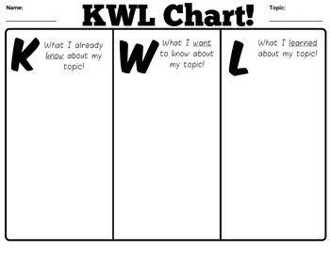



 

**Didactic Planning**

**Week # 4**

|  |  |  |  |  |  |  |
| --- | --- | --- | --- | --- | --- | --- |
| **Level: 10th** | | | | **Unit: 6** | | |
| **Domain:** | | | **Scenario:** What comes next? | | **Theme:** Getting By or Getting Ahead? | |
| **Enduring Understanding**: Everyday people are faced with choices – some big, some small – and the way people react to those choices shape their future.  **Essential Question:** How do decisions we make today change our lives tomorrow? | | | | | | |
| **New Citizenship:**     |  | | --- | | **Dimensions** | | **1.** **Ways of thinking (√ )** | | **2. Ways of living in the world (√ )** | | **3. Ways of relating with others (√ )** | | **4. Tools for integrating with the world ( √ )** | | | | | | | |
| **Learn to Know** | | | **Learn to Do** | | **Learn to Be and Live in Community** | |
| **Grammar & Sentence Frames**  Going to  To talk about plans and intentions   * I’m going to have an interview next week. * He is going to move to the U.S. for an exchange program.   *If* clause   * We won’t be able to get into the university if we don’t pass the bachillerato. * If I graduate from high school, I will try to get a job soon.   Adjectives   * I am a critical and business-oriented person. * I am math-oriented, so I’d like to study something related to that field.   Wh- questions   * **What** are your goals for the future? * **What** do you plan to do after graduating from high school? * **Where** would you like to study? * **Which** profession should I choose?   **Vocabulary**  Getting by or Getting Ahead?  Short- and long- term goals, getting by/ getting ahead, disciplined, down-to-earth, hard-working, responsible, goal-oriented (business-; math-; music, etc.) | | | **Function**  Stating obligation and necessity about getting by or getting ahead in the future.  **Discourse Markers**  Changing the topic   * Anyway…, by the way, there´s something else I wanted to tell you…   Resuming a conversation   * Anyway…, anyway, what I was saying? * What were we talking about? * To get back to what I was saying   Continuing   * Anyway….   So, as I was saying, Well… | | **Psychosocial**   * Managing own emotions and self-control when interacting with others.   **Sociocultural**   * Showing interest and respect for other´s life and feelings with a non-judgmental attitude. | |
| **Assessment Strategies & indicators of learning**  (Diagnostic, formative, summative) | **Learner can** | **Didactic Sequence Mediation** | | | | **Time** Total:  200 min (5 lessons) |
| **SP.3.** explains and justifies points of view, assumptions, and plans, briefly.  Indicators of Learning  Plans the language, content and resources to explain points of view, justifying assumptions and plans, briefly about studying in Costa Rica or abroad in a well-organized presentation.  Makes sentences to explain points of view, justifying assumptions and plans, briefly about studying in Costa Rica or abroad with the appropriate linkers or connecting words in a well-organized presentation.  Expresses ideas to explain points of view, justifying assumptions and plans, briefly about studying in Costa Rica or abroad in a well-organized presentation.  **W.2**.writes a one-page report based on real events.  Indicators of Learning  Prewrites ideas based on a real event for a one-page report about graduating from school, getting interviewed or choosing a career.  Drafts the report based on a real event for a one-page report about graduating from school, getting interviewed or choosing a career.  Revises the report based on a real event for a one-page report about graduating from school, getting interviewed or choosing a career.by checking subject-verb agreement, pronoun and article agreement, sentence sense, text structure, word order and punctuation and content.  Edits the report before publishing. | **SP.3.** explain and justify points of view, assumptions, and future plans, briefly.  **W.2**. write a report on an important personal experience (e.g., graduating from school, getting interviewed, and choosing a career) and check written summaries and reports to look for mistakes (subject-verb agreement, pronoun and article agreement, capitalization, using commas, sentence sense, word order, text structure, concrete ideas). | **Pre-teaching**  **Routine:** Checking attendance, checking in with Ls, T posts the Essential Question on the board, Can Do’s, and class agenda, etc.  **Participating: Warm up** **Brown Bagging It (game)**  Arrange students in a circle and give one person an empty bag. That person must look into the bag and think of an object that would fit inside it. He then asks the person to his right, “Why do you have a ________ in your bag?” That person then answers using be going to and his plan for the object.  For example, an exchange might go like this. “Why do you have a kitten in your bag?”  “I am going to give it to a lonely classmate.” If a person cannot answer a question appropriately or cannot think of a use for the object, he is out of the game and must leave the circle. Continue going around the circle until only one person, the winner, remains.  **Engaging: Activation of prior knowledge**  Teacher shows a mind map before the class starts and she asks learners to provide ideas/vocabulary for each branch. Students get into pairs/groups and the teacher distributes or sends a mind map for each pair/group. Learners complete it with the information required and then answer the following questions:  **Questions:**   1. What do you plan to do after graduating from high school? 2. What are your goals for the future? 3. Where would you like to study? 4. What profession should I choose?     Several pictures allow students to have several discussions. If one picture has been distributed to each group, pictures can rotate after three minutes.  **Introducing**   1. T plays the following video to review the future tense with going to.   <https://www.youtube.com/watch?v=iHug-PjCOng>   1. What qualities do you need to develop to be successful in your future major/ job?   T shows some qualities(adjectives) for learners to join with their definitions.  Adjectives for jobs - English ESL Worksheets for distance learning and  physical classrooms   1. T explains if clauses Type 0 and 1 by using the following images. Then, T models two sentences in the context of the unit.   For example: We will not be able to get into university if we don’t pass the admission test.  If I graduate from high school, I will try to get a job soon.  After that, T asks learners to write 6 sentences using if clauses Type 0 and 1.    **Spoken Production**  **Task:** Antonio and Andrea have great plans for their future. They want to apply for a major that is not offered in our country. They start doing some research about different majors. They are excited; however, they have not considered some challenges they may face studying abroad yet. So, they decided to read different articles and prepare an oral presentation to explain the information found with to the rest of the class.  **Planning**  L read the following article <https://www.topuniversities.com/blog/top-5-challenges-studying-abroad> and list key words, main ideas and find some pictures for the oral presentation.  **Organizing**  Learners go over the words, ideas and pictures to create an outline that will guide their oral presentation about the challenges to study abroad. Then, they start writing sentences including linking words, the appropriate connectors to explain the challenges and organizing their ideas and the material they prepared before. After that, learners make sure their presentation and resources are well-organized and have a logical sequence.  **Rehearsing**  As soon as they finish organizing their ideas and material, learners start practicing what they will explain during the presentation. Teacher walks around and clarifies any questions, doubts or concerns students may have. He/she helps to correct or clarify any grammatical or pronunciation error. Once students have finished, they rehearse their presentation in front of two classmates who will listen and provide recommendations if necessary.  **Producing / Explaining**  Learners give an oral presentation to explain the challenges of studying abroad. After all learners have finished their presentations, T provides positive feedback to motivate them. He/she also lists some aspects regarding the presentation, grammar, vocabulary or any other aspects that can help to improve learners’ presentations.  **Written Production**  **Task**: You have been invited to attend a virtual university admission interview, and you and your classmates are feeling nervous and wondering how to prepare. You surfed the web to find an online article to get informed about tips for university interview success because you decided to write a report to be shared with your classmates.  Read the online article entitled “How to prepare for a university admission interview” <https://www.topuniversities.com/student-info/admissions-advice/how-prepare-university-admission-interview>, and write a one- page report. Include a summary, background information, a body (main point) and a recommendation or conclusion.  **Pre-writing**  Learners brainstorm ideas in an outline to write a report. They complete the following outline to organize their ideas.  Report Outline   1. **Summary** 2. **Background information** 3. **Main Point** 4. **Main Point** 5. **Main Point** 6. **Conclusion**   **Drafting**  Learners write their production that includes a summary, background information, a body (main point) and a recommendation or conclusion.  **Revising**  Then, each learner checks his/her report by using the following editing checklist. After that learner shares his/her report with another classmate, and he/she checks it using the same checklist.   |  |  |  |  |  |  |  | | --- | --- | --- | --- | --- | --- | --- | | **Editing Checklist** | **My revision** | | | **My classmate’s revision** | | | | **The report …** | **Yes** | **No** | **Partially** | **Yes** | **No** | **Partially** | | is well- capitalized. |  |  |  |  |  |  | | ‘s verbs match with the subject. |  |  |  |  |  |  | | has a summary |  |  |  |  |  |  | | Has background information |  |  |  |  |  |  | | has a main body of well -sequenced ideas |  |  |  |  |  |  | | has a recommendation or conclusion. |  |  |  |  |  |  | | is indented. |  |  |  |  |  |  | | has clear sentences. |  |  |  |  |  |  | | fulfills with the information asked in the task. |  |  |  |  |  |  | | has punctuation marks correctly used. |  |  |  |  |  |  |   **Editing & Publishing**  Considering their classmates’ feedback and his/her self-assessment, learners correct and modify their report. Teacher also monitors students and helps them in the editing process before publishing. | | | |  |

|  |  |  |  |
| --- | --- | --- | --- |
| **Integrated Mini-Project** | | | **Time** |
| Allow time for the Mini-Project each week. NOTE: All phases of the Integrated Mini-Project should be opportunities for Ls to practice English, not just those related to presentation.  3. Ls film the video. | | | Adjust previous times listed above to allow 5 min each week.  Group presentations can be week 5 or 6. |
| **Reflective Teaching** | | | |
| What worked well | What didn’t work well | How to improve | |
| **Enduring Understanding Reflection**  How well did the learners progress in their understanding of the Enduring Understanding? | | | |

|  |
| --- |
| **Week Plan Self-Assessment** |
| At the end of the week, T guides the learners to check their progress using the checklist below. (Can be translated into Spanish if needed to ensure Ls’ understanding.)   |  |  |  |  | | --- | --- | --- | --- | | ***Learner Self-Assessment*** | | | | | ***I can…*** | ***Yes*** | ***In progress*** | ***No*** | | plan the language, content and resources to explain points of view, justifying assumptions and plans, briefly about studying in Costa Rica or abroad in a well-organized presentation. |  |  |  | | make sentences to explain points of view, justifying assumptions and plans, briefly about studying in Costa Rica or abroad with the appropriate linkers or connecting words in a well-organized presentation. |  |  |  | | express ideas to explain points of view, justifying assumptions and plans, briefly about studying in Costa Rica or abroad in a well-organized presentation. |  |  |  | | prewrite ideas based on a real event for a one-page report about graduating from school, getting interviewed or choosing a career. |  |  |  | | draft the report based on a real event for a one-page report about graduating from school, getting interviewed or choosing a career. |  |  |  | | revise the report based on a real event for a one-page report about graduating from school, getting interviewed or choosing a career.by checking subject-verb agreement, pronoun and article agreement, sentence sense, text structure, word order and punctuation and content. |  |  |  | | edit the report before publishing. |  |  |  | |

**Materials**



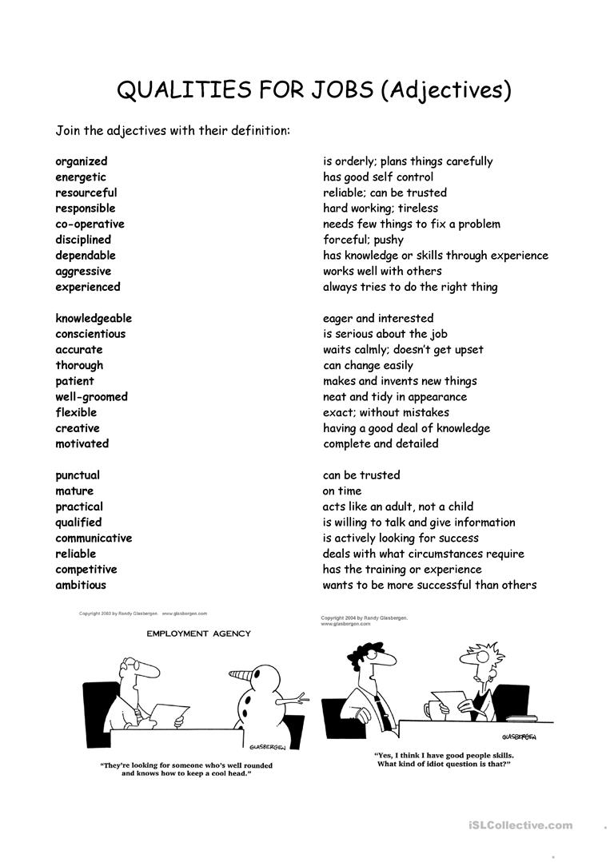 

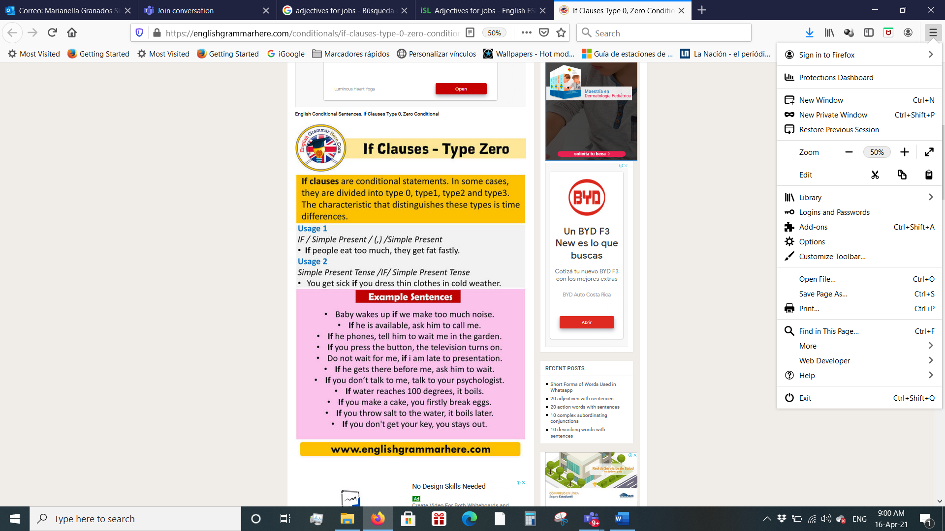 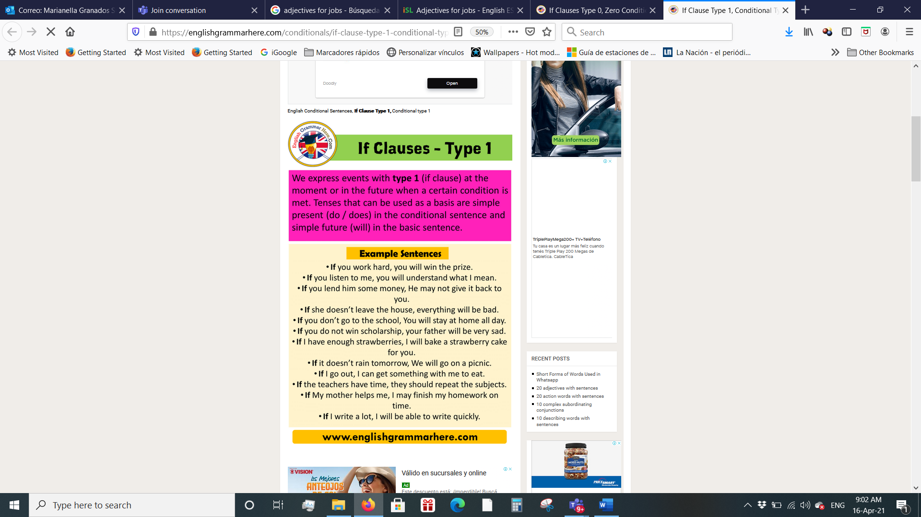

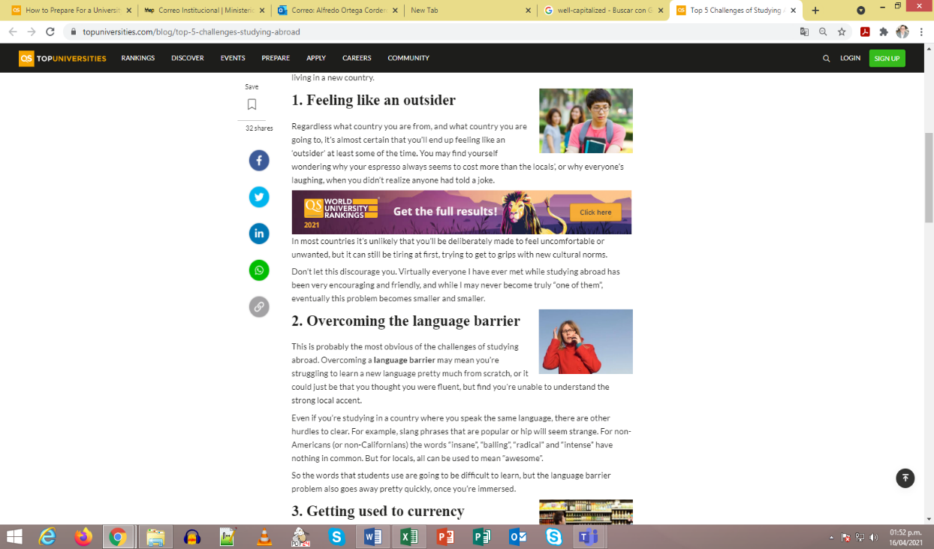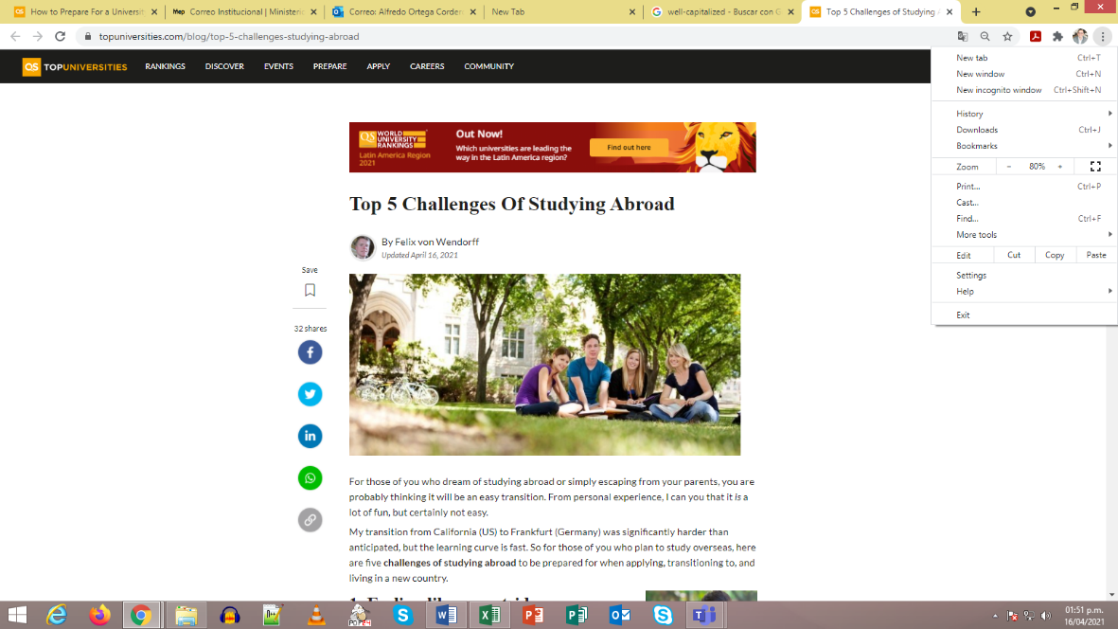

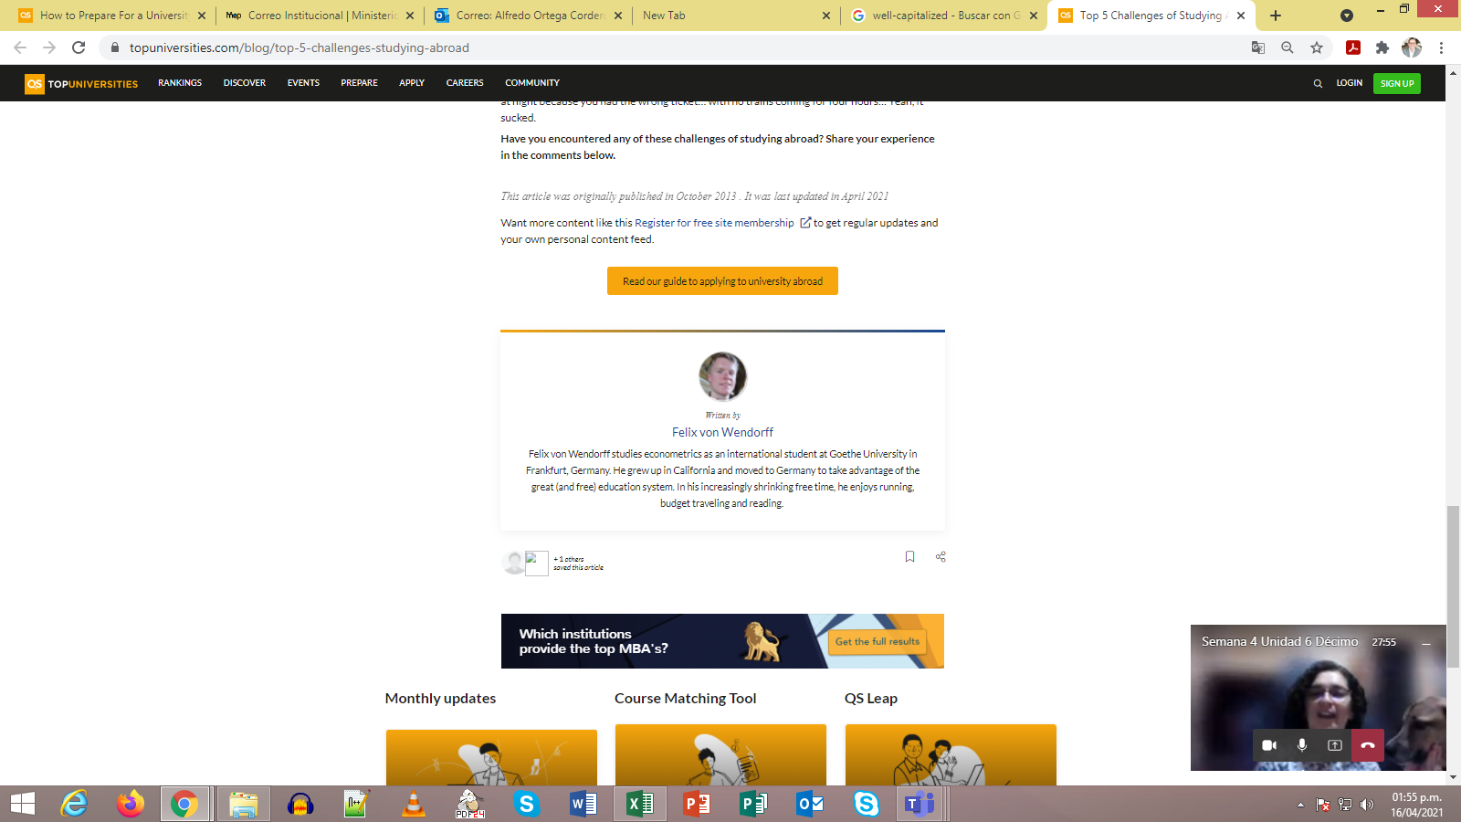

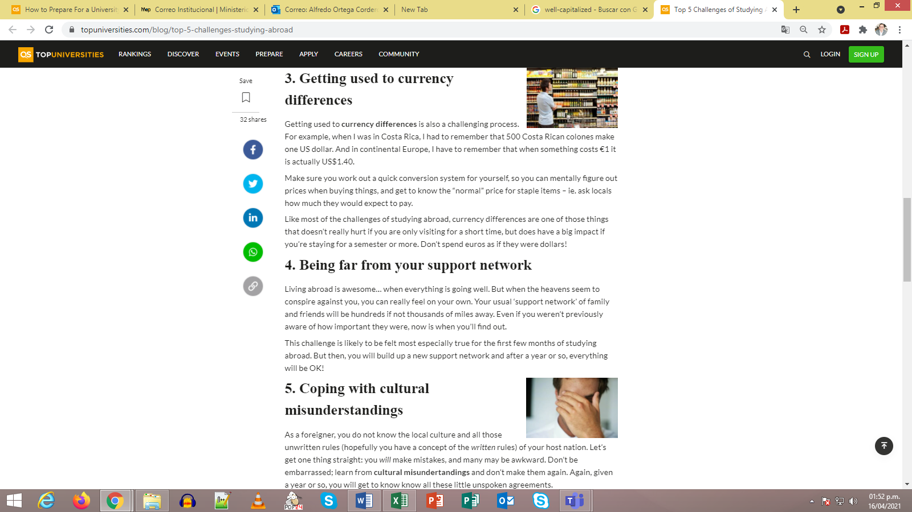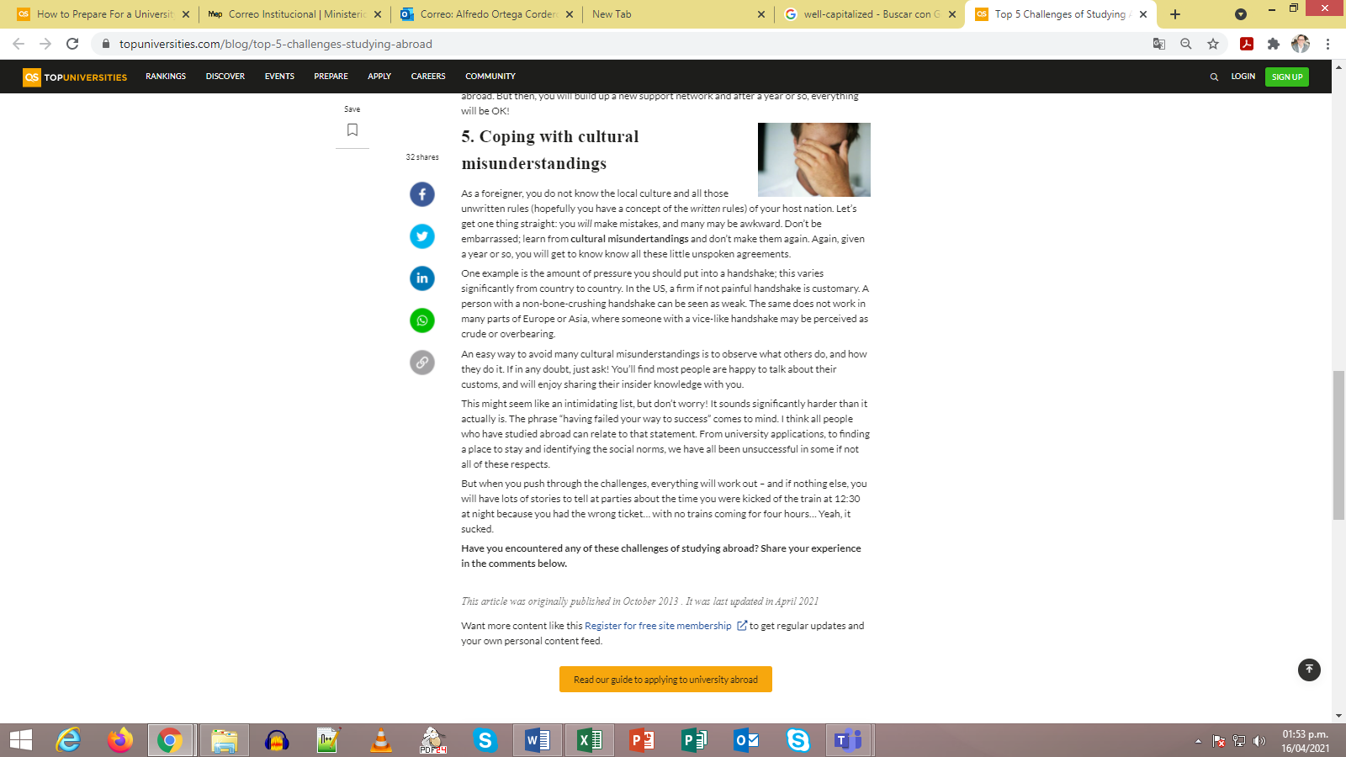

<https://www.topuniversities.com/blog/top-5-challenges-studying-abroad>

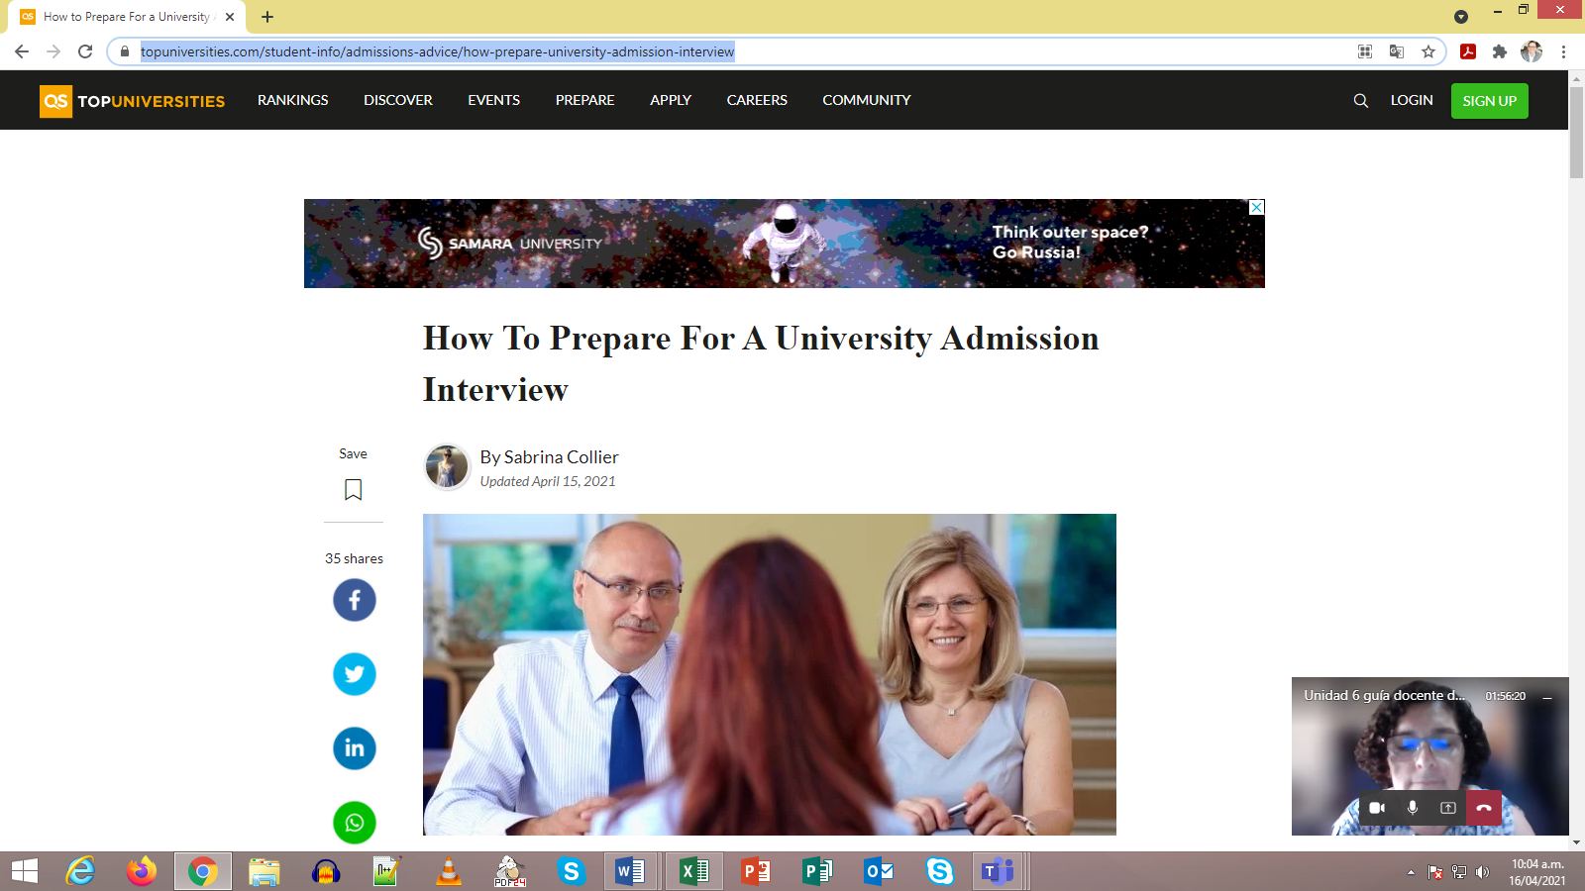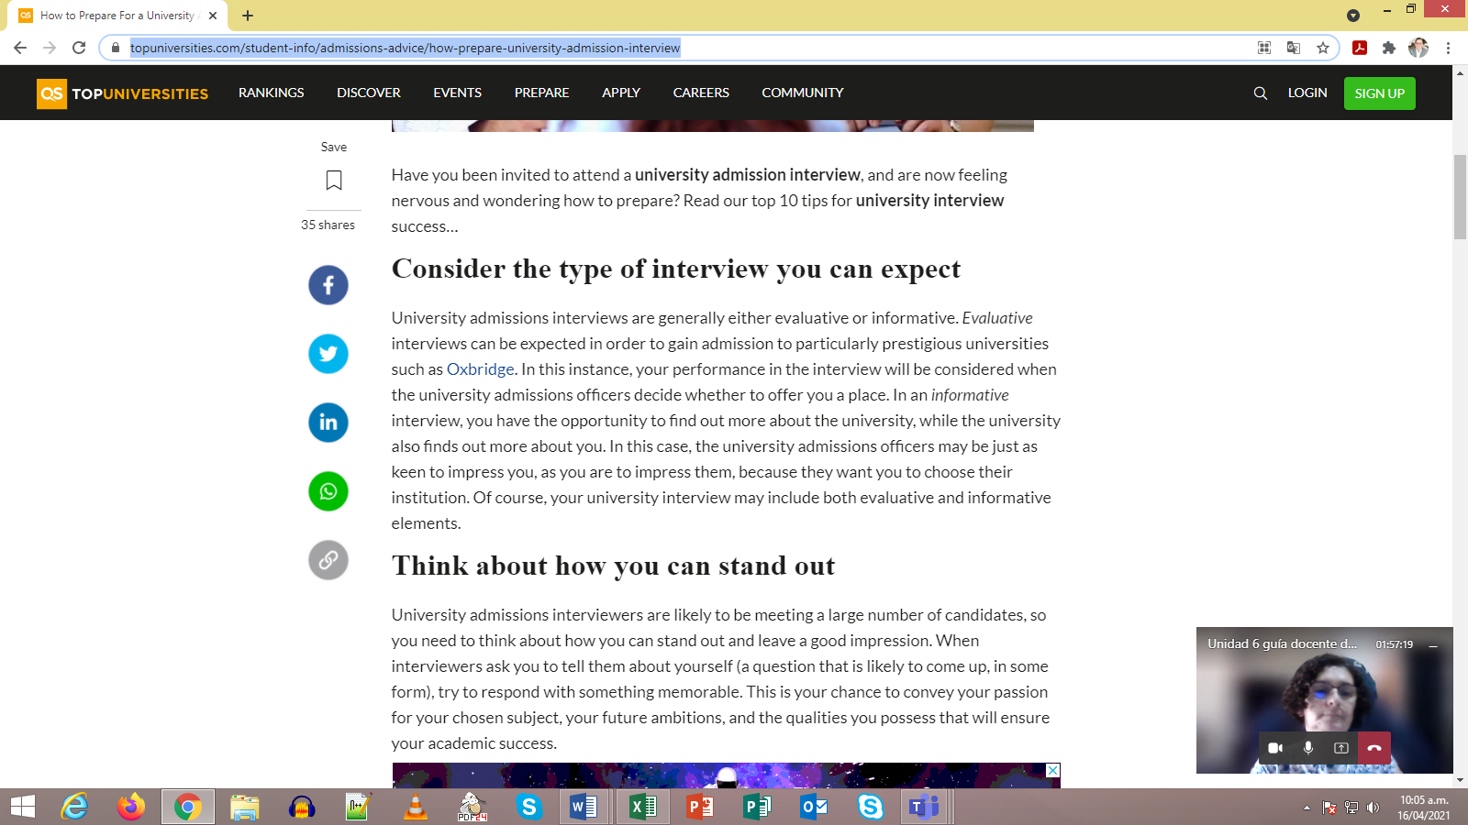

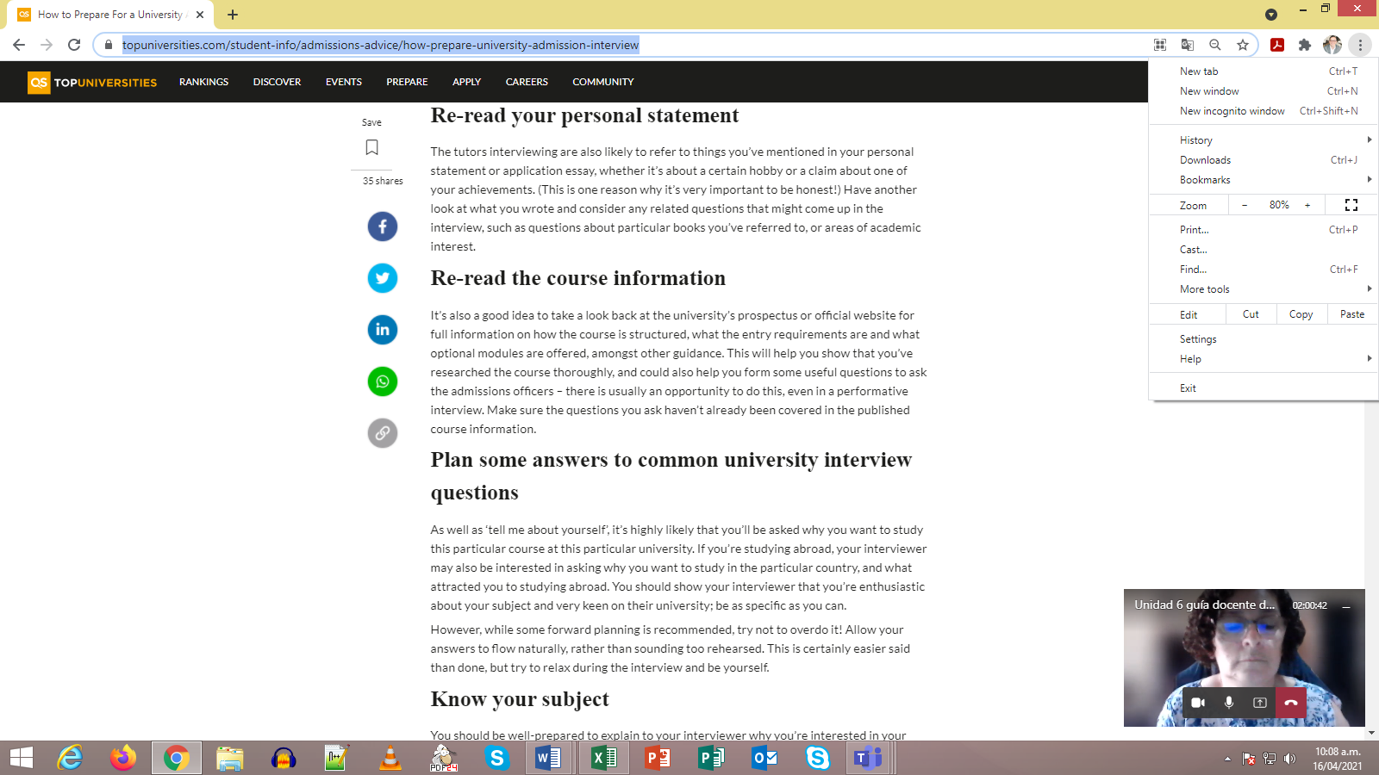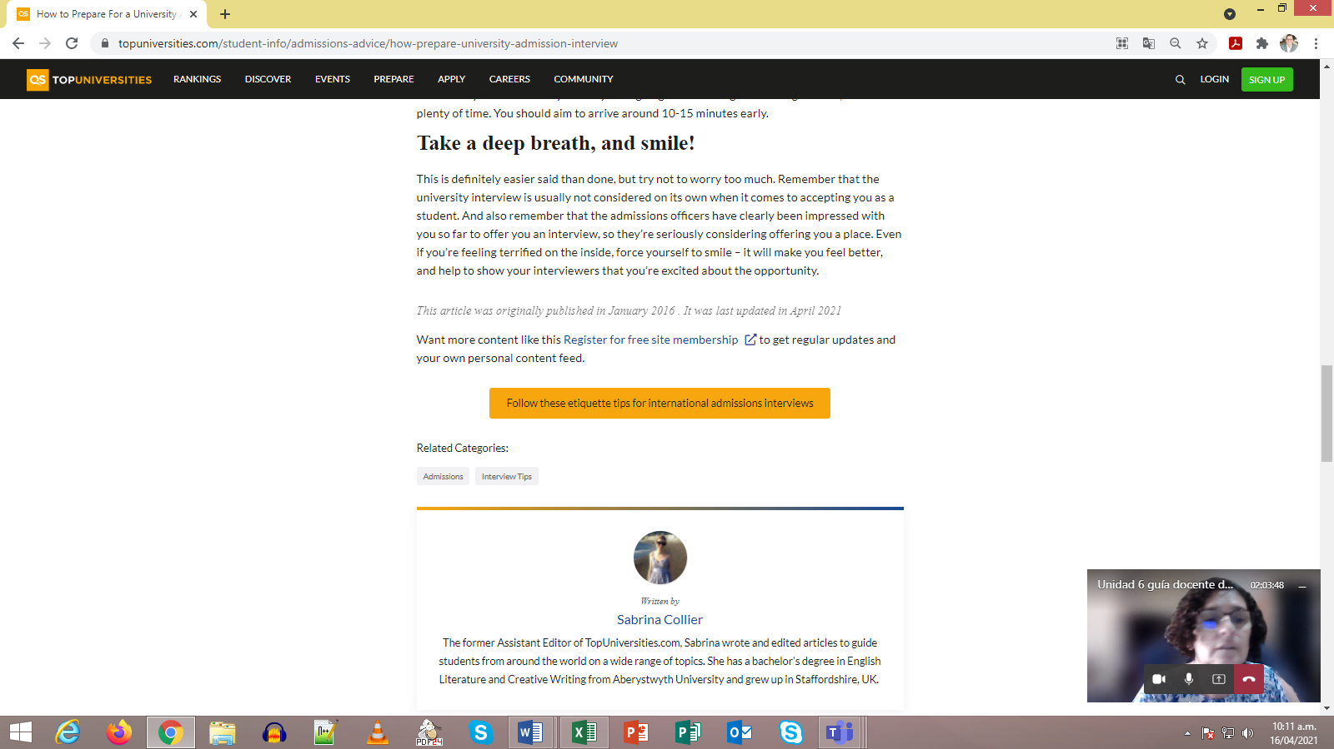

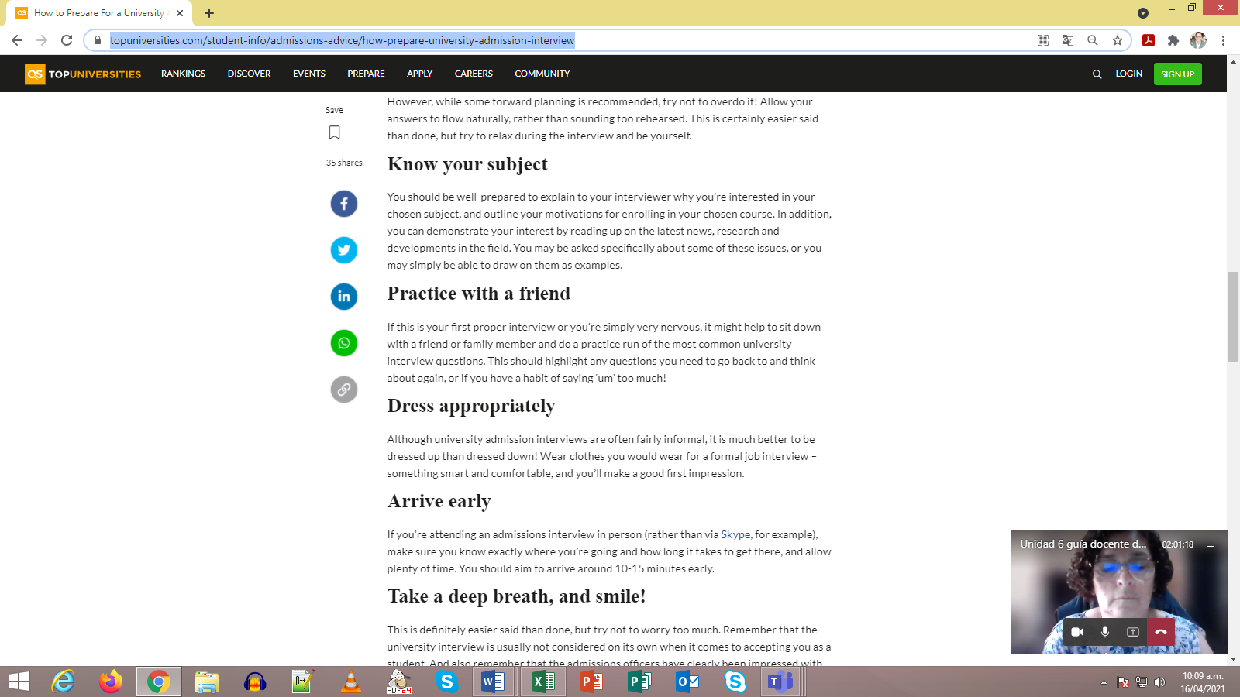

**Source: https://www.topuniversities.com/student-info/admissions-advice/how-prepare-university-admission-i**

|  |  |  |  |  |  |  |
| --- | --- | --- | --- | --- | --- | --- |
| **Editing Checklist** | **My revision** | | | **My classmate’s revision** | | |
| **The report …** | **Yes** | **No** | **Partially** | **Yes** | **No** | **Partially** |
| is well- capitalized. |  |  |  |  |  |  |
| ‘s verbs match with the subject. |  |  |  |  |  |  |
| has a summary |  |  |  |  |  |  |
| Has background information |  |  |  |  |  |  |
| has a main body of well -sequenced ideas |  |  |  |  |  |  |
| has a recommendation or conclusion. |  |  |  |  |  |  |
| is indented. |  |  |  |  |  |  |
| has clear sentences. |  |  |  |  |  |  |
| fulfills with the information asked in the task. |  |  |  |  |  |  |
| has punctuation marks correctly used. |  |  |  |  |  |  |

**Weeks 5 and 6**

**Review and Integrated Mini-Project**

|  |  |  |  |  |  |  |
| --- | --- | --- | --- | --- | --- | --- |
| **Level: 10th** | | | | **Unit: 6** | | |
| **Enduring Understanding**: Everyday people are faced with choices – some big, some small – and the way people react to those choices shape their future.  **Essential Question:** How do decisions we make today change our lives tomorrow? | | | | | | |
| **New Citizenship:**     |  | | --- | | **Dimensions** | | **1.** **Ways of thinking (√ )** | | **2. Ways of living in the world (√ )** | | **3. Ways of relating with others (√ )** | | **4. Tools for integrating with the world ( √ )** | | | | | | | |
| **Learn to Know** | | | **Learn to Do** | | **Learn to Be and Live in Community** | |
| **Grammar & Sentence Frame**   * Did Ls use all sentence frames?   **Vocabulary**   * Did Ls say aloud and write all vocabulary?   **Phonology**   * Did Ls recognize, articulate and produce phonological sounds? | | | **Function**   * Did Ls use all functions?   **Discourse Markers**   * Did Ls practice connecting words: and, but, because? | | **Psychosocial**   * Did Ls show evidence of … * Being aware and committed to protecting the environment * Appreciating natural wonders   **Sociocultural**   * Did Ls practice idioms and quotes? | |
| **Assessment Strategies & indicators of learning**  (Diagnostic, formative, summative) | **Learner can** | **Didactic Sequence Mediation** | | | | **Time** Total:  120 min (3 lessons) |
| * Did Ls achieve all learning outcomes? | * Can Ls do all tasks? | Referencing notes from formative assessments throughout the weeks, repeat activities to strengthen Ls in weaker areas or select from Optional Activities that follow these plans. | | | | All of week 5 or 6 |
| **Options** | | **Integrated Mini-Project** | | | | **Time** |
| **Possible projects:**   * Essay about future plans. * A multi-step research Career Research: “Planning my Future”- Gallery Walk (learners explore different careers and professions they want to pursue, complete with educational requirements, salary and job opportunities) | | By allowing time for the Mini-Project each week for participating, thinking, and acting out, learners should now have a chosen project and determined content and strategies. In the presentation week Ls focus on:  **Responding and sharing:** Participating in individual and peer assessment of mini-project.   |  |  |  |  |  | | --- | --- | --- | --- | --- | | ***Integrated Mini-project Self-Assessment*** | | | | | | ***Participating to Negotiate***  I participated by   * sharing my own ideas and interests with my family or classmates * respecting my family or classmates’ opinions, * communicating respectfully * making decisions | | | | | | **A lot**  **5** | **4** | **A little**  **3** | **2** | **Not at all**  **1** | | ***Thinking****:*  I planned by   * looking for information and resources, * thinking of a design for my presentation * interacting with my classmates. * making decisions | | | | | | **A lot**  **5** | **4** | **A little**  **3** | **2** | **Not at all**  **1** | | ***Acting out:***  I acted out by   * reviewing the information * improving my video * correcting the information, * rehearsing and working on pronunciation, intonation, fluency and other aspects, | | | | | | **A lot**  **5** | **4** | **A little**  **3** | **2** | **Not at all**  **1** | | ***Responding and Sharing****:*  I can demonstrate I was well prepared in delivering and sharing the information by   * responsibly delivering the project during the virtual / classroom exchange. * answering questions from the audience respectfully. * self-assessing the final product. | | | | | | **A lot**  **5** | **4** | **A little**  **3** | **2** | **Not at all**  **1** |   Teachers monitor ….   * Did Ls use English during all aspects of Integrated Mini-Project? * How didproject presentations reflect understanding and/or mastery of Can Do statements? * Did Ls put into practice the focus of Learn to Be and Live in Community? * Did the Integrated Mini-Project provide answers to the Essential Question? | | | | All of week 5 or 6 of unit |