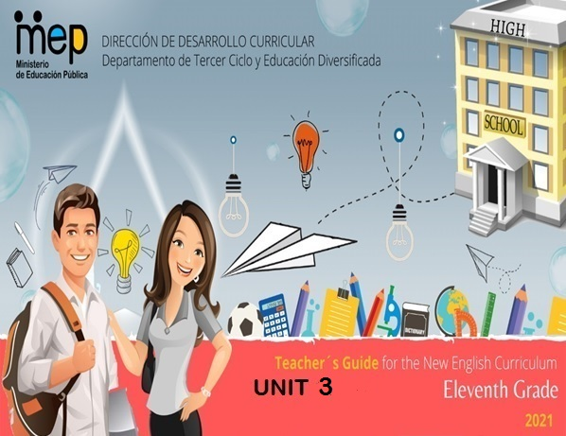
Autoridades

Giselle Cruz Maduro
Ministra de Educación Pública

Melania Brenes Monge
Viceministra Académica de Educación

María Alexandra Ulate Espinoza
Directora de la Dirección de Desarrollo Curricular

Rigoberto Corrales Zúñiga
Jefe del Departamento de Tercer Ciclo y Educación Diversificada

Comisión redactora

Mag. Marianella Granados Sirias,
Asesora Nacional de Inglés, Departamento de Tercer Ciclo y Educación Diversificada

Mag. Alfredo Ortega Cordero,
Asesor Nacional de Inglés, Departamento de Tercer Ciclo y Educación Diversificada

Unidad 3

Livia Gamboa Cordero
Asesora Regional de Inglés, Dirección Regional de Educación San Carlos
Docentes de Inglés de Tercer Ciclo y Educación Diversificada, DRESC
Randall Murillo Benavides, Liceo de Boca Arenal
Karol Vega Villegas, Liceo de Boca Arenal

Juan Carlos Dodero Giusto
Asesor Regional de Inglés, Dirección Regional de Educación Turrialba
Docentes de Inglés de Tercer Ciclo y Educación Diversificada, DRET
Melinda Acuña Sánchez, Liceo Rural Pacayitas
Cristhian Brenes Sánchez, Liceo Rural Grano de Oro
Michael Mora Cordero, Liceo Rural Jak Ksari

Weekly Plans and Materials

Unit 3

Eleventh Grade

Level 11th Unit 3
CEF Level to be Reached B1 Basic User/Independent User
Scenario: The Earth–Our Gift and Our Responsibility
Enduring Understanding |  | Responsible, sustainable and proactive actions have an impact and can positively transform the environment.
Essential Question |  | What are the consequences of our positive actions on changing the environment?
New Citizenship:
Dimensions
1. Ways of thinking (√ )
2. Ways of living in the world (√ )
3. Ways of relating with others (√ )
4. Tools for integrating with the world ( √ )

Assessment and Goals
Week 1  Goals  L.1. understand main ideas/concepts and key points/details of clear standard speech on familiar, everyday subjects related to natural disasters, environmental problems, helping nature, and nonprofit and NGOs.  R.1. understand main idea and supporting details in straightforward factual texts regarding natural disasters, environmental problems, helping nature, and nonprofit and NGOs, well enough to talk about them afterwards. | Week 1  Assessment  L.1. paraphrases main ideas/ concepts and key points.  R.1. summarizes main idea and supporting details. | Week 2  Goals  L.2. understand specific details in clear and organized classroom talks and presentations provided there is some prior knowledge of the topics: natural disasters, environmental problems, helping nature, and nonprofit and NGOs.  R.2. understand most words in narrative and expository text and extract the key ideas from those texts.  SI.1. express feelings and explain the reasons for them in regard to natural disasters, environmental problems, helping nature, and nonprofit and NGOs clearly. | Week 2  Assessment  L.2. extracts specific details and getting the gist.  R.2. interprets most words in narrative and expository texts.  SI.1. expresses feelings and explains the reasons for them in simple face-to-face conversation. | Week 3  Goals  L.3. understand the gist of TV programs on topics of personal interest regarding natural disasters, environmental problems, helping nature, and nonprofit and NGOs when people speak clearly.  SI.2. start, maintain and close simple face-to-face conversation on topics that are familiar or of personal interest regarding natural disasters, environmental problems, helping nature, and nonprofit and NGOs.  W.1. write in simple sentences, an opinion on controversial issues provided regarding natural disasters, environmental problems, helping nature, and nonprofit and NGOs, related to the issue under examination. | Week 3  Assessment  L.3. extracts the gist of TV programs.  SI. 2. starts, maintains and closes simple face-to-face conversation on topics that are familiar or of personal interest regarding natural disasters, environmental problems, helping nature, and nonprofit and NGOs.  W.1. writes in simple sentences, an opinion on controversial issues. | Week 4  Goals  SP.2. speak in a comprehensible and fairly fluent manner using a large number of different words and expressions regarding natural disasters, environmental problems, helping nature, and nonprofit and NGOs, though there may be pauses for self-correction.  W.2. write a persuasive paragraph regarding environmental problems and helping nature and check written paragraphs, sentences, and opinions to look for mistakes (subject-verb agreement, pronoun and article agreement, capitalization, using commas, sentence sense, word order, text structure, concrete ideas, etc.).  SP.1. make announcements using simple words and phrasing about natural disasters, possible solutions, and organizations. | Week 4  Assessment  SP.2. speaks in a comprehensible and fairly fluent manner using a large number of different words and expressions.  W.2. writes a persuasive paragraph regarding environmental problems and helping nature.  SP.1. makes announcements using simple words and phrasing in a presentation. | Week 5/6  Assessment  Anecdotal reports / rubrics / instruments for self and co-assessment  Suggested Integrated Mini project  Environmental art and craft supporting ecology project for the high school or community.  A proposal of own nonprofit organization and NGO (in pro of an environmental issue).
Phonology with formative purpose
- Use of prosodic features (stress, intonation, rhythm) to support the message intended to convey.
- Teachers can reinforce it in Spoken Interaction and Spoken Production activities as well.
Theme  1. Natural Disasters-Is Nature Against us? |  | Theme  2. What´s the Problem? |  | Theme  3. A Helping Hand |  | Theme  4. Who is Doing What?
Function  - Talking about natural disasters. |  | Function  - Describing feelings, emotions and attitudes about environmental problems worldwide. |  | Function  - Initiating and closing conversations about possible solutions to help the environment. |  | Function  - Talk about Nonprofit and NGOs that help environment.
Discourse Markers  Linkers: sequential – past time (later)  They finished picking up the garbage from the beach then they started to classify it. Later, they put it in big plastic bags, to take it for recycling.  After that, they put all the garbage bags into a truck.  Finally, the garbage was taken to a recycling place.  Connecting words expressing cause and effect, contrast, etc.:  Consequently, because of, Due to, In spite of, Despite, Although  On the other hand, we could make a recycling campaign at school.  However, people still throw garbage to the rivers. |  | Discourse Markers  Linkers: sequential – past time (later)  They finished picking up the garbage from the beach then they started to classify it. Later, they put it in big plastic bags, to take it for recycling.  After that, they put all the garbage bags into a truck.  Finally, the garbage was taken to a recycling place.  Connecting words expressing cause and effect, contrast, etc.:  Consequently, because of, Due to, In spite of, Despite, Although  On the other hand, we could make a recycling campaign at school.  However, people still throw garbage to the rivers. |  | Discourse Markers  Linkers: sequential – past time (later)  They finished picking up the garbage from the beach then they started to classify it. Later, they put it in big plastic bags, to take it for recycling.  After that, they put all the garbage bags into a truck.  Finally, the garbage was taken to a recycling place.  Connecting words expressing cause and effect, contrast, etc.:  Consequently, because of, Due to, In spite of, Despite, Although  On the other hand, we could make a recycling campaign at school.  However, people still throw garbage to the rivers.  Markers to structure informal spoken discourse   Oh, I know.   Yes, I supposed so.   I know how you feel  You know, I don´t like it either. |  | Discourse Markers  Linkers: sequential – past time (later)  They finished picking up the garbage from the beach then they started to classify it. Later, they put it in big plastic bags, to take it for recycling.  After that, they put all the garbage bags into a truck.  Finally, the garbage was taken to a recycling place.  Connecting words expressing cause and effect, contrast, etc.:  Consequently, because of, Due to, In spite of, Despite, Although  On the other hand, we could make a recycling campaign at school.  However, people still throw garbage to the rivers.  Markers to structure informal spoken discourse   Oh, I know.   Yes, I supposed so.   I know how you feel  You know, I don´t like it either.
Grammar & Sentence Frames  Wh- in the past   What happened in December 26 014 in Thailand?   When did the ozone layer problem start?   Where did hurricane Katrina hit the USA?  Past continuous  Be past + gerund   ONU was talking about the importance of emergency issues worldwide.  Simple past   NGO’s proposed different solutions to stop animal extinction. |  | Grammar &Sentence Frames  Wh- in the past   What happened in December 26 014 in Thailand?   When did the ozone layer problem start?   Where did hurricane Katrina hit the USA?  Past continuous  Be past + gerund   ONU was talking about the importance of emergency issues worldwide.  Simple past   NGO’s proposed different solutions to stop animal extinction. |  | Grammar & Sentence Frames  Wh- in the past   What happened in December 26 014 in Thailand?   When did the ozone layer problem start?   Where did hurricane Katrina hit the USA?  Modals: must/can’t /have to for deduction   We must take care of our environment, if we want to preserve life for the future generations.   We can’t deny the importance of technology to help the environment   People have to be environmentally responsible to save the planet.  Past continuous  Be past + gerund   ONU was talking about the importance of emergency issues worldwide.  Simple past   NGO’s proposed different solutions to stop animal extinction. |  | Grammar & Sentence Frames  Wh- in the past   What happened in December 26 014 in Thailand?   When did the ozone layer problem start?   Where did hurricane Katrina hit the USA?  Past continuous  Be past + gerund   ONU was talking about the importance of emergency issues worldwide.  Simple past   NGO’s proposed different solutions to stop animal extinction.
Vocabulary  Natural Disasters -- Is Nature Against us?  --Atmosphere, Biodegradable, materials, chemicals, spoiled, destroyed, Deforestation Depletion  Erosion  Hurricane  Twister  Flooding  Earthquake  Drought  Land Sliding |  | Vocabulary  What´s the Problem?  Catastrophe destruction, suffering, death, Contaminate –dirty, harmful chemicals, poison, Deforestation, Overcrowded cities, Greed, Fossil fuels exploitation  Over production of  Consumerism  Global warming  Ozone layer depletion  Acid rain  Aerosol  Animal welfare  Carbon monoxide |  | Vocabulary  A helping Hand (possible solutions)  Conservation,  protection, prevent  Environmental group  Green issues  Pressure group  Recycle  Reuse  Reduce  Safe  Environmentally aware  Green energies |  | Vocabulary  Who is Doing What?  NGOs-Nonprofit Natural disasters, aid response, Humanitarian, economic consequence volunteering  Nonprofit and NGOs (Greenpeace, EWS-WWF, ocean pollution control org
Sociocultural  Reflecting on local environmental needs for finding solution.  Propitiating social participation to find collective solutions for environmental problems and to respect all forms of life.  Idioms  sail close to the wind  at stake  Proverbs or Quotes  A recipe for disaster  No quick fix  A race against time  Ripple effect  To sweep something under the carpet |  | Psycho-social  Sociocultural  Reflecting on local environmental needs for finding solution.  Propitiating social participation to find collective solutions for environmental problems and to respect all forms of life.  Idioms  sail close to the wind  at stake  Proverbs or Quotes  A recipe for disaster  No quick fix  A race against time  Ripple effect  To sweep something under the carpet |  | Psycho-social  Engaging in setting own goals towards healthy and sustainable environment.  Engaging in own true actions to protect the environment.  Sociocultural  Reflecting on local environmental needs for finding solution.  Idioms  sail close to the wind  at stake  Proverbs or Quotes  A recipe for disaster  No quick fix  A race against time  Ripple effect  To sweep something under the carpet |  | Psycho-social  Engaging in setting own goals towards healthy and sustainable environment.  Engaging in own true actions to protect the environment.  Sociocultural  Propitiating social participation to find collective solutions for environmental problems and to respect all forms of life.  Idioms  sail close to the wind  at stake  Proverbs / Quotes  We won't have a society if we destroy the environment. -- Margaret Mead

Didactic Planning
Week # 1
Term: I |  | Level: Eleventh |  | Unit:3 |  | Week: 1
Domain: Socio-Interpersonal and Academic |  |  | Scenario: The Earth–Our Gift and Our Responsibility |  | Theme: Natural Disasters-Is Nature Against us?
Enduring Understanding: Responsible, sustainable and proactive actions have an impact and can positively transform the environment.
Essential Question: What are the consequences of our positive actions on changing the environment?
New Citizenship:
Dimensions
1. Ways of thinking (√ )
2. Ways of living in the world (√ )
3. Ways of relating with others (√ )
4. Tools for integrating with the world ( √ )

Learn to Know |  |  | Learn to Do |  | Learn to Be and Live in Community
Grammar & Sentence Frames  Wh- in the past  - What happened on December 26th,2014 in Thailand?  - When did the ozone layer problem start?  - Where did hurricane Katrina hit the USA?  Past continuous  Be past + gerund  - ONU was talking about the importance of emergency issues worldwide.  Simple past  - NGO’s proposed different solutions to stop animal extinction.  Vocabulary  Natural Disasters -- Is Nature Against us?  --Atmosphere, Biodegradable, materials, chemicals, spoiled, destroyed, Deforestation Depletion  Erosion  Hurricane  Twister  Flooding  Earthquake  Drought  Land Sliding |  |  | Function  Talking about natural disasters.  Discourse Markers  Linkers: sequential – past time (later)  They finished picking up the garbage from the beach then they started to classify it. Later, they put it in big plastic bags, to take it for recycling.  After that, they put all the garbage bags into a truck.  Finally, the garbage was taken to a recycling place.  Connecting words expressing cause and effect, contrast, etc.:  Consequently, because of, Due to, In spite of, Despite, Although  On the other hand, we could make a recycling campaign at school.  However, people still throw garbage to the rivers. |  | Sociocultural  Reflecting on local environmental needs for finding solution.  Propitiating social participation to find collective solutions for environmental problems and to respect all forms of life.  Idioms  sail close to the wind  at stake  Proverbs or Quotes  A recipe for disaster  No quick fix  A race against time  Ripple effect  To sweep something under the carpet
Assessment Strategies & indicators of learning  (Diagnostic, formative, summative) | Goals |  | Pedagogical Mediation/ Didactic Sequence |  |  |  | Time
Learner… | Learner can … |  | Pre-teaching  Routine: Checking attendance, checking in with Ls, teacher sticks the Essential Question on the wall and shares Can Do’s, and class agenda, etc.  Participating: Warm up  Teacher pastes on the board or shows some pictures about natural disasters, and their definitions. Learners match them with the correct concept as it corresponds.  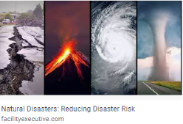  - A natural disaster is the effect of a natural hazard (e.g., flood, tornado, hurricane, volcanic eruption, earthquake, or landslide) that affects the environment.  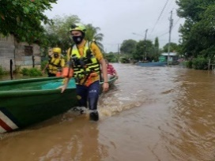  - A flood is an overflow of an expanse of water that submerges land. taken from: https://ticotimes.net/2020/11/04/evacuations-landslides-and-road-damage-reported-in-costa-rica-wednesday-afternoon-update  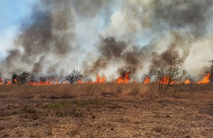  - The wildfire is any uncontrolled fire in combustible vegetation that occurs in the countryside or a wilderness area.  Taken from: https://ticotimes.net/2017/03/23/wildfires-costa-rica  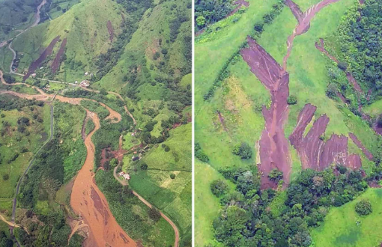  - The landslide or landslip is a geological phenomenon which includes a wide range of ground movement, such as rock falls, deep failure of slopes and shallow debris flows, which can occur in offshore, coastal and onshore environments.  Taken from: https://ticotimes.net/2017/05/26/landslides-costa-rica-tilaran  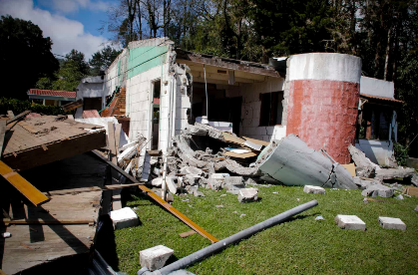  - An earthquake is a sudden shake of the Earth's crust caused by the tectonic plates colliding. The vibrations may vary in magnitude. The underground point of origin of the earthquake is called the "focus". The point directly above the focus on the surface is called the “epicenter”.  Taken from: https://ticotimes.net/2014/09/21/photos-costa-ricas-70-most-historic-earthquakes  - A volcanic eruption may in itself be a disaster due to the explosion of the volcano or the fall of rock.  Taken from: https://www.arenalobservatorylodge.com/en/40-years-eruption-arenal-volcano/  Engaging: Activation of prior knowledge  Teacher writes on the board or screen the following question: Is nature against us? Teacher asks learners to think for one minute about some natural disasters they remember have happened in our country, and how they affected us. Then, the teacher brainstorms ideas on the board or on the screen to answer the question.  Introducing  Teacher reviews the simple past tense with some questions and sentences. For example: What happened on December 26th ,2014 in Thailand? / When did the ozone layer problem start? When did hurricane Katrina hit USA? / . Learners get in pairs and surf the net to find the answers to the questions. |  |  |  | ´  5’  15´  10´  10´
L.1. paraphrases main ideas/ concepts and key points.  Indicators of learning  L.1.2. Puts in order important details from conversations about natural disasters, possible solutions, environmental problems, helping nature or Nonprofit NGO's  L.1.1. Lists main ideas and important details in conversations about natural disasters, possible solutions, environmental problems, helping nature or Nonprofit NGO's.  L.1.3. Retells main ideas and important details from conversations about natural disasters, possible solutions, environmental problems, helping nature or Nonprofit NGO's in order. | L.1. understand main ideas/concepts and key points/details of clear standard speech on familiar, everyday subjects related to natural disasters, environmental problems, helping nature, and nonprofit and NGOs. |  | Pre-listening:  Learners work in groups to complete a graphic organizer related to tips on what to do to face a natural disaster while vacationing.  Listening for the first time:  Learners listen to a conversation about natural disasters. between a host and Monica Taken fromhttps://es.liveworksheets.com/md1463083xy. Teacher plays the audio without the script.  Students are asked to put in order the sequence of the important details based on what they heard.  - Know what your airline will do if there's a natural disaster. _________  - It's really important to get a travel insurance. _________  - To contact your family and friends at home as soon as possible __________  - If you plan to visit a region where there are natural disasters at certain times of the year, try not to go at that time. _________  - To stay calm and be patient. ___________  Pair/group feedback  Teacher asks learners to work in groups of four and compare the information they got from the audio.  Listening for the second time:  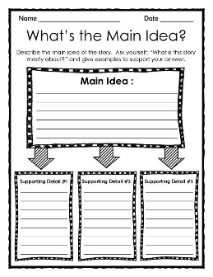  Students will listen to the audio again. Then, they complete a template with the main ideas and important details from the conversation. Teacher checks it orally. Taken from https://es.liveworksheets.com/md1463083xy  Taken from https://www.theteachertreasury.com/store/p18/Graphic_Organizer%3A_What%27s_the_Main_Idea%3F.html  Post-listening:  After that, each group chooses a learner to go to the front of the class to retell the ideas his/her group wrote in their templates to the rest of the group. |  |  |  | 5’  15´  20´  10´
R.1. summarizes main idea and supporting details.  Indicators of learning:  R.1.1. Recognizes topic in factual texts about natural disasters, possible solutions, environmental problems, helping nature or Nonprofit NGO's.  R.1.2. Identifies key words in factual texts about natural disasters, possible solutions, environmental problems, helping nature or Nonprofit NGO's.  R.1.3. Finds main points in factual texts about natural disasters, possible solutions, environmental problems, helping nature or Nonprofit NGO's.  R.1.4. Differentiates supporting details in factual texts about natural disasters, possible solutions, environmental problems, helping nature or Nonprofit NGO's.  R.1.5. Summarizes main idea and supporting details in factual texts about natural disasters, possible solutions, environmental problems, helping nature or Nonprofit NGO's. | R.1. understand main idea and supporting details in straightforward factual texts regarding natural disasters, environmental problems, helping nature, and nonprofit and NGOs, well enough to talk about them afterwards. |  | Pre-reading  Teacher prepares a couple of simple discussion questions and plays the following video (https://www.youtube.com/watch?v=QXT0pHFkJUM). After learners have seen the video, teacher asks learners to talk with a partner about what they saw by using the following discussion questions:  Discussion questions:  What can we do to protect the planet?  What measures can we take to avoid natural disasters?  Reading for the first time  Learners go over the text and try to decide on the best tittle for the reading.  Source: https://en.islcollective.com/english-esl- worksheets/vocabulary/environment/saving-planet/6150  Pair/Group feedback Learners let know their partners the title chosen in pairs/groups.  Reading for the second time  Learners read the text for the second time and underline key words that give examples of environmental problems. Then, learners complete a chart provided by the teacher.  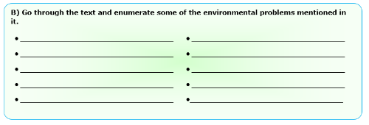  Source: https://en.islcollective.com/english-esl-worksheets/vocabulary/environment/saving-planet/6150  After that, learners complete a True/False exercise based on the text they read before. Finally, teacher checks answers orally.  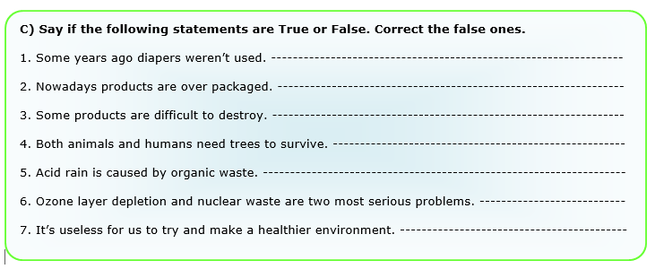  Source: https://en.islcollective.com/english-esl-worksheets/vocabulary/environment/saving-planet/6150  Learners are asked to complete a graphic organizer given by the teacher.  Learners organize their ideas by using the previous activity to write a summary. In order to create the summary, use ideas to write the beginning, the middle and the end. Once students have finished, they complete the summary by combining all the ideas with the appropriate linkers and discourse markers (cause-effect, contrast).  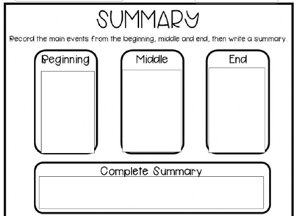  https://es.liveworksheets.com/ou1495678aa  Post-reading  Learners share their summary orally by working in pairs. Don’t forget to use connecting words to express cause-effect and contrast. |  |  |  | 5’  15´  20´  10´  10’

Integrated Mini-Project |  |  | Time
Phase 1: Participating  - Teacher explains and writes on the board ALL options of projects learners have. Learners are asked to think about each mini-project and choose their favorite.  Suggested Integrated Mini Project  - Make a brochure from two different points of view a. Things that helps the environment or b. Things that not helps the environment.  - Environmental arts and craft supporting ecology projects for the high school or community.  - Interviewing someone who works for an NGO, asking questions about their objectives and how they help nature.  - Presenting a natural disaster or environmental problem your community has faced in a round table. |  |  | 8´
Reflective Teaching
What worked well | What didn’t work well | How to improve
Enduring Understanding Reflection
How well did the learners progress in their understanding of the Enduring Understanding?
Week Plan Self-Assessment
At the end of the week, teacher guides the learners to check their progress using the checklist below. (can be translated into Spanish if needed to ensure learners’ understanding.)
Learner Self-Assessment
I can… | Yes | In progress | No
list main ideas and important details in conversations about natural disasters, possible solutions, environmental problems, helping nature or nonprofit NGO's.
put important details from conversations about natural disasters, possible solutions, environmental problems, helping nature or nonprofit NGO's in order.
retell main ideas and important details from conversations about natural disasters, possible solutions, environmental problems, helping nature or nonprofit NGO's in order.
recognize topic in factual texts about natural disasters, possible solutions, environmental problems, helping nature or nonprofit NGO's.
identify key words in factual texts about natural disasters, possible solutions, environmental problems, helping nature or nonprofit NGO's.
find main points in factual texts about natural disasters, possible solutions, environmental problems, helping nature or nonprofit NGO's.
differentiate supporting details in factual texts about natural disasters, possible solutions, environmental problems, helping nature or nonprofit NGO's.
summarize main idea and supporting details in factual texts about natural disasters, possible solutions, environmental problems, helping nature or nonprofit NGO's.

Warm- up flashcards:
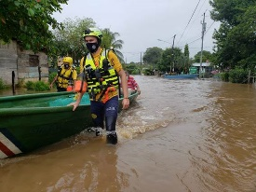

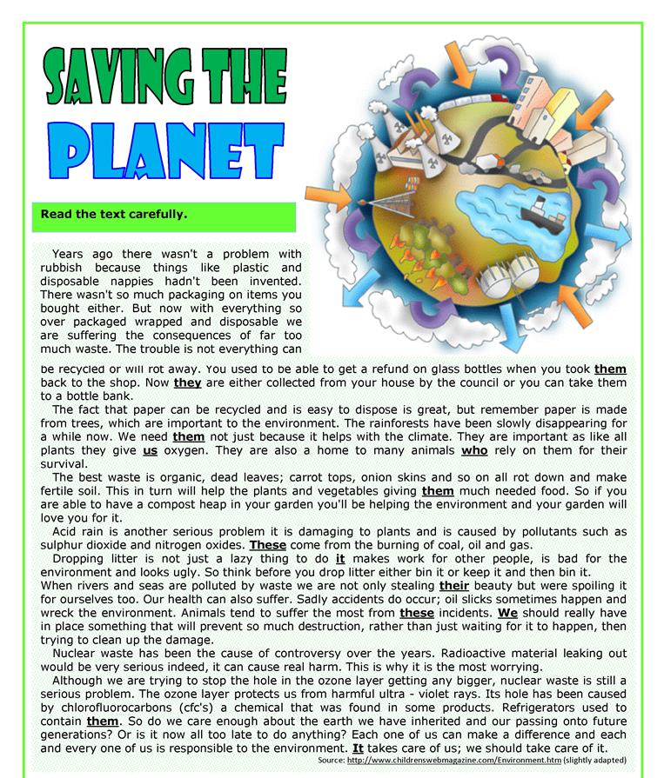
Title:
_________________________

Graphic organizers

Source: https://en.islcollective.com/english-esl-worksheets/vocabulary/environment/saving-planet/6150

Source:https://www.google.com/url?sa=i&url=https%3A%2F%2Fes.liveworksheets.com%2Fou1495678aa&psig=AOvVaw0iV5BH7VgN0UYrvH36rXmR&ust=1622741950094000&source=images&cd=vfe&ved=2ahUKEwj1gKD9vvnwAhVcQEIHHbN2AeoQr4kDegUIARCpAQ

Didactic Planning
Week # 2
Term: I |  | Level: Eleventh |  |  | Unit:3 |  | Week: 2
Domain: Socio-Interpersonal and Academic |  |  |  | Scenario: The Earth–Our Gift and Our Responsibility |  | Theme: What´s the Problem?
Enduring Understanding: Responsible, sustainable and proactive actions have an impact and can positively transform the environment.
Essential Question: What are the consequences of our positive actions on changing the environment?
New Citizenship:
Dimensions
1. Ways of thinking (√ )
2. Ways of living in the world (√ )
3. Ways of relating with others (√ )
4. Tools for integrating with the world ( √ )

Learn to Know |  |  |  | Learn to Do |  | Learn to Be and Live in Community
Grammar & Sentence Frames  Wh- in the past  - What happened on December 26th, 2014 in Thailand?  - When did the ozone layer problem start?  - Where did hurricane Katrina hit the USA?  Past continuous  Be past + gerund  - ONU was talking about the importance of emergency issues worldwide.  Simple past  - NGO’s proposed different solutions to stop animal extinction.  Vocabulary  What’s the Problem?  Catastrophe destruction, suffering, death, Contaminate –dirty, harmful chemicals, poison, Deforestation, Overcrowded cities, Greed, Fossil fuels exploitation  Over production of  Consumerism  Global warming  Ozone layer depletion  Acid rain  Aerosol  Animal welfare  Carbon monoxide |  |  |  | Function  Describing feelings, emotions and attitudes about environmental problems worldwide.  Discourse Markers  Linkers: sequential – past time (later)  They finished picking up the garbage from the beach then they started to classify it. Later, they put it in big plastic bags, to take it for recycling.  After that, they put all the garbage bags into a truck.  Finally, the garbage was taken to a recycling place.  Connecting words expressing cause and effect, contrast, etc.:  Consequently, because of, Due to, In spite of, Despite, Although  On the other hand, we could make a recycling campaign at school.  However, people still throw garbage to the rivers. |  | Sociocultural  Reflecting on local environmental needs for finding solution.  Propitiating social participation to find collective solutions for environmental problems and to respect all forms of life.  Idioms  sail close to the wind  at stake  Proverbs or Quotes  A recipe for disaster  No quick fix  A race against time  Ripple effect  To sweep something under the carpet
Assessment Strategies & indicators of learning  (Diagnostic, formative, summative) | Goals |  |  | Pedagogical Mediation/ Didactic Sequence |  |  |  | Time
Learner… | Learner can … |  |  | Pre-teaching  Routine: Checking attendance, checking in with Ls, teacher sticks the Essential Question on the wall and shares Can Do’s, and class agenda, etc.  Participating: Warm up  The teacher gives learners a handout. Learners solve a word search about natural disasters vocabulary.  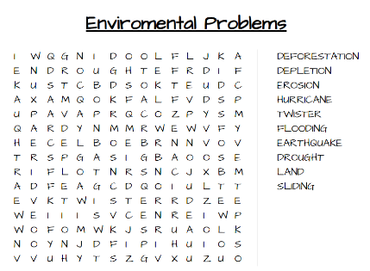  Engaging: Activation of prior knowledge  Teachers asks learners to complete a KWL chart to answer the following question:  How much do I know about pollution?  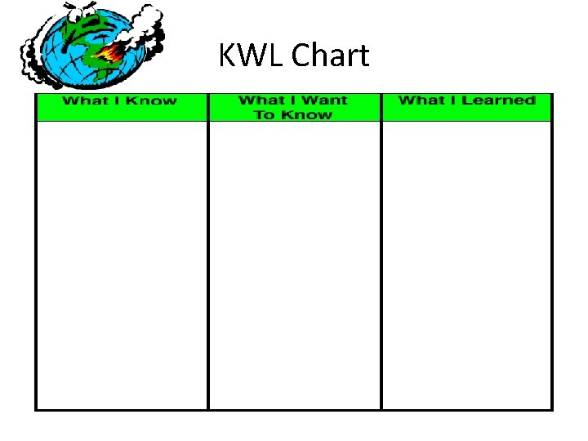  Introducing  Teacher shares a chart with past continuous information. T models how to use this tense in all its forms by using examples in units ‘context.  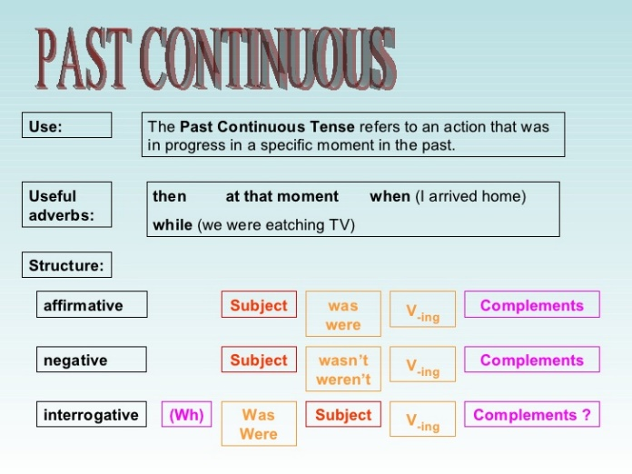  Examples  - People were sleeping when Otto hurricane hit our country.  - The National Emergency Commission was warning people about the hurricane while hospitals were getting ready to rescue people in danger.  - The woman was asking her husband to rescue some animals at the moment the hurricane was approaching.  - After the hurricane hit the community, some leaders were then organizing people and sending them to a shelter.  - Was UN talking about the importance of emergency issues worldwide?  - Were authorities talking about some security measures to face the hurricane in USA?  T asks learners to write some examples using all the forms present in the chart. Then, learners read them out loud. T helps learners to improve intonation if necessary. |  |  |  | 5’  15´  20´  20´
L.2. extracts the gist and specific details.  Indicators of learning  L.2.1. Recognizes the topic in classroom talks and presentations about natural disasters, possible solutions, environmental problems, helping nature or Nonprofit NGO's in order.  L.2.2 Identifies key words in classroom talks and presentations about natural disasters, possible solutions, environmental problems, helping nature or Nonprofit NGO's in order.  L.2.3. Finds main points in classroom talks and presentations about natural disasters, possible solutions, environmental problems, helping nature or Nonprofit NGO's in order.  L.2.4. Differentiates supporting details in classroom talks and presentations about natural disasters, possible solutions, environmental problems, helping nature or Nonprofit NGO's in order. | L.2. understand specific details in clear and organized classroom talks and presentations provided there is some prior knowledge of the topics: natural disasters, environmental problems, helping nature, and nonprofit and NGOs. |  |  | Pre-listening:  Learners watch a presentation muted for three minutes and predict what the presentation will about. Then, they answer the following question: What kind of information will the presentation show?  https://youtu.be/zRwDc97Tc2A  Listening for the first time  Learners watch the presentation with sound this time. Teacher asks learners to listen to it carefully and to write a √ next to the information the presenter mentioned.  What of these ideas was the presenter mentioning during the presentation? Write a check next to the ones mentioned  Floods, coastal erosion, earthquakes, tsunamis and landslides are some types of natural disasters.  Flash floods or river floods can break down house and structures.  A way to prevent floods is to plant as many trees as possible.  Build houses near water ways.  Listen to the news for any warning sign.  It is a good idea to use elevators during an emergency.  Pair/group feedback  Teacher asks learners to work in groups of four to compare the information they got from the audio.  Listening for the second time  Learners watch the presentation again and fill in the blanks with the missing words.  WORD BANK  flood coastal erosion earthquakes warnings  tsunami landslides preventing floods indoors  - _______is caused by monsoons, storms, water break rocks and human activities.  - If you are _________during an earthquake hide under the table or bed.  - ________ are caused by movements within the Earth.  - ________ must be followed during landslides.  - Clear water ways by removing any garbage in them can be a way of _____________.  - ____________ is an overflow of water that covers dry land.  - Tsunamis are caused by __________ under the ocean.  - ___________ is a long or high ocean wave.  Learners get in groups of four to list five main ideas form the presentation.  Main ideas:  - _________________________________________________.  - _________________________________________________.  - _________________________________________________.  - _________________________________________________.  - _________________________________________________.  Teacher asks learners to work in pairs. Based on the presentation, learners complete a chart with actions that should be taken during and after each emergency.  Disaster Action(s) during Action(s) after  Flood  Tsunami  Coastal erosion  Landslides  Earthquakes  Each group will share their ideas with the rest of the class.  Post-listening  Learners work in the same groups and design a summary poster about one of the disasters that includes the definition of the disaster and what to do during and after it. |  |  |  | 5’  15´  15´  15’  10´  15´
R.2. interprets most words in narrative and expository texts.  Indicators of learning  R.2.1. Identifies topic in narrative and expository texts.  R.2.2. Uses context clues to guess meaning of words in narrative and expository texts.  R.2.3. Recognizes subject specific words in narrative and expository texts.  R.2.4. Identifies main idea in narrative and expository texts.  R.2.5. Distinguishes supporting details in narrative and expository texts.  R.2.6. Explains main idea and supporting details in narrative and expository texts. | R.2. understand most words in narrative and expository text and extract the key ideas from those texts. |  |  | Pre-reading  Learners are asked to make a circle. They are divided into two groups. Each group get a set of set of pictures and words. Leaners put the pictures and words upside down on the floor. Learners are told they are going to play “Memory Game” in which they have have match a picture and words. They have two minutes per group. The group which guesses more pairs wins. Once the game is over in both groups, teacher reviews the vocabulary by showing the pictures and saying aloud the name of that picture.  Reading for the first time  Learners are asked to skim the text for thirty seconds named “The biggest forces of nature and the damage they cause” to answer the following question: What is the text about?  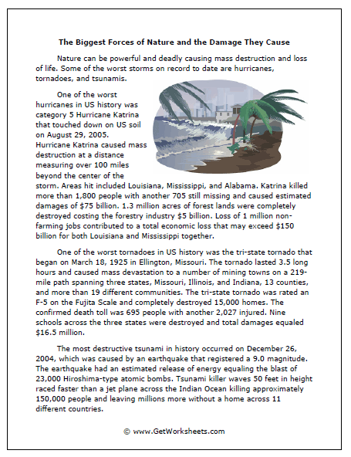  Taken From: http://www.getworksheets.com/samples/worksheets/science/forces.html  Pair/Group feedback: Learners share with their answers with their classmates.  After that, students are given a matching, in which they have to match column B that has some definitions with column A which includes the words, by writing letter into the space provided.  Name: ________________________________  Nature Words  Match the definitions in the column B with the corresponding word in Column A. Use the letters.  ____________ Storms The fact or process of losing something  ____________ Damages Land covered with forest or reserved for the growth of forests.  ____________ The worst Most severely or seriously.  ____________ Killed Violent disturbances of the atmosphere with strong winds and usually rain, thunder, lightning, or snow.  ____________ Loss Assign a standard or value to (something) according to a particular scale.  ____________ Lasted Physical harm caused to something in such a way as to impair its value, usefulness, or normal function.  ____________ Forest Lands Continue for a specified period of time.  ____________ Rated Cause the death of a (person, animal, or other living thing).  https://worksheets.theteacherscorner.net/make-your-own/match-up/match-up-worksheet.php#  Reading for the second time  Learners are asked to read again the text and highlight subject specific words for two minutes. Then, swap texts and check each other’s work or highlight the missing ones.  Learners go over the text again to underline the main idea of each paragraph to complete the following graphic organizer.  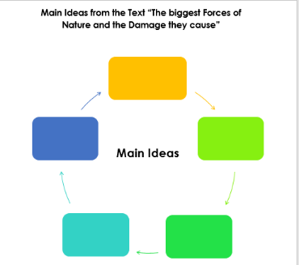  Learners circle the main idea of each paragraph with a color pencil, marker or pen. Then, they underline with a different color any supporting details that give more information about the main idea.  Post-reading  Make a summary to retell important information of the reading. Use the main ideas and supporting details found in the previous activities. Share your summary with your classmates. |  |  |  | 5’  5´  10´  10´  10’  5´  10’
SI.1. expresses feelings and explains the reasons for them in simple face-to-face conversation.  Indicators of learning  SI.1.1. Identifies his/her opinion about natural disasters, possible solutions, environmental problems, helping nature or Nonprofit NGO's.  SI.1.2. Gives opinion about natural disasters, possible solutions, environmental problems, helping nature or Nonprofit NGO's.  SI.1.3. Expresses agreement/disagreement about natural disasters, possible solutions, environmental problems, helping nature or Nonprofit NGO's.  SI.1.4. Gives reasoning/justification about natural disasters, possible solutions, environmental problems, helping nature or Nonprofit NGO's. | SI.1. express feelings and explain the reasons for them in regard to natural disasters, environmental problems, helping nature, and nonprofit and NGOs clearly. |  |  | Task: You are asked to represent your high school in the meeting of your community local emergency committee to evaluate and propose actions to mitigate flooding in your community. You want to share some ideas you have collected by conducting a online survey in your high school.  Planning  Learner makes an outline with the survey findings (opinions given by learners) including his or hers.  Organizing  Each learner will organize the points he/she wants to share in the meeting. He /she needs to include the following connecting words: consequently, because of, due to, in spite of, despite, although, on the other hand or however.  Rehearsing  Learner will practice the points he/she prepared by taking into account how to initiate a conversation, how to give opinions and feeling and how to close the conversation, how to agree or disagree and how to give justifications. He/she asks other classmates to provide feedback on what he/she said.  Interacting  He /she shares with the local emergency committee what was prepared before and closes the interaction with his/her opinion.  Then, he /she listens to attentively to what the committee members say and he /she reacts to it expressing agreement or disagreement.  He /she reflects on the local flooding problem to finding solutions and propitiates students ‘participation to find collective solutions for the problems in his /her community. |  |  |  | ´20´
Integrated Mini-Project |  |  |  |  |  |  |  | Time
Phase 2: Thinking  - Teacher explains and writes on the board ALL options of projects learners have. Learners are asked to think about each mini-project and choose their favorite.  Suggested Integrated Mini Project  - Make a brochure from two different points of view a. Things that helps the environment or b. Things that not helps the environment.  - Environmental arts and craft supporting ecology projects for the high school or community.  - Interviewing someone who works for an NGO, asking questions about their objectives and how they help nature.  - Presenting a natural disaster or environmental problem your community has faced in a round table. |  |  |  |  |  |  |  | 8´
Reflective Teaching
What worked well |  |  | What didn’t work well |  |  | How to improve
Enduring Understanding Reflection
How well did the learners progress in their understanding of the Enduring Understanding?
Learner Self-Assessment
I can… | Yes | In progress | No
recognize the topic in classroom talks and presentations about natural disasters, possible solutions, environmental problems, helping nature or nonprofit NGO's in order.
identify key words in classroom talks and presentations about natural disasters, possible solutions, environmental problems, helping nature or nonprofit NGO's in order.
find main points in classroom talks and presentations about natural disasters, possible solutions, environmental problems, helping nature or nonprofit NGO's in order.
differentiate supporting details in classroom talks and presentations about natural disasters, possible solutions, environmental problems, helping nature or nonprofit NGO's in order.
identify topic in narrative and expository texts.
use context clues to guess meaning of words in narrative and expository texts.
recognize subject specific words in narrative and expository texts.
identify main idea in narrative and expository texts.
distinguish supporting details in
explain main idea and supporting details in narrative and expository texts.
plan the information and visuals to make announcements using simple words and phrasing about natural disasters, possible solutions and organizations.
organize the information and visuals to make announcements using simple words and phrasing about natural disasters, possible solutions and organizations.
form sentences with the information to make announcements using simple words and phrasing about natural disasters, possible solutions and organizations.
give well -organized announcements using simple words and phrasing about natural disasters, possible solutions and organizations.

Source:https://slideplayer.com/slide/8710368/
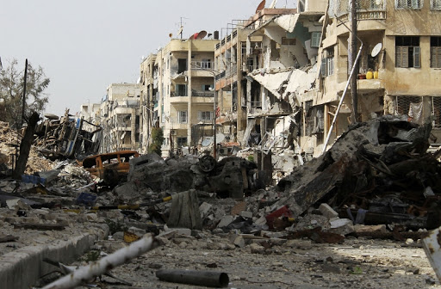

Catastrophe
destruction
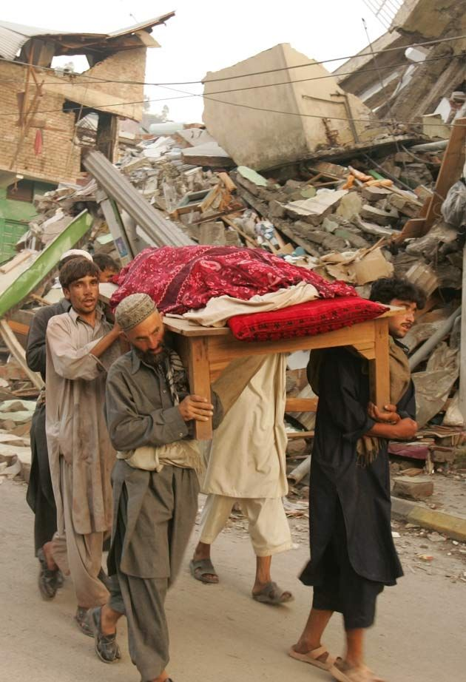

death

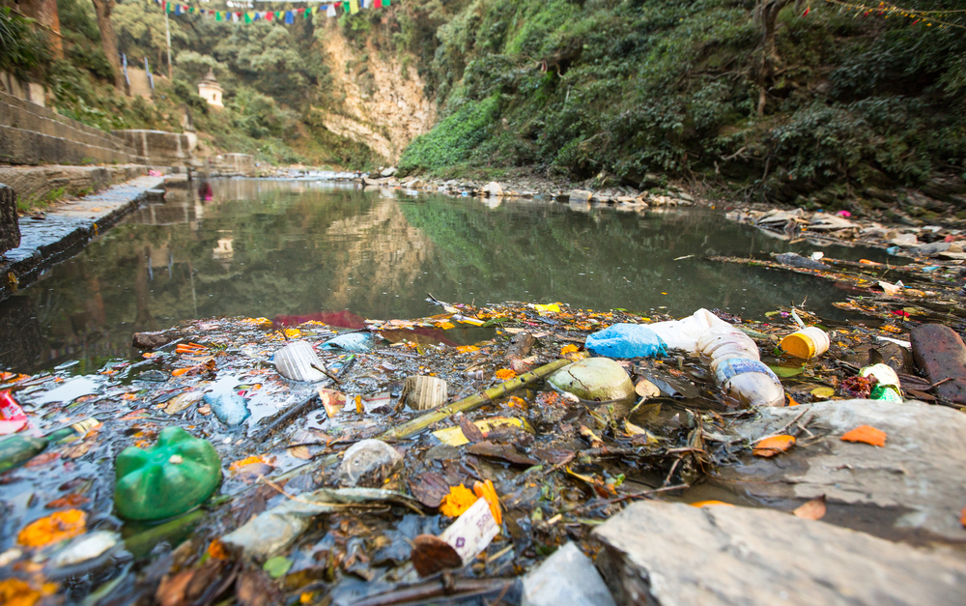

contaminate

harmful chemicals
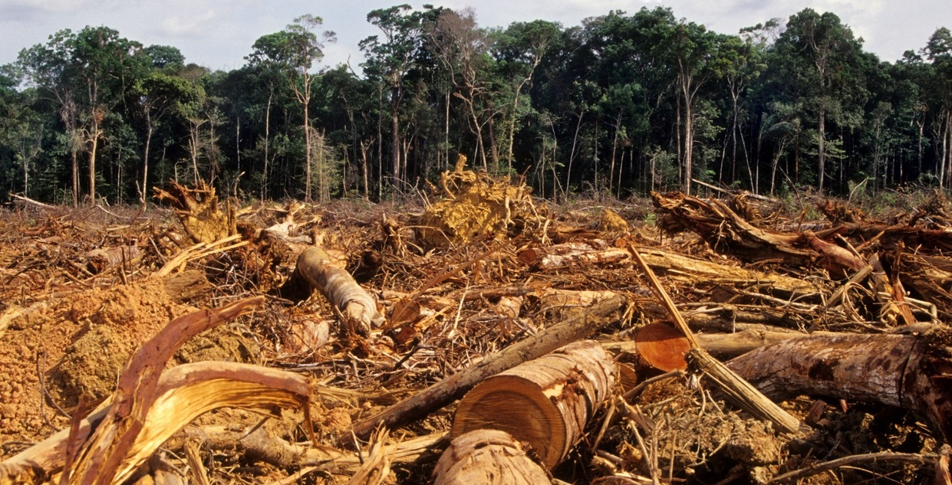

deforestation

overcrowded cities

greed

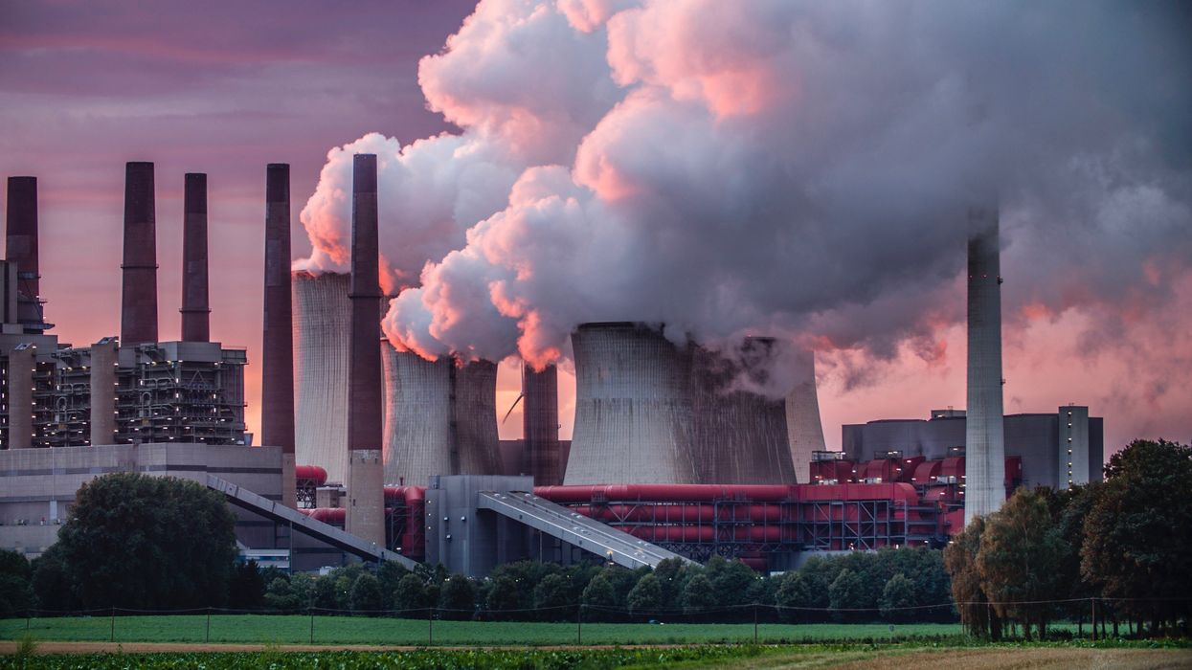

fossil fuels exploitation

over production of consumerism

global warming
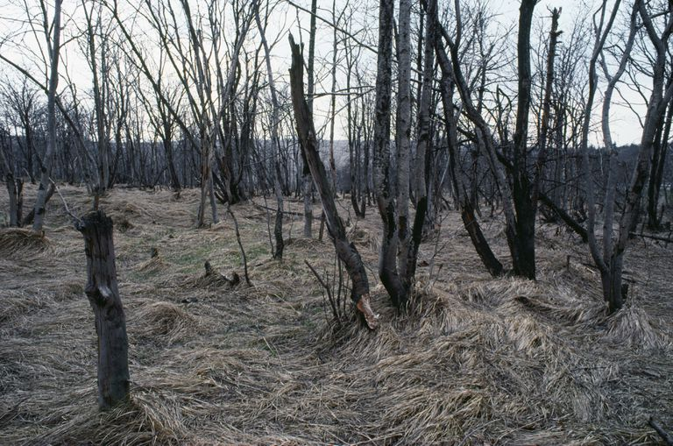

acid rain

animal welfare

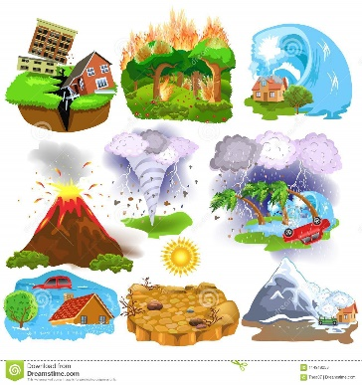

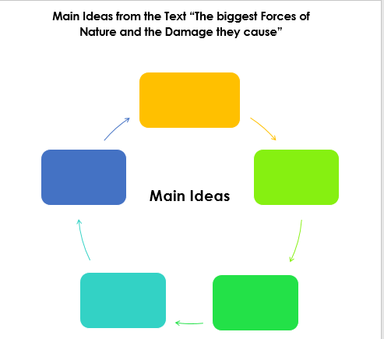
Name: ________________________________
Nature Words
Associate the letters given in the Column B that contains definitions related to nature by writing the letter into the space provided in Column A.
- ____________ | Storms |  | - The fact or process of losing something
- ____________ | Damages |  | - Land covered with forest or reserved for the growth of forests.
- ____________ | The worst |  | - Most severely or seriously.
- ____________ | Killed |  | - Violent disturbances of the atmosphere with strong winds and usually rain, thunder, lightning, or snow.
- ____________ | Loss |  | - Assign a standard or value to (something) according to a particular scale.
- ____________ | Lasted |  | - Physical harm caused to something in such a way as to impair its value, usefulness, or normal function.
- ____________ | Forest Lands |  | - Continue for a specified period of time.
- ____________ | Rated |  | - Cause the death of a (person, animal, or other living thing).

https://worksheets.theteacherscorner.net/make-your-own/match-up/match-up-worksheet.php#

Didactic Planning
Week # 3
Term: I |  | Level: Eleventh |  |  | Unit:3 |  |  | Week: 3
Domain: Socio-Interpersonal and Academic |  |  |  | Scenario: The Earth–Our Gift and Our Responsibility |  |  | Theme: A Helping Hand
Enduring Understanding: Responsible, sustainable and proactive actions have an impact and can positively transform the environment.
Essential Question: What are the consequences of our positive actions on changing the environment?
New Citizenship:
Dimensions
1. Ways of thinking (√ )
2. Ways of living in the world (√ )
3. Ways of relating with others (√ )
4. Tools for integrating with the world ( √ )

Learn to Know |  |  |  | Learn to Do |  |  | Learn to Be and Live in Community
Grammar & Sentence Frames  W-h in the past  - What happened on December 26th, 2014 in Thailand?  - When did the ozone layer problem start?  - Where did hurricane Katrina hit the USA?  Modals:  must/can’t /have to for deduction  -We must take care of our environment, if we want to preserve life for the future generations.  -We can’t deny the  importance of technology to help the environment.  − People have to be environmentally responsible to save the planet.  Past continuous  Be past + gerund  - ONU was talking about the importance of emergency issues worldwide.  Simple past  - NGO’s proposed different solutions to stop animal extinction.  Vocabulary  A helping Hand (possible solutions)  Conservation,  protection,  prevent  Environmental group  Green issues  Pressure  Group  Recycle  Reuse  Reduce  Safe  Environmentally aware  Green energies |  |  |  | Function  Initiating and closing conversations about possible solutions to help the environment.  Discourse Markers  Linkers: sequential – past time (later)  They finished picking up the garbage from the beach then they started to classify it. Later, they put it in big plastic bags, to take it for recycling.  After that, they put all the garbage bags into a truck.  Finally, the garbage was taken to a recycling place.  Connecting words expressing cause and effect, contrast, etc.:  Consequently, because of, Due to, In spite of, Despite, Although  On the other hand, we could make a recycling campaign at school.  However, people still throw garbage to the rivers.  Markers to structure informal spoken discourse  - Oh, I know.  - Yes, I supposed so.  - I know how you feel  - You know, I don´t like it either. |  |  | Sociocultural  Reflecting on local environmental needs for finding solution.  Propitiating social participation to find collective solutions for environmental problems and to respect all forms of life.  Idioms  sail close to the wind  at stake  Proverbs or Quotes  A recipe for disaster  No quick fix  A race against time  Ripple effect  To sweep something under the carpet
Assessment Strategies & indicators of learning  (Diagnostic, formative, summative) | Goals |  |  | Pedagogical Mediation/ Didactic Sequence |  |  |  |  | Time
Learner… | Learner can … |  |  | Pre-teaching  Routine: Checking attendance, checking in with Ls, teacher sticks the Essential Question on the wall and shares Can Do’s, and class agenda, etc.  Participating: Warm up  The students listen to the song about The Earth’s Day, https://sapiensevn-repo.s3-us-west-2.amazonaws.com/videos/Costa+Rica+2020/SpeedUp/11/P98_Earth+Day+Song+++Reduce%2C+Reuse%2C+Recycle++++The+3+R’s+of+Recycling.mp4 or https://youtube.com/watch?v=qtyBzFV9yTs . Then, they write five concrete actions from the song that we can do regularly to protect the environment.  Engaging: Activation of prior knowledge  Learners complete the following concept map with their own ideas about Conservation of Energy.  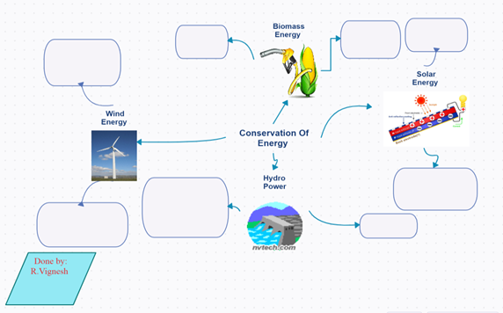  Introducing  Teacher shares a chart with morals of obligation and prohibition information. T models how to use them in all by using examples in units ‘context.  MODALS OF OBLIGATION AND PROHIBITION  MUST: We use this auxiliary to express a strong obligation or necessity that comes from the speaker. For example:  We must do something to stop pollution.  HAVE / HAS TO: It shows that the obligation comes from outside the speaker (like an external obligation). For example:  We have to fill out this form and add some pictures to denounce the environmental problem.  Use have to for I / you / we / they or plural nouns as subjects.  Use has to for she / he / it or singular nouns as subjects.  CAN’T: We use it to talk about something that is against the rules. For example:  We can’t throw garbage into the rivers.  REMEMBER: These modal auxiliaries are always followed by the verb in the base form.  CAN’T is sometimes used as a synonym of MUSTN’T. For example:  We can’t throw our leftovers here = We mustn’t throw our leftovers here.  The students complete the following sentences with the correct auxiliary: must – have to – has to – can’t.  - We ____________ recycle and protect the environment at school as well.  - Students ___________ discuss about green issues.  - People ____________ be environmentally responsible to save the planet.  - We ____________ feed the animals in this reserve. It is against the rules.  - You ___________ pick up all the garbage from the camping area before you set up the tent. It is part of the rules here.  - Steve _________ hand in his proposal to protect the local streams next week in his meeting with the governor. |  |  |  |  | 5’  15’  20’
L.3. extracts the gist of TV programs.  Indicators of learning  L3.1 Recognizes topic in TV programs about natural disasters, possible solutions, environmental problems, helping nature or Nonprofit NGO's.  L3.2 Identifies key words in TV programs about natural disasters, possible solutions, environmental problems, helping nature or Nonprofit NGO's.  L3.3 Finds main points in TV programs about natural disasters, possible solutions, environmental problems, helping nature or Nonprofit NGO's.  L.3.4 Differentiates supporting details in TV programs about natural disasters, possible solutions, environmental problems, helping nature or Nonprofit NGO's.  SI.2. starts, maintains and closes simple face-to-face conversation on topics that are familiar or of personal interest regarding natural disasters, environmental problems, helping nature, and nonprofit and NGO’s.  Indicators of learning  SI2.1 Starts a face-to-face conversation about natural disasters, environmental problems, helping nature or Nonprofit NGO's by checking understanding from the speaker's point of view or listener's point of view.  SI2.2 Interrupts the listener in a conversation.  SI2.3 Continues with the conversation about natural disasters, environmental problems, helping nature or Nonprofit NGO’s .  SI2.4 Changes the topic in the conversation.  SI2.5 Closes the conversation about natural disasters, environmental problems, helping nature or Nonprofit NGO’s by using a leave-taking.  W.1. writes in simple sentences, an opinion on controversial issues.  Indicators of learning:  W1. 1 Plans an opinion on a controversial issue including a thesis statement, its reasons / justifications.  W1. 2 Drafts an opinion on a controversial issue by using a phrase that tells the reader that this is opinion, counter example / opposing opinions, supporting points and linking words to show relations between ideas.  W1. 3 Revises an opinion on a controversial issue by checking subject-verb agreement, pronoun and article agreement, sentence sense, text structure, work order, content and punctuation.  W1. 4 Edits an opinion on a controversial issue. | L.3. understand the gist of TV programs on topics of personal interest regarding natural disasters, environmental problems, helping nature, and nonprofit and NGOs when people speak clearly.  SI.2. start, maintain and close simple face-to-face conversation on topics that are familiar or of personal interest regarding natural disasters, environmental problems, helping nature, and nonprofit and NGO´s.  W.1. write in simple sentences, an opinion on controversial issues provided regarding natural disasters, environmental problems, helping nature, and nonprofit and NGOs, related to the issue under examination. |  |  | Pre-Listening:  Learners reflect on the following question and list possible answers in groups.  Is there a way to reverse all damage we have done to Earth?  Listening for the first time:  Learners watch the video by David Attenborough  https://youtu.be/0Puv0Pss33M and circle the topic from the following three options.  - Different actions to save the ocean.  - Different actions to save the world.  - Different actions to have a sustainable lifestyle.  Learners watch the video again and look for the best definition of the following key words taking into account the video content.  Key words Definition  reducing  anthropocene  biodiversity  domesticated animals  balance  population  wild  humans  healthy  problems  goals  Pair-group feedback:  Learners share their definitions in groups of three to find the best definition based on the video.  Listening for the second time:  Learners watch the video again and take notes to list the main 4 goals to reduce our impact on Earth.  - ___________________________________________________.  - ___________________________________________________.  - ___________________________________________________.  - ___________________________________________________.  Learners complete the following graphic organizer with their favorite main idea and its supporting details. Then, learners write 2 questions about the video and a connection they made with their own lives.  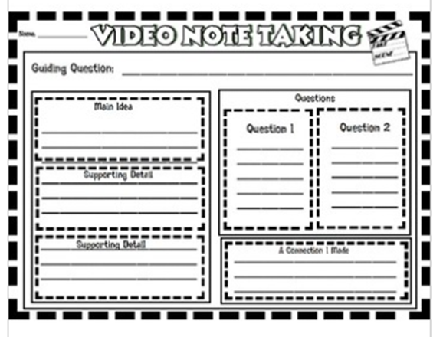  Taken from: https://www.teacherspayteachers.com/  Post-listening  By using previous the previous graphic organizer, learners share their questions and the connections they made related to the video.  Planning  Task: Your community has faced four different natural disasters in the last two decades: floods, an earthquake, forest fires, landslides and volcanic eruptions. You belong to the local emergency committee, and you are having a meeting to write an emergency plan to be ready after a disaster.  Teacher provides some pictures and useful verbs.  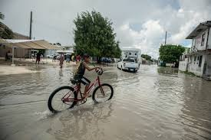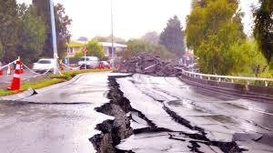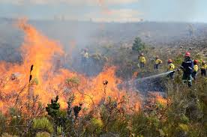  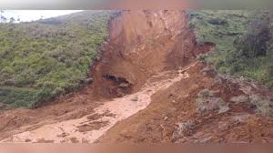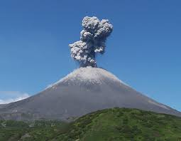  took called donated cleaned worked  built organized got made gathered  attended had found moved gave  collect checked visited brought bought  *Learners can use different verbs.  Organizing  Learners work in groups and pretend they are having the meeting. Learners will use the pictures and verbs to have a conversation including the following aspects:  Learners organize their ideas by including the linkers to give a sequence of the events: First, then, later, and after that. They have to interrupt the other student conversation and continues with it by changing the topic.  Students think about how to organize the information on a poster board or sheet of paper. They have to plan the closure of the conversation.  Rehearsing  Students write down the information on the poster board or sheet of paper. When the conversation is ready, the students practice their information before presenting. Teacher monitors the pronunciation.  Interacting  Students share their plans in groups of three.  Task: You are invited to give your opinion in a high school blog about a controversial issue regarding environmental problems. You decided to focus your attention on the ecological footprint. You did some research and found an image called “Solving Global Warming: Doing Something” to guide yourself to write your opinion.  Pre-writing  Learners look at the following brainstorming to have an idea of possible actions to take care of the environment. Learners choose one main area (global warming, water, forest, wildlife, etc) and write their own outline.  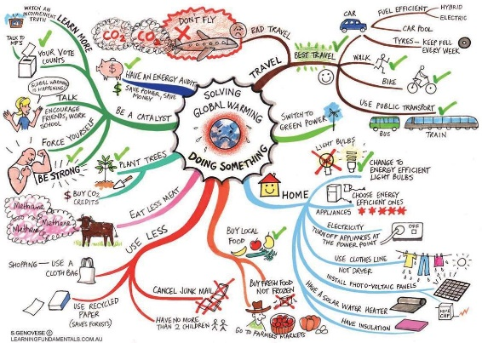  Drafting  Learners write their opinion about how to help the environment using a phrase that tells the reader that this is his / her opinion, with 5 actions using the modals should, can, can´t and must. They can show examples, opposing opinions and supporting points of view to show the relation between their ideas.  Revising  Learners take some time to revise their opinions individually and then in pairs. They use the following checklist for the revision:  Editing Checklist My opinion My classmate´s opinion  The opinion… Yes No Partially Yes No Partially  is well- capitalized.  ‘s verbs match with the subject.  has a beginning.  has a main body of well sequenced ideas.  has a conclusion.  is indented.  has clear sentences.  fulfills with the information asked in the task.  has punctuation marks correctly used.  Editing  Learners make the corrections discussed during the revision phase before publishing their opinions. |  |  |  |  | ´  10’  15’  5’  10’  10’  15’  15’  5’  25’  15’  15’  10’
Integrated Mini-Project |  |  |  |  |  |  |  |  |  | Time
Phase 3: Acting out  Allow time for the Mini-Project each week. NOTE: All phases of the Integrated Mini-Project should be opportunities for Ls to practice English, not just those related to presentation. |  |  |  |  |  |  |  |  |  | 8´
Reflective Teaching
What worked well |  |  | What didn’t work well |  |  | How to improve
Enduring Understanding Reflection
How well did the learners progress in their understanding of the Enduring Understanding?
Learner Self-Assessment
I can… | Yes | In progress | No
recognize topic in tv programs about natural disasters, possible solutions, environmental problems, helping nature or nonprofit NGO's.
identify key words in tv programs about natural disasters, possible solutions, environmental problems, helping nature or nonprofit NGO's.
find main points in tv programs about natural disasters, possible solutions, environmental problems, helping nature or nonprofit NGO's.
differentiate supporting details in tv programs about natural disasters, possible solutions, environmental problems, helping nature or nonprofit NGO's.
start a face-to-face conversation about natural disasters, environmental problems, helping nature or nonprofit NGO's by checking understanding from the speaker's point of view or listener's point of view.
interrupt the listener in a conversation.
continue with the conversation about natural disasters, environmental problems, helping nature or nonprofit NGO's .
change the topic in the conversation.
close the conversation about natural disasters, environmental problems, helping nature or nonprofit NGO's by using a leave-taking.
plan an opinion on a controversial issue including a thesis statement, lists reasons/justifications.
draft an opinion on a controversial issue by using a phrase that tells the reader that this is opinion, counter example/opposing opinions, supporting points and linking words to show relations between ideas.
revise an opinion on a controversial issue by checking subject-verb agreement, pronoun and article agreement, sentence sense, text structure, word order, content and punctuation.
edit an opinion on a controversial issue.

Didactic Planning
Week # 4
Term: I |  | Level: Eleventh |  |  | Unit:3 |  |  | Week: 4
Domain: Socio-Interpersonal and Academic |  |  |  | Scenario: The Earth–Our Gift and Our Responsibility |  |  | 4. Theme: Who is Doing What?
Enduring Understanding: Responsible, sustainable and proactive actions have an impact and can positively transform the environment.
Essential Question: What are the consequences of our positive actions on changing the environment?
New Citizenship:
Dimensions
1. Ways of thinking (√ )
2. Ways of living in the world (√ )
3. Ways of relating with others (√ )
4. Tools for integrating with the world ( √ )

Learn to Know |  |  |  | Learn to Do |  |  | Learn to Be and Live in Community
Grammar & Sentence Frames  Wh- in the past  - What happened on December 26th , 2014 in Thailand?  - When did the ozone layer problem start?  - Where did hurricane Katrina hit the USA?  Past continuous  Be past + gerund  - ONU was talking about the importance of emergency issues worldwide.  Simple past  - NGO’s proposed different solutions to stop animal extinction.  Vocabulary  Who is Doing What?  NGOs-Nonprofit Natural disasters, aid response, Humanitarian, economic consequence volunteering  Nonprofit and NGOs (Greenpeace, EWS-WWF, ocean pollution control org |  |  |  | Discourse Markers  Linkers: sequential – past time (later)  They finished picking up the garbage from the beach then they started to classify it. Later, they put it in big plastic bags, to take it for recycling.  After that, they put all the garbage bags into a truck.  Finally, the garbage was taken to a recycling place.  Connecting words expressing cause and effect, contrast, etc.:  Consequently, because of, Due to, In spite of, Despite, Although  On the other hand, we could make a recycling campaign at school.  However, people still throw garbage to the rivers.  Markers to structure informal spoken discourse  - Oh, I know.  - Yes, I supposed so.  - I know how you feel  - You know, I don´t like it either. |  |  | Psycho-social  Engaging in setting own goals towards healthy and sustainable environment.  Engaging in own true actions to protect the environment.  Sociocultural  Propitiating social participation to find collective solutions for environmental problems and to respect all forms of life.  Idioms  sail close to the wind  at stake  Proverbs / Quotes  We won't have a society if we destroy the environment. -- Margaret Mead
Assessment Strategies & indicators of learning  (Diagnostic, formative, summative) | Goals |  |  | Pedagogical Mediation/ Didactic Sequence |  |  |  |  | Time
Learner… | Learner can … |  |  | Pre-teaching  Routine: Checking attendance, checking in with Ls, teacher sticks the Essential Question on the wall and shares Can Do’s, and class agenda, etc.  Participating: Warm up  Teacher presents a short video related to the Nonprofit organization Greenpeace (The History of Greenpeace: Environmental Activists) and its function in the world. Learners give their impression with some brief personal opinions. Teacher uses phrases such as: This is amazing, Greenpeace is a wonderful organization. They help a lot of people and animals around the world.  Link: https://www.youtube.com/watch?v=9jDMjfSU-uE  Teacher gives learners a worksheet with some written definitions (Nonprofit, volunteering, NGO, .org domain) and its corresponding explanation.  The worksheet can be found in .docx format at the end of this unit.  Engaging: Activation of prior knowledge  Teacher writes or shows some questions on the board/screen. (Do you know a Costa Rican nonprofit organization? Which one/s?, Have you ever participated in one of these organizations? When? For how long?) Have you ever donated some money, clothing or food to one of these organizations? How did you feel about it?  If learners do not answer any of the questions, teacher can give some suggestions:  “I know https://www.amigosofcostarica.org/ and https://cepiacostarica.org/ are great nonprofit organizations located in our country.”  Teacher also can visit this page online in class and show learners some information about it. If technology is not available, the page information can be download it and print it.  Introducing  Teacher makes a PPT or PDF presentation (depending on technology access) about different Nonprofit and ONG´s in the world as well as their functions, location, people involved, donations, etc. Teacher also presents a video with the positive impact, people´s changed lives and the improvement on vulnerable communities.  The information for the PPT can be found in .docx format at the end of this unit.  Teacher gives learners a handout with different linkers or connecting words such as: however, because, moreover, in order to, before/after, etc. Teacher explains their use with some sample sentences in the context of the unit.  The handout can be found in .docx format at the end of this unit. |  |  |  |  | 5 min  15 min  20 min  20 min
SP.2. speaks in a comprehensible and fairly fluent manner using a large number of different words and expressions.  Indicators of learning  SP.2.1Plans the information and visuals to give a presentation about natural disasters, possible solutions and organizations.  SP.2.2 Organizes the information and visuals to give a presentation about natural disasters, possible solutions and organizations.  SP2.2.3Makes sentences with the information and the appropriate linkers or connecting words to give a presentation about natural disasters, possible solutions and organizations.  SP.2.2.4 Gives well- organized presentation about natural disasters, possible solutions and organizations. | SP.2. speak in a comprehensible and fairly fluent manner using a large number of different words and expressions regarding natural disasters, environmental problems, helping nature, and nonprofit and NGOs, though there may be pauses for self-correction. |  |  | Task: You were asked to prepare a three – minute PPT with sound on different ways to save the world to celebrate the World Environment Day at your school. Your English teacher sent you an article entitled: David Attenborough lays out 7 actions to save the world https://www.mindfood.com/article/david-attenboroughs-7-actions-to-save-the-world/ to be used for your presentation. You will have to work in groups (7) with an assigned section of the reading. Each group reads the section assigned and does extra research to expand the information.  Teacher provides learners with a set of useful expressions learners can use to give opinions:  - In my opinion, ... In my eyes, ...  - To my mind, ... As far as I am concerned, ... ...  - From my point of view, ... As for me / As to me, ...  - My view / opinion / belief / impression / conviction is that ... ...  - I would say that ... ...  - My impression is that ... ...  - I have the feeling that ... ...  - I have no doubt that …  Planning  Learners create an outline with the information from the article and the information learners got from the extra research they did. They also select the best visuals to create the presentation.  Organizing  Learners select the appropriate oral and visual forms to share the information they planned before in a well-organized presentation using relevant sentence frames and connecting words covered in the unit.  Rehearsing  Learners practice with the oral and visual forms prepared before. T helps them by giving feedback correcting mistakes like grammar, vocabulary, pronunciation, and intonation among others. Learner use the following checklist  PPT with Sound Checklist  My PPT … Yes No Partially  has well- capitalized sentences.  ´s verbs match with the subject.  Has well -sequenced ideas.  Has clear sentences.  Fulfills the information asked in the task  has illustrations that match the information given.  ‘sound is clear and easy to understand  ´length is adequate  Producing  Each group gives a well–organized presentation to the rest of the group. At the end of the presentations, T asks students about the most important challenges humans still have to save the world. |  |  |  |  | 40 min
W.2. writes a persuasive paragraph regarding environmental problems and helping nature.  Indicators of learning:  W2. 1 Plans a persuasive paragraph regarding environmental problems and helping nature.  W2. 2 Drafts a persuasive paragraph regarding environmental problems and helping nature that includes thesis statement, arguments, facts and examples and a conclusion.  W2. 3 Revises a persuasive paragraph regarding environmental problems and helping nature by checking subject-verb agreement, pronoun and article agreement, sentence sense, text structure, word order, content and punctuation.  W2. 4 Edits a persuasive paragraph regarding environmental problems and helping nature. | W.2. write a persuasive paragraph regarding environmental problems and helping nature and check written paragraphs, sentences, and opinions to look for mistakes (subject-verb agreement, pronoun and article agreement, capitalization, using commas, sentence sense, word order, text structure, concrete ideas, etc.). |  |  | Pre-writing  Learners read the following information:  “A persuasive paragraph tries to convince the reader that a particular point of view is worthy of consideration. It wants you to consider both sides of an issue, but it reveals a bias in favor of one side over another.” (Taken from: https://www.learnamericanenglishonline.com/Write_in_English/WL14_persuasive_paragraphs.html#:~:text=A%20persuasive%20paragraph%20tries%20to,of%20one%20side%20over%20another .)  Teacher shares with the class some tips on how to write a persuasive paragraph: use:  - Pick a topic you’re passionate concerning environmental problems and helping nature.  - Research both sides. In order to convince the reader to agree with you, you also have to know what you’re trying to get them to disagree with.  - Be empathetic. An effective persuasion technique is the use of empathy. A reader is more inclined to believe you if they feel like you can relate to and understand their experiences.  - Ask rhetorical questions. Presenting questions that the reader will be forced to answer for themselves later on is another good persuasive strategy, especially when the information provided to help make that decision is supportive of your point of view.  - Emphasize your point. The use of exaggeration in order to express urgency, exclusivity, or just to make a point is another useful persuasive technique.  - Repeat yourself. Strategic repetition can be an effective way to gradually remind the reader of your message. Finding different ways to make the same point by use of rephrasing, true stories, metaphors, or other literary devices all serve to reinforce your point without bogging down the reader with repetitiveness.  (Taken and adapted from: https://www.masterclass.com/articles/persuasive-writing-tips-and-techniques#8-tips-for-better-persuasive-writing .)  Task: You are in charge of the environment section of your school digital newspaper and you want to write a 150- word persuasive paragraph about different ways to help nature to be included in the next issue. Include a title, a thesis statement, main reasons (arguments), facts and examples (evidence) and a conclusion.  Drafting  Learners start planning their persuasive paragraph with the help of the following template (Teacher can use other worksheet to help them planning)  Revising  In groups, learners share their paragraphs with the rest of the group. They take time to revise their paragraph individually and then with a classmate using the checklist provided. Teacher moves around the class to give feedback.  Persuasive Paragraph Checklist  The persuasive paragraph … Yes No Partially  is well -capitalized.  ‘s verbs match with the subject.  has an introduction thesis statement (that states a position/claim).  has main reasons (arguments).  has facts and examples (evidence).  has a conclusion (most important details of the argument and what you want the reader to do)  is indented.  has clear ideas.  fulfills information asked in the task.  has 150 words.  has punctuation marks correctly used.  has correct use of commas and spelling rules.  uses the correct linkers or connecting words to connect ideas  Editing  Considering their classmates’ feedback, learners correct and modify their persuasive paragraph. Teacher also monitors students and helps them in the editing process before publishing. |  |  |  |  | 40 ‘
Integrated Mini-Project |  |  |  |  |  |  |  |  |  | Time
Allow time for the Mini-Project each week. NOTE: All phases of the Integrated Mini-Project should be opportunities for Ls to practice English, not just those related to presentation.  Acting out and responding: (5 or 10 minutes in week 3 or 4) |  |  |  |  |  |  |  |  |  | 8´
Reflective Teaching
What worked well |  |  | What didn’t work well |  |  | How to improve
Enduring understanding reflection
how well did the learners progress in their understanding of the enduring understanding?
LEARNER SELF-ASSESSMENT
I can… | YES | IN PROGRESS | NO
sustain a face-to-face conversation by checking understanding from the speaker's point of view or listener's point of view in topics related to technology, safety and technological advance.
interrupt the listener in a conversation related to technology, safety and technological advance by using phrases such as: excuse me, may i say something? no, i'm sorry but…
continue with the conversation related to technology, safety and technological advance by using phrases such as: really,…, right,…
change the topic in the conversation related to technology, safety and technological advance.
close the conversation related to technology, safety and technological advance by using a leave-taking.
plan a persuasive paragraph regarding environmental problems and helping nature.
draft a persuasive paragraph regarding environmental problems and helping nature that includes thesis statement, arguments, facts and examples and a conclusion.
revise a persuasive paragraph regarding environmental problems and helping nature by checking subject-verb agreement, pronoun and article agreement, sentence sense, text structure, word order, content and punctuation.
edit a persuasive paragraph regarding environmental problems and helping nature.
plan the information and visuals to make announcements using simple words and phrasing about natural disasters, possible solutions and organizations.
organize the information and visuals to make announcements using simple words and phrasing about natural disasters, possible solutions and organizations.
form sentences with the information to make announcements using simple words and phrasing about natural disasters, possible solutions and organizations.
give well organized announcements using simple words and phrasing about natural disasters, possible solutions and organizations.
plan stretches of language to deliver an announcement that shouldn’t be any longer than 100 words for a group meeting, a social project or collaborative activities.
organize the information to include 5 w’s (who, where, when, what & why) in the announcement.
make sentences with the information and with the appropriate linkers or connecting words supported by illustrations.
state the reason people should listen compels them to listen and take action.
use stretches of language about with reasonable accuracy to deliver an announcement for a group meeting, a social project or collaborative activities

.Annexes with supplementary materials for the lessons

Unit 3. The Earth–Our Gift and Our Responsibility
Week 4. Who is Doing What?

VOCABULARY WORKSHEET

- Nonprofit: A nonprofit organization is one that qualifies for tax-exempt status by the IRS because its mission and purpose are to further a social cause and provide a public benefit. Nonprofit organizations include hospitals, universities, national charities and foundations.
- Volunteering: Volunteering is a voluntary act of an individual or group freely giving time and labour for community service. Many volunteers are specifically trained in the areas they work, such as medicine, education, or emergency rescue. Others serve on an as-needed basis, such as in response to a natural disaster.
- NGO: Organizations which are independent of government involvement are known as non-governmental organizations or non-government organizations, with NGO as an acronym. NGOs are a subgroup of organizations founded by citizens, which include clubs and associations that provide services to their members and others. NGOs are usually nonprofit organizations, and many of them are active in humanitarianism or the social sciences. Surveys indicate that NGOs have a high degree of public trust, which can make them a useful proxy for the concerns of society and stakeholders. However, NGOs can also be lobby groups for corporations, such as the World Economic Forum.
- .org domain: The .org domain extension stands for “organization” and is more appropriate for non-profit organizations, but has a wide range of uses in for-profit websites. They can also be used for websites that provide people with free resources and information

8 Simple Ways to Help the Environment

Every little thing YOU do really makes a difference!
Ashley Paskill, Student Contributor
April 08, 2020

Students are constantly learning how they can make a difference in the world. There are classes and clubs focused on various social issues, and these places teach students how they can change these issues. One popular cause that has been popular in recent years is the helping the environment and preserving our resources. Become a Fastweb member to make paying for school easier! Don’t miss out on the scholarships YOU specially qualify for, important pre-college tasks and current college student must-dos. Make paying for school easier! There are several ways that you – yes, YOU- can help protect this planet we call Earth. What you do makes a difference!

Use Reusable Bags
Plastic grocery-type bags that get thrown out end up in landfills or in other parts of the environment. These can suffocate animals who get stuck in them or may mistake them for food. Also, it takes a while for the bags to decompose.
Whether you are shopping for food, clothes or books, use a reusable bag. This cuts down on litter and prevents animals from getting a hold of them. There are even some stores (such as Target) that offer discounts for using reusable bags! These bags are useful for things other than shopping as well. I have heard of people using reusable bags when they move! If you forget your bags at home, buy a new one. Better yet, keep a couple bags in your car so you never leave home without them (just make sure you remember you put them there)! If you are in a position where you need to use the plastic bags, reuse them the next time you go shopping, or use them for something else. Just do not be so quick to throw them out! There are some states that are outlawing or charging extra for using plastic bags. Using reusable bags helps the environment AND your budget!

2. Print as Little as Necessary
We have all had that teacher that wanted us to have a copy of every single reading when we come to class, or that professor who wanted a hard copy of the ten-page paper that is due next week. These are fine but it seems as if they do not understand that using so much paper is detrimental to the environment. What can you do? Ask your teacher if you can bring a laptop or an e-reader to class so that you can download the reading onto that and read it from there. If not, print on both sides of the page to reduce the amount of paper used. If you need to turn in a long paper, ask the professor if it is okay to print on both sides of the page and explain why you’re asking. Most teachers care about the environment as well and would be willing to allow you to do so.

3. Recycle
Recycling is such a simple thing to do, but so many people don’t do it. Many garbage disposal companies offer recycling services, so check with the company you use to see if they can help you get started! It is as simple as getting a bin and putting it out with your trash cans for free! Also, check with your RA to see if recycling options are offered in your dorm. Another way to recycle is to look for recycling cans near trashcans. Instead of throwing recyclables in the trash with your non-recyclables, make a point to take an extra step to locate recycling cans around your campus.

4. Use a Reusable Beverage Containers
Instead of buying individually-packaged drinks, consider buying a bulk container of the beverage you want and buying a reusable water bottle. Not only will this help the environment, but it will also help you save money since you are buying a bulk container. Many campuses offer water fountains designed for drinking as well as for refilling reusable water bottles. Make use of these fountains throughout the day when you finish off the initial beverage. Along these lines, many restaurants offer reusable containers for drinks. If you go to a certain place a lot, consider buying one of these containers to help minimize waste. A lot of coffee shops even offer a discount to customers who use a reusable container for their drinks. Starbucks, as an example, offers a small discount for customers who do this. Saving the environment and money? Win-win.

5. Don’t Throw Your Notes Away
At the end of the semester, students are often stuck with notes they don’t need anymore, especially from GenEd classes that had little, if anything, to do with their major. The good news is that teachers that teach GenEd classes have to keep their material consistent with guidelines from the college/university. This means that students next semester will be learning basically the same material you learned from a class. If you took great notes, ask your teacher to connect you with students in a future class so that you can give them your notes. These notes will help students by being able to read what they are learning in the words of another student. It is beneficial to read things that are worded differently than what the teacher said. You may need to find a student on your own, depending on the teacher’s load for the semester. It will feel great to help others taking the same class! You can list your notes on online college boards. While some may be willing to buy the notes at a price, it will feel just as good giving them your notes for free since you are helping them out! Also, other student organizations may appreciate notes. At the community college I attended, the Veteran’s Club had a separate building for resources. They had an area for textbooks used by students, and they could check the books out for a semester, and many people would bundle notes in with the books. Ask around to see if any organization has something like this. If you can’t find anyone to give the notes to, at the very least, recycle the paper you used.

6. Save Electricity!
Use energy-efficient light bulbs instead of regular bulbs. They last longer, which will save you a bit of money (every little bit helps on a college budget, right?). Make you turn off lights, the TV, and other appliances when you are not using them. Lower your air conditioning or heat when it’s not necessary. This is especially true for between seasons. Open your windows in the early fall or layering your clothes in the early fall.

7. Save Water
Water is wasted more frequently than we can see. Turn off the faucet as you are brushing your teeth. Don’t turn your shower on until you’re ready to get in and wash your hair. Limit your water usage as you wash dishes. Changing old habits will be good for both the environment and your wallet!

8. Avoid Taking Cars or Carpool When Possible
Cars are harmful to the environment. Taking public transportation, walking, or riding a bike to class are better options that help the environment and your budget, as well as getting some exercise in! If you do need to use your car, compare schedules and places of residency with those in your classes. You can split the cost of gas and have alternating schedules for who drives when. This is cheaper than everyone driving separately and you’ll be closer with friends!
References
Paskill, A. S. C. (2021, march 15th). 8 Simple Ways to Help the Environment. Fastweb. https://www.fastweb.com/student-life/articles/eight-simple-ways-to-help-the-environment

Advantages & Disadvantages of Nonprofit Organizations
- Small Business
- Business Models & Organizational Structure
- Advantages of Organizational Structure

By Ruth Mayhew
Updated February 13, 2019
Nonprofit organizations have many purposes and functions in society and they serve the needs and interests of millions of people in the United States and abroad. However, nonprofits aren’t without their disadvantages, stemming from funding issues to social pressure. Despite the challenges, nonprofits survive through generous donations of money and in-kind donations from benefactors and supporters.

Advantage: Employee Commitment
Many employees who work for nonprofits have a personal interest in and commitment to the organization’s cause. For example, a woman whose relative or close friend fought breast cancer may look for a career opportunity with the nonprofit Susan G. Komen foundation. A parent whose child is active in scouting may enjoy a staff position with the Boy Scouts of America. There is an advantage to employing workers who believe in the nonprofit’s mission, values and philosophy. In addition, employees with a personal interest may have a better understanding of the structure and processes of a nonprofit organization.

Disadvantage: Limited Funding
Fund development and fund-raising can be a nonprofit organization's greatest challenge, particularly during an economic downturn and when unemployment rates are high. In fact, some nonprofits are forced to discontinue services to populations in need when the nonprofit itself lacks funding. Fund development also requires a competent grant writer with a relatively high success rate. Hiring the services of a grant writer can be costly and turn the fund development hurdle into an essential gamble.

Advantage: Intrinsic Rewards
The services that nonprofit organizations provide benefit communities and segments of the population that are often overlooked or underserved, such as homeless children. According to the United States Interagency Council on Homelessness, about 58,000 families in the United States experience homelessness on a given night. It’s impossible to measure the tangible effects a nonprofit organization can have on families, but the intangible benefits far outweigh the dollar value of their services.
Nonprofits and their employees reap intrinsic rewards from the satisfaction of helping clients and community members who are not in a position to fend for themselves. This is a distinct advantage for nonprofits and the people associated with nonprofit organizations.

Disadvantage: Social Pressure
Potential backlash and social fracas plague some nonprofit organizations whose missions are considered extreme, whether they are based on fundamentalist beliefs or progressive attitudes. For example, religious-focused nonprofits whose actions incite an emotional response to the privacy of fallen soldiers and their families receive social pressure to cease activities. Progressive organizations whose goal is to enlighten communities and expand the concept of diversity through redefining family structure also encounter protests and opposition to their causes and philosophy.

Advantage: Financial Benefits
When an organization has nonprofit status, particularly when recognized at the federal level by the IRS, it can take advantage of tax and financial benefits:
- When donations to an organization are tax-deductible, donors have an incentive to contribute.
- Nonprofit organizations may be given favorable terms and discounts by landlords, service providers and retail companies.
- IRS-recognized nonprofit 501(c)(3) public charities do not have to pay corporate income tax.

Disadvantage: Public Scrutiny
The financial statements of nonprofit organizations are subject to public scrutiny. This means that the organization must make its financial statements available to the general public: While this type of accountability can have its benefits, it can also, in some cases, result in unflattering press coverage, particularly if the organization is experiencing financial or administrative challenges. Many nonprofits opt to periodically hire a third-party organization to audit the nonprofit's books and operations to ensure compliance with tax codes and industry best practices.

Advantage: Protection from Personal Liability
Incorporation as a nonprofit can protect an organization's founders, officers and workers from personal liability for the organization's debts, including fines and lawsuits. This protection is particularly important for charitable organizations that work directly with the public.
References
Mayhew, R. (2019, February 13th). Advantages & Disadvantages of Nonprofits. Small Business - Chron.com. https://smallbusiness.chron.com/advantages-disadvantages-nonprofits-11430.html

LINKERS AND CONNECTING WORDS

PURPOSE | Linkers /Connecting words | EXAMPLES
RESULT | So  Consequently / As a result / Therefore  So / Such (a) ........... that | I was late for the conference about global warming, so I decided to take a taxi.  It rained a lot. As a result, the streets were flooded.  The storm was so terrible that the roofs were ripped off.  He was such a great metereologist that he led research on climate change.
CAUSE AND REASON | Because / Since / As  Because of / Due to | Since we got late to the local emergency committee meeting, all the important decisions were already made.  We were unable to go by plane because of a terrible storm.
CONTRAST | Although / Even though / But  Despite / In spite of  However / Nevertheless/ On the other hand | Although the bike is a slow means of transportation, it is still one of the cleanest ways to reduce air pollution.  Despite / In spite of the rain, the NGO´s members came to the meeting.  Using plastic bags is not good for the environment. However, many shoppers still do it.
TIME | When / While / After / Before / As soon as / Until / By the time | While I was driving home, I saw a huge twister.  He went out after the storm was over.
ADDITION | And  In addition / Furthermore / Moreover / Besides  In addition to / As well as  Also / Too | I don´t feel like going out tonight. Besides, the weather channel says there´s a huge storm coming.  She writes articles about conservation. In addition, she also produces documentaries about the same topic.  The planet is alive. It “rewires” itself as humans do, too.
PURPOSE | In order (not) to / So as (not) to + inf  So that + subject + modal verb + inf | Anita phoned me in order to recommend me to join a webinar about green issues.  I left early so that I would participate in the conference about green energies on time.

Planning Worksheet Week 4

Weeks 5 and 6
Review and Integrated Mini-Project
Level: 11th |  |  |  | Unit: 3
Enduring Understanding: Responsible, sustainable and proactive actions have an impact and can positively transform the environment.
Essential Question: What are the consequences of our positive actions on changing the environment?
New Citizenship:

Dimensions
1. Ways of thinking (√ )
2. Ways of living in the world (√ )
3. Ways of relating with others (√ )
4. Tools for integrating with the world ( √ )

Learn to Know |  |  | Learn to Do |  | Learn to Be and Live in Community
Grammar & Sentence Frame  - Did Ls use all sentence frames?  Vocabulary  - Did Ls say aloud and write all vocabulary?  Phonology  - Did Ls recognize, articulate and produce phonological sounds? |  |  | Function  - Did Ls use all functions?  Discourse Markers  - Did Ls practice connecting words: and, but, because? |  | Psychosocial  - Did Ls show evidence of …  - Being aware and committed to protecting the environment  - Appreciating natural wonders  Sociocultural  - Did Ls practice idioms and quotes?
Assessment Strategies & indicators of learning  (Diagnostic, formative, summative) | Learner can | Didactic Sequence Mediation |  |  |  | Time  Total:  120 min  (3 lessons)
- Did Ls achieve all learning outcomes? | - Can Ls do all tasks? | Referencing notes from formative assessments throughout the weeks, repeat activities to strengthen Ls in weaker areas or select from Optional Activities that follow these plans. |  |  |  | All of week 5 or 6
Options |  | Integrated Mini-Project |  |  |  | Time
 |  | By allowing time for the Mini-Project each week for participating, thinking, and acting out, learners should now have a chosen project and determined content and strategies. In the presentation week Ls focus on:  Responding and sharing: Participating in individual and peer assessment of mini-project.  Integrated Mini-project Self-Assessment  Participating to Negotiate  I participated by  - sharing my own ideas and interests with my family or classmates  - respecting my family or classmates’ opinions,  - communicating respectfully  - making decisions  A lot 5 4 A little 3 2 Not at all 1  Thinking:  I planned by  - looking for information and resources,  - thinking of a design for brochure/environmental art and craft supporting ecology project /interview  - interacting with my classmates.  - making decisions  A lot 5 4 A little 3 2 Not at all 1  Acting out:  I acted out by  - reviewing the information  - improving my app/paper /poster design  - correcting the information,  - rehearsing and working on pronunciation, intonation, fluency and other aspects,  A lot 5 4 A little 3 2 Not at all 1  Responding and Sharing:  I can demonstrate I was well- prepared in delivering and sharing the information by  - responsibly delivering the project during the virtual / classroom exchange.  - answering questions from the audience respectfully.  - self-assessing the final product.  A lot 5 4 A little 3 2 Not at all 1  Teachers monitor ….  - Did Ls use English during all aspects of Integrated Mini-Project?  - How did project presentations reflect understanding and/or mastery of Can Do statements?  - Did Ls put into practice the focus of Learn to Be and Live in Community?  - Did the Integrated Mini-Project provide answers to the Essential Question? |  |  |  | All of week 5 or 6 of unit

