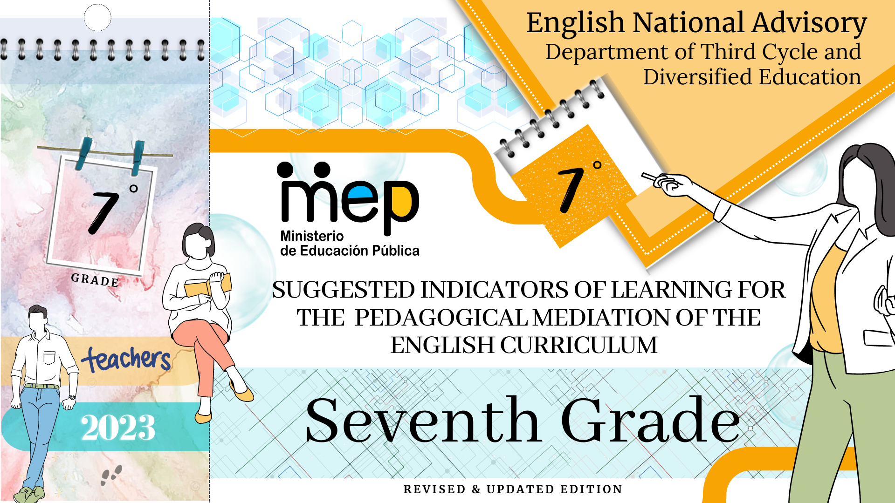

Comisión redactora

Mag. Marianella Granados Sirias,
Asesora Nacional de Inglés, Departamento de Tercer Ciclo y Educación Diversificada

Mag. Andrea Cruz Badilla
Asesora Nacional de Inglés, Departamento de Tercer Ciclo y Educación Diversificada

Validación

Camille Ann Campbell
Voluntaria de respuesta Cuerpo de Paz

Diseño de portada

Noelia González Cascante
Dirección de informática de Gestión
Dirección Regional de Educación Guápiles

Table of Contents

- Presentation ……………………………………………………………………………………………………………………….…3
- Aim of the document ……………………………………………………………………………………………………….….…….3
- Important points to keep in mind when working with the indicators……………………………………………………………..4
- Indicators of Learning ………..............................................................................................................................................5
- How to use this document………………………………………….………………………………………………………………..7
- How to incorporate the indicators of learning in your lesson plan………………………………………………….……………8
- Suggested Indicators of Learning Unit 1……………………………………………………………..…………………………...12
- Suggested Indicators of Learning Unit 2 ……………………….……………………………………………………….……......15
- Suggested Indicators of Learning Unit 3 …………………………………………………………………………………..…..…18
- Suggested Indicators of Learning Unit 4 …………………………………………………………………………………………21
- Suggested Indicators of Learning Unit 5 ………………………………………………………………………………….…...…26
- Suggested Indicators of Learning Unit 6 ………………………………………………………………………………….…...…30
- Samples for In-Class Progress and Performance Scale Instruments..………………………………………………......……34
- References …………………………………………………………………………………………………………..………………40

Presentation

This booklet provides English teachers of seventh grade with important information about suggested indicators of learning for the pedagogical mediation. This school year, teachers must write their own indicators. This document intends to be another resource that teachers can or might use as a reference to write their own indicators for planning and assessment. It includes a sample instrument for registering In -Class Progress and performance scales for oral exams. All the suggested indicators will help teachers to measure the goals, assessment strategies and the three learning strands (Learn to Know, Learn to Do, Learn to Be and Live in Community) set in the English curriculum when designing their lesson plans. As a result, learners can achieve the expected level of performance in the target language according to the CEFR.
Remember to visit the resource site for seventh grade in which you can find videos, audios, and the Teacher’s Guide for seventh grade.

https://www.mep.go.cr/educatico/recursos-guia-setimo-ano
https://recursos.mep.go.cr/teachers_guide7/videos.html
https://recursos.mep.go.cr/teachers_guide7/audios.html

Aim of this document:

- To provide a list of indicators of learning per unit and for each linguistic competence for seventh grade.
Important points to keep in mind when working with the indicators.

The CEFR defines communication as a social act, where learners are social agents, developing a range of general and specific communicative language competences, moving from learning about the language to learning to communicate in the language in active, spontaneous, and authentic language interaction. Most of the tasks to be accomplished have a meaningful communication objective, for example, solving a problem in a given scenario.
The CEFR defines competences as “the sum of knowledge, skills and characteristics that allow a person to perform actions in society (p.9). They are comprised of general and specific competences as shown in the following graphic organizer. General competences consist of knowledge, skills, and abilities to learn and existential competences that are not language-specific, but learners use them when performing all kinds of actions including language activities.

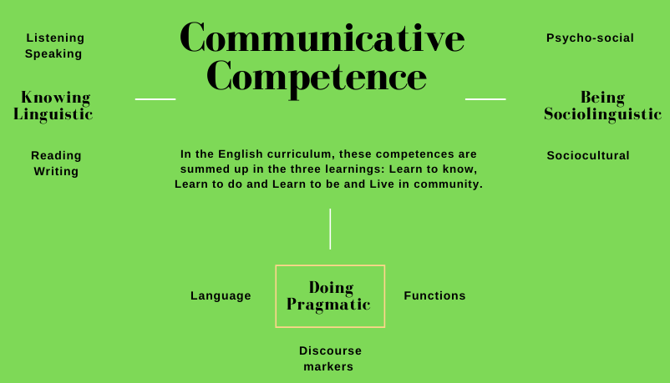
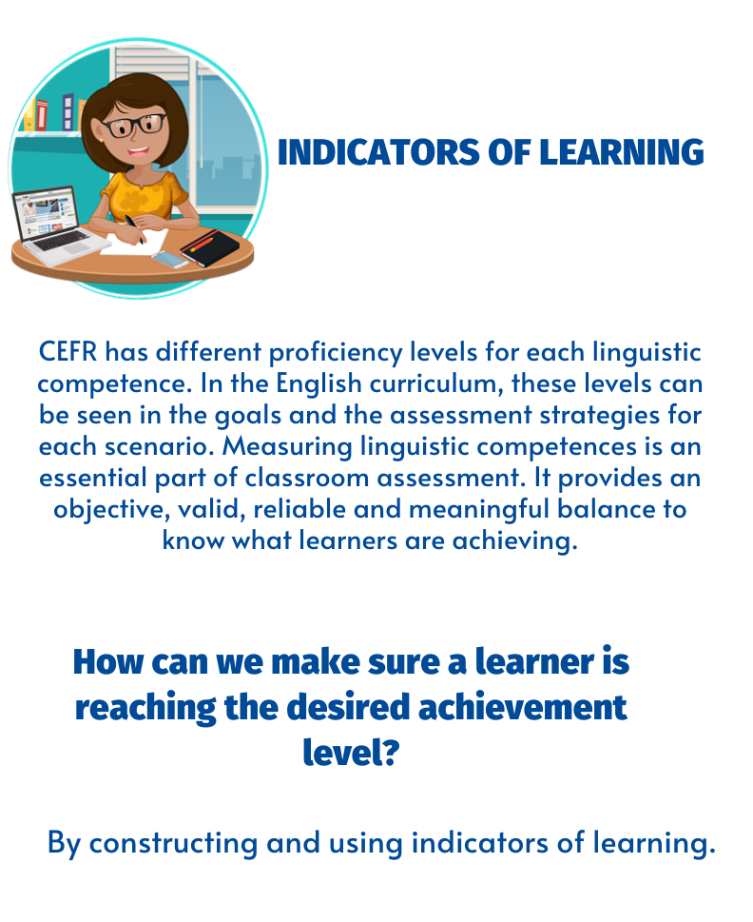
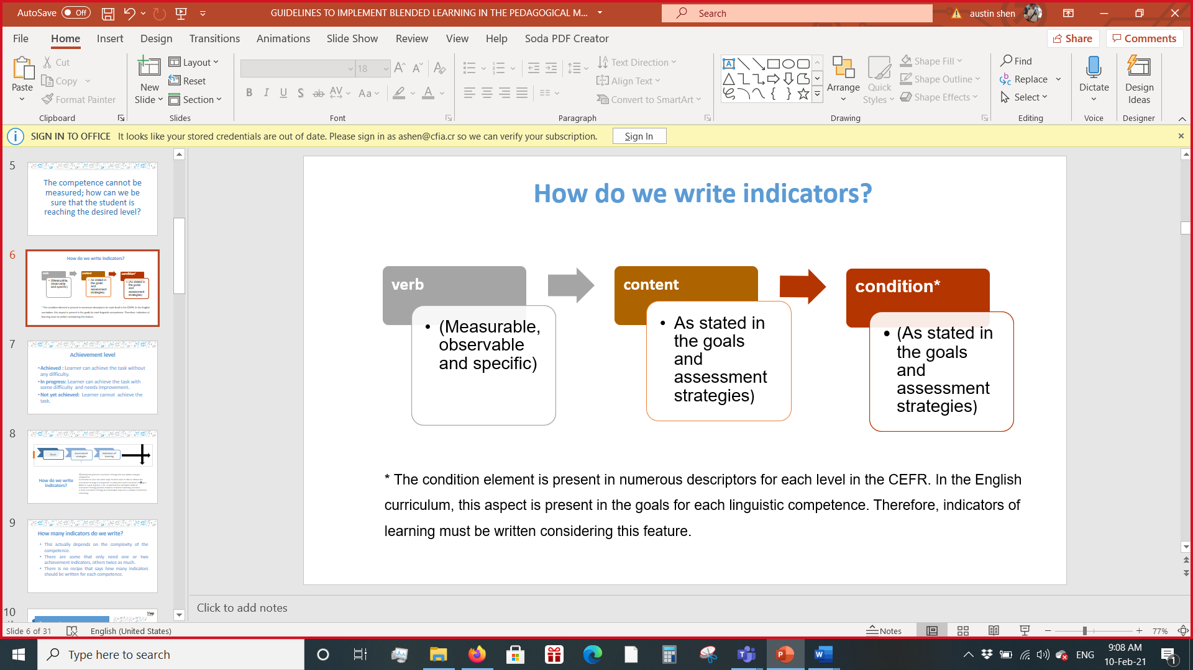
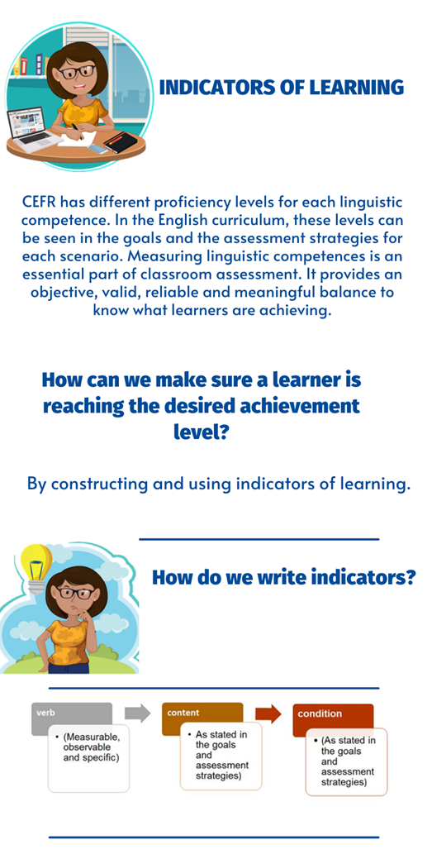
* The condition element is present in numerous descriptors for each level in the CEFR. In the English curriculum, this aspect is present in the goals for each linguistic competence. Therefore, indicators of learning must be written considering this feature.

.

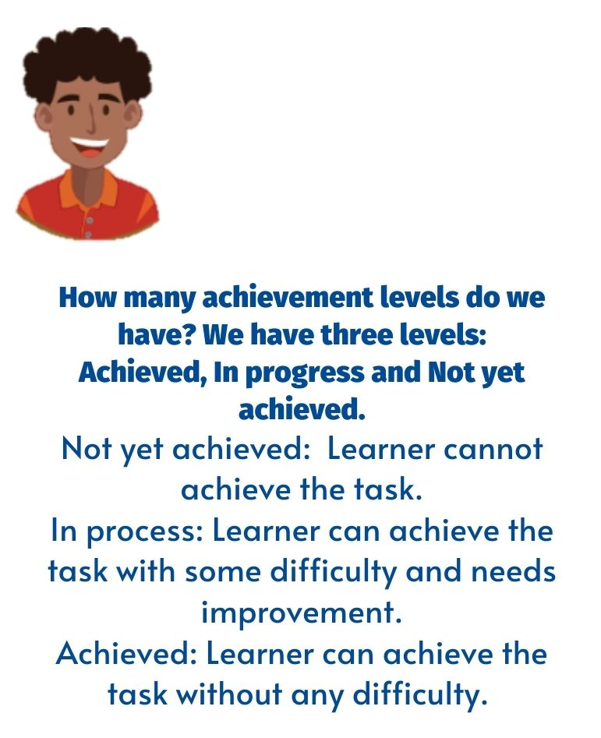
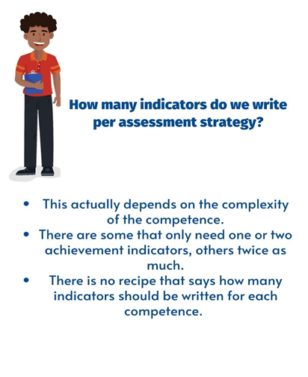
How to use this document

- Keep in mind that indicators have the following characteristics: measurable, observable and specific.
- Indicators of learning are organized by unit, then by each assessment strategy from the curriculum.
- Identify the goal and assessment strategy that you will be using. Remember, a goal is a can- do performance descriptor while an assessment strategy provides evidence of learner’s learning outcomes.
- Use indicators of learning throughout each unit to monitor students’ progress and make the corresponding mediation changes if necessary.
- The indicators of learning for each assessment strategy are arranged in sequential order for students to perform them appropriately.
- Remember that the Pre-teaching Stage must not have indicators of learning. They are strictly related to the suggested mediation sequence for each linguistic competence.

How to incorporate the indicators of learning in your lesson plan

  - While teaching (Oral Comprehension, Written Comprehension, Oral Production, Written Production), remember that there should be a connection between the goals, assessment strategies, indicators of learning, and pedagogical mediation for each competence.
  - The written indicators for each assessment strategy and goal must be incorporated in your lesson plan. They are scaffolded to ensure the learner achieves the assessment strategy and ultimately develops competency.
  - In the example below, with only one audio, all the indicators written for the assessment strategy were incorporated in the pedagogical mediation. This means you need to include all the indicators when planning, not only the ones you want to work with. They are written as small, essential steps that help to achieve the assessment strategy, the goal and finally to develop competency.
  - See the following example to integrate the indicators to your lesson plans.

Learner…  L.1. distinguishes the main points and the important details of audio recordings.  Indicator of learning:  L.1.1 Gets main points of audio recordings about healthy living.  L.1.2 Recognizes the topic of the conversation about recommendations to get a healthy lifestyle.  L.1.3 Identifies some supporting details in audio recordings about healthy living.  L.1.4 Identifies key words in audio recordings about healthy living. | Learner can …  L.1. understand the main points and the important details of audio recordings provided standard language is used regarding ingredients for healthy living, positive attitude, plans for success, and stories of successful people. | Oral Comprehension  Pre-listening  Learners match words with their corresponding meaning in a copy given by the teacher. She/he explains that those words are going to be found in the next listening activity. Teacher asks learners for the pronunciation of the words and reinforces it if necessary.  Teacher explains that they are going to listen to a conversation between a man and his wife, and they have to pay attention to what they are talking about.  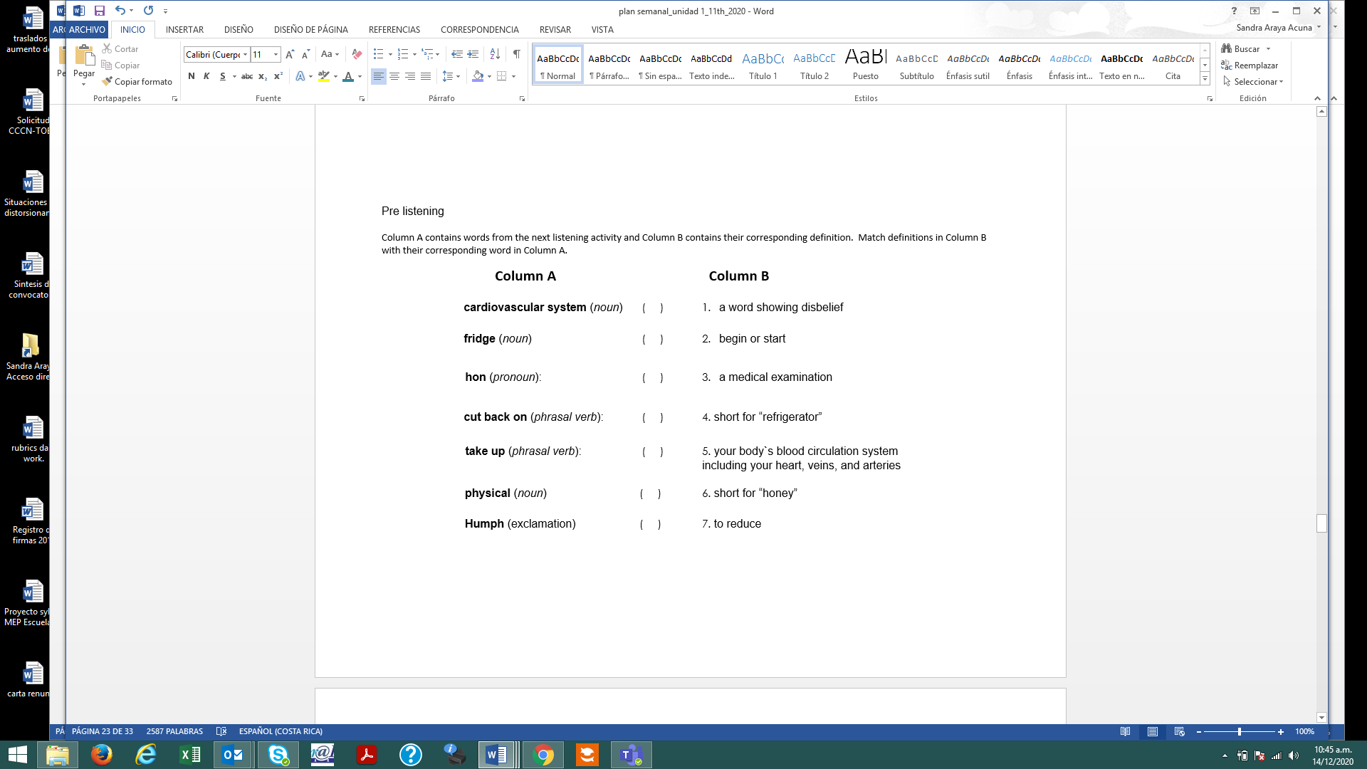  Learners compare answers and teacher checks them out loud.  Listening for the first time  Learners listen to a conversation taken from https://www.esl-lab.com/intermediate/healthy-lifestyle/ . Teacher can download the audio from https://www.esl-lab.com/quizzes/healthylifestyle-cloze.htm  Learners listen to the conversation for the first time and complete the following statements.  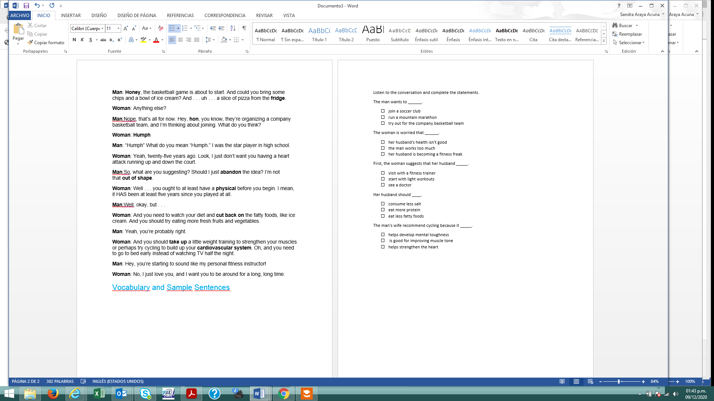  Pair /Group feedback: Learners share answers with the rest of the class.  With the information they got from the audio, learners, in pairs, have to choose the topic of the conversation. Teacher writes on the board the three options.  - My wife´s recommendations  - Recommendations to be a fitness freak  - Loving diet and exercise  Orally, learners should give at least two supporting details that helped them to choose that topic.  Pair/Group feedback: Learners share answers with the rest of the class.  Listening for the second time  Learners listen to the conversation again and fill in all the missing words below.  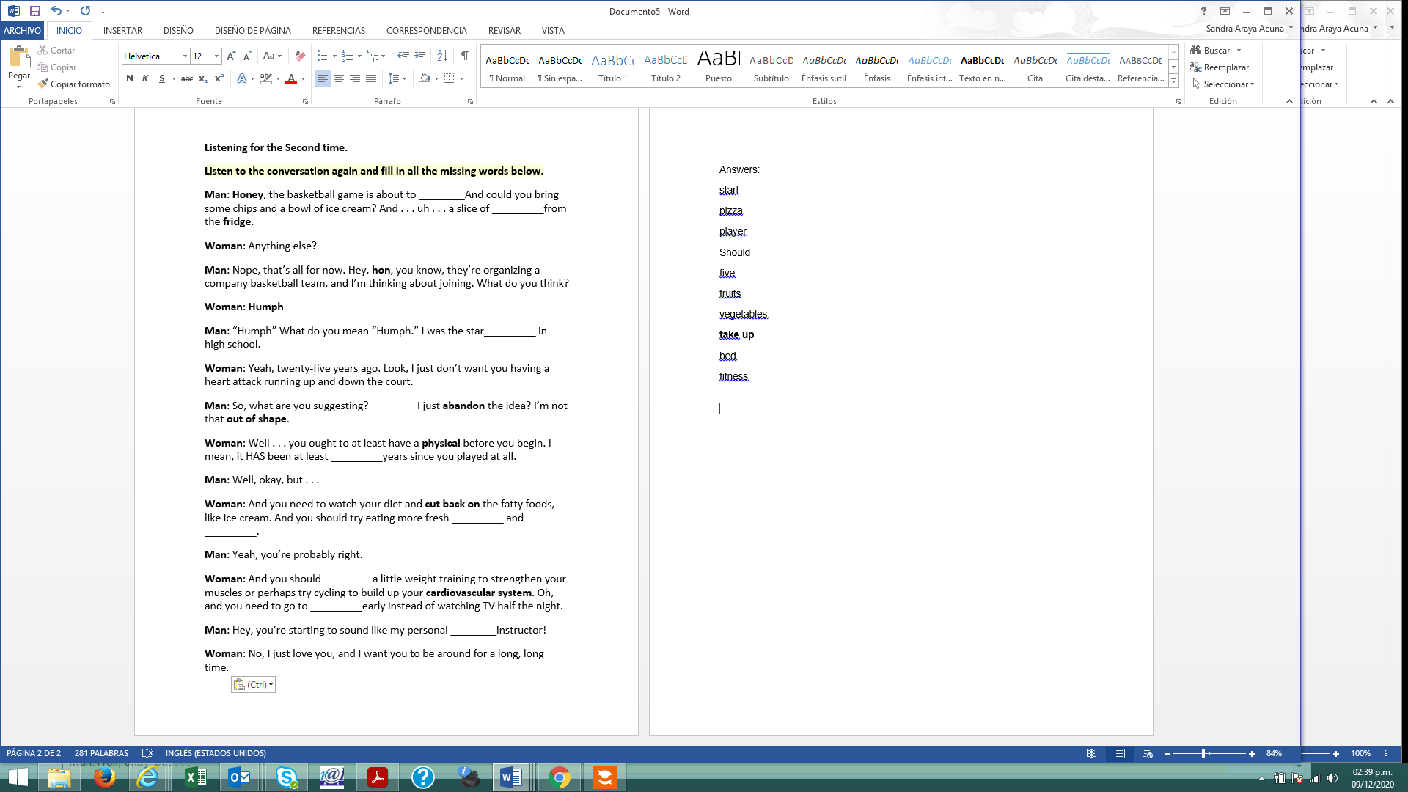  Learners check answers with their elbow partner.  Post-listening  Learners are asked to think about three things they need to change right now to have a healthy lifestyle. They should write their ideas on a piece of paper and stick it on the wall (as a reminder of things that need to be changed) | 5´  5’  5´  5´  10´  22´  25´  5

Unit 1
Scenario: Here I Am!
Assessment Strategies | Indicators of Learning
L.1. identifies basic greetings, farewells and common expressions of politeness. | L1.1 | Identifies basic greetings and farewells from an aural/oral prompt.
 | L1.2 | Identifies common expressions of politeness from an aural/oral prompt.
L.2. discriminates classroom language within oral utterances. | L2.1 | Distinguishes among basic classroom expressions from aural/oral prompt.
L.3. recognizes simple personal questions when they hear them. | L.3.1 | Recognizes simple personal information questions from aural/oral prompt
R.1. identifies brief, simple instructions if encountered in similar form. | R.1 | Identifies brief, simple instructions if encountered in similar form.
R.2. discriminates English language sounds. | R2.1 | Discriminates English language sounds.
R.3. recognizes some expressions and the main information in texts (heard or read) with instructional support. | R3.1 | Recognizes some expressions on posters, brochures, signs, invitations, and simple texts.
 | R3.2 | Recognizes main information in on posters, brochures, signs, invitations, and simple texts.
SI.1. spells out words. | SI.1.1 | Spells out words correctly.
SI.2. uses basic greeting and leave-taking expressions, farewell, and politeness and basic classroom language. | SI.2.1 | Recognizes and responds appropriately to basic greetings and farewells.
 | SI.2.2 | Recognizes and responds appropriately to basic classroom language.
SI.3. asks personal information to others. | SI.3.1 | Asks and answers spoken personal information questions.
SP.1. introduces him/herself providing personal information | SP.1.1 | Investigates and determines the appropriate information and visuals for a personal introduction in an oral presentation.
SP.1. introduces him/herself providing personal information | SP.1.2 | Organizes the information and visuals for a personal introduction in an oral presentation.
SP.1. introduces him/herself providing personal information | SP.1.3 | Constructs sentences with the information and the appropriate linkers or connecting words for a personal introduction in an oral presentation.
SP.1. introduces him/herself providing personal information | SP.1.4 | Introduces themselves in a well-organized oral presentation.
SP.2. describes his/her family simply. | SP2.1 | Investigates and determines the appropriate information to describe their family.
SP.2. describes his/her family simply. | SP2.2 | Organizes the information and resources to describe their family.
SP.2. describes his/her family simply. | SP2.3 | Constructs sentences with the information and the appropriate linkers or connecting words to describe their family.
SP.2. describes his/her family simply. | SP2.4 | Orally describes their family using prepared sentence frames.
W.1. writes labels on familiar objects in a picture or diagram. | W.1.1 | Labels familiar objects in a picture or diagram.
W.2. writes straightforward information about him/herself in short sentences. | W.2.1 | Prewrites ideas about personal information.
 | W.2.2 | Drafts personal information sentences using sentence frames and appropriate linkers or connecting words.
 | W.2.3 | Revises personal information sentences with a focus on content and checking for errors in subject-verb agreement, capitalization, spelling, and basic punctuation).
 | W.2.4 | Edits the sentences before publishing them.
Propuesta revisada y actualizada por: Marianella Granados Sirias y Andrea Cruz Badilla. Asesoras Nacionales de Inglés. Departamento de Tercer Ciclo y Educación Diversificada. Dirección de Desarrollo Curricular con la colaboración de Camille Campbell. Response Volunteer. Peace Corps Costa Rica

Unit 2
Scenario: Enjoying Life
Assessment Strategies | Indicators of Learning
L1. identifies the sound of words heard in context. | L1.1 | Identifies the sound of words heard in context.
L2. distinguishes simple phrases about daily routines, eating habits, hobbies and hanging out activities. | L2.1 | Distinguishes among simple phrases about daily routines, eating habits, hobbies and hanging out activities.
R.1. recognizes by manipulating English language sounds using knowledge in phonics, syllabification and word parts. | R1.1 | Recognizes targeted sounds in words.
 | R1.2 | Articulates targeted sounds.
 | R1.3 | Produces targeted sounds in simple sentences.
R.2. recognizes the main information on posters, brochures, signs, and invitations. | R2.1 | Recognizes the topic on posters, brochures, signs, and invitations.
 | R2.2 | Recognizes specific details on posters, brochures, signs, and invitations.
R.3. distinguishes brief, simple instructions and some expressions if encountered previously in the same or similar form. | R3.1 | Recognizes simple instructions in texts.
 | R3.2 | Differentiates among instructional expressions in texts.
SI.1. asks and answers in a predictable pattern simple questions about daily routines, eating habits, hobbies and hanging out activities if the other person speaks slowly and clearly. | SI.1.1 | Uses information questions to ask simple questions about daily routines, eating habits, hobbies and hanging out activities.
 | SI.1.2 | Constructs short sentences to answer information questions about daily routines, eating habits, hobbies and hanging out activities.
SI.2. expresses when he /she does not understand. | SI.2.1 | Communicates lack of comprehension using simple phrases and memorized patterns. Ex. I don’t understand. Can you repeat again, please?
S.P.1. describes how he/she enjoys life by using simple standard expressions. | SP1.1 | Investigates and determines the appropriate information to describe how they enjoy life.
 | SP1.2 | Constructs sentences by using sentence frames and the appropriate linkers or connecting words to describe how they enjoy life.
 | SP1.3 | Orally describes how they enjoys life.
W1. writes labels on familiar objects in a picture or diagram. | W1.1 | Writes labels on familiar objects in a picture or diagram.
W2. writes straightforward information about themselves in short simple sentences or provides that information on a questionnaire. | W2.1 | Prewrites personal information sentences ideas about habits, hobbies, and enjoying life.
 | W2.2 | Drafts personal information sentences about habits, hobbies, and enjoying life using sentence frames and the appropriate linkers or connecting words.
 | W2.3 | Revises the personal information sentences with a focus on content and checking for errors in subject-verb agreement, capitalization, spelling, and basic punctuation.
 | W2.4 | Edits the sentences or the information in the questionnaire before publishing them.
Propuesta revisada y actualizada por: Marianella Granados Sirias y Andrea Cruz Badilla. Asesoras Nacionales de Inglés. Departamento de Tercer Ciclo y Educación Diversificada. Dirección de Desarrollo Curricular con la colaboración de Camille Campbell. Response Volunteer. Peace Corps Costa Rica

Unit 3
Scenario: Getting Back to Nature
Assessment Strategies | Indicators of Learning
L.1. identifies instructions for games and follows teacher or students’ modeling of the activity. | L1.1 | Identifies and follows teacher’s or student’s instructions for games.
L.2. recognizes some isolated vocabulary, terms, and main ideas from specific subject areas. | L2.1 | Recognizes targeted terms in oral advertisements or conversations.
 | L2.2 | Recognizes the main idea and specific details in oral advertisements or conversations.
L.3. recognizes specific information about natural beauties and wonders. | L3.1 | Identifies the topic in oral texts about natural beauties and wonders.
 | L3.2 | Recognizes specific information in oral texts about natural beauties and wonders.
R.1. identifies English language sounds using knowledge in phonics, syllabification and word parts. | R1.1 | Recognizes targeted sounds in words.
 | R1.2 | Articulates the targeted sounds.
 | R1.3 | Produces the targeted sound in sentences in an oral or written form.
R.2. identifies key words related to nature in texts. | R2.1 | Identifies key words related to nature in texts.
R.3. recognizes main ideas in texts. | R3.1 | Recognizes the topic in texts about natural beauties and wonders when accompanied by illustrations.
R.3. recognizes main ideas in texts. | R3.2 | Recognizes the main ideas in texts about natural beauties and wonders when accompanied by illustrations.
R.4. recognizes specific details in texts accompanied by illustrations. | R4.1 | Identifies the topic in texts related to natural beauties and wonders when accompanied by illustrations.
 | R4.2 | Recognizes specific details in texts related to natural beauties and wonders when accompanied by illustrations.
SI.1. talks about tours and plans briefly. | SI1.1 | Briefly discusses a simple tour or place to visit using sentence frames and key words.
SI.1. talks about tours and plans briefly. | SI1.2 | Briefly discusses plans for the tour or place to visit using sentence frames and key words.
SI.2. asks somebody to repeat what he or she said more slowly. | SI.2.1 | Asks for repetition and clarification using simple phrases and memorized patterns.
SI.3. asks people for information related to places, tours and plans. | SI3.1 | Formulates basic yes/no questions to ask about places, tours and plans.
 | SI3.2 | Formulates basic wh- questions to get information about places, tours and plans.
SP.1. provides basic information about favorite natural beauties in the country and wonders all over the world. | SP1.1 | Orally shares information about natural beauties in the country by using sentence frames, key words and the appropriate linkers or connecting words.
SP.2. describes what he/she likes about places and tours. | SP2.1 | Investigates and determines the appropriate information to describe a favorite place or a tour.
SP.2. describes what he/she likes about places and tours. | SP2.2 | Organizes the information and resources to describe a place or a tour by using sentence frames and the appropriate linkers or connecting words.
SP.2. describes what he/she likes about places and tours. | SP2.3 | Orally describes the location, transportation, activities, prices and any other important information of different places or tours.
W.1. completes gapped sentences using a word list of familiar words. | W1.1 | Completes sentences by using the appropriate word according to the context.
W2. writes simple descriptions on traveling places and making plans, checking written sentences to look for mistakes (e.g., subject-verb agreement, capitalization, spelling, and basic punctuation). | W2.1 | Prewrites ideas for a description about a place, tour or plan using sentence frame and key words.
 | W2.2 | Drafts a description about a place, tour or plan using the appropriate linkers or connecting words.
 | W2.3 | Revises the description sentences with a focus on content and checking for errors in subject-verb agreement, capitalization, spelling, and basic punctuation).
 | W2.4 | Edits the description before publishing it.
Propuesta revisada y actualizada por: Marianella Granados Sirias y Andrea Cruz Badilla. Asesoras Nacionales de Inglés. Departamento de Tercer Ciclo y Educación Diversificada. Dirección de Desarrollo Curricular con la colaboración de Camille Campbell. Response Volunteer. Peace Corps Costa Rica

Unit 4
Checking Things of the Shopping List
Assessment Strategies | Indicators of Learning
L.1. identifies specific information when communicated to directly, provided something is already known about the subject, and when the speech is accompanied by pictures or drawings. | L.1.1 | Identifies the topic and key words in conversations about shopping for groceries and clothing when accompanied by pictures or drawings.
 | L.1.2 | Identifies specific details in conversations about shopping for groceries and clothing when accompanied by pictures or drawings.
L.2. recognizes what is being said about shopping for groceries and clothing. | L.2.1 | Recognizes key words and specific details in conversations about shopping for groceries and clothing.
L.3. recognizes most of a story when read slowly and accompanied by pictures. | L.3.1 | Recognizes the setting of a story when read slowly and accompanied by pictures.
 | L.3.2 | Recognizes the characters of a story when read slowly and accompanied by pictures.
 | L.3.3 | Recognizes the problem of a story when read slowly and accompanied by pictures.
 | L.3.4 | Recognizes the ending of a story when read slowly and accompanied by pictures.
R.1. identifies English-language sounds using knowledge in phonics, syllabification, and word parts. | R1.1 | Recognizes targeted sounds in words.
 | R1.2 | Articulates the targeted sounds.
 | R1.3 | Produces the targeted sounds in sentences in an oral or written form.
R.2. recognizes previously encountered parts of words, prefixes, and suffixes. | R.2.1 | Demonstrates recall of previously studied root word, prefixes, and suffixes in words.
R.3. distinguishes information related to groceries and clothing in posters, ads, catalogues and everyday signs and short texts. | R.3.1 | Identifies key words in each part of the posters, ads, catalogues and everyday signs and short texts.
 | R.3.2 | Finds specific details (price, size, quantity, and other characteristics) in each part of the in posters, ads, catalogues and everyday signs and short texts.
SI.1. asks and tells others his/her desires about shopping prices, size and where to get things. | SI.1.1 | Formulates basic yes/no questions and wh- questions to ask others about desires regarding shopping prices, size and where to get things.
 | SI.1.2 | Interacts with others to discuss shopping prices, size and where to get things.
SI.2. asks somebody to speak more slowly when needed. | SI.2.1 | Asks speaker to adjust speed using simple phrases and memorized patterns.
SI.3. buys things in shops by pointing or other gestures that can support what he/she says. | SI.3.1 | Asks for groceries, clothing or food at a store using short phrases and nonverbal cues.
 | SI.3.2 | Asks for prices, using short phrases and nonverbal cues.
 | SI.3.4 | Asks for different payment options to buy groceries, clothing or food using short phrases and nonverbal cues.
SI.4. uses simple numbers in everyday conversations. (e.g. prices) | SI.4.1 | Asks for prices to get groceries, clothing, or food at a store
SP.1. gives basic information about shopping preferences and prices. (e.g. favorite clothing, favorite shops). | SP.1.1 | Investigates and determines the appropriate information to give basic information about shopping preferences and prices in a presentation.
 | SP.1.2 | Organizes the information and resources to give basic information about shopping preferences and prices in a presentation by using sentence frames and the appropriate linkers or connecting words.
 | SP.1.3 | Constructs sentences to give basic information about shopping preferences and prices in a presentation by using sentence frames and the appropriate linkers or connecting words.
 | SP.1.4 | Orally presents basic information about shopping preferences and prices.
SP.2. describes shopping items using simple words and sentence frames. (For example: their size, color, material, price). | SP.2.1 | Investigates and determines the appropriate information to describe shopping items using simple words and sentence frames.
 | SP.2.2 | Organizes the information and resources to describe shopping items by using sentence frames and the appropriate linkers or connecting words.
 | SP.2.3 | Constructs sentences to describe shopping items by using sentence frames and the appropriate linkers or connecting words.
 | SP.2.4 | Orally describes shopping items using simple words and sentence frames.
W.1. writes simple descriptions of shopping lists and budget charts (e.g., I need some milk.) | W.1.1 | Prewrites ideas for a description of shopping lists and budget charts using sentence frames.
 | W.1.2 | Drafts a description of shopping lists and budget charts using the appropriate linkers or connecting words.
 | W.1.3 | Revises the descriptions with a focus on content and checking for errors in subject-verb agreement, capitalization, spelling, and basic punctuation.
 | W.1.4 | Edits the description before publishing it.
W.2. writes short, simple texts about shopping at grocery stores, clothing stores and supermarkets, checking written sentences to look for mistakes (e.g., subject-verb agreement, capitalization, spelling, basic punctuation etc.). | W.2.1 | Prewrites ideas for a short, simple text about shopping at grocery store, clothing stores and supermarkets.
 | W.2.2 | Drafts sentences for a short, simple text about shopping at grocery store, clothing stores and supermarkets using the appropriate linkers or connecting words.
 | W.2.3 | Revises a short, simple text with a focus on content and checking for errors in subject-verb agreement, capitalization, spelling, and basic punctuation.
 | W.2.4 | Edits a short, simple text before publishing it.
Propuesta revisada y actualizada por: Marianella Granados Sirias y Andrea Cruz Badilla. Asesoras Nacionales de Inglés. Departamento de Tercer Ciclo y Educación Diversificada. Dirección de Desarrollo Curricular con la colaboración de Camille Campbell. Response Volunteer. Peace Corps Costa Rica

Unit 5
Let’s Celebrate Costa Rican Culture
Assessment Strategies | Indicators of Learning
L.1. identifies basic phrases that denote facts about Costa Rican culture. | L.1.1 | Identifies key words and basic phrases that denote facts about Costa Rican culture in conversations.
L.2. recognizes pieces of short information about holidays and celebrations. | L.2.1 | Recognizes specific details in pieces of short information about holidays and celebrations in conversations.
L.2.1 recognizes what is being said about holidays and celebrations. | L.2.1.1 | Recognizes the gist or basic summary of what is being said about holidays and celebrations in conversations.
R.1. identifies and manipulates English language sounds using knowledge in phonics, syllabification and word parts. | R1.1 | Recognizes targeted sounds in words.
 | R1.2 | Articulates the targeted sounds.
 | R1.3 | Produces the targeted sound in sentences in an oral or written form.
R.2. recognizes vocabulary and important information on basic promotional material. (e.g., date, place and activities, on poster). | R.2.1 | Recognizes key words on basic promotional material such as posters.
 | R.2.2 | Recognizes specific details on basic promotional material such as posters.
R.3. discriminates straightforward information, words and expressions on Costa Rican culture. | R.3.1 | Labels pictures with words related to Costa Rican culture.
 | R.3.2 | Recognizes expressions on Costa Rican culture in texts.
 | R.3.3 | Locates straightforward information on Costa Rican culture in texts.
SI.1. answers simple questions using individual words, expressions, or short  sentences. | SI.1.1 | Uses individual words, expressions, or short sentences to answer questions about holidays and celebrations, orally.
SI.2. asks for specific information regarding holidays and celebrations. | SI.2.1 | Formulates yes/no questions to ask for specific information regarding holidays and celebrations.
 | SI.2.2 | Formulates wh- questions to ask for specific information regarding holidays and celebrations.
SI.3. interacts using basic language. | SI.3.1 | Interacts with others to exchange feelings and opinions regarding holidays and celebrations.
SP.1. talks about celebrations and holidays in Costa Rica briefly. | SP2.1 | Investigates and determines the appropriate information and illustrations to talk about celebrations and holidays in Costa Rica briefly.
 | SP2.2 | Organizes the information and illustrations to talk about celebrations and holidays in Costa Rica briefly.
 | SP2.3 | Constructs sentences with the information and the appropriate linkers or connecting words about celebrations and holidays in Costa Rica.
 | SP2.4 | Describes celebrations and holidays in Costa Rica briefly using sentence frames and illustrations.
SP.2. very simply describes how he/she celebrates holidays and special occasions and inquiries about others. | SP2.1 | Investigates and determines the appropriate information to very simply describe how he/she celebrates holidays and special occasions
 | SP2.2 | Organizes the information and resources to very simply describes how he/she celebrates holidays and special occasions.
 | SP2.3 | Constructs sentences with the information and the appropriate linkers or connecting words to describe how he/she celebrates holidays and special occasions.
 | SP2.4 | Describes how he/she celebrates holidays and special occasions using sentence frames and inquiries about others.
W.1. completes gapped sentences using a word list. | W.1. | Identifies the appropriate words to complete gapped sentences by using context clues.
W.2. writes simple descriptions of holidays and celebrations. | W2.1 | Prewrites a list of ideas for a simple description of a holiday or a celebration.
 | W2.2 | Drafts a simple description of a holiday or a celebration using the appropriate linkers or connecting words.
 | W2.3 | Revises the description with a focus on content and checking for errors in subject-verb agreement, capitalization, content, spelling, basic punctuation.
 | W2.4 | Edits the description by correcting mistakes before publishing.
W.2. writes cards for a holiday. | W2.1 | Prewrites a list of ideas for a card to give on a holiday.
W.2. writes cards for a holiday. | W2.2 | Drafts a card to give on a holiday using the appropriate linkers or connecting words.
W.2. writes cards for a holiday. | W2.3 | Revises a card to give on a holiday with a focus on content and checking subject-verb agreement, capitalization, content, spelling, basic punctuation and content.
W.2. writes cards for a holiday. | W2.4 | Edits a card to give on a holiday by correcting mistakes before publishing.
W.2. writes invitations for a celebration. | W2.1 | Prewrites a list of ideas for an invitation.
W.2. writes invitations for a celebration. | W2.2 | Drafts an invitation using the appropriate linkers or connecting words.
W.2. writes invitations for a celebration. | W2.3 | Revises an invitation with a focus on content and checking subject-verb agreement, capitalization, content, spelling, basic punctuation, and content.
W.2. writes invitations for a celebration. | W2.4 | Edits an invitation before publishing.
Propuesta revisada y actualizada por: Marianella Granados Sirias y Andrea Cruz Badilla. Asesoras Nacionales de Inglés. Departamento de Tercer Ciclo y Educación Diversificada. Dirección de Desarrollo Curricular con la colaboración de Camille Campbell. Response Volunteer Peace Corps Costa Rica

Unit 6
Getting from Here to There
Assessment Strategies | Indicators of Learning
L.1. follows simple directions on how to get from one place to another, on foot or by public transport. | L1. 1 | Follows simple directions on how to get from one place to another, on foot or by public transport in conversations.
L.2. recognizes figures given in clear announcements, for example at the airport or at a bus station. | L.2.1 | Recognizes numbers given in clear announcements, for example at the airport or at a bus station.
L.2. recognizes times given in clear announcements, for example at the airport or at a bus station. | L.2.2 | Recognizes times given in clear announcements, for example at the airport or at a bus station.
L.3. recognizes instructions for games and follows teacher/students’ modeling of the activity. | L.3.1 | Identifies key words in game’s instructions.
 | L.3.2 | Reproduces the instruction by following teacher/students’ modeling of the activity.
L.4. recognizes the main idea of presentations related to places, goods and services. | L.4.1 | Recognizes the main ideas of presentations related to places, goods and services.
R.1. labels diagrams with appropriate pieces of familiar goods and services. | R1.1 | Labels diagrams with appropriate pieces of familiar goods and services.
R.2. identifies English language sounds using knowledge in phonics, syllabification and word parts. | R2.1 | Recognizes targeted sounds in words.
 | R2.2 | Articulates the targeted sounds.
 | R2.3 | Produces targeted sounds in sentences in an oral or written form.
R.3. recognizes familiar names of places, goods and services in short and simple texts. | R3.1 | Recognizes familiar names of places, goods and services in short and simple texts.
R.4. recognizes main ideas of text when accompanied by illustrations. | R4.1 | Recognizes the gist in texts about places, goods and services when accompanied by illustrations.
SI.1.1 expresses preferences about places to visit. | S.1.1 | Orally expresses preferences about places to visit, orally. For example: My favorite place is.., I like …, I love …. I prefer…, I don´t like ….
SI.1 expresses preferences about ways to move around. | SI.1.1 | Orally expresses preferences about ways to move around.
SI.2. interacts in a simple way, asking and answering questions about places, where they are and how to get to them if they are articulated slowly and clearly. | SI.2.1 | Formulates yes/no questions to ask about places, where they are and how to get to them if they are articulated slowly and clearly
 | SI.2.2 | Correctly formulates wh- questions to ask about places, where they are and how to get to them.
 | SI.2.3 | Interacts by making complete sentences to answer what is being asked about places, where they are and how to get to them.
SP.1. uses simple words to tell where a place is and ways to get there. | SP.1.1 | Investigates and determines the appropriate information to tell where a place is and ways to get there.
 | SP.1.2 | Tells where a place is and ways to get there.
SP.2. describes places and ways to move around (towns, holiday resorts, car, plane, and bike). | SP2.1 | Investigates and determines the appropriate information to describe places and ways to move around (towns, holiday resorts, car, plane, and bike).
 | SP2.2 | Organizes the information and resources to describe places and ways to move around (towns, holiday resorts, car, plane, and bike).
 | SP2.3 | Constructs complete sentences to describe places and ways to move around (towns, holiday resorts, car, plane, and bike).
 | SP2.4 | Describes places and ways to move around (towns, holiday resorts, car, plane, and bike) using sentence frames.
SP.3. describes briefly weekend or holiday plans. | SP3.1 | Investigates and determines the appropriate information to describe briefly weekend or holiday plans.
SP.3. describes briefly weekend or holiday plans. | SP3.2 | Organizes the information and resources to describe briefly weekend or holiday plans.
SP.3. describes briefly weekend or holiday plans. | SP3.3 | Constructs complete sentences to describe briefly weekend or holiday plans.
SP.3. describes briefly weekend or holiday plans. | SP3.4 | Briefly describes weekend or holiday plans using sentence frames.
W.1. fills in a hotel registration form with personal details. | W1.1 | Fill in a hotel registration form with personal details.
W.2. writes simple descriptions of places (e.g., location, direction, activities) | W2.1 | Prewrites a list of ideas for a simple description of a place. (e.g., location, direction, activities)
 | W2.2 | Drafts a simple description of a place. (e.g., location, direction, activities) using the appropriate linkers or connecting words.
 | W2.3 | Revises the description with a focus on subject-verb agreement, capitalization, content, spelling, basic punctuation.
 | W2.4 | Edits the description before publishing.
Propuesta revisada y actualizada por: Marianella Granados Sirias y Andrea Cruz Badilla. Asesoras Nacionales de Inglés. Departamento de Tercer Ciclo y Educación Diversificada. Dirección de Desarrollo Curricular con la colaboración de Camille Campbell. Response Volunteer. Peace Corps Costa Rica

Samples for In-Class Progress and Performance Scale Instruments

Instrumento 7°,8°,9° y 10° 11° años académico y bilingüe / Módulo 46, Módulo 71 -CINDEA/ IPEC / INCO

Instrument for Registering In -Class Progress
Grade/ Level ____ Unit ____ | Performance Measure | Student name | Student name | Student name | Student name | Student name | Student name | Student name | Student name | Student name | Student name | Student name | Student name | Student name | Student name | Student name | Student name
Grade/ Level ____ Unit ____ | 3= Achieved: Learner can achieve the task without any difficulty.
Grade/ Level ____ Unit ____ | 2= In process: Learner can achieve the task with some difficulty and needs improvement.
Grade/ Level ____ Unit ____ | 1= Not yet achieved:  Learner cannot achieve the task.
Assessment Strategy | Indicators of learning
 | €
 | €
 | €
 | €
 | €
 | €
 | €
 | €
 | €
Total
Porcentaje

Oral Performance Scale-Sample (Oral Production)
____________High School Score: _____________
Summative instrument Total Points: ________
Allotted Time: ____________minutes Gotten points: _______
Level: Seventh Grade Percentage: __________%
Teacher: __________________________ Obtained Percentage: ____________
Date: _____________________________
Student`s name: ____________________________________ Group: ___________
Scenario: |  | Scenario: Enjoying Life
Assessment Strategy |  | SI.1. Asks and answers in a predictable pattern simple questions about daily routines, eating habits, hobbies and hanging out activities if the other person speaks slowly and clearly.
Description of linguistic task |  | Information exchange (2 minutes)  You met a friend online. He / she lives in a rural part of the country. You both would like to know more about each other’s daily routines, eating habits, hobbies or hanging out activities. So, you both agreed to have a virtual call to share some information. Choose one topic. And ask and answer questions to each other. You can use pictures to talk about it.
Indicators* | Points per indicator
Indicators* |  |  | N/A | 1 | 2 | 3 | 4
Uses information questions to ask about daily routines, eating habits, hobbies and hanging out activities. | 3 |  |  | Asks questions about daily routines, eating habits, hobbies or hanging out activities. The student fails to ask for most of the information (He/she cannot control memorized language structures (question patterns), so it is hard to be understood. | Asks questions about daily routines, eating habits, hobbies or hanging out activities appropriately sometimes. The student asks information about some of the elements. He/she can partially control memorized language structures (question patterns), to be somehow understood. | Asks questions about daily routines, eating habits, hobbies or hanging out activities appropriately and with ease. The student gets to ask for information about all the elements. He/she can consistently control basic language structures (question patterns)
Makes complete sentences to answer information questions about daily routines, eating habits, hobbies and hanging out activities. | 4 |  |  | Answers were incomplete He/she hardly answers questions about daily routines, eating habits, hobbies or hanging out activities appropriately when asked. He/she cannot identify the question word and helping verb to provide an answer with control of memorized language structures (sentence patterns), so it is hard to be understood. | Answers were partially accomplished. He/she sometimes answers questions about daily routines, eating habits, hobbies or hanging out activities appropriately when asked. He/she can partially identify the question word and helping verb to provide an answer with control of memorized language structures (sentence patterns) to be somehow understood. | Answers were accomplished. Most of the time, he/she answers questions about daily routines, eating habits, hobbies or hanging out activities appropriately when asked.  He/she can identify question words, helping verb and basic language structures (sentence patterns) at most times. | Answers were successfully accomplished. He/she, at all times, answers questions about daily routines, eating habits, hobbies or hanging out activities appropriately when asked.  He/she can consistently identify question words, helping verb and basic language structures (sentence patterns)
*Uses appropriate  communication  strategies (uses of facial expressions  and gestures, asks for repetition, indicates lack of understanding,  repeats words). | 3 |  |  | Fails in maintaining communication most of the time. Hard for him/her to use the communication strategies to overcome difficulties. | Makes use of some of the communication strategies to maintain communication going, but not all the time and inconsistently. | Makes use of many communication strategies to maintain communication going, which helps to keep the flow of the conversation | .
*Pronounces the target language correctly | 3 |  |  | Difficulty at understanding. Constant mistakes in pronunciation  (More than 4 mistakes) | Understandable at most times. Occasional mispronunciation; some consistent mistakes.  (3-4 mistakes) | Clear and smooth pronunciation at this level. Few sporadic deviations.  (1-2 mistakes)
*Stresses words and sentences correctly | 2 |  |  | Sometimes  stresses individual words correctly and uses appropriate intonation when forming sentences | Constantly stresses individual words correctly and uses appropriate intonation when forming sentences
*Speaks at a  normal speed | 3 |  |  | Carried out with hesitation that sometimes interferes with the message. Some long pauses to recall meaning. | Carried out adequately with some hesitation that seldom interferes with the message. Few short pauses to recall meaning. | Carried out with confidence. Sporadic short pauses to recall meaning.
Total: | 23
Comments:
Propuesta revisada y actualizada por: Marianella Granados Sirias y Andrea Cruz Badilla. Asesoras Nacionales de Inglés. Departamento de Tercer Ciclo y Educación Diversificada. Dirección de Desarrollo Curricular.

Oral Performance Scale-Sample (Oral Production)
Dos Cercas High School Score:_____________
Summative instrument Total Points: ________
Allotted Time: ____________minutes Gotten points: _______
Level: Eighth Grade Percentage: __________%
Teacher: __________________________ Obtained Percentage: ____________
Date: _____________________________
Student`s name:____________________________________ Group:___________
Scenario: |  | Something to Celebrate!
Assessment Strategy |  | SI.2. Asks and answers about holidays and festivals in Costa Rica, Latin America and around the World.
Description of linguistic task |  | Information exchange (2 minutes)  You are participating in an international school summer camp. You were asked to talk about favorite holidays or celebrations around the world. Choose one and talk about when and where it is celebrated, special food, activities. Use pictures to talk about it and ask questions to the teacher or classmates. Answer a couple of questions from your teacher or classmates.
Indicators* | Points per indicator
Indicators* |  |  | N/A | 1 | 2 | 3 | 4
Asks questions about holidays and festivals in Costa Rica, Latin America and around the World. | 3 |  |  | Asks questions about holidays and festivals in Costa Rica, Latin America and around the World with a lot of difficulty. The student fails to ask for most of the information (He/she cannot control memorized language structures (question patterns), so it is hard to be understood. | Asks questions about holidays and festivals in Costa Rica, Latin America and around the World appropriately sometimes. The student asks information about some of the elements. He/she can partially control memorized language structures (question patterns), to be somehow understood. | Asks questions about holidays and festivals in Costa Rica, Latin America and around the World appropriately and with ease. The student gets to ask for information about all the elements. He/she can consistently control basic language structures (question patterns)
Answers questions about holidays and festivals in Costa Rica, Latin America and around the World. | 4 |  |  | Answers were incomplete He/she hardly answers questions about holidays and festivals in Costa Rica, Latin America and around the World appropriately when asked. He/she cannot identify the question word and helping verb to provide an answer with control of memorized language structures (sentence patterns), so it is hard to be understood. | Answers were partially accomplished. He/she sometimes answers questions about holidays and festivals in Costa Rica, Latin America and around the World appropriately when asked. He/she can partially identify the question word and helping verb to provide an answer with control of memorized language structures (sentence patterns) to be somehow understood. | Answers were accomplished. Most of the time, he/she answers questions about holidays and festivals in Costa Rica, Latin America and around the World appropriately when asked.  He/she can identify question words, helping verb and basic language structures (sentence patterns) at most times. | Answers were successfully accomplished. He/she, at all times, answers questions about holidays and festivals in Costa Rica, Latin America and around the World appropriately when asked.  He/she can consistently identify question words, helping verb and basic language structures (sentence patterns)
Gives information about holidays and festivals in Costa Rica, Latin America and around the World. | 3 |  |  | The task was incomplete He/she hardly gives information about holidays and festivals in Costa Rica, Latin America and around the World. He/she cannot control memorized language structures (sentence patterns), so it is hard to be understood | The task was partially accomplished. He/she somewhat gives information about holidays and festivals in Costa Rica, Latin America and around the World by either talking about the holiday or festival name or date of celebration. He/she can partially control memorized language structures  (sentence pattern), to be somehow understood | The task was successfully accomplished. He/she gives information about holidays and festivals in Costa Rica, Latin America and around the World by talking about when and where they are celebrated, special food, activities. He/she can consistently control basic language structures (sentence patterns)
*Uses appropriate  communication  strategies (uses of facial expressions  and gestures, asks for repetition, indicates lack of understanding,  repeats words). | 3 |  |  | Fails in maintaining communication most of the time. Hard for him/her to use the communication strategies to overcome difficulties. | Makes use of some of the communication strategies to maintain communication going, but not all the time and inconsistently. | Makes use of many communication strategies to maintain communication going, which helps to keep the flow of the conversation | .
*Pronounces the target language correctly | 3 |  |  | Difficulty at understanding. Constant mistakes in pronunciation  (More than 4 mistakes) | Understandable at most times. Occasional mispronunciation; some consistent mistakes.  (3-4 mistakes) | Clear and smooth pronunciation at this level. Few sporadic deviations.  (1-2 mistakes)
*Stresses words and sentences correctly | 2 |  |  | Sometimes  stresses individual words correctly and uses appropriate intonation when forming sentences | Constantly stresses individual words correctly and uses appropriate intonation when forming sentences
*Speaks at a  normal speed | 3 |  |  | Carried out with hesitation that sometimes interferes with the message. Some long pauses to recall meaning. | Carried out adequately with some hesitation that seldom interferes with the message. Few short pauses to recall meaning. | Carried out with confidence. Sporadic short pauses to recall meaning.
Total: | 23
Comments:
*The indicators related to pronunciation, fluency and sociolinguistic appropriateness were constructed to measure overall achievement. They must be present in all instruments related to Spoken Interaction and Spoken production as required.

Propuesta elaborada por: Marianella Granados Sirias y Alfredo Ortega Cordero. Asesores Nacionales de Inglés. Departamento de Tercer Ciclo y Educación Diversificada. Dirección de Desarrollo Curricular, 2021.

References
Curriculum Services Canada, A Guide to Reflective Practice for Core French Teachers, The Action-Oriented Approach. Module 3. Ministry of Education and the Government of Canada through the Department of Canadian Heritage.

Common European Framework of Reference for Languages: Learning, Teaching, Assessment (2003). Cambridge, U.K.: Press Syndicate of the University of Cambridge.

Common European Framework of Reference for Languages: Learning, Teaching, Assessment (2018). Cambridge, U.K.: Press Syndicate of the University of Cambridge.

Frade, L. (2009) Desarrollo de Competencias en Educación. Inteligencia Educativa. 2 edición (295-402)

Ministerio de Educación Pública (2021). Lineamientos técnicos para el proceso de evaluación, curso lectivo 2021. San José, Costa Rica: MEP.

Ministerio de Educación Pública (2021). Mediación Pedagógica para la Educación Combinada, curso lectivo 2021. San José, Costa Rica: MEP.

Ministerio de Educación Pública (2016). Programa de Estudio de Inglés Tercer Ciclo y Educación Diversificada Académico. San José, Costa Rica: MEP.

Ministerio de Educación Pública (2017). Programa de Estudio de Inglés Plan de Estudios Liceo Bilingüe Secciones Bilingües español –Inglés Tercer Ciclo. San José, Costa Rica: MEP.

Ministerio de Educación Pública (2020). Programa de Estudio de Inglés Plan de Estudios Liceo Bilingüe Secciones Bilingües español –Inglés Educación Diversificada. San José, Costa Rica: MEP.

https://www.orientacionandujar.es/2016/11/06/taxonomia-robert-marzano-verbos-recomendados-indicadores-niveles-cognitivos/

