Autoridades

Giselle Cruz Maduro
Ministro de Educación Pública

Melania Brenes Monge
Viceministra Académica de Educación

María Alexandra Ulate Espinoza
Directora de la Dirección de Desarrollo Curricular

Rigoberto Corrales Zúñiga
Jefe del Departamento de Tercer Ciclo y Educación Diversificada

Comisión redactora

Mag. Marianella Granados Sirias,
Asesora Nacional de Inglés, Departamento de Tercer Ciclo y Educación Diversificada

Mag. Alfredo Ortega Cordero,
Asesor Nacional de Inglés, Departamento de Tercer Ciclo y Educación Diversificada

Mag. Andrea Cruz Badilla
Asesora Nacional de Inglés, Departamento de Tercer Ciclo y Educación Diversificada

Comisión validadora
Ivannia Arias Zúñiga. Sección Bilingüe Español-Inglés Liceo de Sinaí
Félix Díaz Castañeda, Sección Bilingüe Español-Inglés Liceo de Nicoya
Karen Pereira Meneses, Liceo de Costa Rica
Ana Lucía Ramírez Rodríguez, Liceo de Costa Rica
David Valerio Sánchez, Liceo de Costa Rica
Juliana Sánchez Sánchez, Sección Bilingüe Español-Inglés Liceo San Rafael
Roberto Segnini Cabezas, Sección Bilingüe Español-Inglés Liceo de Colorado
Luis Diego Soto Delgado, Sección Bilingüe Español-Inglés Liceo de Higuito

Diseño de portada
Noelia González Cascante
Direccion Regional de Educación Guápiles

Table of Contents

- Presentation ………………………………………………………………………………………………………………….…5
- Aims of the document ……………………………………………………………………………………………….….……..5
- Important points to keep in mind when working with the Literature in English Language Program……………………6
- About the indicators for the pedagogical mediation …................................................................................................7
- 9th Grade Performance Indicators for the Pedagogical Mediation ……………………………………………..….……12
- Important Considerations………………………………………………………………………………………………..……13
- Suggested Performance Indicators for the Pedagogical Mediation Term 1, 2, 3..……….………………….…….…...14
- References …………………………………………………………………………………………………..……………...…22

Presentation
Dear teachers:

These guidelines intend to provide you, Literature teachers of ninth grade, with important information on how effectively write indicators to help you to plan your lessons and create assessment instruments for their Self-Study Guides (GTA) and the assessment promotion strategy or estrategia de promoción in Spanish. All the indicators will help teachers to measure the performance indicators set in the Literature in English Language curriculum. We believe that you know your students best and therefore we encourage you to adapt and contextualize what you find here so that it responds to the needs of your learners. Remember to visit the following link with supplementary resources for your lessons. https://recursos.mep.go.cr/lebs_y_sebi/:

Aims of this document:

- To give teachers a brief explanation on how to write indicators of learning for planning their Self-Study Guides (GTA in Spanish).
- To recommend a list of suggested performance Indicators for the pedagogical mediation to teach Literature in English Language in Ninth Grade.

Best,
English Secondary National Advisors

Important points to keep in mind when working with the Literature in English Language Program.

- Literature should connect with life experiences, beliefs, and convictions, which have to be faced through a methodological approach of ethical dilemmas (daily life, artistic, fictitious and historical) within a new democratic perspective.

- Literature constitutes a valid opportunity to promote the use of critical and creative skills in the process of building up a classroom community of inquiry, adapted by teachers, according to the learner´s interest and level of English.

- Literature is an invitation to a dialogue. It teaches about humanity and reveals pros and cons of characters in specific situations and times. Learning a language is also learning about culture and values.

- Literature mirrors our own lives and provides a window into distant places, times, and people.

- Reading literature can increase the chances of students becoming passionate readers, who read with a purposeful objective, as well as enjoyment. Additionally, students can improve other skills through literature. As an illustration, creativity and reflection can be reinforced as students perform, write, and analyze different literary texts. Perhaps, this is the ultimate reason that students have for writing with joy and pleasure; that is, their education will be going beyond the reading.

Programa de Literatura en Lengua Inglesa Liceos Experimentales Bilingües, 2011, MEP

About the indicators for the pedagogical mediation…

When working with the Literature in the English Language program, teachers need to design their own teaching procedures, in the mediation activities, on the basis of the learners’ pre-and post-assessments, as well as performance and reaction to instructional practices, circumstances and interests of each class community. The use of a rich variety of techniques and activities in the class will lead the students to establish positive cross curricular connections with suggested and flexible literature contents and within a socio-constructivist curricular approach. Consequently, visualizing, planning, and implementing techniques relevant to student-need and selecting coherent activities with the method, and in harmony with the approach, is the teacher’s job. In regard to the performance indicators for the pedagogical mediation, they are used to assess the activities proposed during the pedagogical mediation process. Performance indicators for the pedagogical mediation are strictly related to the activity’s achievement, and they help to provide specific and timely descriptive feedback to students.

It is important to clarify that this document includes only performance indicators that are measurable, observable and specific. However, we ask teachers to pay special emphasis on the following observable behaviors since they are as equally important because of nature and purpose of this subject:

- Appreciate and enjoy intermediate oral and written literature.
- Enjoy and understand a variety of literary passages.
- Value authors ‘literary contributions.
- Demonstrate development of social strategies.
- Appreciate and talk about other cultures.
- Apply collaborative work and learning strategies (outline, graphic organizers, etc.).
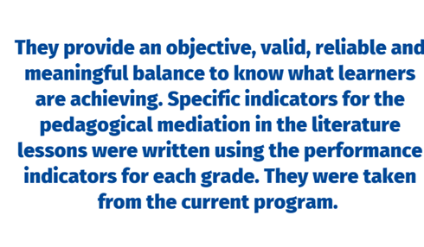
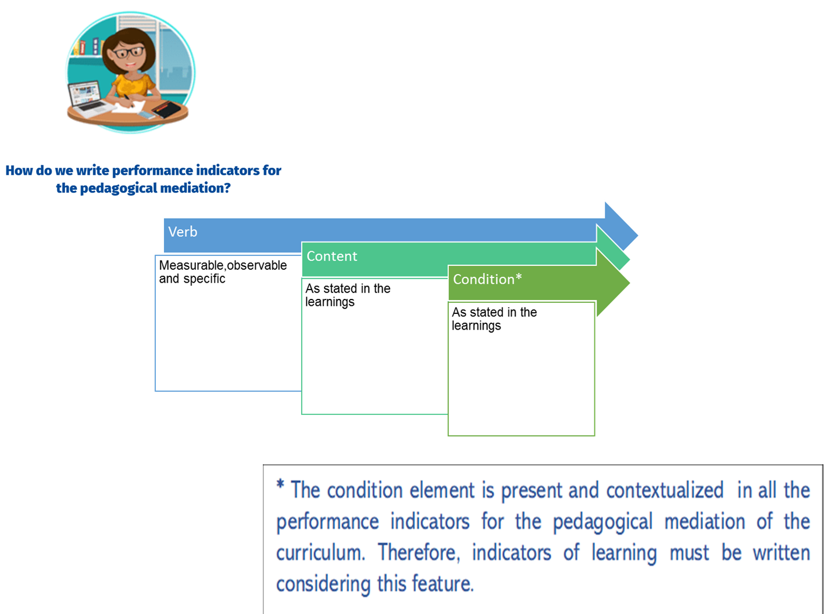
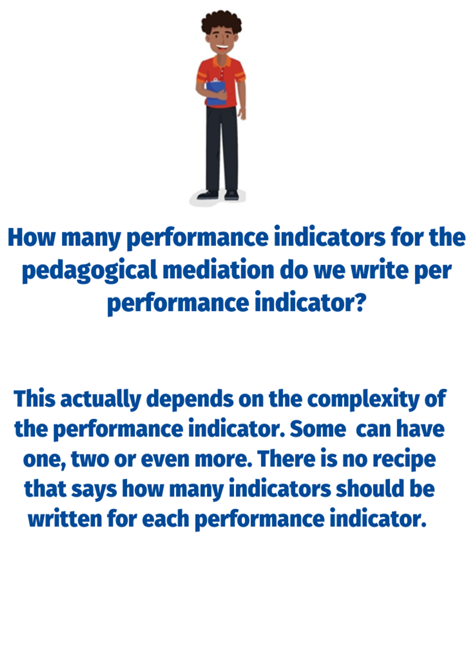
9th Grade Performance Indicators for the Pedagogical Mediation
The 9th Grade Literature in English Language curriculum provides performance indicators. These performance indicators are evidence that a teacher can record to show that students are achieving the learnings.
As classroom teachers, however, we do not simply assess students´ progress. We must guide students step by step through activities that enable them to reach the learnings.
This document breaks each performance indicator down into a number of specific performance indicators for the pedagogical mediation. They are the steps that learners follow to achieve the performance indicators. The performance Indicators for the pedagogical mediation have the following characteristics: measurable, observable and specific.

How to use this document:

1) Identify the performance indicator that you will be using.
2) Consider the steps or indicators for the pedagogical mediation learners need to follow to achieve each specific performance indicator.
3) Remember that there should be a connection between each performance indicator with the specific indicator for the pedagogical mediation proposed in this document.
4) Use specific indicators for the pedagogical mediation to monitor students’ progress and make the corresponding mediation changes if necessary.

Important considerations:
- Indicators for the pedagogical mediation are organized in terms.
- In some of the indicators proposed, teachers have to include the content of these indicators.
- In most of the cases, indicators for the pedagogical mediation are arranged in a suggested order for students to perform them appropriately.
- It is always necessary to use indicators for the pedagogical mediation, such as the ones suggested in this document. As educators, teachers must use their own professional judgement to identify the steps their students most need to take to achieve the learnings and that is reflected in the pedagogical mediation.
- During the face- to- face and/or distance pedagogical mediation process, and therefore, at the end of each self-study guide, the teacher will use the indicators to create instruments (rubrics and /or performance scales) to assess students’ achievement level.
- The mediation activities in the self-study guides must be coherent with the indicators for the pedagogical mediation to be included in the corresponding achievement level rubric.
- When revising the indicators for the pedagogical mediation, consider that you can follow the steps below as suggested by the Institute of Collaborative Learning:

- Select the activity and leave it as it is.
- Adapt it or change it somehow.
- Reject it. Choose not to use it
- Supplement it. Enrich the activity with extra material to make it more appropriate.

Level: 9th
Terms: 1-2-3
Performance indicators from the program | Suggested Performance Indicators for the Pedagogical Mediation
Reacts to different oral and visual tasks (role plays, poems, songs, videos, dialogues and storytelling, etc.). | Identifies the title (role plays, poems, songs, videos, dialogues and storytelling.
 | Recognizes the writer’s purpose by paying attention to the title.
 | Distinguishes images, techniques and literary figures.
 | Describes the artwork (oeuvre) including information about what, who, when, where, what it is about.
 | Reacts in a written / oral form towards the artwork (oeuvre).
Identifies some elements of fiction (archetypes, irony, narrator’s point of view, and dialogue.) | Gets the gist of international folktales, myths, poetry, short stories, science fiction, mystery, crime, detective, horror, graphic novels, comics, cartoon, and short novels.
 | Distinguishes main ideas and specific details in international folktales, myths, poetry, short stories, science fiction, mystery, crime, detective, horror, graphic novels, comics, cartoon, and short novels.
 | Identifies some elements of fiction (archetypes, irony, narrator’s point of view, and dialogue) in international folktales, myths, poetry, short stories, science fiction, mystery, crime, detective, horror, graphic novels, comics, cartoon, and short novels.
Identifies some elements of poetry (alliteration and onomatopoeia). | Recognizes some elements of fiction (archetypes, irony, narrator’s point of view, and dialogue) in of international folktales, myths, poetry, short stories, science fiction, Mystery, Crime, Detective, horror, graphic novels, comics, cartoon, and short novels.
Identifies some elements of the English language (idioms, diction, and syntax). | Recognizes some elements of the English language (idioms, diction, and syntax) in of international folktales, myths, poetry, short stories, science fiction, Mystery, Crime, Detective, horror, graphic novels, comics, cartoon, and short novels.
Produces poems (narrative, free verse, lyrics, and concrete) | Prewrites lines and stanzas for a narrative, free verse, lyrics, and concrete poems.
 | Drafts lines and stanzas for a narrative, free verse, lyrics, and concrete poems.
 | Revises lines and stanzas for a narrative, free verse, lyrics, and concrete poems.
 | Edits narrative, free verse, lyrics, and concrete poems by correcting the mistakes before publishing them. (jargon and slang are respected if they are part of the author writing style)
Produces simple cartoons. | Prewrites ideas for characters and speech bubbles to produce a simple cartoon.
 | Drafts sentences for speech bubbles and the punch line for a simple cartoon.
 | Revises sentences in speech bubbles and the punch line for a simple cartoon by looking for mistakes. (jargon and slang are respected if they are part of the author writing style)
 | Edits speech bubbles and the punch line for a simple cartoon by correcting the mistakes before publishing it.
Writes an integrated project based on a literary piece (short play). | Prewrites ideas for a short play script including title, setting, characters, imagery conflict, rising action, climax, falling action, resolution and plot.
 | Drafts the script of a short play.
 | Revises the script of a short play by looking for mistakes.
 | Edits the script of a short play by correcting the mistakes before publishing it.
Discriminates main ideas and specific details in a variety of oral, visual, and written passages. | Identifies the topic in a variety of oral, visual, and written passages.
 | Identifies main ideas in a variety of oral, visual, and written passages.
 | Extracts details in a variety of oral, visual, and written passages.
Distinguishes meaning in context. | Identifies written and spoken forms of vocabulary.
 | Recognizes the different meanings of the same word by using the context.
Expresses ideas, feelings, likes and dislikes, preferences, opinions, hypotheses using appropriate vocabulary in oral and written oral forms. | Plans a set of ideas to express ideas, feelings, likes and dislikes, preferences, and opinions hypotheses, using appropriate vocabulary in oral and written forms towards the artwork (oeuvre).
 | Makes complete sentences to express ideas, feelings, likes and dislikes, preferences, and opinions hypotheses using appropriate vocabulary in oral and written forms towards the artwork (oeuvre).
 | Expresses ideas, feelings, likes and dislikes, preferences, opinions, hypotheses using appropriate vocabulary in oral and written oral forms.
Defends arguments using appropriate vocabulary in oral and written oral forms. | Plans a set of ideas to defend arguments using appropriate vocabulary in oral and written forms towards the artwork (oeuvre).
 | Makes complete sentences to defend arguments using appropriate vocabulary in oral and written forms towards the artwork (oeuvre).
 | Defends arguments using appropriate vocabulary in oral and written forms towards the artwork (oeuvre).
Paraphrases different literary passages. | Lists main ideas and important details of different literary passages.
 | Sequences important details of different literary passages.
 | Recaps main ideas and important details of different literary passages.
Summarizes different literary passages. | Prewrites important details about different literary passages.
 | Drafts a summary with important details about different literary passages.
Revises a summary with important details about different literary passages
by checking subject-verb agreement, pronoun and article agreement, capitalization, indentation, sentence sense, text structure, word order, punctuation and content.
 | Edits the summary with important details about different literary passages. before publishing.
Analyzes short drama. | Identifies the tittle’s meaning in a short drama.
 | Describes the characters in a short drama.
 | Describes the structure of the plot in a short drama.
 | Distinguishes the setting, place and time in a short drama
 | Relates the short drama with cultural context.
 | Describes the connections between plot and character developments in a short drama.
 | Infers character motivations in a short drama.
 | Explains recurring motifs and themes in a short drama.
Talks about other cultures. | Selects the appropriate information and visuals to give a presentation about other cultures
 | Organizes the information and visuals to give a presentation about other cultures.
 | Makes sentences with the information and with the appropriate linkers or connecting words to give a well-organized presentation about other cultures.
 | Gives a well-organized presentation about other cultures.
Predicts events, consequences of different literary passages. | Foretells events in different literary passages.
 | Foretells consequences in different literary passages.
Questions events and consequences of different literary passages. | Identifies facts from events in different literary passages.
 | Recognizes details from the events and consequences.
 | Describes the relationship between events and consequences in different literary passages.
Infers events, consequences of different literary passages. | Gets the gist of an event in different literary passages.
 | Identifies main ideas in different literary passages.
 | Recognizes specific details of an event different literary passages.
 | Establishes connections and links among the gist, main ideas and details.
 | Draws conclusions about the consequences of an event based on connection and links in different literary passages.
Sequences events of different literary passages. | Skims for the gist of different literary passages.
 | Scans the text to find words that explicit sequence events such as first, next, last.
 | Identifies the problem/situation, rising action, climax, falling action, and resolution of different literary passages.
 | Sequences the problem/situation, rising action, climax, falling action, and resolution of different literary passages.
Evaluates events, consequences of different literary passages. | Gets the gist of different literary passages.
 | Identifies the most important events of different literary passages.
 | Recognizes major topics discussed in different literary passages.
 | Distinguishes characters that appear the most in different literary passages.
 | States the story line from in different literary passages.
 | Links events and consequences in different literary passages.
 | Infers the author’s goal, tone and point of view in different literary passages.
Compares texts, events, consequences of different literary passages. | Skims for the gist of different literary passages.
 | Scans different literary passages to find the events.
 | Recognizes the consequences from the events in different literary passages.
 | States similarities in events and consequences of different literary passages.
Contrasts texts, events, consequences of different literary passages. | Skims for the gist of different literary passages.
 | Recognizes the structure of the text.
 | Scans different literary passages to find the events.
 | Recognizes the consequences from the events in different literary passages.
 | States differences in events and consequences of different literary passages.
Paraphrases texts, events, consequences of different literary passages. | Lists events, consequences of different literary passages.
 | Puts in order events, consequences of different literary passages.
 | Recaps main ideas, important details, events, consequences of different literary passages.
Summarizes texts, events, consequences of different literary passages. | Scans different literary passages to list main points, details, events and consequences.
 | Drafts a short summary of a piece of literature including main points and giving specific details about events, consequences using the appropriate linkers or connecting words.
 | Revises a short summary of a piece of literature by checking subject-verb agreement; pronoun and article agreement, capitalization (at the beginning of sentences, proper nouns, the pronoun “I,” proper adjectives, titles, and abbreviations), sentence sense, word order, text structure, concrete ideas, using commas: (to punctuate items in a series, dates), spelling, punctuation and content. accurately in a pair-share activity.
 | Edits a short summary by correcting mistakes before publishing.
Propuesta elaborada por: Marianella Granados Sirias, Alfredo Ortega Cordero, Andrea Cruz Badilla. Asesores Nacionales de Inglés. Departamento de Tercer Ciclo y Educación Diversificada. Dirección de Desarrollo Curricular
References
Common European Framework of Reference for Languages: Learning, Teaching, Assessment (2003). Cambridge, U.K.: Press Syndicate of the University of Cambridge.

Common European Framework of Reference for Languages: Learning, Teaching, Assessment (2018). Cambridge, U.K.: Press Syndicate of the University of Cambridge.

Ministerio de Educación Pública (2021). Lineamientos técnicos para el proceso de evaluación, curso lectivo 2021. San José, Costa Rica: MEP.

Ministerio de Educación Pública (2021). Mediación Pedagógica para la Educación Combinada, curso lectivo 2021. San José, Costa Rica: MEP.

Ministerio de Educación Pública (2011). Programa de Estudio de Literatura en Lengua Inglesa Liceos Experimentales Bilingües. San José, Costa Rica: MEP.

https://www.orientacionandujar.es/2016/11/06/taxonomia-robert-marzano-verbos-recomendados-indicadores-niveles-cognitivos/

