Asesoría Nacional de Inglés
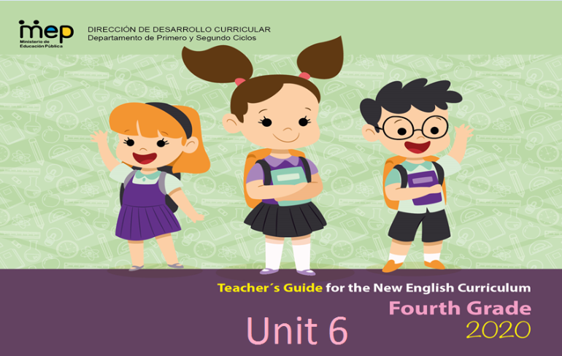

Scenario: OH! The places you will Go
Enduring Understanding | A good vacation requires proper planning. Different people like to do different things on their vacations.
Essential Question | What makes a good vacation?
ALL THE MATERIALS SUGGESTED IN THIS PLANNING (PPT, PDF, WORKSHEETS) CAN BE FOUND IN THIS LINK, JUST CLICK AND DOWNLOAD THEM
https://drive.google.com/drive/folders/1xMsAvUcLwlH_cVo3vaDQqOnVz1laye8D?usp=sharing

Assessment and Goals
Week 1 | Week 2 | Week 3 | Week 4 | Week 5
Theme  - Where to Go | Theme  - Where can I Go? | Theme  - Planning a Vacation | Theme  4. Oh, The Things that you will do
Assessment:  L.1. Recognizes the main points in short, simple stories and reports.  R.PA.1. Identifies English sounds /ɜ: // ɔ:/ æ/ / ʌ/ and decodes words.  S.I.1. Asks others about their likes and dislikes.  Goals:  L.1. Understands the main points in short, simple stories and reports when there is some previous understanding of the topic and if they are read slowly, clearly and possibly repeated.  R.PA.3. Identifies the sounds /ɜ: / ɔ://æ // ʌ/  SI.1. Asks others about their likes and dislikes (e.g. discuss favorite foods of Costa Rican vacation destinations). | Assessment:  L.2. Recognizes phrases and high frequency vocabulary related to areas of personal interest by circling them in songs, conversations among others.  R.1. Recognizes and enjoys texts.  R.PA.1. Identifies English sounds /ɜ: // ɔ:/ æ/ / ʌ/ and decodes words.  SP.1. Describes basic aspects of an event in an oral presentation.  Goals:  L.2. Understands phrases and high frequency vocabulary related to areas of personal interest (e.g. On vacation, we will swim in the sea and eat fish).  R.1. Comprehends readings, analyses and enjoys texts.  R.PA.3. Identifies the sounds /ɜ: / ɔ://æ // ʌ/  SP.1. Describes basic aspects of an event. | Assessment:  R.2. Recognizes most of what occurs in a well-structured short story by ordering the events in a story coherently.  R.PA.1. Identifies English sounds /ɜ: // ɔ:/ æ/ / ʌ/ and decodes words.  SI.2. Asks straightforward questions in familiar situations and understand the responses during dialogues and conversations.  W1. Writes a short text related to personal  vacation plan.  Goals:  R.2. Understands most of what occurs in a well-structured short story and can identify the story’s main characters.  R.PA.1. Identifies the sounds /ɜ: / ɔ://æ // ʌ/  SI.2. Asks straightforward questions in familiar situations and understand the responses.  W.1. Writes, with the help of illustrations, an explanation of where they will go how to get there, and what they will do. | Assessment:  R.PA.1. Identifies English sounds /ɜ: // ɔ:/ æ/ / ʌ/ and decodes words.  SI.2. Asks straightforward questions in familiar situations and understand the responses during dialogues and conversations.  SP.1. Describes basic aspects of an event in an oral presentation.  W.2. Applies conventions of standard English.  Goals:  R.PA.1. Identifies the sounds /ɜ: / ɔ://æ // ʌ/  SI.2. Asks straightforward questions in familiar situations and understand the responses.  SP.1. Describes basic aspects of an event.  W.2. Applies conventions of standard English. | Assessment  Instruments for Process/Product  Week 6  Suggested Integrated Mini project  My Dream Vacation Flipbook
Function  Describing places and people | Function  Describing daily activities | Function  Expressing preferences (likes and dislikes) | Function  Making suggestions
Discourse Markers  Linkers: Sequential - past tense | Discourse Markers  Linkers: Sequential - past tense | Discourse Markers  First, then, after that, finally | Discourse Markers  First, then, after that, finally
Grammar & Sentence Frames  Describing places  My _____ (hotel) has _____ (a swimming pool).  ___ (Guanacaste) is ___ (hot) and ___ (dry).  Yes/no questions present simple  Do you have a double/single room for tonight?  Do you accept credit cards?  Does the hotel have a swimming pool?  Prepositions of places  - At, in, on…)  - The hotel restaurant is____ (on) the second floor.  - We are leaving___ (on) December the 24th.  - She is____ (in) her room now.  Possessive adjectives  - ___ (My mother) likes to go to the beach, but ___ (my father) likes to go to the mountains. | Grammar &Sentence Frames  Present Progressive:  I´m going to______  Verb +ING  I like going to the beach  Simple future  I will bring my ___ (sunglasses).  We will go to the (beach) _____,  We will swim in the (river) _____.  - Want= would like  I would like to go to the beach. | Grammar & Sentence Frames  Simple present tense with a conjunction  I like____ (camping), but I prefer ____ (staying at a hotel).  On vacation I like to_____ (sleep late/wake up early) and eat a______ (big breakfast/lunch/dinner) | Grammar & Sentence Frames  Wh- questions  Where will you go on vacation this summer?  When are you going?  What will you bring to ______?  Simple future and first conditional  If we ___ (go) to Cahuita, we ____ (will surf).  If I ___ (go) to the beach, I ____ (will play soccer on the sand).
Phonemic Awareness  Practicing minimal pair sounds:  - work / walk  - bird / bored  - fur / for  - shirt / short  - sir / saw | Phonemic Awareness  Practicing minimal pair sounds: æ /  - cat / cut  - ankle / uncle  - ran / run  - drank / drunk  - match / much | Phonemic Awareness  Practicing vowel consonant combinations to form several words:  - /m/, /s/, /a/,  /t/, /n/,/e/ | Phonemic Awareness  Practicing vowel consonant combinations to form several words:  - /m/, /s/, /a/,  /t/, /n/,/e/
Vocabulary  Where to go  Places  - Beach, River, Beach hotel, waterfall  Typical foods:  - Rice and beans  - Coffee, Tamales,  - Seafood,  Expressing preferences  - I like/ don’t like/ she likes/she doesn’t like..  - I would like… | Vocabulary  Different people, different places  Places to go  - Going to visit my grandparents  - Going to the beach  - Going to a beach hotel  - Going to the river  Descriptive words  - Happy, Excited  - Hot, Cold  People to meet  - Uncle-aunt  - Grandparents  Transportation  - Bus, car… | Vocabulary  Planning vacations  Making a hotel reservation  - Book a room  - I need a single or double room  - How much is it?  - I need some personal information  Packing:  - T-shirt, shorts  - Suitcase,  - backpack  Daily routines:  - sleep (late)  - wake up (early)  - eat breakfast/ lunch/ dinner | Vocabulary  Oh, the things that you will do  Vacation activities:  - Hiking, Walking  - Dancing, Eating  - Swimming  - Do karaoke  - Horse back riding  Expressing future  - I will go hiking/swimming  If I go… I will….
Psycho-social  - Showing creativity for selecting a vacation place.  Sociocultural  - Using “please” and “thank you” appropriately in rehearsing and preparing for vacation  Idioms/phrases  - “I can’t wait … “ | Psycho-social  - Communicating ideas and desires politely.  Sociocultural  - Using “please” and “thank you” appropriately in rehearsing and preparing for vacation  Idioms/phrases  - “What do you want to do?”  “This is the best yet.” | Psycho-social  - Using technology to get information and share information  Sociocultural  - Using formal and Informal registers when greeting and saying good-bye  Idioms/phrases  Have a safe trip | Psycho-social  - Using technology to get information and share information  Sociocultural  - Using formal and Informal registers when greeting and saying good-bye  Idioms/phrases  Have a safe trip

Term: 3 |  | Level: Fourth Grade |  |  | Unit: 6 |  |  | Week:1
Domain: |  |  |  | Scenario: OH! The places you will Go |  | Theme: Where to Go
Enduring Understanding: A good vacation requires proper planning. Different people like to do different things on their vacations.
Essential Question: What makes a good vacation?
Dimensions
1. Ways of thinking ( )

2. Ways of living in the world ( )
3. Ways of relating with others ( )
4. Tools for integrating with the world ( )
New Citizenship:

Learn to Know |  |  |  | Learn to Do |  | Learn to Be and Live in Community
Grammar & Sentence Frames  Describing places  - My _____ (hotel) has _____ (a swimming pool).  - ___ (Guanacaste) is ___ (hot) and ___ (dry).  Yes/no questions present simple  - Do you have a double/single room for tonight?  - Do you accept credit cards?  - Does the hotel have a swimming pool?  Prepositions of places  - At, in, on…)  - The hotel restaurant is____ (on) the second floor.  - We are leaving___ (on) December the 24th.  - She is____ (in) her room now.  Possessive adjectives  - ___ (My mother) likes to go to the beach, but ___ (my father) likes to go to the mountains.  Vocabulary  Where to go  Places  - Beach, River, Beach hotel, waterfall  Typical foods:  - Rice and beans  - Coffee, Tamales,  - Seafood,  Expressing preferences  - I like/ don’t like/ she likes/she doesn’t like..  - I would like…  Phonemic Awareness  Practicing minimal pair sounds:  - work / walk  - bird / bored  - fur / for  - shirt / short  - sir / saw |  |  |  | Function  Describing places and people  Discourse Markers  Linkers: Sequential - past tense |  | Psycho-social  - Showing creativity for selecting a vacation place.  Socio-cultural  - Using “please” and “thank you” appropriately in rehearsing and preparing for vacation  Idioms/phrases  - “I can’t wait … “
Assessment Strategies & indicators of learning  (Diagnostic, formative, summative) | Goals |  |  | Pedagogical Mediation/ Didactic Sequence |  |  |  |  | Time
Learner…  L.1. Recognizes the main points in short, simple stories and reports.  SI.1. Ask others about their likes and dislikes (e.g. discuss favorite foods of Costa Rican vacation destinations).  R.PA.1. Identifies English sounds /ɜ: // ɔ: / and decodes words. | Learner can  L.1. Understands the main points in short, simple stories and reports when there is some previous understanding of the topic and if they are read slowly, clearly and possibly repeated.  S.I.1. Asks others about their likes and dislikes.  R.PA.3. Identifies the sounds /ɜ: / ɔ: / |  |  | ALL THE MATERIALS SUGGESTED IN THIS PLANNING  CAN BE DOWNLOADED FROM THIS LINK  https://drive.google.com/drive/folders/1xMsAvUcLwlH_cVo3vaDQqOnVz1laye8D?usp=sharing  Pre-teaching  Students watch and listen to a video where an American family describes the adventures they went through during their visit to Costa Rica https://www.youtube.com/watch?v=gRnkXuky7f4  Teacher introduces essential question and motivates students to participate by telling them where to go on vacations.  Activation of prior knowledge  Teacher introduces sentence frames and vocabulary about places to visit and traditional food to eat in Costa Rica by using real pictures from a power point presentation.  Modeling  Teacher uses a power point presentation while pronouncing the new sentence frames when introducing vocabulary about places to visit and traditional food to eat in Costa Rica. Students repeat after the teacher.  Clarifying  The teacher locates images related to places and typical food around the class (under the chair, on the walls, behind something, etc). If the group is large, divide it into small groups. The teacher says students to walk around in order to grab an image; when everybody has one tell students to look for his/her pair to mention the frame structures previously practiced.  Pre-task  The teacher introduces the goal of the lesson, sentence frames, and vocabulary needed for the main task by using pictures.  Task-rehearsal  Students listen to information related to places to go and food to eat from different provinces of Costa Rica. They have to recognize information according to the listened by choosing one option in a given multiple choice practice.  Task completion  Students listen to the teacher saying some sentences about places to go and food to eat according to Costa Rican provinces in order to distinguish images. (teacher can use the flashcards from Clarifying). Students get in groups of four; listen to the teacher, and then each group goes in front of the classroom to paste images on the board according to the listened sentences.  Task assessment  Students listen to three different short stories related to places to go and food to eat in Costa Rica according to character´s experiences. They have to distinguish the sequence of done activities by arranging images.  Speaking Interaction  Pre-task  The teacher shows a Costa Rican map in order to elicit students’ knowledge and experiences. As the teacher points, students have to name provinces and tell about activities to do and food to eat according to previous knowledge. Then, the teacher introduces the goal of the lesson, sentence frames, and vocabulary needed for the main task by using pictures.  Task-rehearsal  Students get in pairs. Each pair goes in front of the classroom to play by using a power point wheel. One student asks questions written on the board (where would you like to go? What food would you like eat?) and the other spins the wheel to answer according to the option showed. He/she has to spin the wheel twice; one in the first slide which indicates place. The second time in the next slide to indicate the traditional food to mention about.  Students can switch turns. To answer they have to use the structures “I would like to go to __________ and I would like to eat __________”.  Task completion  Teacher and students’ competition. The teacher chooses one picture for place and one for food. The teacher asks students to guess the image´s situation he/she has on his/her hands by saying a sentence. Example: The teacher would like to visit Puntarenas and eat seafood.  Students has three opportunities to guess; if they do not guess, the teacher scores one point. As soon as students have lost the opportunity of guessing the teacher shows the images he/she had on hands and says the expected sentence.  Finally, the teacher changes images and starts again. (use flashcards from clarifying)  Task assessment  Students create their own flip book named Exploring Costa Rica. They have to complete information about weather, place and food for each province by writing it on given lines. After that, they get in pairs to ask each other about two of their favorite food and destinations to go on vacations in Costa Rica.  They have to ask each other the following questions: where would you like to go on vacations? Where would you like to stay? What places would you like to visit? What food would you like to eat?  Phonemic Awareness (Week 1)  Pre-task  Teacher introduces the goal for the lesson.  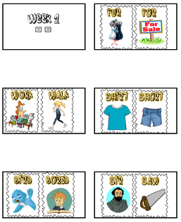  Teacher designates particular movements to particular sounds, as lively or as gentle as you like. For instance, the students could be sitting at their desks and raise a hand, clap or stand up when they hear a particular sound, or they could be standing in space and jump or run in response to sounds. They could respond to words on flashcards by correctly pronouncing them and moving in the prescribed way, or they could respond to the teacher (or another student) saying the words.  Teacher uses a power point presentation with the different minimal pair sounds /ɜ: / /ɔ:/. Teacher says the words and students repeat chorally. Teacher emphasizes the sounds and the difference.  Task-rehearsal  The class is divided into four groups to play a memory fame. Words and pictures are mixed up, faced down on the floor in rows. Learners tale turns to turn over two cards, and if the two cards march (minimal pairs), they keep them. The game is over when all the cards have been matched. Learners work on self and peer assessment, as well as the whole class assesses their achievement of the goal.  Task completion  Learners, individually work on the following worksheets.  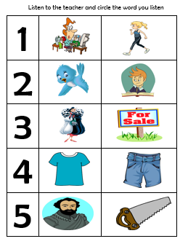  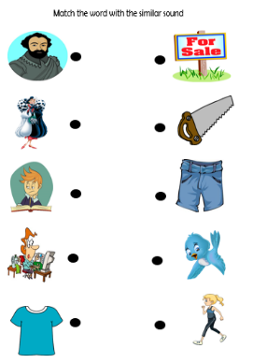  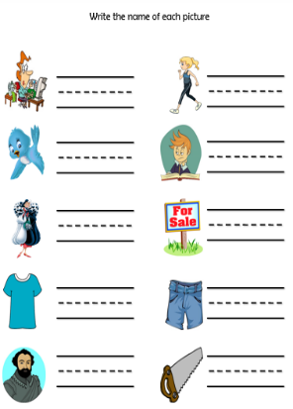  Task assessment  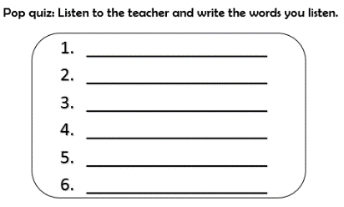  - Pop quiz: Teacher gives students a pop quiz paper sheet. Teacher pronounces minimal pair words.  - Minimal pair race: Teacher forms students in three teams and ask them to form lines. Teacher stands in front of the teams and show a set of minimal pairs. Students run to the board and write the name of the minimal pair’s name. Teacher checks grammar if necessary and continues to show the pictures until they are finished.
Reflective Teaching
What worked well |  |  | What didn’t work well |  |  |  | How to improve
Enduring Understanding Reflection

Term: I |  | Level: Fourth Grade |  |  | Unit:6 |  |  | Week:2
Domain: Socio-interpersonal |  |  |  | Scenario: OH! The places you will Go |  | Theme: Where can I Go?
Enduring Understanding: A good vacation requires proper planning. Different people like to do different things on their vacations.
Essential Question: What makes a good vacation?
Learn to Know |  |  |  | Learn to Do |  | Learn to Be and Live in Community
Grammar &Sentence Frames  Present Progressive:  - I´m going to______  Verb +ING  - I like going to the beach  Simple future  - I will bring my ___ (sunglasses).  - We will go to the (beach) _____,  - We will swim in the (river) _____.  - Want= would like  I would like to go to the beach. |  |  |  | Function  Describing daily activities  Discourse Markers  Linkers: Sequential - past tense |  | Psycho-social  Communicating ideas and desires politely.  Socio-cultural  Using “please” and “thank you” appropriately in rehearsing and preparing for vacation  idioms/ phrases  “What do you want to do?”  “This is the best yet.”
Assessment Strategies & Evidences of learning  (Diagnostic, formative, summative) | Goals |  |  | Pedagogical Mediation/ Didactic Sequence |  |  |  |  | Time
Learner…  L.2. Recognizes phrases and high frequency vocabulary related to areas of personal interest by circling them in songs, conversations among others.  R.1. Recognizes and enjoys  SP.1. Describes basic aspects of an event in an oral presentation.  R.PA.1. Identifies English sounds / æ/ / ʌ/ and decodes words. | Learner can  L.2. Understands phrases and high frequency vocabulary related to areas of personal interest (e.g. On vacation, we will swim in the sea and eat fish).  R.1. Comprehend sreadings, analyze and enjoy texts.  SP.1. Describes basic aspects of an event.  R.PA.3. identify the sounds /æ // ʌ/ |  |  | ALL THE MATERIALS SUGGESTED IN THIS PLANNING  CAN BE DOWNLOADED FROM THIS LINK  https://drive.google.com/drive/folders/1xMsAvUcLwlH_cVo3vaDQqOnVz1laye8D?usp=sharing  Pre-teaching  Teacher plays the “Vacation Song” video (https://www.youtube.com/watch?v=fWuiq2tW8LQ) for learners to watch different activities they can do during vacations.  Activation of prior knowledge:  Teacher provides to the students a piece of paper where they will write a place that they would like to visit during their next vacation period. The teacher will invite the students to come in front, read the paper and paste it on the board. The teacher will ask to the rest of the class if they would like to visit that place. Annex 1  Pre-task  Teacher introduces the goal of the lesson. Using a Power Point Presentation teacher shows how to plan a vacation trip using sentence frames. The teacher models pronunciation. Annex 2  For example:  - I am going to visit the beach  - I am going to get there by bus  - I am going to take the sun and have some fun on the waves  - I am going to eat hamburgers  - I will bring my sunglasses  Task-rehearsal  Teacher split the class into two teams. Teacher paste pictures of activities to do during vacations on the board. Teacher models pronunciation for each activity. Students play ¨listen and run” (Each team choose a student, teacher says a phrase “During my vacations I am going to swim” Students listen, when the teacher indicates (1,2,3 go) students run and touch the picture that represents the activity described by the teacher, the team that choose the correct picture first win a point) Annex 3  Task completion  -Students listen an audio about Allison´s travel plans. Students answer questions based on the conversation. Annex 4 and 5  Task assessment  -Teacher ask the students to describe what the conversation is about by brainstorming ideas.  Pre-task  -Teacher introduces the goal of the lesson. Teacher activates prior knowledge by showing different flashcards about places to visit during vacations. Annex 6  -Teacher pastes on the board the question: Where can I go? Students brainstorm about where they want to go on vacation.  Task-rehearsal  -In pairs students talk about what places they would like to visit for their next vacations.  Task completion  -Students read a text called “My dream vacations” and answer the questions below based on the text. Annex 7  Task assessment  -Teacher ask the students to describe what they consider than that will be their dream vacation.  Pre-task  -Teacher introduces the goal of the lesson. Teacher activates prior knowledge by showing a presentation about his/her travel plans. Teacher will describe where he will go and what he would do there. Annex 8  Task-rehearsal  Students brainstorm about his/her teacher travel plans. Teacher will ask questions (Where am I going? How am I going to get there? What am I going to do? Students answer the questions based on the teacher´s presentation.  Task completion  -Students create a travel plan passport by filling blanks, pasting pictures and drawing. (teacher provides pictures or ask in advance for pictures related to travel plans) Annex 9  Task assessment  -Teacher ask the students to describe they travel plans to the class by describing what they have on their “Passports”  Phonemic Awareness  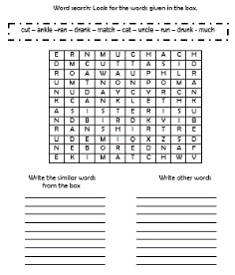  Pre-task  Teacher introduces the goal for the lesson.  Teacher asks the students to search some words in a word search. Then to write under the words they consider are similar or related.  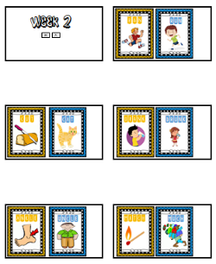  Teacher uses a power point presentation with the different minimal pair sounds /æ // ʌ/. Teacher says the words and students repeat chorally. Teacher emphasizes the sounds and the difference.  Task-rehearsal  The class is divided into four groups to play. Teacher gives each group a set of letter cards. Students must form the words learned (minimal pairs). When they have formed all the words they should call the teacher. The teacher reviews the correct grammar, then asks students to repeat all the words chorally.  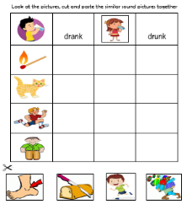  Task completion  Learners, individually work on the following worksheets.  Task assessment  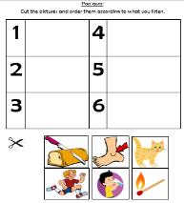  - Pop quiz: Teacher gives students a pop quiz paper sheet. Teacher pronounces a word and students paste the correct picture.  - Oral presentation: Teacher previously asks students to bring newspapers, magazines, pictures or drawings. Students are form into four groups they must make a mural or poster including all the minimal pairs (week 1 and week 2) they have learned. Students must paste the minimal pairs pictures next to each other and write the name. Then each group present the poster or mural to the class, they have to read the words.  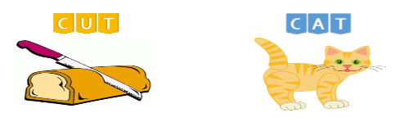  Example: |  |  |  |  | 5 minutes  10 minutes  10 minutes  10 minutes  10 minutes
Reflective Teaching
What worked well |  |  | What didn’t work well |  |  |  | How to improve
Enduring Understanding Reflection

Term: III |  | Level: Fourth Grade |  |  | Unit: 6 |  |  | Week:3
Domain: |  |  |  | Scenario: OH! The places you will Go |  | Theme: Planning a Vacation
Enduring Understanding: A good vacation requires proper planning. Different people like to do different things on their vacations
Essential Question: What makes a good vacation?
Learn to Know |  |  |  | Learn to Do |  | Learn to Be and Live in Community
Grammar & Sentence Frames  Simple present tense with a conjunction  - I like____ (camping), but I prefer ____ (staying at a hotel).  On vacation I like to_____ (sleep late/wake up early) and eat a______ (big breakfast/lunch/dinner)  Vocabulary  3. Planning vacations  Making a hotel reservation  - Book a room  - I need a single or double room  - How much is it?  - I need some personal information  Packing:  - T-shirt, shorts  - Suitcase,  - backpack  Daily routines:  - sleep (late)  - wake up (early)  - eat breakfast/ lunch/ dinner  Phonology  Phonemic Awareness  Practicing vowel consonant combinations to form several words:  - /m/, /s/, /a/,  /t/, /n/,/e/ |  |  |  | Function  Expressing preferences (likes and dislikes)  Discourse Markers  First, then, after that, finally |  | Psycho-social  - Using technology to get information and share information  Sociocultural  - Using formal and Informal registers when greeting and saying good-bye  Idioms/phrases  Have a safe trip
Learner…  R.2. understand most of what occurs in a well-structured short story and can identify the story’s main characters.  SI.2. Asks straightforward questions in familiar situations and understand the responses during dialogues and conversations.  W.1. Writes, with the help of illustrations, an explanation of where they will go how to get there, and what they will do.  W.2. Applies conventions of standard English.  R.PA.1. Identifies English sounds /ɜ: // ɔ:/ æ/ / ʌ/ and decodes words. | Learner can  R.2. Recognizes most of what occurs in a well-structured short story by ordering the events in a story coherently.  SI.2. Asks straightforward questions in familiar situations and understand the responses.  W.1. Writes a short text related to a personal vacation plan.  R.PA.1. Identifies the sounds /ɜ: / ɔ://æ // ʌ/ |  |  | ALL THE MATERIALS SUGGESTED IN THIS PLANNING  CAN BE DOWNLOADED FROM THIS LINK  https://drive.google.com/drive/folders/1xMsAvUcLwlH_cVo3vaDQqOnVz1laye8D?usp=sharing  Pre-teaching  Warm up:  - Students listen, repeat and dance the Boom Chicka boom song from the next video: https://youtu.be/hfZ-438DrIs  - Brainstorming: Teacher asks students to brainstorm words that come to their minds when thinking about planning a vacation.  - Teacher asks students to draw their favorite activity during vacation time.  Activation of prior knowledge  - Teacher introduces the question: What do you like todo for vacation time?  - Then, Teacher shows the video https://youtu.be/mVhh0oATqBI to elicit some examples of activities to do during vacation time.  - Teacher ask students about their favorite activities.  Modeling  - Teacher shows a power point presentation to introduce sentence structures to use when planning a vacation:  - I like____ (camping), but I prefer ____ (staying at a hotel).  - On vacation I like to_____ (sleep late/wake up early) and eat a______ (big breakfast/lunch/dinner)  Clarifying  - Using flashcards with pictures about vacation activities from the previous PPT, the teacher checks if learners know the vocabulary and the use of sentence frames by asking: what do you like to do on vacations?  - Students must pick up the activity they want and answer with it in the next way: I like ___________, but I prefer_________________.  Pre-task  - The teacher shares the goal of the lesson.  - Teacher introduces the topic of planning vacations by telling one her favorite vacation activities.  Task-rehearsal  - Students will organize some vacation activities.  - Students will number some articles of clothing to use during vacations.  Task completion  - Students read the text “Planning my vacations” and check the activities each member of a family enjoy doing.  Task assessment  - Students re-read the previous text to circle and underline the family members and their favorite activity at the beach. Also, they write the activities mentioned in the reading.  Pre-task  - The teacher shares the goal of the lesson.  - Students watch a video about a person making a hotel reservation. Link: https://youtu.be/zKeIMFMlae0  Task-rehearsal  - Students and teacher brainstorm some tips presented in the video about what to ask when you are booking a hotel room.  Task completion  - Students interview a classmate about a place they would like to visit (hotel, beach, mountain, river, and city), the activities they would like to enjoy and the type of clothing they would choose for the occasion. Encourage students to review the previous information about vacation activities and clothing to answer the interview questions.  Task assessment  - In pairs, students will create a dialogue about a person making a hotel reservation. The teacher will provide a sample dialogue for them to follow it.  - Students perform a role play with the dialogue they created.  Pre-task  - The teacher shares the goal of the lesson.  - Students watch the video “I Love Summer Time”. Link https://youtu.be/Xg5i9rxxuJM  - Students mention the different places mentioned in the video.  Task-rehearsal  - In pairs, students answer the question what do you like to do in vacation? In my vacations I like _____________________.  Task completion  - Students write sentences related to places to visit and match them with activities to do according to the place and their preferences.  Task assessment  - Students write a short paragraph saying a place they would like to visit for vacation and the activities they would like to do.  - Example: For my vacations I would like to go to the beach. I would like playing soccer but I prefer swimming in the ocean.  Phonemic Awareness  Pre-task  - The teacher shares the task of the lesson.  - The teacher shows to the learners the power point presentation related to the sounds and words that they have to learn.  - Learners have to go to the board and say the name of the pictures that the teacher shows them.  Task-rehearsal  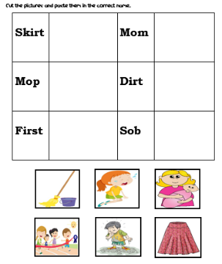  - Learners have to cut the pictures and paste them in the corresponding column according to each words.  Task completion  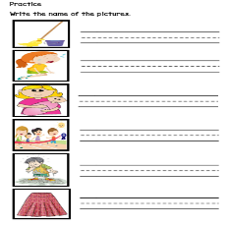  - Learners have to look at the pictures, listen to what the teacher said and write the name of each one in the corresponding line.  Task assessment  - The teacher have to project the images on the board or print them and paste them on the board. The students have to listen to the words that the teacher said and run to the board to touch the correct pictures
 |  |  |  | 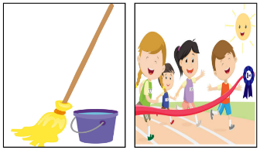
Reflective Teaching
What worked well |  |  | What didn’t work well |  |  |  | How to improve
Enduring Understanding Reflection

Term: III |  | Level: Fourth Grade |  |  | Unit: 6 |  |  | Week:4
Domain: |  |  |  | Scenario: OH! The places you will Go |  | Theme: Oh, The Things that you will do
Enduring Understanding: A good vacation requires proper planning. Different people like to do different things on their vacations
Essential Question: What makes a good vacation?
Learn to Know |  |  |  | Learn to Do |  | Learn to Be and Live in Community
Grammar & Sentence Frames  Wh- questions  - Where will you go on vacation this summer?  - When are you going?  - What will you bring to ______?  Simple future and first conditional  - If we ___ (go) to Cahuita, we ____ (will surf).  If I ___ (go) to the beach, I ____ (will play soccer on the sand).  Vocabulary  Vacation activities:  - Hiking, Walking  - Dancing, Eating  - Swimming  - Do karaoke  - Horse back riding  Expressing future  - I will go hiking/swimming  If I go… I will….  Phonology  Phonemic Awareness  Practicing vowel consonant combinations to form several words:  - /m/, /s/, /a/,  /t/, /n/,/e/ |  |  |  | Function  Making suggestions  Discourse Markers  First, then, after that, finally |  | Psycho-social  - Using technology to get information and share information  Socio-cultural  - Using formal and Informal registers when greeting and saying good-bye
SI.2. Asks straightforward questions in familiar situations and understand the responses during dialogues and conversations.  SP.1. Describes basic aspects of an event in an oral presentation.  W.2. Applies conventions of standard English.  R.PA.1. identifies English sounds /ɜ: // ɔ:/ æ/ / ʌ/ and decodes words. | SI.2.Asks straightforward questions in familiar situations and understand the responses.  SP.1. Describes basic aspects of an event.  W.2. Applies conventions of standard English.  R.PA.1. Indentify the sounds /ɜ: / ɔ://æ // ʌ/ |  |  | ALL THE MATERIALS SUGGESTED IN THIS PLANNING  CAN BE DOWNLOADED FROM THIS LINK  https://drive.google.com/drive/folders/1xMsAvUcLwlH_cVo3vaDQqOnVz1laye8D?usp=sharing  Pre-teaching  Warm up: Two truths and a lie  - Teacher writes three sentences about his/her vacations. Two statements should be true and one false, for example: I went to a Disney the last year. I went to a volcano with my family on January, and I played soccer at the beach the last weekend. Ask each pair which statement they think is untrue and have them explain why. Reveal your answer at the end.  - Then, the teacher can ask learners to mention their preferences about places for summer vacations.  Activation of prior knowledge  - Teacher introduces wh – questions with a song named 6 Questions song in the following link https://youtu.be/D5KuipbiL5k  - Teacher plays the song for a second time and asks learners sing the song.  - Teacher asks students to watch the videos Type 1 if conditional https://youtu.be/Tz-35-2pWpU  - and First conditional if. https://youtu.be/WX6rviEY-TE  Modeling  Teacher introduces the basic questions to know people vacation plans, and vacations activities. ppt: “wh-questions”. And “Simple future and first conditional”.  - Teacher asks students read and repeat.  Clarifying  Using the examples from the ppts the teacher checks if learners know the vocabulary and the use of sentence frames.  - Students look at the questions around the classroom.  - In pairs, write down the correct question word  - on the post it note to fill in the gap.  - Stick the question word next to the question. For example  - ______ will you go on vacation this summer?  - ______ are you going to the beach?  - ______ will you bring to the beach?  Pre-task  - The teacher shares the goal of the lesson.  - Teacher Introduces the topic of vacations by telling about one of his/her future vacations. Should include place, date, and useful things.  - Ask students to come up with different useful items for their vacation according to the place, and write them on the board.  Task-rehearsal  Students will think about a dream vacation place, time and things that they will bring to the trip. They can take notes if they want.  Task completion  In pairs, students will make a vacation interview each other.  For example:  When will you go on vacation this summer?  - I will go to grandma’s farm  When are you going to the Grandma’s farm?  - I`m going to grandma’s farm on October 12th  What will you bring to the Grandma’s farm?  - I will bring ______________, _______________, and __________.  Task assessment  Once they've interviewed each other, have students choose a dream vacation for their partner.  Pre-task  - The teacher shares the goal of the lesson.  - Students watch a video named: “My summer vacations” Link: https://youtu.be/V_BnhRJmxtA  Task-rehearsal  Students brain storm some vacation activities presented in the video. The teacher can write them on the board as they said them.  Task completion  Students talk about what activities will they do if they were in that place. First in pairs, and then some volunteers say it to the whole class.  Task assessment  - Students will pair and match first conditional correct structure, and say them aloud when the teacher asks them.  - The class is divided into two groups, one group will have the “main clause” and the other the “if clause”. They will talk about the vacation activities. (Annex 1)  - When they found the correct pair, they will present them orally in front of the class making the motions that represents the sentences.  Pre-task  - The teacher shares the goal of the lesson.  - Students watch the video “My Summer vacations” again.  Task-rehearsal  In pairs, students write up from the video at least 5 activities that people do on their vacations.  Task completion  Students have to complete the paragraph with the information seen in the video.  For example:  In my summer vacations  I am on vacation in ________________ with my parents and my sister. We are staying at a beautiful _____________ on the beach. There is a big ______________ pool in the hotel. My family enjoy playing _______________ on the beach. We also like to eat ___________________ on the beach. Also, we _______________ over the waves!. My favorite summer activity is riding on a ________________. It’s so exciting!  When there are big waves on the sea, you can go _______________. I am crazy about swimming and _________________. We are having many other activities like archery, rock __________________, ropes course, Tarzan Swings, sack ____________, jumping on a trampoline, playing frisbee, tug of war, water _________, kayaking, and finally in the evening we share ____________ sat around the campfire.  Teacher with examples highlights the importance of capitalizing the first letter of a word at the beginning of sentences and proper names. Techer also reminds to finish sentences with a period.  Task assessment  Students should write the main items needed for at least three vacation activities.  For example:  For swimming you should bring: _____________, ______________ and ___________  Phonemic Awareness  Pre-task  - The teacher shares the task of the lesson.  - The teacher shows to the learners the power point presentation related to the sounds and words that they have to learn.  - Learners have to go to the board and say the name of the pictures that the teacher shows them.  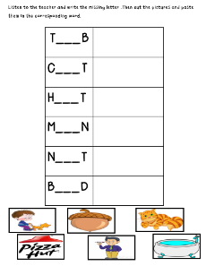  Task-rehearsal  - Learners listen to the teacher and write the missing letter .Then cut the pictures and paste them in the corresponding word.  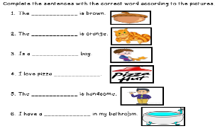  Task completion  - Learners have to complete the sentences with the correct word according to the pictures related to the new sounds combinations.  Task assessment  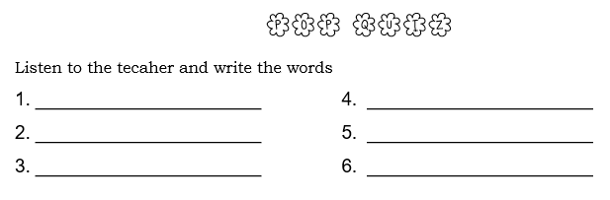  - Learners have to write the words that the teacher said in the corresponding space.
Integrated Mini-Project
All the activities for this planning can be download from this link:
https://drive.google.com/drive/folders/1xMsAvUcLwlH_cVo3vaDQqOnVz1laye8D?usp=sharing

MY DREAM VACATION
Learners use prior knowledge and linguistic skills to select the vocabulary required to describe their favorite vacation. Students choose which information they want to include. They complete a flipbook with the missing information including: place they will go, food they will find, transportation, people they will meet, what they need to pack and activities they will do. Once they complete the flipbook, they describe it orally to the rest of the class. Students should use the following structures:

*Greeting and name
Part 1: Students choose where they would like to travel to, complete the sentences and represent it with drawings or pictures.
Example: I would like to go to Guanacaste.
Part 2: Students describe what mean of transportation they will use to get there.
Example: I will go by train.
Part 3: Learners indicate what they expect to find there and what they will eat.
Example: I will eat tanelas and I will visit my uncle Joey.
Part 4: Learnes will explain what activities they will do during the vacation and what clothes are needed to wear there.
Example: I will play in the sand. I will wear my bathing suit and my sunglasses.
*Leave-taking
Reflective Teaching
What worked well |  |  | What didn’t work well |  |  |  | How to improve
Enduring Understanding Reflection

ANNEXES:
ALL THE ACTIVITIES SUGGESTED IN THIS PLANNING CAN BE DOWNLOADED IN THIS LINK: https://drive.google.com/drive/folders/1xMsAvUcLwlH_cVo3vaDQqOnVz1laye8D?usp=sharing

Créditos: Esta unidad fue elaborada por las siguientes docentes de la Dirección Regional de Guápiles:
Roxana Vargas, Esc Las Palmitas
Keylin Aguilar, Esc Campo Cinco
Stephanie Barrantes, Esc Barrio Los Ángeles
Leticia Cruz, Esc San Martín
Katherine Naranjo, Esc Cuatro Esquinas
Vianney Salazar, Esc Huétas
Deikelyn López, Esc Campo Cinco
Evelyn Guillén, Esc Los Ángeles
Katerine Mora, Esc Palermo

Revisión técnica: Ana Isabel Campos Centeno, Asesora nacional de inglés, Departamento de Primero y Segundo Ciclos

